SYMBIOSIS INSTITUTE OF BUSINESS MANAGEMENT, NAGPUR
DATA ANALYSIS USING PYTHON

TIME SERIES SALES FORECASTING
Walmart Weekly Sales Analysis Using Python

Particular | Details
Programme | MBA
Semester & Batch | Sem 1 | 2026–2028
Course | Data Analysis Using Python
Faculty | Harsh Jinger
Student | Anushka Singru
Experiential Learning | Coding Test & Presentation
Colab link | Link
Excel data | Link

Academic Report

Executive Summary
This report presents a time-series analysis and sales forecasting exercise using an aggregate Walmart weekly sales dataset. The analysis was conducted in Google Colab using the prescribed Time_Series_Analysis_most_common_models.ipynb tool. The assignment requires students to select an open time-series dataset, study the prescribed forecasting methodologies, analyse the data using the provided tool, and present the results through the tool.
The final analytical dataset contains 143 weekly observations from 05 February 2010 to 26 October 2012. The dependent time-series variable is aggregate Weekly_Sales. Data preparation included date conversion, removal of duplicates/missing observations, validation of sales values, and aggregation of store- and department-level sales by week.
Stationarity diagnostics produced consistent results: the ADF test reported a p-value of approximately 0.000 and classified the series as stationary, while the KPSS test reported p = 0.100 and also classified the series as stationary. The Ljung-Box test at lag 10 reported p = 0.7359, indicating no statistically significant autocorrelation at that lag.
Four forecasting models were evaluated in the supplied notebook: ARIMA, SARIMA, Holt-Winters and Prophet. Prophet produced the lowest RMSE (1,897,305), MAE (1,561,990) and MAPE (3.2627%) among the models reported in the final leaderboard. Therefore, based on the notebook's reported evaluation metrics, Prophet was selected as the preferred model.

1. Introduction
Time-series forecasting is used by organisations to understand patterns in historical observations and estimate future values. In a sales context, forecasts can support inventory planning, procurement, production scheduling, workforce planning, budgeting and target setting.
The SIBM Nagpur experiential learning brief states that the objective is to familiarise students with the actual programming workflow and actual analysis workflow without mixing the two. The activity is weighted 60% toward the coding test and 40% toward presentation/analysis, with emphasis on conceptual understanding, clarity of written code and presentation.

2. Objectives of the Study
- To prepare a weekly sales time series from Walmart sales data.
- To examine the statistical properties and time-dependent behaviour of weekly sales.
- To assess stationarity using ADF and KPSS tests.
- To examine autocorrelation using ACF, PACF and the Ljung-Box test.
- To decompose the series into observed, trend, seasonal and residual components.
- To compare ARIMA, SARIMA, Holt-Winters and Prophet forecasting approaches.
- To identify the preferred model using RMSE, MAE and MAPE.
- To translate the forecasting results into managerial implications.

3. Assignment Context and Methodology
According to the assignment brief, the task requires: (a) selecting a time-series dataset from Kaggle or another open dataset site; (b) reading the methodologies from the prescribed references; (c) analysing the dataset using Time_Series_Analysis_most_common_models.ipynb in Colab; and (d) presenting the results on the tool, with no PowerPoint required.
Stage | Activity | Output
1 | Dataset selection and preparation | Clean weekly sales time series
2 | Date/time-series setup | Date index and weekly observations
3 | Data diagnostics | ADF, KPSS, ACF/PACF, Ljung-Box
4 | Decomposition | Trend, seasonal and residual components
5 | Forecast modelling | ARIMA, SARIMA, Holt-Winters, Prophet
6 | Model comparison | RMSE, MAE, MAPE and AIC
7 | Managerial interpretation | Model selection and recommendations

4. Data Description and Preparation
The source Walmart sales data contains store- and department-level weekly sales observations. For the forecasting exercise, these observations were aggregated by Date to obtain a single weekly sales series.
Data characteristic | Result
Time-series variable | Weekly_Sales
Frequency | Weekly
Number of observations | 143
Start date | 05-Feb-2010
End date | 26-Oct-2012
Mean weekly sales | ₹47,114,036.00
Median weekly sales | ₹46,243,964.08
Standard deviation | ₹5,444,161.47
Minimum weekly sales | ₹39,600,376.50
Maximum weekly sales | ₹80,931,586.20
Coefficient of variation | 11.56%
Missing Date values after cleaning | 0
Missing Weekly_Sales values after cleaning | 0

The mean weekly sales were approximately ₹47.11 million, while the standard deviation was approximately ₹5.44 million. The coefficient of variation was approximately 11.56%, indicating moderate variation around the average weekly sales level. The wide difference between minimum and maximum observations also indicates the presence of high and low sales weeks.
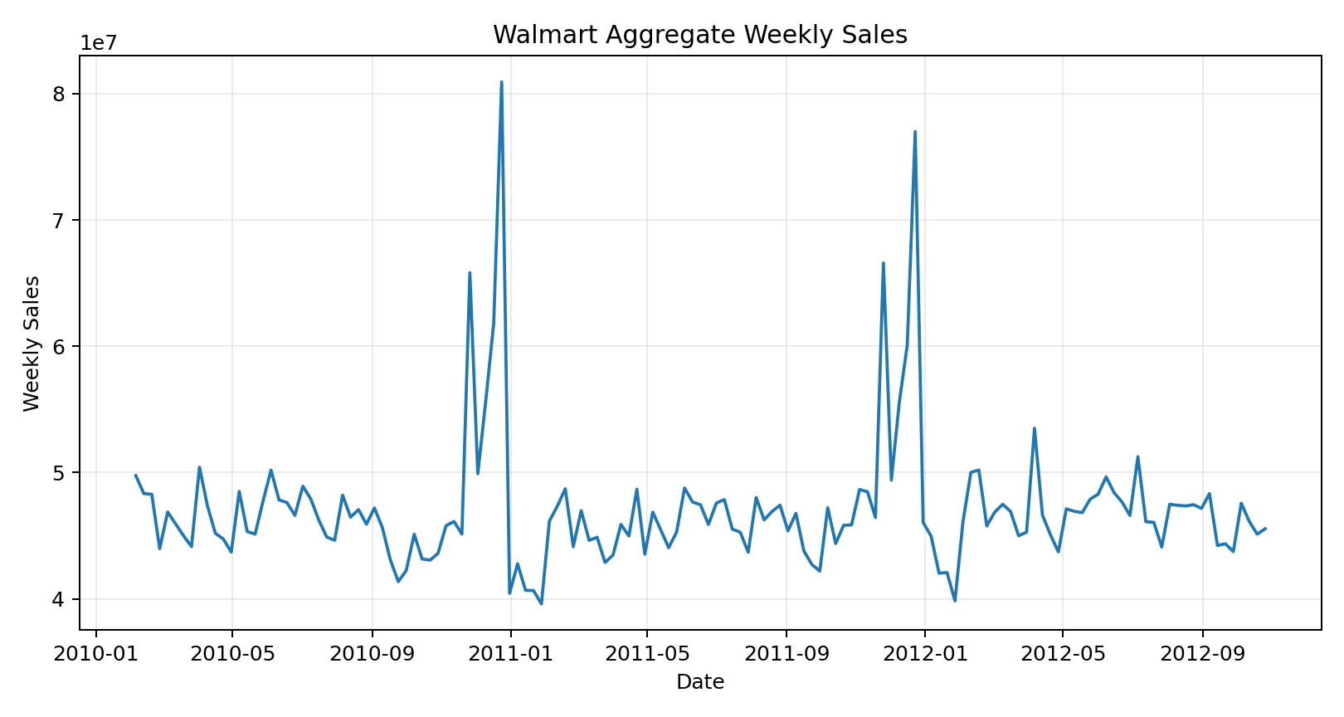
Figure 1. Aggregate Walmart Weekly Sales over the study period.

5. Time-Series Diagnostics

5.1 Augmented Dickey-Fuller (ADF) Test
The ADF test reported a test statistic of -7.8644 and a p-value of approximately 0.0000. At the 5% significance level, the null hypothesis of a unit root is rejected. The notebook therefore classified Weekly_Sales as stationary.

5.2 KPSS Test
The KPSS test reported a test statistic of 0.067 and p = 0.100. Since the reported p-value is greater than 0.05, the notebook classified the series as stationary. The ADF and KPSS results therefore provide consistent evidence of stationarity.

5.3 ACF and PACF
The ACF and PACF plots were examined to understand lag relationships in weekly sales. Most displayed correlations were within the confidence bands, with a few isolated spikes. These plots were used as diagnostic information rather than as the sole basis for selecting model parameters.

5.4 Ljung-Box Test
The Ljung-Box test at lag 10 reported a test statistic of 6.889 and p = 0.7359. Because the p-value is greater than 0.05, there is insufficient evidence of significant autocorrelation up to lag 10.

5.5 Seasonal Decomposition
An additive seasonal decomposition was successfully performed using a period of 12 weeks. The resulting plot separates the observed series into trend, seasonal and residual components. The decomposition shows changes in the underlying sales level and recurring short-cycle fluctuations.
A 52-week decomposition was also attempted because the data are weekly and a 52-week period would represent an approximate annual cycle. However, the supplied notebook reported that only 57 usable observations were available to the decomposition function, whereas 104 observations are required for two complete 52-week cycles. Consequently, the 12-week decomposition is treated as an exploratory diagnostic and is not presented as proof of annual seasonality.
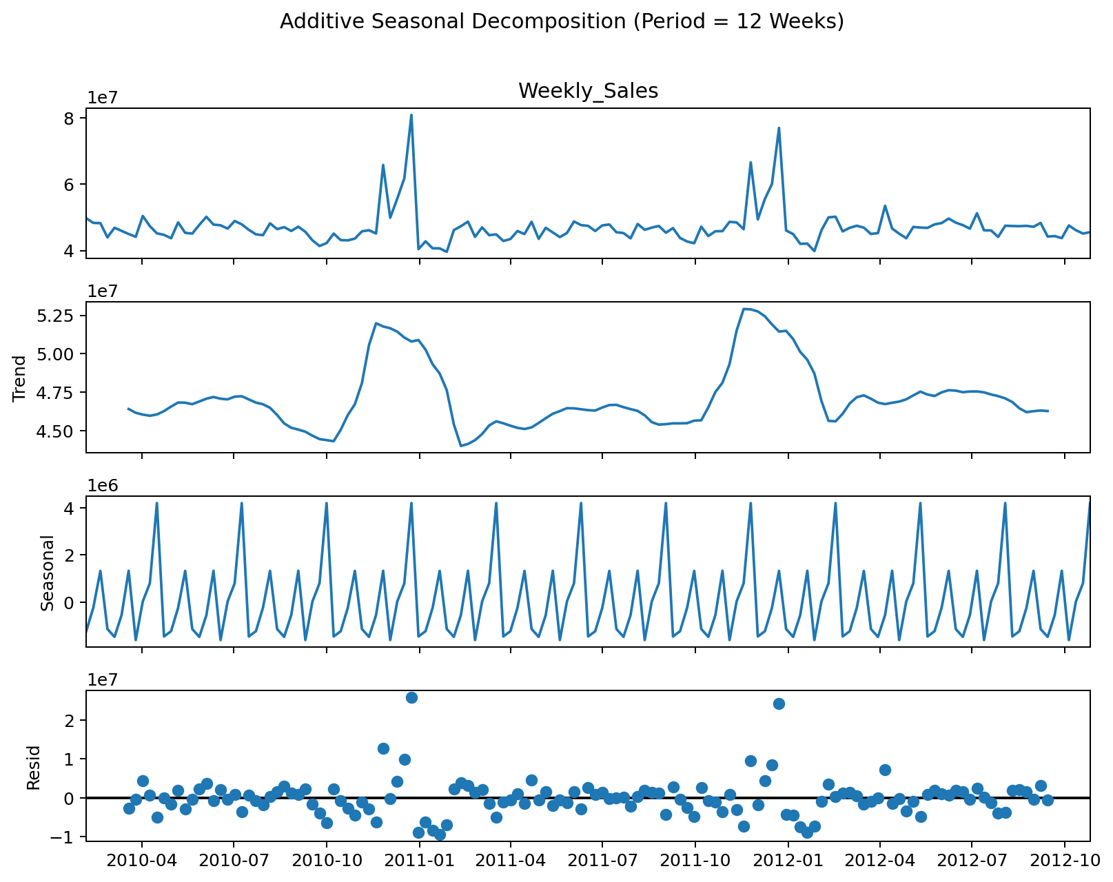
Figure 2. Additive seasonal decomposition using a 12-week period.
Diagnostic | Statistic / p-value | Notebook interpretation
ADF | Statistic = -7.8644; p ≈ 0.0000 | Stationary
KPSS | Statistic = 0.067; p = 0.100 | Stationary
Ljung-Box (lag 10) | Statistic = 6.889; p = 0.7359 | No significant autocorrelation
ACF/PACF | Visual diagnostic | Some isolated lag relationships
Seasonal decomposition | Period = 12 | Trend/seasonal/residual components identified

6. Forecasting Model Development
The supplied Colab tool was used to estimate four models: ARIMA, SARIMA, Holt-Winters and Prophet. The target variable for each model was Weekly_Sales.

6.1 ARIMA
ARIMA(1,0,1) was evaluated. Since the diagnostic tests classified the original series as stationary, the differencing parameter d was set to 0. The model combines an autoregressive component with a moving average component.

6.2 SARIMA
The reported SARIMA specification was (1,0,1) × (0,0,0)[12]. Because the seasonal P, D and Q parameters were all zero, this configuration did not introduce a seasonal AR, differencing or MA component. This is why its reported performance was identical to ARIMA(1,0,1).

6.3 Holt-Winters
The final leaderboard records Holt-Winters as trend=None, seasonal=None, sp=12. It therefore represents a comparatively simple exponential-smoothing specification rather than an explicitly configured trend-plus-seasonality model.

6.4 Prophet
Prophet was run with Weekly_Sales as the target. The model generated a forecast series with uncertainty bands and produced the strongest error metrics in the final leaderboard.

7. Model Evaluation and Comparison
The final model leaderboard compares RMSE, MAE, MAPE and AIC. For RMSE, MAE and MAPE, lower values indicate lower forecasting error. AIC is a relative model-selection measure in which lower values are generally preferred among comparable models; Prophet and Holt-Winters did not report AIC in the supplied leaderboard.
Model | Parameters | RMSE | MAE | MAPE | AIC
Prophet | default | 1,897,305.36 | 1,561,989.90 | 3.2627% | N/A
ARIMA | (1,0,1) | 2,417,670.49 | 1,712,108.20 | 3.5549% | 1845.2482
SARIMA | (1,0,1)x(0,0,0)[12] | 2,417,670.49 | 1,712,108.20 | 3.5549% | 1845.2482
Holt-Winters | trend=None,seasonal=None,sp=12 | 2,462,156.96 | 1,707,702.97 | 3.5447% | N/A

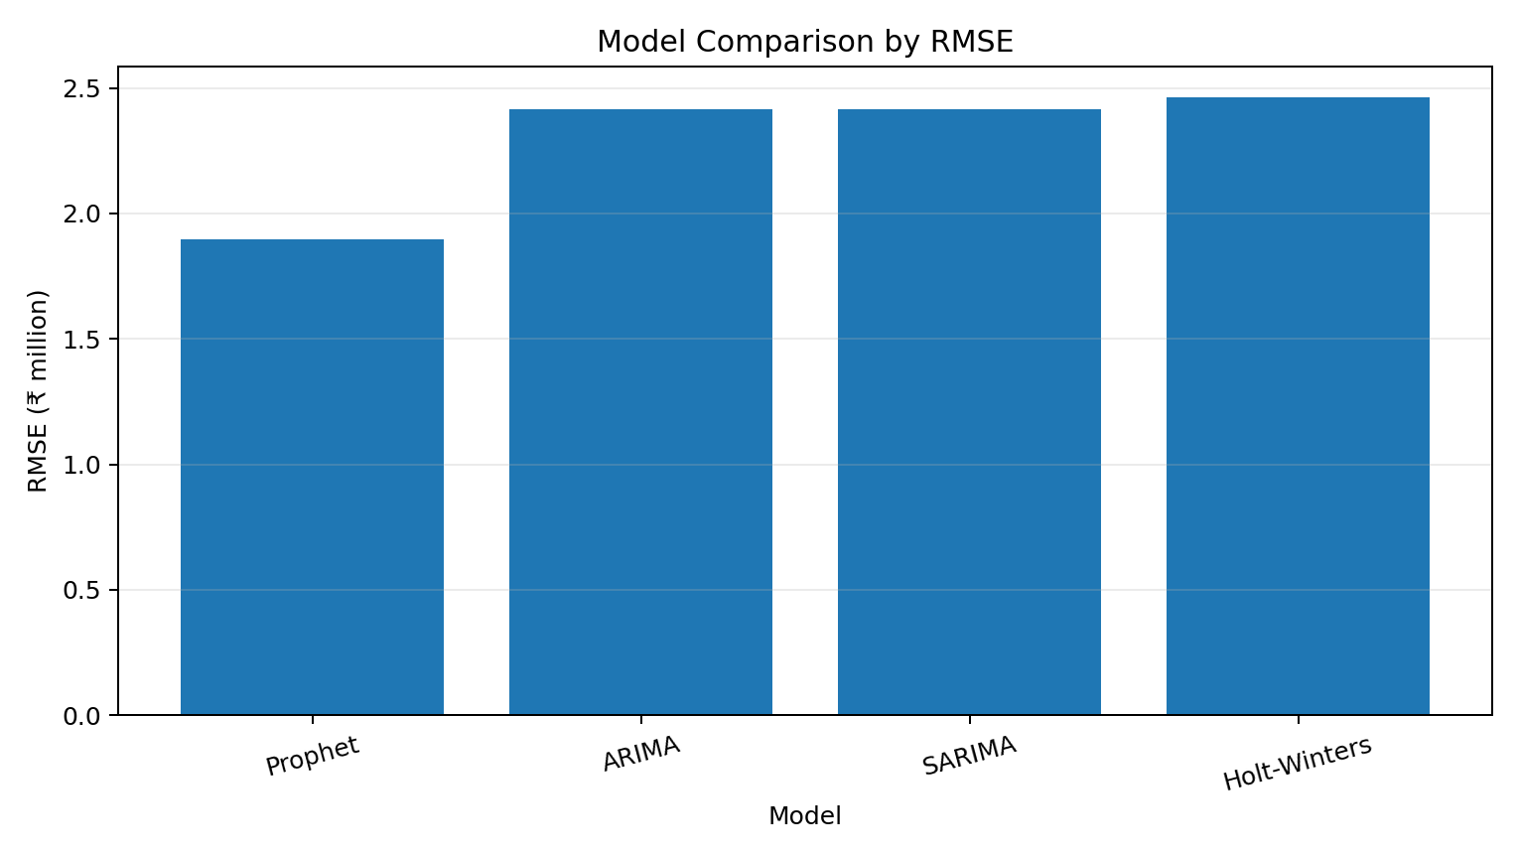
Figure 3. RMSE comparison across the four forecasting models.

7.1 Preferred Model
Prophet is the preferred model based on the supplied leaderboard. It achieved the lowest RMSE (₹1,897,305), lowest MAE (₹1,561,990) and lowest MAPE (3.2627%) among the four evaluated models. Its RMSE was approximately ₹0.52 million lower than ARIMA/SARIMA and approximately ₹0.56 million lower than Holt-Winters.

7.2 Interpretation of MAPE
The Prophet MAPE of 3.2627% indicates a relatively small average absolute percentage error for the observations used in the notebook's evaluation. It should not be interpreted as '96.74% accuracy'; MAPE is an error measure, not an accuracy percentage.

8. Managerial Interpretation and Business Implications
Inventory planning: Use the selected forecast as an input to inventory and replenishment planning, particularly before periods where the historical series shows higher sales.
Procurement: Align procurement quantities and supplier schedules with expected demand to reduce both stock-outs and excess inventory.
Sales target setting: Use forecast values as a quantitative baseline for weekly sales targets rather than relying only on historical averages.
Workforce planning: Higher expected sales periods can be used to anticipate requirements for store, warehouse, logistics and customer-facing resources.
Budgeting and cash planning: Sales forecasts can support short-term revenue planning and working-capital decisions.
Scenario planning: Management should consider the forecast together with uncertainty and business events rather than treating the point forecast as a guaranteed outcome.

9. Conclusion
The analysis demonstrates a complete time-series workflow using Walmart weekly sales data: data preparation, time indexing, statistical diagnostics, decomposition, forecasting and model comparison. Both ADF and KPSS classified the series as stationary, while the Ljung-Box test did not identify significant autocorrelation at lag 10.
Among the four models evaluated by the prescribed Colab tool, Prophet achieved the lowest RMSE, MAE and MAPE. Accordingly, Prophet is selected as the preferred model for this analysis. The result provides a practical basis for short-term sales planning, although forecasts should be interpreted alongside business context and uncertainty.

10. Limitations and Methodological Considerations
- The final analysis uses aggregate weekly sales across stores and departments, so store- or department-specific patterns are not modelled separately.
- The notebook's 52-week seasonal decomposition could not be completed because its decomposition step reported only 57 usable observations, below the 104 observations required for two complete annual cycles.
- The final leaderboard evaluates models using the notebook's built-in evaluation procedure. Therefore, the reported metrics should be interpreted as tool-based model-comparison results rather than definitive out-of-sample performance.
- The reported SARIMA specification contains zero seasonal AR, differencing and MA parameters, so it does not provide a substantive seasonal extension beyond the ARIMA specification.
- The final Holt-Winters row records trend=None and seasonal=None; therefore, the result should not be interpreted as a full trend-and-seasonality Holt-Winters configuration.
- External explanatory variables such as holidays, promotions, weather and economic indicators were not included in the final univariate forecasting target.

11. References
- Symbiosis Institute of Business Management, Nagpur. Template for Assignment/Case Analysis/Project Allocation: Data Analysis Using Python, Sem 1 2026–2028, Faculty: Harsh Jinger.
- Harvard Business Publishing. Time Series Sales Forecasting. Product No. IES497-PDF-ENG.
- Harvard Business Publishing. Time Series Forecasting. Product No. UV0678-PDF-ENG.
- Walmart weekly sales open dataset used for the analysis; cleaned and aggregated to a single weekly sales series.

Appendix A: Key Python Workflow
import pandas as pd
df = pd.read_csv("walmart.csv")
df = df.drop_duplicates()
df["Date"] = pd.to_datetime(
df["Date"], format="%d-%m-%Y", errors="coerce"
)
df = df.dropna(subset=["Date", "Weekly_Sales"])
df = df[df["Weekly_Sales"] >= 0]
weekly_sales = (
df.groupby("Date", as_index=False)["Weekly_Sales"]
.sum()
.sort_values("Date")
)
weekly_sales.to_csv(
"walmart_final_timeseries.csv", index=False
)
Note: The supplied experiential-learning brief states that the final presentation is to be made on the analysis tool and that no PowerPoint is required.

