SmartBus — Software Engineering Lab 5 Submission
UML Class Diagram & UML Sequence Diagrams
Corrected, Formatted, and Submission-Ready

1. UML Class Diagram — SmartBus Allocation System
Correct UML 3-compartment notation with typed attributes (+ attributeName: Type) and method signatures. Establishes explicit associations without unneeded inheritance or floating classes:
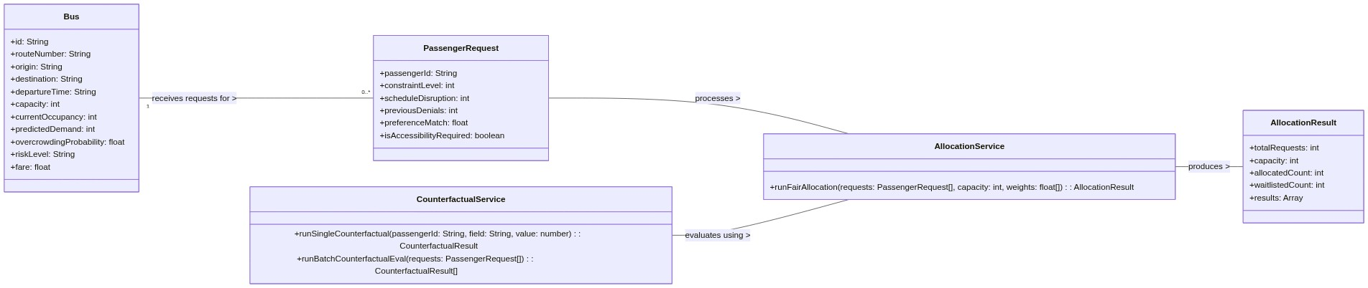

2. UML Sequence Diagram — Passenger Seat Allocation & Explainability
Traces passenger interaction with SHAP explainability (C14) and fair seat allocation under hard capacity bounds (N <= 50):
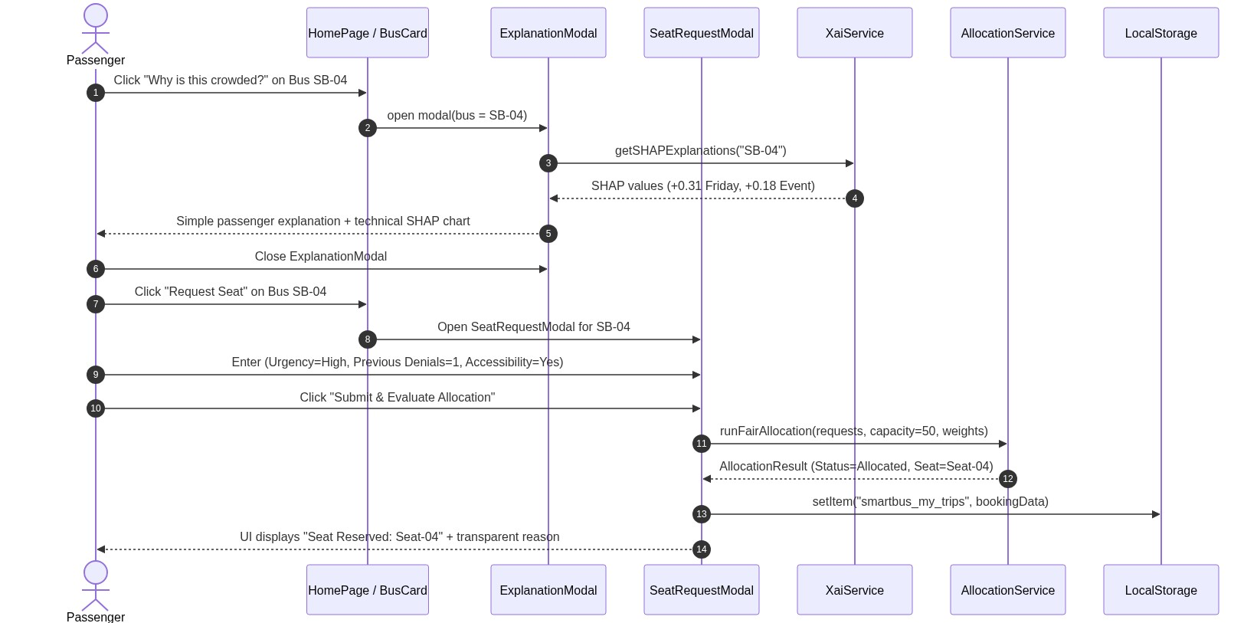

3. UML Sequence Diagram — Counterfactual Analysis & Policy Calibration
Traces single-attribute perturbation testing in CounterfactualLabPage (C11) and multi-policy Pareto trade-off calibration:
