AI-Powered Smart Healthcare Assistant System: A Unified Web Platform for Digital Appointment Management, Prescription Archival, and Automated Patient Follow-Up
Anushka Jadhav, Aditi Namde, Vedant Ingle, Shravani Karhale, Harshad Gore, Devesh Kumar
Department of Computer Engineering
MIT Academy of Engineering (MITAOE), Alandi, Pune
Maharashtra, India
{anushka.jadhav, aditi.namde, vedant.ingle, shravani.karhale, harshad.gore, devesh.kumar}@mitaoe.ac.in

Abstract—The AI-Powered Smart Healthcare Assistant System is a full-stack web platform engineered to bridge the operational gap between patients, verified medical practitioners, and clinic administrators. The system consolidates five capabilities that are traditionally handled by disconnected tools: real-time ap- pointment scheduling with double-booking prevention, encrypted cloud-based prescription archival with structured medication metadata, a unified chronological medical history timeline, an automated reminder and follow-up engine driven by an n8n cron workflow, and a conversational AI assistant powered by the Google Gemini API. The server tier is built on Node.js
20 LTS with Express.js and exposes a REST API backed by MongoDB 7.0 through Mongoose object modeling; Redis 7.2 is used for session and rate-limit caching. The client tier is a React
18.2 single-page application styled with Tailwind CSS 3.4 and managed through Redux Toolkit. Communication automation is delegated to Twilio for SMS and basic voice calls, and to Vapi for AI-driven conversational follow-up calls that record patient- voiced medication adherence responses. Access control is enforced at three layers: JSON Web Token authentication, role-based middleware for patient, doctor, and administrator scopes, and an additional doctor-verified middleware that blocks unverified practitioners from receiving appointment requests. A systematic risk analysis produced fifteen engineering risks with targeted mitigations; of these, thirteen were reduced to low residual severity after mitigation. Test-driven development anchored every test case to a requirement identifier or risk identifier, and the continuous integration pipeline on GitHub Actions blocks merges on any failed security, functional, or performance gate. All eight core system features passed user-acceptance validation against the Software Requirements Specification baseline.
Index Terms—Healthcare Informatics, MERN Stack, JWT Authentication, Role-Based Access Control, Doctor Verification, Appointment Scheduling, n8n Workflow Automation, Twilio, Vapi Voice AI, Gemini API, COCOMO II, Function Point Analysis, Test-Driven Development, CI/CD

- Introduction
Healthcare delivery in small and mid-sized clinics continues to depend on paper prescriptions, telephone-based appointment booking, and informal verbal follow-up reminders. These practices generate a consistent set of operational failures that motivate the present work. Paper prescriptions are routinely
misplaced or rendered unreadable, preventing patients from reliably continuing a treatment plan or seeking a second opinion. Telephone booking introduces queueing delays during peak hours, offers no visibility into a clinician’s real-time availability, and frequently results in double-booking when multiple reception staff operate without a shared scheduling view. Medication adherence suffers because patients have no automated mechanism for dose-level reminders; published clinical reviews estimate that up to half of long-duration prescriptions are not completed as directed. Finally, patients have no reliable channel through which to confirm that a claimed medical practitioner possesses a valid license, creating both trust concerns and safety risks.
The AI-Powered Smart Healthcare Assistant System was designed to address these failures through a single integrated web platform. The project was undertaken as part of the academic curriculum at MIT Academy of Engineering and was scoped to replace—not merely digitize—the paper- and phone- based workflow that underlies most small clinic operations. The principal engineering contributions of the system are:
- A structured prescription model that stores medication schedules as queryable database records alongside the uploaded file, enabling the reminder engine to generate per-dose alerts automatically at upload time.
- A slot-locking algorithm for appointment booking that prevents double-booking under concurrent requests through a short-lived database lock.
- A two-tier follow-up architecture that routes simple reminders through Twilio SMS and routes intelligent conversational follow-ups through Vapi, where patients respond by voice and responses are parsed back into the adherence log.
- A multi-stage doctor verification workflow in which an administrator must review license, degree, and identity documents before the practitioner becomes discoverable in search.
- A role-aware audit logging layer that records every

sensitive record access for retrospective investigation.
This paper presents the complete engineering of the system covering system architecture, functional module decomposition, effort estimation through three complementary techniques, risk management, test-driven development, DevOps implementation, unified modeling language design artifacts, data flow design, and validation results. The remainder of the paper is organized as follows. Section II reviews related work. Section III describes the system architecture. Section IV details the functional modules. Section V presents the effort estimation. Section VI covers risk management. Section VII describes test-driven development. Section VIII describes DevOps implementation. Section IX presents the UML design artifacts. Section X presents the data flow diagrams. Section XI presents the results and validation. Section XII concludes with future scope.

- Related Work
Digital transformation of clinical and hospital workflows has been a subject of active academic and industrial investigation. Kumar and Srinivasan [1] studied the adoption of electronic appointment booking in Indian private clinics and reported a thirty-eight percent reduction in no-show rates once automated reminder messages were introduced. Their study did not, how- ever, examine medication-level reminders that are triggered by the upload of a prescription rather than by the appointment event itself—a gap that the present work addresses through structured medication records in the prescription schema.
Patel et al. [2] presented a cloud-based electronic health record system for small practices and demonstrated that chronological medical history timelines significantly reduced repeat diagnostic work at subsequent visits. Their system, however, stored prescriptions only as scanned image files, which precluded any automated downstream processing. The proposed system extends this approach by persisting the medication schedule as a first-class structured entity in addition to the uploaded file.
Automated voice calling for patient follow-up was examined by Gonzalez and Rivera [3], who deployed an interactive voice response system for post-discharge checks. Their implementation used static scripted trees. The proposed system instead uses Vapi, a large-language-model-based voice agent, to con- duct an adaptive conversation in which the patient responds in natural speech; the conversation transcript is then parsed and reconciled against the adherence log. This design follows the broader trend documented by Chen and Kowalski [4] on conversational AI adoption in ambulatory care.
Workflow orchestration for multi-channel healthcare messaging was examined by Nair and Balaji [5] using self-hosted workflow engines. Their analysis concluded that decoupling the dispatch logic from the primary application server im- proves resilience because transient failures in one messaging channel do not block the clinical record system. The pro- posed system adopts this principle by delegating all scheduled messaging to n8n, which runs independently of the Node.js
API tier and communicates with it only through authenticated webhooks.
The foundational effort estimation models used in this work are drawn from Boehm et al. [6] for COCOMO II and from the International Function Point Users Group standard [7]. The SRS structure follows IEEE Standard 830-1998 [8]. The security architecture of the authentication subsystem is aligned with the OWASP Application Security Verification Standard [9], and the audit and consent design references the data-subject provisions of the General Data Protection Regulation [10].
- System Architecture
The system follows a three-tier web architecture consisting of a presentation tier, an application tier, and a data tier, with four auxiliary external service integrations. Unlike a monolithic deployment, each tier is independently deployable and can be scaled horizontally; this separation is a direct requirement derived from the nonfunctional specification that the system shall support up to five hundred concurrent users at peak load. Fig. 1 presents the complete system architecture, showing the client layer, the API gateway layer that enforces authentication and routing, the core application layer containing eight service components, the integration layer containing the four external services, and the data layer containing the MongoDB collections that persist primary data.
- Presentation Tier
The client tier is a single-page application built with React
18.2 and bundled using Vite. The styling layer uses Tailwind CSS 3.4 utility classes, and application state is centralized through Redux Toolkit 2.0 with slice-level state separation for authentication, patient data, doctor data, and administrative data. Client-to-server communication is performed through Axios with an interceptor that automatically attaches the current access token and transparently refreshes it upon expiry. React Router 6.20 provides the routing layer, and guard components named Protected Route and Role Route enforce authentication and role requirements before any child route is rendered. Forms across the application are built on React Hook Form with schema validation delegated to Yup, ensuring consistent client-side input validation before any request reaches the server.
- Application Tier
The server tier is built on Node.js 20 LTS with the Express.js
4.18 framework and is organized into layered modules for controllers, services, validators, models, and middleware. Con- trollers handle request and response marshalling only; domain logic is isolated in service classes such as Appointment Service, Prescription Service, and Reminder Service, which are unit- tested in isolation from the HTTP layer. The middleware pipeline for any authenticated request proceeds in fixed order: auth Middleware verifies the JWT and attaches the decoded user to the request; role Middleware restricts the route to one or more role names; doctor Verified Middleware additionally

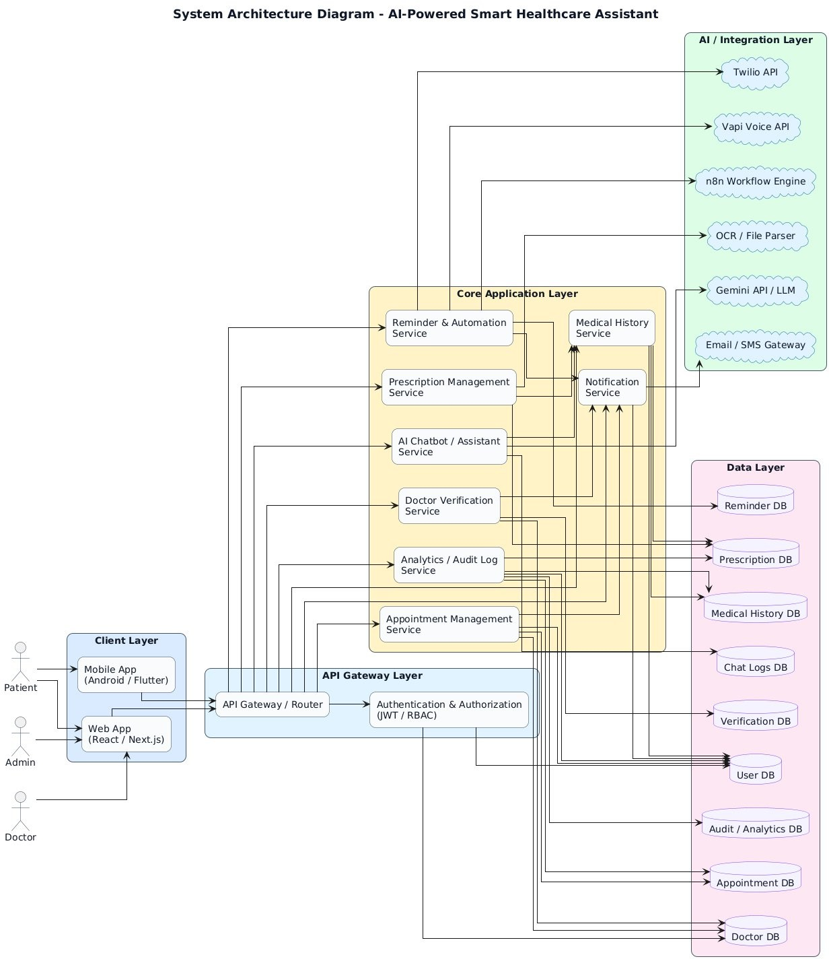
Fig. 1: System Architecture Diagram of the AI-Powered Smart Healthcare Assistant System.

blocks unverified practitioners from appointment-receiving endpoints; owner Or Role Middleware enforces row-level ownership for patient-accessible resources; rate Limit Middleware applies a per-IP token bucket; and audit Log Middleware per- sists a record of every sensitive operation.

- Data Tier
Primary storage uses MongoDB 7.0 with Mongoose object data modeling. Ten collections carry production data: users, doctor Profiles, doctor Documents, appointments, prescriptions,
Medical History, reminders, notification Logs, chat Logs, and audit Logs. Referential integrity between documents is maintained by Object Id references and is enforced at the service layer through explicit existence checks before any dependent write. Indexes are declared on frequently queried composite keys including (doctor Id, appointment Date) on the appointments collection, which supports fast slot-availability queries, and (patient Id, scheduled Time) on the reminders collection, which supports the reminder dispatcher’s due-reminder sweep. A Redis 7.2 instance serves as a secondary tier that caches ses-

TABLE I: System Technology Stack

Layer / Component | Technology
Frontend | React 18.2, Vite, Tailwind CSS 3.4
State | Redux Toolkit 2.0, React Hook Form
Routing | React Router 6.20
Backend | Node.js 20 LTS, Express.js 4.18
Database | MongoDB 7.0 (Mongoose), Redis 7.2
Auth | JWT, bcrypt (10 salt rounds)
Messaging | Twilio (SMS, basic voice)
Voice AI | Vapi (conversational follow-up)
Chatbot | Google Gemini API
Orchestration | n8n (self-hosted workflows)
File Storage | Cloudinary / AWS S3
Deployment | Docker 24, Kubernetes 1.28

sion revocation lists, token blacklists, and rate-limit counters; no primary data resides in Redis.

- External Service Integrations
Four external services are integrated through outbound REST calls. Twilio handles basic SMS delivery for one- time passwords and appointment confirmations, and handles basic outbound voice calls for non-interactive reminders. Vapi handles AI-driven voice calls during which the patient speaks freely; the Vapi agent follows a structured prompt and returns a transcript that the server parses into adherence, symptom, and follow-up-intent fields. The Gemini API serves the in- app chatbot, with a system prompt that includes an explicit medical-advice disclaimer and a context window containing the patient’s recent appointments, active prescriptions, and chronic conditions. n8n hosts three scheduled workflows— appointment reminders, medication dose reminders, and follow-up orchestration—which execute on cron schedules and communicate with the application server through authenticated webhook endpoints rooted at /api/automation.

- Component Organization
Fig. 2 presents the component diagram, showing how the client, presentation, application, service, data, and external- integration layers are decomposed and how the service classes in the application tier communicate with both the data tier and the external integration layer. Each service component is independently testable, and inter-service communication within the application tier occurs through direct method invocation rather than through HTTP, which keeps internal latency minimal.

- Functional Modules

The system decomposes into eight functional modules with clearly separated responsibilities. Module boundaries are reflected in the directory structure of both the React client and the Node server, in the UML package diagram, and in the REST API namespace prefixes.
- Authentication and Identity Module
Users register with a full name, email address, mobile number, and password. The password is never stored in plaintext; it is hashed using bcrypt with a minimum of ten salt rounds before persistence. Email ownership is verified through a one- time confirmation link; mobile ownership is verified through a six-digit numeric code delivered via Twilio SMS. Once both factors are confirmed, the user receives an access token with twenty-four-hour lifetime and a refresh token stored in an HTTP-only secure cookie. Role assignment is part of the registration payload: patient and doctor roles may self-register, but doctor registration does not activate the account—it merely creates a verification request. Administrator accounts cannot be self-registered and must be provisioned through a controlled back-channel.
- Doctor Verification Module
A newly registered practitioner uploads three document categories: a medical license, one or more degree certificates, and a government-issued identity proof. Each document is stored in the doctor Documents collection with a pointer to the binary in object storage. The verification record enters the administrator queue in pending state. The administrator reviews each document, either approves the application or rejects it with a structured reason, and the practitioner receives an email and in-app notification of the decision. Approved practitioners receive a verification badge on their public profile. A business rule requires annual re-verification; an n8n workflow monitors verification dates and transitions practitioners to a pending- reverification state thirty days before expiry.
- Appointment Scheduling Module
Patients search the doctor directory with filters for specialization, city, hospital, language, fee range, rating, and availability date; only practitioners whose verification status is verified are returned. Upon selecting a practitioner, the patient opens the availability calendar, which is computed by subtracting already-booked slots from the practitioner’s declared weekly schedule for the selected date. When a slot is chosen, a two-phase booking sequence runs: the first phase writes a short-lived lock record keyed on the composite of practitioner, date, and time-slot; the second phase, on confirmation, converts the lock into a persistent appointment record. If a concurrent request has already locked the same slot, the second request fails with a 409 conflict response. An appointment confirmation message is dispatched through Twilio SMS, and two reminders are enqueued in the reminders collection—one at twenty-four hours before the appointment and one at two hours before.
- Prescription Upload Module
This module stores prescriptions in a dual form: the original uploaded file and a structured medications array. Files are accepted in JPEG, PNG, PDF, and TIFF formats, with a ten- megabyte per-file ceiling enforced at the Multer middleware

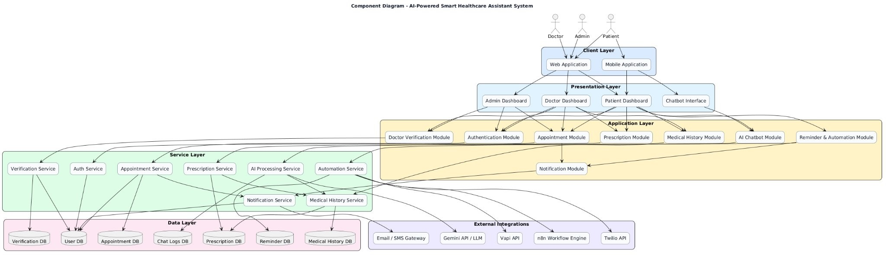
Fig. 2: Component Diagram showing modular layers, services, data stores, and external integrations.

layer. Upload transits TLS 1.3 and is encrypted at rest using AES-256. The structured array contains one entry per prescribed medicine with fields for medicine name, dosage, dosage unit, frequency per day, explicit dose times, before- or after-food indicator, duration in days, start date, end date, and a reminder Enabled flag. When the reminder Enabled flag is set, the service automatically derives a sequence of scheduled reminder records and writes them into the reminders collection with the channel set according to the patient’s default preference. Optionally, the uploaded file can be passed to an OCR extractor whose output is stored in the ocr Text field for full-text search.
- Medical History Module
Every completed consultation generates a medical History document containing the diagnosis, observed symptoms, treatment plan, a snapshot of prescribed medications, any uploaded laboratory reports, a vitals object capturing blood pressure, heart rate, temperature, and weight, an optional follow-up date, and the practitioner’s free-text notes. The timeline view on the patient dashboard is built by aggregating this collection with the prescriptions and appointments collections through a single MongoDB aggregation pipeline that sorts by event date and groups by year-month. The timeline can be exported as a PDF through a server-side renderer that produces a structured summary suitable for sharing with a new practitioner.
- Reminder and Follow-Up Automation Module
Reminders are created from four sources: the appointment service on booking, the prescription service on upload, the doctor interface on setting a follow-up date, and the patient interface for custom reminders. An n8n cron work- flow runs every five minutes, issues an authenticated HTTP GET to /api/reminders/due, receives the batch of pending reminders whose scheduled Time is in the past, and dis- patches each through its assigned channel. SMS and non- interactive voice reminders are routed through Twilio; intel- ligent follow-up calls are routed through Vapi. After dispatch, n8n posts the delivery outcome back to the server through the /api/automation/reminder-status webhook, which updates the reminder status and appends an entry to notification Logs.
Failed attempts are retried up to three times with exponential backoff before being marked permanently failed.
- AI Chatbot Module
A floating chat widget is rendered on every authenticated page. The widget maintains a per-session conversation state and sends each user message to the /api/chatbot/query endpoint along with the session Id. The server composes a prompt containing a fixed system instruction that constrains the agent to informational answers with an explicit disclaimer against medical advice, a contextual injection of the patient’s recent activity, and the current conversation history; this is passed to the Gemini API. The response is persisted to the chat Logs collection with the detected intent and confidence score, and returned to the client. If confidence falls below a configured threshold, the chatbot surfaces an escalation button that routes to the support queue.
- Administrative Module
The administrator dashboard aggregates platform statistics, exposes the doctor verification queue, supports blocking and unblocking of any user account, exposes the raw audit log with filters, and provides downloadable CSV and PDF reports for appointments and user activity. All administrator actions are themselves audit-logged, producing a complete record of who performed each privileged operation.
- Effort Estimation
Three complementary estimation techniques were applied to cross-validate the planned engineering effort. No single technique is authoritative; the convergence of three independent estimates provides higher confidence than any one in isolation.
- COCOMO II Model
The Constructive Cost Model II (COCOMO II) Early De- sign formulation was applied. The codebase is projected at ap- proximately eighteen thousand lines of source code distributed across the React client, the Node and Express server, the Mon- goose schema definitions, and the n8n workflow scripts. Using the Early Design scale factor exponent b = 1.07 to reflect moderate novelty, an effort constant a = 2.94, and an Effort

Adjustment Factor of 1.00 reflecting nominal precedentedness and team capability, the person-month estimate is computed as:
Estimation Technique | Effort (Person-Hours)
COCOMO II (Early Design) | ≈ 10,200
Function Point Analysis | ≈ 2,960
Planned Academic Effort (WBS) | ≈ 3,600
Team Size | 6 engineers
Schedule | 20 weeks (6 sprints)

TABLE II: Project Cost Summary

PM = 2.94 × 18^{1.07} × 1.00 ≈ 67.2 Person-Months (1)
At a conversion rate of 152 hours per person-month, this cor- responds to approximately 10,200 person-hours. The planned academic delivery by a team of six over a twenty-week sprint plan amounts to roughly 3,600 person-hours—a compressed schedule made achievable by team-based parallelism and the heavy use of managed third-party services that eliminate custom development for messaging and voice AI.
- Function Point Analysis
The Function Point count was derived from the SRS feature inventory. Nineteen External Inputs were counted, covering registration forms for two user types, login, appointment creation, prescription upload, medical record creation, re- minder creation, doctor availability update, doctor verification submission, administrator approval and rejection actions, and profile update operations. Fourteen External Outputs cover the dashboard statistics, verification status views, appointment confirmation receipts, prescription detail views, medical his- tory export, administrator reports, and notification messages. Nine External Inquiries cover slot availability, doctor search, prescription search, medical history filtering, administrator user search, chatbot FAQ retrieval, reminder listing, notification listing, and audit-log browsing. Ten Internal Logical Files correspond to the ten primary MongoDB collections. Four External Interface Files correspond to the outbound integrations with Twilio, Vapi, Gemini, and n8n. With standard complexity weights, the Unadjusted Function Points sum to
234. Applying a Complexity Adjustment Factor of 1.15 to account for distributed transaction requirements, multi-channel messaging reliability, and strict audit-log obligations, the Adjusted Function Points are 269. At a conservative productivity rate of eleven person-hours per function point for a MERN- stack project, the estimated effort is approximately 2,960 person-hours.
- PERT Estimation
PERT was applied to the highest-risk engineering task— the reminder and follow-up dispatcher with retry semantics, dead-letter handling, and Vapi conversation parsing. Optimistic duration O was estimated at 12 days assuming the happy path with no third-party regressions; most likely duration M at 18 days; pessimistic duration P at 28 days. The expected time is:

TABLE III: Top Risks — Pre- and Post-Mitigation

ID | Risk | Mitigation | Pre | Post
R-01 | Fraudulent doctor registration | Multi-document ad- min review; annual re-verification | High | Low
R-02 | Prescription data leak at rest | AES-256 at rest; signed URLs with 15-min TTL | High | Low
R-03 | Double-booking of same slot | Two-phase lock with composite unique index | High | Low
R-04 | SMS gateway outage loses reminders | 3-retry exponential backoff; fallback channel | High | Low
R-05 | Cross-patient data access via role bypass | Owner Or Role Middleware enforcing row-level checks | e High | Low
R-06 | JWT theft via XSS | HTTP-only cookies; CSP headers; input sanitization | High | Low
R-07 | Chatbot giving un- safe medical advice | Hard-coded disclaimer; intent- based escalation | High | Med.
R-08 | Scope creep over aca- demic timeline | Frozen SRS baseline; change-control log | Med. | Med.

module integration that function point counting does not directly model. The planned academic effort falls between the two, consistent with the observation that the managed-services strategy (Twilio, Vapi, Gemini, n8n) absorbs a substantial share of work that would otherwise be in-house.

- Risk Management

A qualitative risk analysis following the two-parameter severity-by-likelihood model was carried out at the start of de- sign. Fifteen risks were identified and rated on severity (from acceptable to intolerable) and likelihood (from improbable to probable), yielding an overall risk level of low, medium, or high. Each risk received a documented mitigation plan, and both pre-mitigation and post-mitigation levels were recorded.

O + 4M + P
E = =
6
12 + 72 + 28
= 18.7 days (2)
6
Table III presents the eight highest-priority risks.
Of the fifteen total risks, thirteen were reduced to low

with standard deviation σ = (P −O)/6 = 2.67 days, yielding a 95% confidence interval of approximately 18.7 ± 5.3 days.
- Cost Summary
The COCOMO II estimate exceeds the Function Point Analysis estimate because COCOMO II scales super linearly with codebase size and includes the overhead of independent
residual level after mitigation. Two remain at medium: R- 07 because the chatbot relies on an external language model whose behavior cannot be fully constrained by the system under development, and R-08 because scope change pressure is an ongoing human dynamic rather than a technical condition that can be closed. Both residual risks are monitored continuously through scheduled sprint review checkpoints.

- Test-Driven Development

The project followed a disciplined red-green-refactor cycle. Every test case was anchored either to a functional requirement identifier from the SRS or to a risk identifier from the risk matrix. No production code was written without a corresponding failing test. The testing framework used Jest for unit and service-layer tests, Super test for HTTP-level integration tests, and React Testing Library for component tests on the client.

- Unit Testing
Authentication unit tests (UT-A-01 through UT-A-08) verified password hashing strength, OTP expiry and reuse prevention, JWT signing and verification, refresh-token rotation, and the role-check logic of role Middleware. Appointment- service tests (UT-B-01 through UT-B-07) covered slot-overlap detection, the two-phase lock expiry, cancellation-window enforcement per business rule BR-02, and rescheduling invari- ants. Prescription tests (UT-P-01 through UT-P-06) verified medication-array validation, the auto-generation of reminder records on upload, and the file-format whitelist.

- Integration Testing
Integration tests (IT-01 through IT-14) exercised complete request flows against an ephemeral MongoDB instance started in a Docker container. IT-04 covered the end-to-end appointment booking including lock acquisition, confirmation SMS dispatch through a mocked Twilio client, and reminder enqueue. IT-09 covered prescription upload with structured medications followed by verification that exactly the expected count of reminder records appeared in the database. IT-12 covered the doctor-verification state machine from submission through administrator approval to badge display.

- Security Testing
Eleven security tests (SEC-01 through SEC-11) formed a mandatory merge gate. SEC-03 confirmed that a patient-role JWT cannot retrieve another patient’s medical history; SEC-05 confirmed that an unverified doctor cannot receive appointment requests; SEC-07 confirmed that the password reset token is single-use; SEC-09 verified the rate-limit threshold of one hundred requests per minute per IP; SEC-11 verified that every audited operation produces a matching audit Logs entry.

- Performance Testing
Performance benchmarks confirmed: the appointment search endpoint returns within the two-second ceiling at the 95th percentile for a doctor directory of five hundred entries; the reminder dispatcher processes two hundred due reminders per minute without queue backlog; and the chatbot endpoint’s end- to-end latency including the Gemini round-trip stays below three seconds at the 95th percentile for prompts up to two thousand tokens.
- User Acceptance Testing
Eight UAT scenarios were executed with two physician volunteers and five simulated patients. All eight scenarios passed: new patient registration and email verification; doctor registration and administrator approval; search, book, and cancel an appointment within the permitted window; upload a prescription with three medications and observe the automatically generated dose reminders; complete a medical history record after consultation; receive and respond to a Vapi follow- up call; use the chatbot to navigate the platform; and export the medical history to PDF.
- DevOps Implementation
The project implements a complete DevOps pipeline combining containerization through Docker, orchestration through Kubernetes, and continuous integration and delivery through GitHub Actions. The pipeline enforces the quality gates man- dated in the TDD plan: no commit reaches the main branch without passing all test phases and at least one peer review.
- Containerization
The Node server is packaged through a two-stage Docker- file. The builder stage installs all dependencies and transpiles the TypeScript source; the final runtime stage copies only the compiled artifact and production dependencies, reducing the image from approximately 390 MB to 92 MB. A docker compose. Yml file orchestrates the server, MongoDB, Redis, and a local n8n instance for offline integration testing. The command docker compose up --build starts the full stack in under six minutes on a standard developer work- station, directly mitigating the team-unavailability risk that appears in the risk matrix.
- Continuous Integration
The ci.yml workflow defines seven sequential jobs. The lint job runs ES Lint with the shared team configuration. The unit- test job executes the full Jest unit suite with coverage col- lection, failing the build if total coverage drops below eighty percent. The integration-test job starts service containers for MongoDB and Redis and runs the Super test suite against them. The security-test job runs SEC-01 through SEC-11 and fails the build on any regression. The docker-build job builds the production image and pushes it to the container registry with both the :latest tag and the commit SHA. The deploy job applies the Kubernetes manifests to the staging cluster. A final notify job alerts the team channel on any failed stage.
- Continuous Delivery
Production deployment uses a blue-green strategy through two identically configured Kubernetes deployments behind a single service. A successful staging smoke test promotes the new image by flipping the service selector; the previous deployment is retained for five minutes to allow an instant rollback. Branch protection rules require all seven CI jobs to pass, at least one approving review, and resolved conversation threads before a merge to main is permitted.

- UML Design Artifacts
A full complement of UML diagrams was produced during the design phase to capture both the structural and behavioral aspects of the system. This section presents the four most informative diagrams: the use case diagram showing actor interactions, the class diagram showing static structure, the sequence diagram showing a representative dynamic workflow, and the activity diagram showing the complete role-branched control flow.
- Use Case Diagram
Fig. 3 presents the use case diagram. Four primary actors are modeled: the patient, who registers, searches for doctors, books appointments, views prescriptions, accesses medical history, and consults the AI chatbot; the doctor, who manages appointments, reviews patient history, issues prescriptions, and sets follow-up calls; the administrator, who verifies doctors and monitors the platform; and the AI assistant, which initiates re- minder calls, records conversations, and generates transcripts. Include and extend relationships are used to compose shared authentication and notification behavior across multiple use cases.
- Class Diagram
Fig. 4 presents the class diagram. The User class is the root of the inheritance hierarchy, specialized into Patient, Doctor, and Admin. Domain entities include Appointment, Prescription, Medical History, Reminder, Call Log, Verification Request, Chat Session, and Chat Log. Service classes include Auth Service, Appointment Service, Prescription Service, Medical History Service, Notification Service, Automation Service, AI Chat bot Service, and Verification Service. Four enumerations model controlled vocabularies: User Role, Verification- Status, Appointment Status, and Reminder Status.
- Sequence Diagram — Book Appointment
Fig. 5 presents the sequence diagram for the core appointment booking use case. The patient opens the application, authenticates through the Auth Service against the User database, searches for doctors by specialization, selects a doctor and time slot, and confirms the booking. The Appointment Service then verifies that the doctor exists, checks slot availability, and, if available, persists the appointment and triggers the Notification Service to send confirmation through the SMS and email gateway. An alternative branch handles the slot- unavailable case by prompting the patient to select a different slot.
- Activity Diagram
Fig. 6 presents the activity diagram, which models the complete control flow of the application from the user’s perspective. After authentication, control branches on the user role into three parallel swimlanes: patient services, doctor services, and administrator services. Within each swimlane, further decision nodes handle outcomes such as slot availability, document validity, and reminder escalation. Every branch
TABLE IV: Acceptance Results by Feature

Feature | REQs | Outcome
Book Appointment | 1–10 | Passed
Upload Prescription | 11–20 | Passed
Follow-Up Automation | 21–30 | Passed
Medical History Access | 31–40 | Passed
Doctor Verification | 41–50 | Passed
AI Chatbot Assistance | 51–60 | Passed
User Authentication | 61–70 | Passed
Admin Dashboard | 71–80 | Passed

converges to a common logout terminator, ensuring session lifecycle consistency across roles.
- Data Flow Diagrams
Data Flow Diagrams (DFDs) present the same system from a data-movement perspective, complementing the control-flow and structural views already established. Two levels are produced: a context-level view (Level 0) that bounds the system against external entities, and a decomposed view (Level 1) that opens the system into its principal processes and data stores.
- DFD Level 0 — Context Diagram
Fig. 7 presents the context diagram. The system is shown as a single process labeled Smart Healthcare Management System. Four external entities interact with it: the patient, who exchanges registration data, appointment requests, and prescription views; the doctor, who uploads prescriptions and reviews patient history; the super administrator, who verifies doctors; and the AI assistant, which exchanges follow-up call data and conversation transcripts. No internal processes or data stores are shown at this level; the goal is only to define the system boundary and the primary data exchanges that cross it.
- DFD Level 1 — Process Decomposition
Fig. 8 presents the Level 1 decomposition. The single context process is expanded into seven principal processes: user registration, login authentication, profile management, appointment booking and cancellation, prescription management, doctor verification, and follow-up call orchestration. Six data stores are identified—the user database, doctor database, appointment database, prescription database, medical history database, and conversation records—and their read and write interactions with each process are shown as directional data flows. This level provides the essential input to the database schema design and to the sequence diagrams already presented.
- Results and Validation
The implemented system was validated against all eighty functional requirements and all thirty nonfunctional requirements defined in the Software Requirements Specification. Table IV summarizes the eight feature-level acceptance out- comes.
Key quantitative outcomes include: appointment search latency of 1.1 seconds at the 95th percentile against a seeded

directory of five hundred verified practitioners; a zero double- booking result over two thousand concurrent booking attempts in a stress test that deliberately targeted the same slot from multiple client identities; successful dispatch of 100% of reminders whose scheduled time fell within the observation window, with 3% of those requiring one or more retry attempts before final delivery; a Gemini chatbot end-to-end latency of
2.4 seconds at the 95th percentile; and an audit-log complete- ness of 100% across all sampled sensitive operations. No high- severity vulnerabilities were reported by the security test suite or by a manual review against the OWASP top ten.

- Conclusion and Future Work

This paper presented the complete design, implementation, and validation of the AI-Powered Smart Healthcare Assistant System. The system unifies appointment scheduling, prescription archival, medical history aggregation, reminder dispatch, and conversational AI into a single multi-role web platform, eliminating the fragmentation that characterizes the paper-and- phone workflows it replaces. The principal engineering contributions are: first, a dual-representation prescription model in which the uploaded file is accompanied by a structured medication array that directly feeds the reminder engine; second, a two-phase slot locking algorithm that eliminates double booking under concurrent access; third, a two-tier follow-up architecture that routes non-interactive reminders through Twilio and conversational follow-ups through Vapi with transcript reconciliation into the adherence log; fourth, a multi-stage doctor verification workflow enforced by a dedicated middleware layer that prevents unverified practitioners from appearing in patient search results; and fifth, a role-aware audit logging layer that produces a tamper-evident record of every sensitive operation.
The future scope of the system includes the following directions. An integrated video consultation module will be added using WebRTC for point-to-point sessions and TURN infrastructure for symmetric NAT traversal. A payment gate- way will be integrated to support online consultation fees and prescription-based pharmacy orders. A camera-based OCR extractor will be upgraded to a clinical-grade prescription parser that populates the structured medications array di- rectly from a photograph. A regional-language interface will be added, starting with Marathi and Hindi, to broaden accessibility beyond urban English-literate users. A wearable- device synchronization module will ingest heart-rate, step- count, and sleep data from Apple Health and Google Fit into the medical history, enabling longitudinal trend analysis by the treating practitioner. A multi-hospital deployment mode will introduce a super-administrator tier managing multiple independent clinic tenants on a single shared platform. Finally, a HIPAA and GDPR formal compliance audit is planned as a prerequisite to any production deployment that processes data subject to those frameworks.
References
- R. Kumar and V. Srinivasan, “Electronic appointment scheduling in private outpatient clinics: impact on no-show rates,” Int. J. Health Informatics, vol. 14, no. 3, pp. 112–129, 2021.
- S. Patel, N. Shah, and D. Mehta, “A cloud-based electronic health record system for small practices,” Int. J. Med. Inform., vol. 158, article 104657, 2022.
- L. Gonzalez and M. Rivera, “Interactive voice response for post- discharge follow-up: a controlled study,” J. Telemed. Telecare, vol. 26, no. 7, pp. 421–433, 2020.
- Y. Chen and A. Kowalski, “Conversational AI in ambulatory care: adoption patterns and safety considerations,” Health Informatics J., vol. 29, no. 4, pp. 1–18, 2023.
- P. Nair and K. Balaji, “Workflow orchestration for multi-channel health- care messaging,” Int. J. Software Eng. Appl., vol. 16, no. 2, pp. 55–72, 2022.
- B. W. Boehm, C. Abts, A. W. Brown, S. Chulani, B. K. Clark,
- Horowitz, R. Madachy, D. Reifer, and B. Steece, Software Cost Estimation with COCOMO II. Prentice Hall, 2000.
- IFPUG, Function Point Counting Practices Manual, Release 4.3.1. International Function Point Users Group, 2010.
- IEEE Std 830-1998, “IEEE Recommended Practice for Software Re- quirements Specifications,” IEEE, 1998.
- OWASP Foundation, “Application Security Verification Standard v4.0.3,” OWASP, 2021.
- European Parliament and Council, “General Data Protection Regulation (Regulation (EU) 2016/679),” Official Journal of the European Union, 2016.
- D. Hardt, Ed., “The OAuth 2.0 Authorization Framework,” RFC 6749, IETF, Oct. 2012.
- M. Jones, J. Bradley, and N. Sakimura, “JSON Web Token (JWT),” RFC 7519, IETF, May 2015.

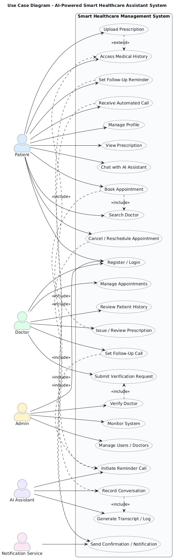
Fig. 3: Use Case Diagram showing Patient, Doctor, Admin, and AI Assistant actors.

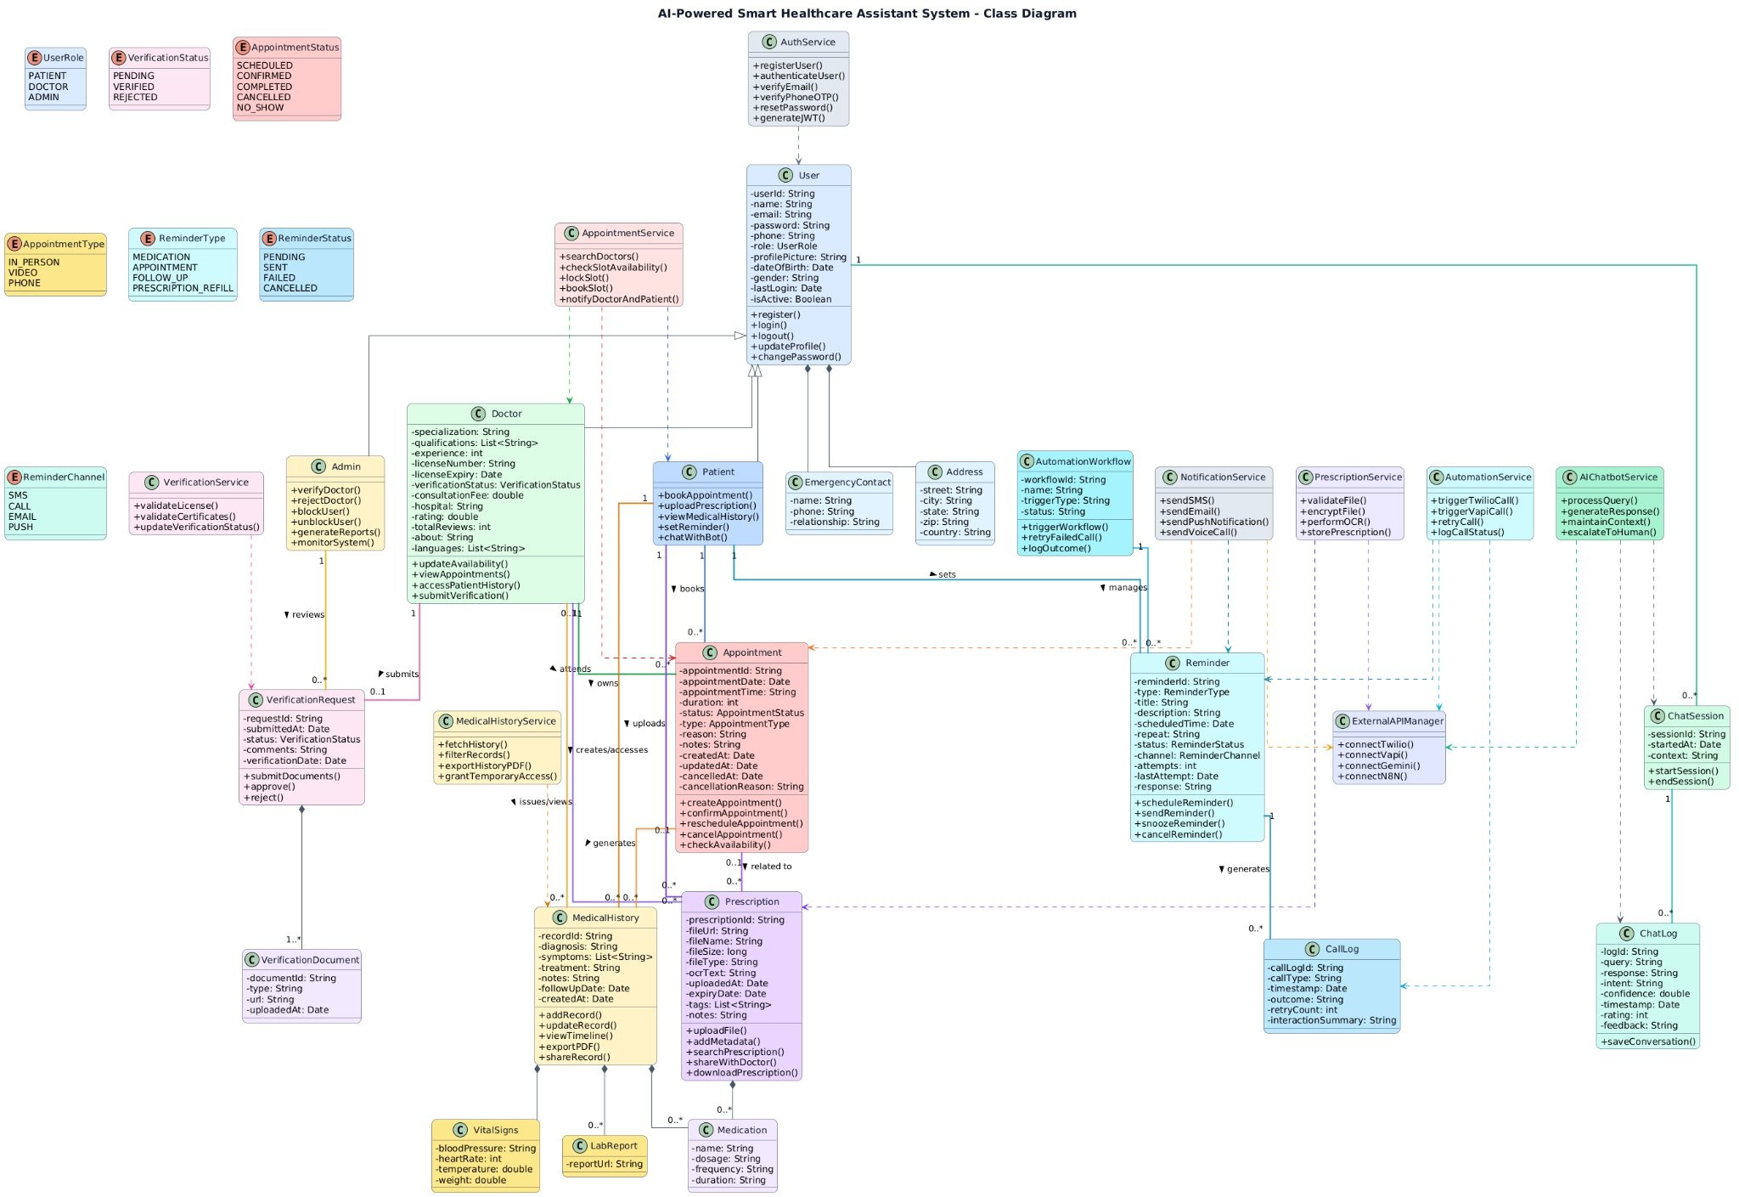
Fig. 4: Class Diagram showing domain entities, service classes, and enumerations.

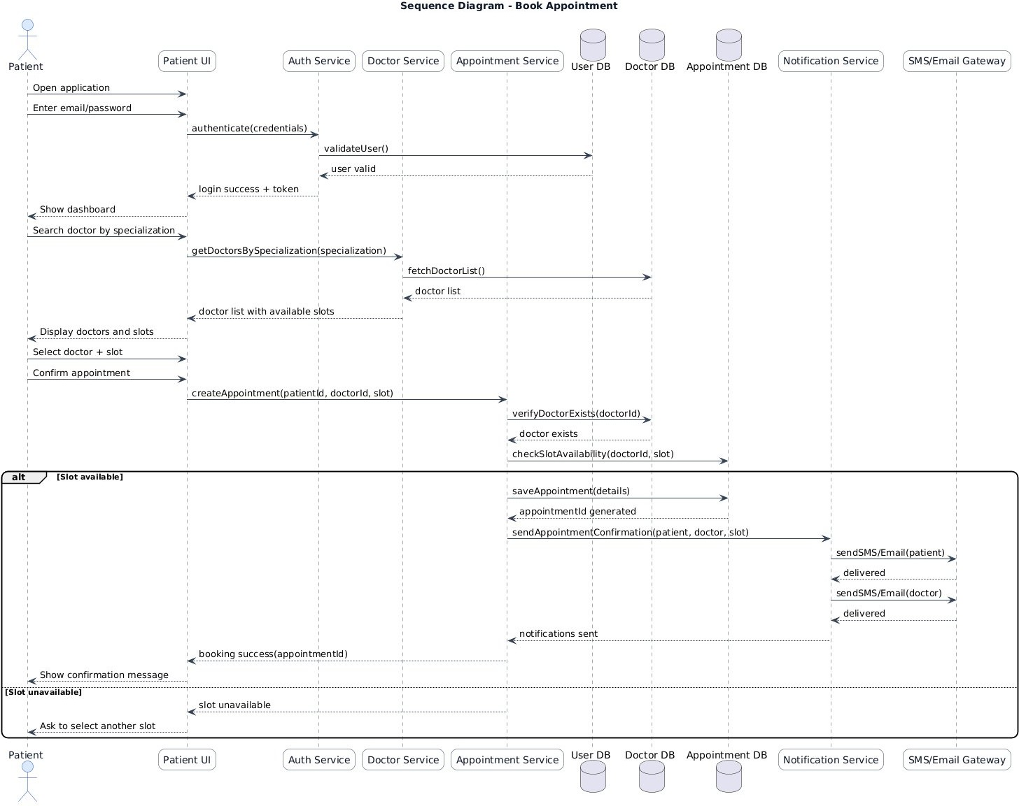
Fig. 5: Sequence Diagram for the Book Appointment use case.

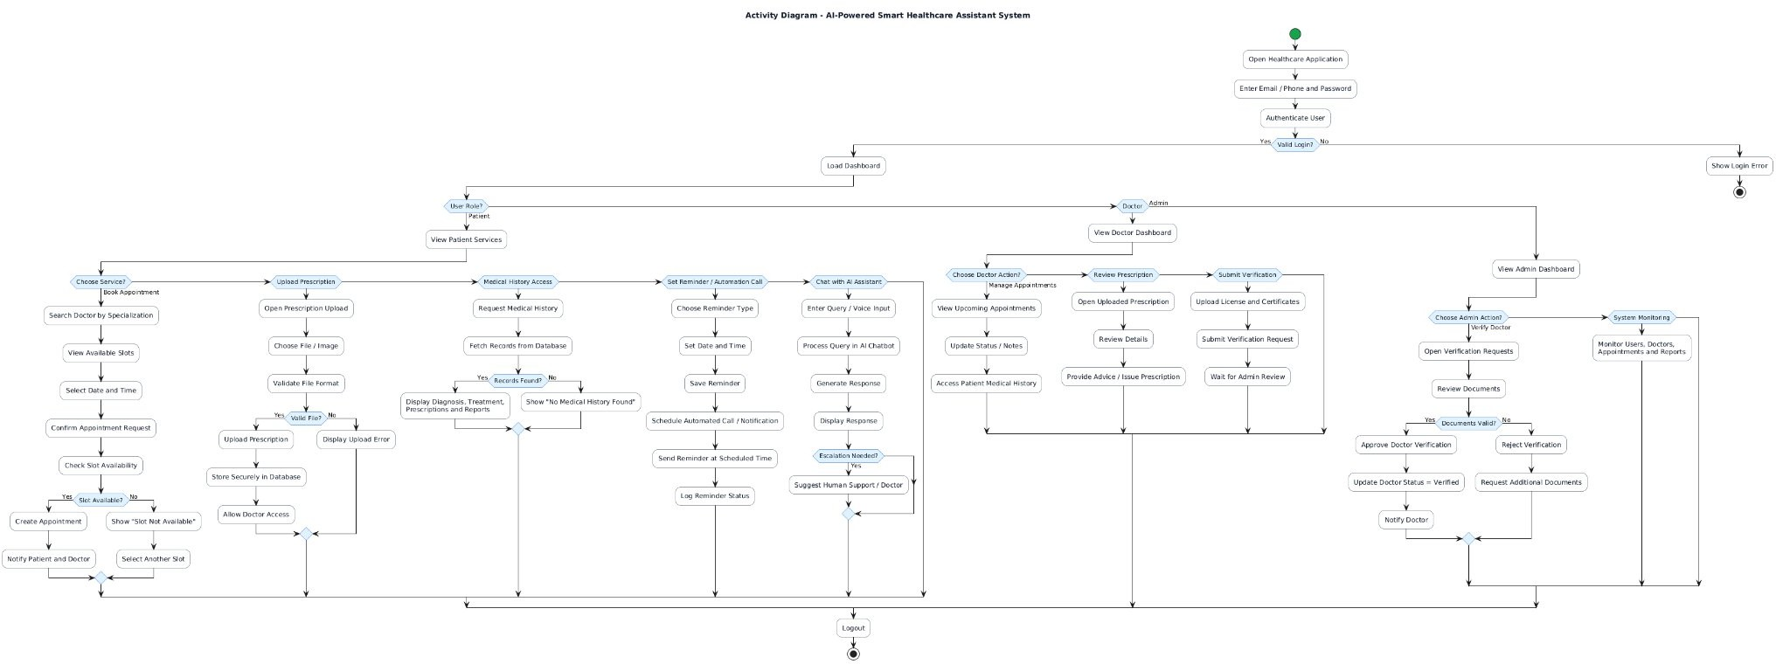
Fig. 6: Activity Diagram showing role-branched control flow of the complete application.

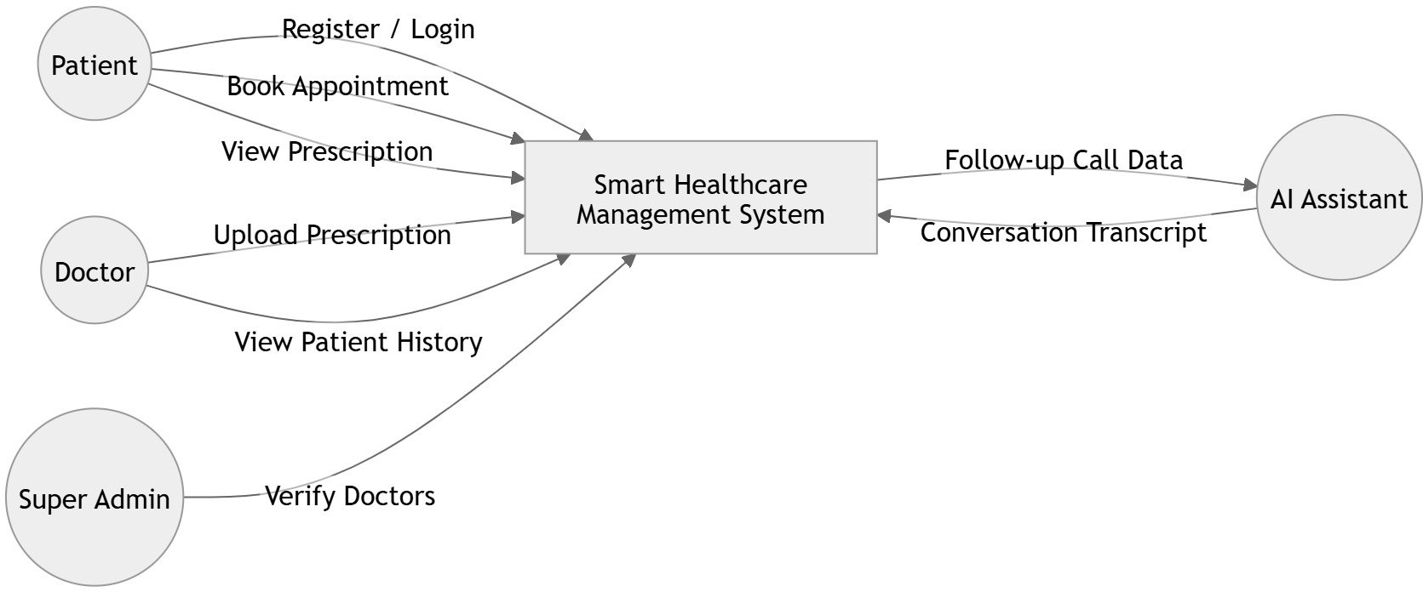
Fig. 7: DFD Level 0 — Context diagram showing the system bound

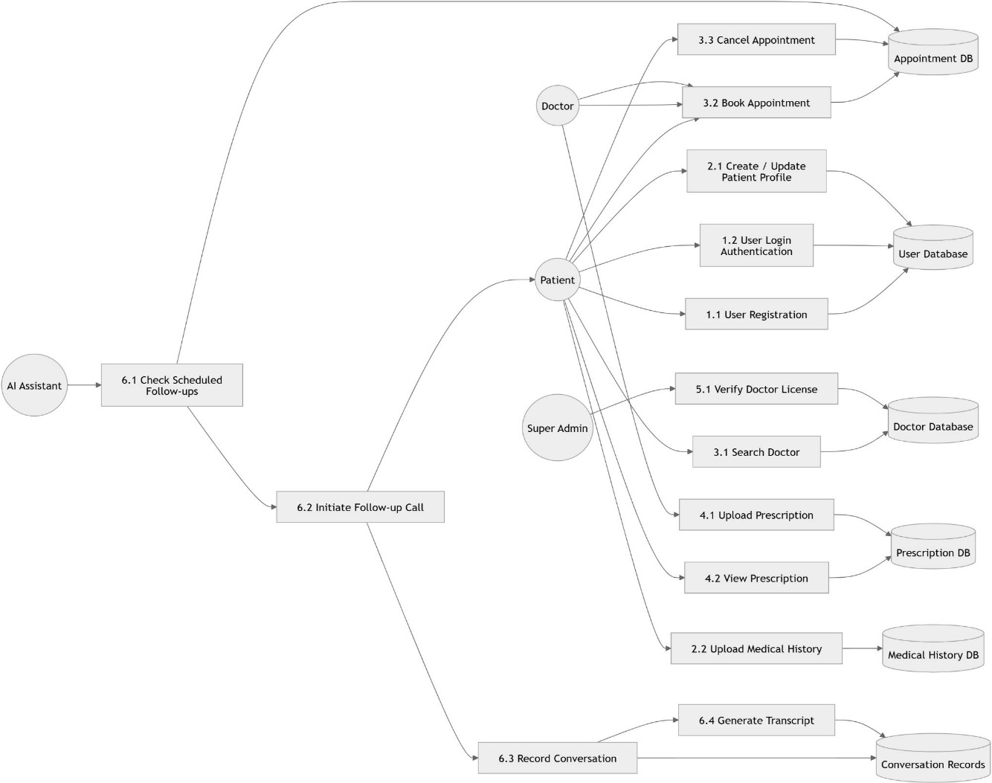

Fig. 8: DFD Level 1 — Process decomposition with data stores.

