HR & RECRUITMENT
HireMate
AI recruiter assistant

Complete Project Document
What HireMate does, every feature, and the full technology: Python, NLP, machine learning, LLMs, FastAPI and Streamlit. One file that replaces the Scope Document, Feature Guide, Technical Document and Complete Specification.

Item | Details
Product | HireMate, with the in-app assistant Ask AI and HireMate Plus
Users | HR Admin, Recruiter, Interviewer, Candidate
Built with | Python 3.11+, FastAPI, Streamlit, SQLite, scikit-learn, BM25, TF-IDF, embeddings, Gemini / Claude / Ollama
Scope | 5 assignment requirements + 8 competitor-gap features + 40 HireMate Plus features
Quality | 40 automated tests (pytest), all passing
Date | 1 November 2026 · Version 2.0
Data | All demo data is synthetic. No real candidates.
Contents

If the page numbers are empty, right-click this table in Word and choose Update Field.

1. What HireMate does
HireMate is an AI recruiter assistant for an HR team hiring store, cashier and warehouse staff. In short:
- Reads CVs and job descriptions (PDF, Word, text, even Hindi) and pulls out skills, experience and contact details.
- Ranks every candidate against the job with a score from 0 to 100, showing the skills they have, the gaps, and why.
- Prepares interviews: a short summary of each person and questions written for that person and that job.
- Drafts every message: interview invitations, assessment instructions, offers and polite rejections, in English or Hindi. A person presses Send.
- Answers questions about candidates, jobs and HR policies from the team's own data, with sources.
- Gives candidates a portal to apply, see their status, reply, book an interview and accept an offer.
People make every decision; the AI only reads, explains and drafts.

1.1 What is in the box
Layer | What it does
Core (R1–R5) | Upload and analyse CVs and JDs · match and rank with skills and gaps · summaries and role-specific questions · email drafts · Ask AI over the data and policies
Gap features (8) | Pipeline board, screening questions, offer letters, WhatsApp, calendar invites, source of hire and speed reports, Excel export, privacy (DPDP Act 2023)
HireMate Plus (40) | Dropout risk, best fit elsewhere, hidden gems, why this score, CV integrity, career path, AI chat screening, billing test, self-booking, joining checklist, notes to scorecard, panel check, Hindi CVs, decision journal, blind first look and more
Two portals | Recruiter portal for HR staff, candidate portal for applicants (they never see scores)

1.2 Technology in one line
Streamlit (Python UI) → FastAPI REST API with JWT → services → core NLP/ML (pdfplumber, python-docx, skill dictionary, BM25, TF-IDF, bge embeddings, scikit-learn: Naive Bayes, Logistic Regression, KNN, K-Means + PCA) → SQLite + ChromaDB → LLM adapter (Gemini free by default, Claude, Ollama/Qwen offline, or templates).

1.3 Safety rules that never switch off
- Scores are computed in code; the AI only explains and writes.
- AI never rejects anyone; wrong screening answers only raise a flag.
- Every email and offer stays a draft until a person presses Send; sending is logged.
- Ask AI cites its sources or says "not in the data".
- Employment gaps are never scored; JDs are checked for biased words; blind review hides names.
- API keys stay on the server; candidates only see their own data.

2. Assignment requirements and how they are met

2.1 Key requirements (R1–R5)
# | Requirement | Where in the app | How (AI / NLP / ML)
R1 | Upload and analyse CVs and JDs | Jobs → New job · Job → Add CVs · Portal sign-up · Documents · Plus → Hindi CV | pdfplumber + python-docx text extraction, regex parsing, skill dictionary with synonyms, proof sentences, JD quality and bias check
R2 | Match and rank candidates, show skills and gaps | Job page (list + board), Quick review, Candidate → Why this match / Insights | Weighted score: skills (proof-based) + text similarity (bge / TF-IDF) + experience; recruiter rules; Logistic Regression shortlist chance
R3 | Candidate summaries and role-specific interview questions | Candidate → Overview (summary), Interview (questions, task), Plus → Interviews | LLM grounded in the CV, the JD and match data; JSON output validated; template fallback
R4 | Draft recruitment emails (invitation, assessment) | Candidate → Emails, Offer · auto-drafts on book / hire / not selected | LLM drafts in English or Hindi; tone switch; WhatsApp version; human presses Send
R5 | Answer recruitment queries from the data | Ask AI on every page · Documents → Ask · policy answers in Plus | Intent router + SQL insights + RAG (BM25 + vectors, reciprocal rank fusion) + LLM with sources; streaming

2.2 Technical expectations
Expectation | How HireMate meets it
Python and AI/ML, NLP or LLM technologies | 100% Python. NLP: tokenising, TF-IDF, BM25, embeddings, regex parsing, transliteration. ML: Naive Bayes, Logistic Regression, KNN, K-Means, PCA. LLM: Gemini, Claude, Ollama
Working prototype with a simple UI | Streamlit app with a recruiter portal and a candidate portal, live on Render and runnable locally with one click (run.bat)
Sample data, source code, setup steps | Synthetic seed: 3 jobs, 9 CVs, 9 policy documents, interviews, emails and Plus demo data. README with setup, this document, tests
Accurate, grounded responses | Scores computed in code; answers cite sources; "not in the data" gate; AI never invents salary, dates or names; JSON validation; template fallback

3. Hiring process
The flow below shows the full journey. Yellow shapes are human decisions; green shapes are where AI or NLP helps.
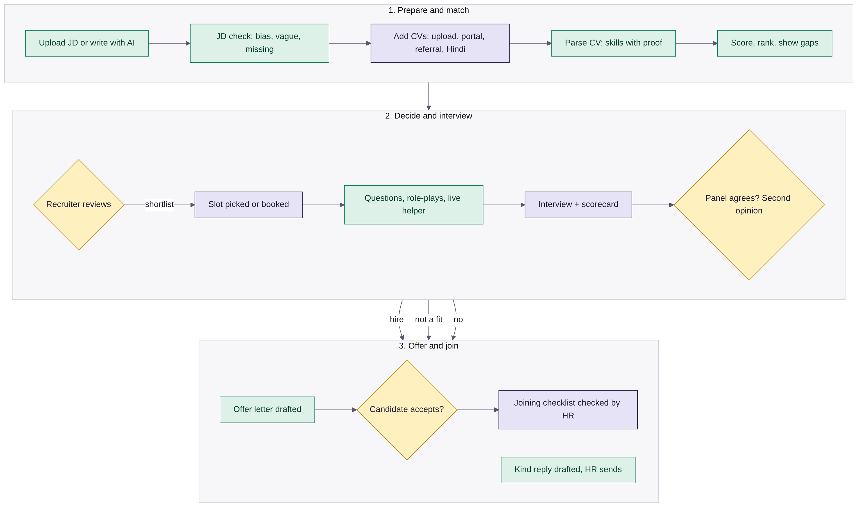
Figure 1: End-to-end hiring process (yellow = human decision, green = AI help)

3.1 Stages
Stage in database | Shown to HR as | Shown to candidate as | Meaning
Applied | New | Received | Just arrived
Screening | Reviewing | Under review | HR is reading the CV
Shortlisted | Shortlisted | Shortlisted | Worth an interview; candidate can pick a slot
Interview | Interview | Interview | Booked or done
Selected | Hired | Selected | Offer stage
Rejected | Not selected | Closed | Closed with a kind reply

3.2 Two-way messages
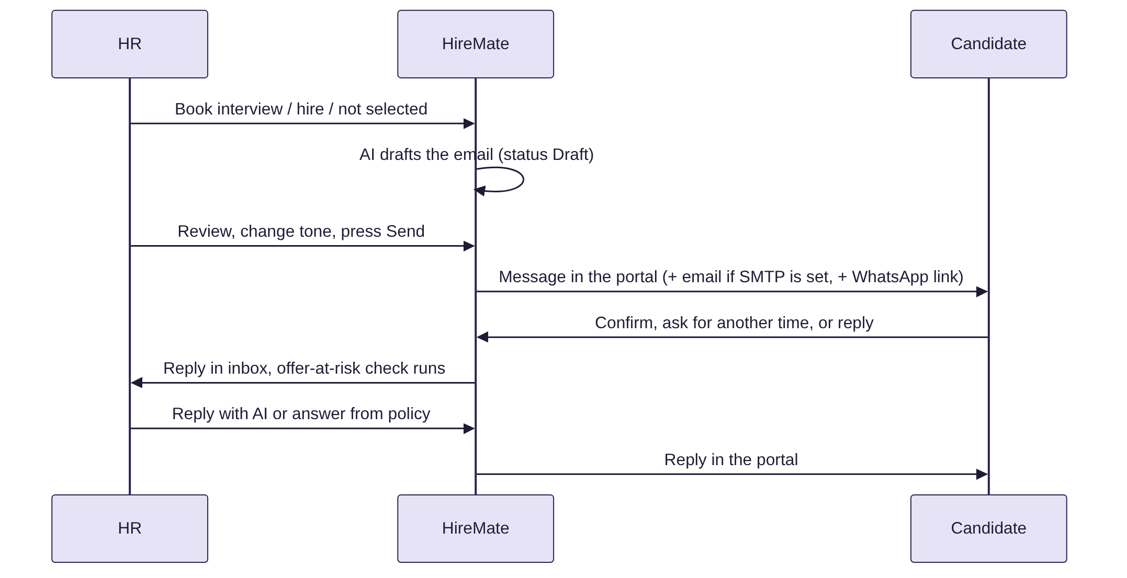
Figure 2: Drafts, sending and candidate replies

3.3 A recruiter's day with HireMate
- Open Home and read the 9 AM briefing and To do today.
- Act on Might drop out and Waiting too long first.
- Review new CVs with Quick review; shortlist.
- Check drafts (tone switch if needed) and press Send.
- After interviews: notes to scorecard, panel check, second opinion, decide.
- Send the offer; check joining documents as they arrive.
- Ask AI for anything else.

4. Features

4.1 Core features
Area | Features
Dashboard (Home) | Greeting, KPIs, 9 AM briefing, To do today (decide, feedback, book, review), replies from candidates, emails ready to send, your jobs with best match, upcoming interviews, waiting too long
Jobs | Create from JD upload, pasted text or AI-written JD (.docx download); JD check (vague, biased, missing items); edit must-have / nice-to-have skills and years with instant re-rank; open, paused, closed
Job page | Do this next bar; Candidates list best-first with Has ✓ / Missing ✗; Board view by stage; Job details; Screening questions; Your rules; Find more people (talent pool); share shortlist; compare 2–3 people; CSV export
Quick review | One CV at a time: Shortlist / Maybe later / Not selected, with Undo
Candidate page | Overview (screening answers, things to check, why this match with proof, AI summary, highlighted CV), Insights (Plus), Interview (free slots, booking, .ics, questions, practical task, scorecard), Emails (drafts, Send, WhatsApp, conversation), Offer, Notes and activity
Interviews | Upcoming and past interviews, candidate confirmation, feedback status
Ask AI | Floating button on every page and a full page; reads all jobs, candidates, interviews, emails, offers and policies; actions with confirm; file attach; streaming; next-step buttons
Documents | Knowledge store for policies, FAQs, JDs, CVs: upload, create, edit, download, delete; answers with sources
Reports | Funnel, applications and average match by job, most-missing skills, talent groups (K-Means + PCA), time to hire, time to interview, days per stage, source of hire, offer acceptance, referrals
Settings and Team | AI model and key (free or paid), test connection, score weights, recruiter rules for all jobs, AI guidelines, blind review, team and roles, logs, privacy and retention, reset demo data
Candidate portal | Sign up with CV (or answer 6 questions), my applications with progress, messages and replies, confirm or reschedule interview, open jobs, profile, delete my data, My next steps, Improve my CV

4.2 Features added after the competitor review
HireMate was compared with Greenhouse, Lever, Ashby, Workable, Zoho Recruit, Naukri RMS, Darwinbox, Manatal and Paradox. These common features were missing and are now built:
Feature | What it does | Tech
Pipeline board | One column per stage; move people with one click | Streamlit columns, stage API
Screening (knockout) questions | Yes/No, number and short-answer questions per job; a wrong "must" answer flags, never rejects | Rule evaluation (>=, <=, equals)
Offer letters | Form → letter; AI may reword but every figure must survive; Word download; accept / decline in the portal | python-docx, LLM with figure check
WhatsApp | Short version of any sent email + wa.me click-to-chat link | LLM summarise, URL encoding
Calendar invites | iCalendar (.ics) with Asia/Kolkata time and a 1-hour reminder | RFC 5545 text
Source of hire + speed | Source and referrer on every application; time to hire, time in stage, offer acceptance | Activity-log timestamps
Excel export | Ranked list as UTF-8 CSV with BOM (₹ and Hindi names show correctly) | csv module
Privacy (DPDP Act 2023) | Consent at sign-up, candidate self-erase, admin retention clean-up | Anonymisation, vector delete

5. HireMate Plus: 40 extra features
Plus lives in its own folders (backend/app/plus and frontend/plus) so the core stays exactly as specified. HR reaches it from the Plus menu item, the Insights tab on every candidate, and the briefing card on Home. Candidates get two new portal pages: My next steps and Improve my CV.
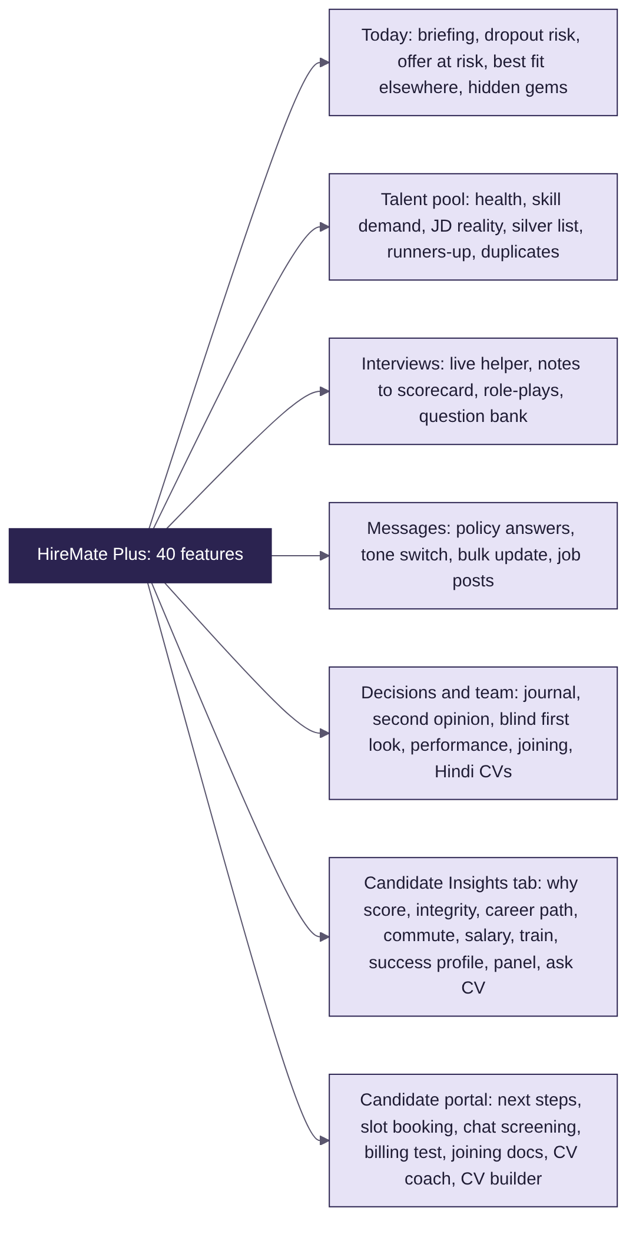
Figure 3: HireMate Plus at a glance

5.1 Smarter matching
# | Feature | How it works
1 | Best fit elsewhere | Scores every person against every open job; suggests a job where they score 60%+ and at least 10 points more than now
2 | Success profile | Traits shared by good hires (Selected or interview average 4+), or the top quarter of applicants: proves must-haves, results in numbers, 12+ months per job, commute under 45 min, enough years
3 | Hire and train | Missing must-haves mapped to weeks to learn (POS 1, Excel 2, inventory 3, forklift 4 …); trainable if 4 weeks or less
4 | Ask the CV | BM25 over CV sentences + skill-synonym matching; answers only with quoted lines, or "Not in the CV"
5 | CV integrity check | Overlapping jobs, claimed years vs dated jobs, big title jumps, figures over 100%, future dates, near-copy CV text (TF-IDF KNN ≥ 90%)
24 | Why this score? | Lists reasons, then re-scores the CV with each single fix (a missing skill proven, enough years) to find the biggest gain
25 | JD reality check | % of the talent pool that proves each must-have; flags rare asks (under 25%)
26 | Hidden-gem finder | Lower score but 2+ signals: results with numbers, awards, promotions, long stays
27 | Career-path view | Timeline chart of jobs with seniority levels: growth, hopping, gap or stable

5.2 Spotting problems early
# | Feature | How it works
6 | Dropout risk | Adds points for 8 warning signs (see Figure), caps at 95; High 50+, Medium 25–49; suggests the action and drafts a check-in
7 | Commute check | 26 Delhi-NCR places; haversine distance × 1.35 road factor at about 22 km/h + 10 min; easy (≤ 45), long (≤ 75), very long
8 | Salary fit meter | Expected salary (screening answer) vs the job's pay band: within, negotiate (≤ 15% over), too high
9 | Offer at risk | Finds hesitation phrases ("another offer", "think about it", "too far") in replies and quotes them
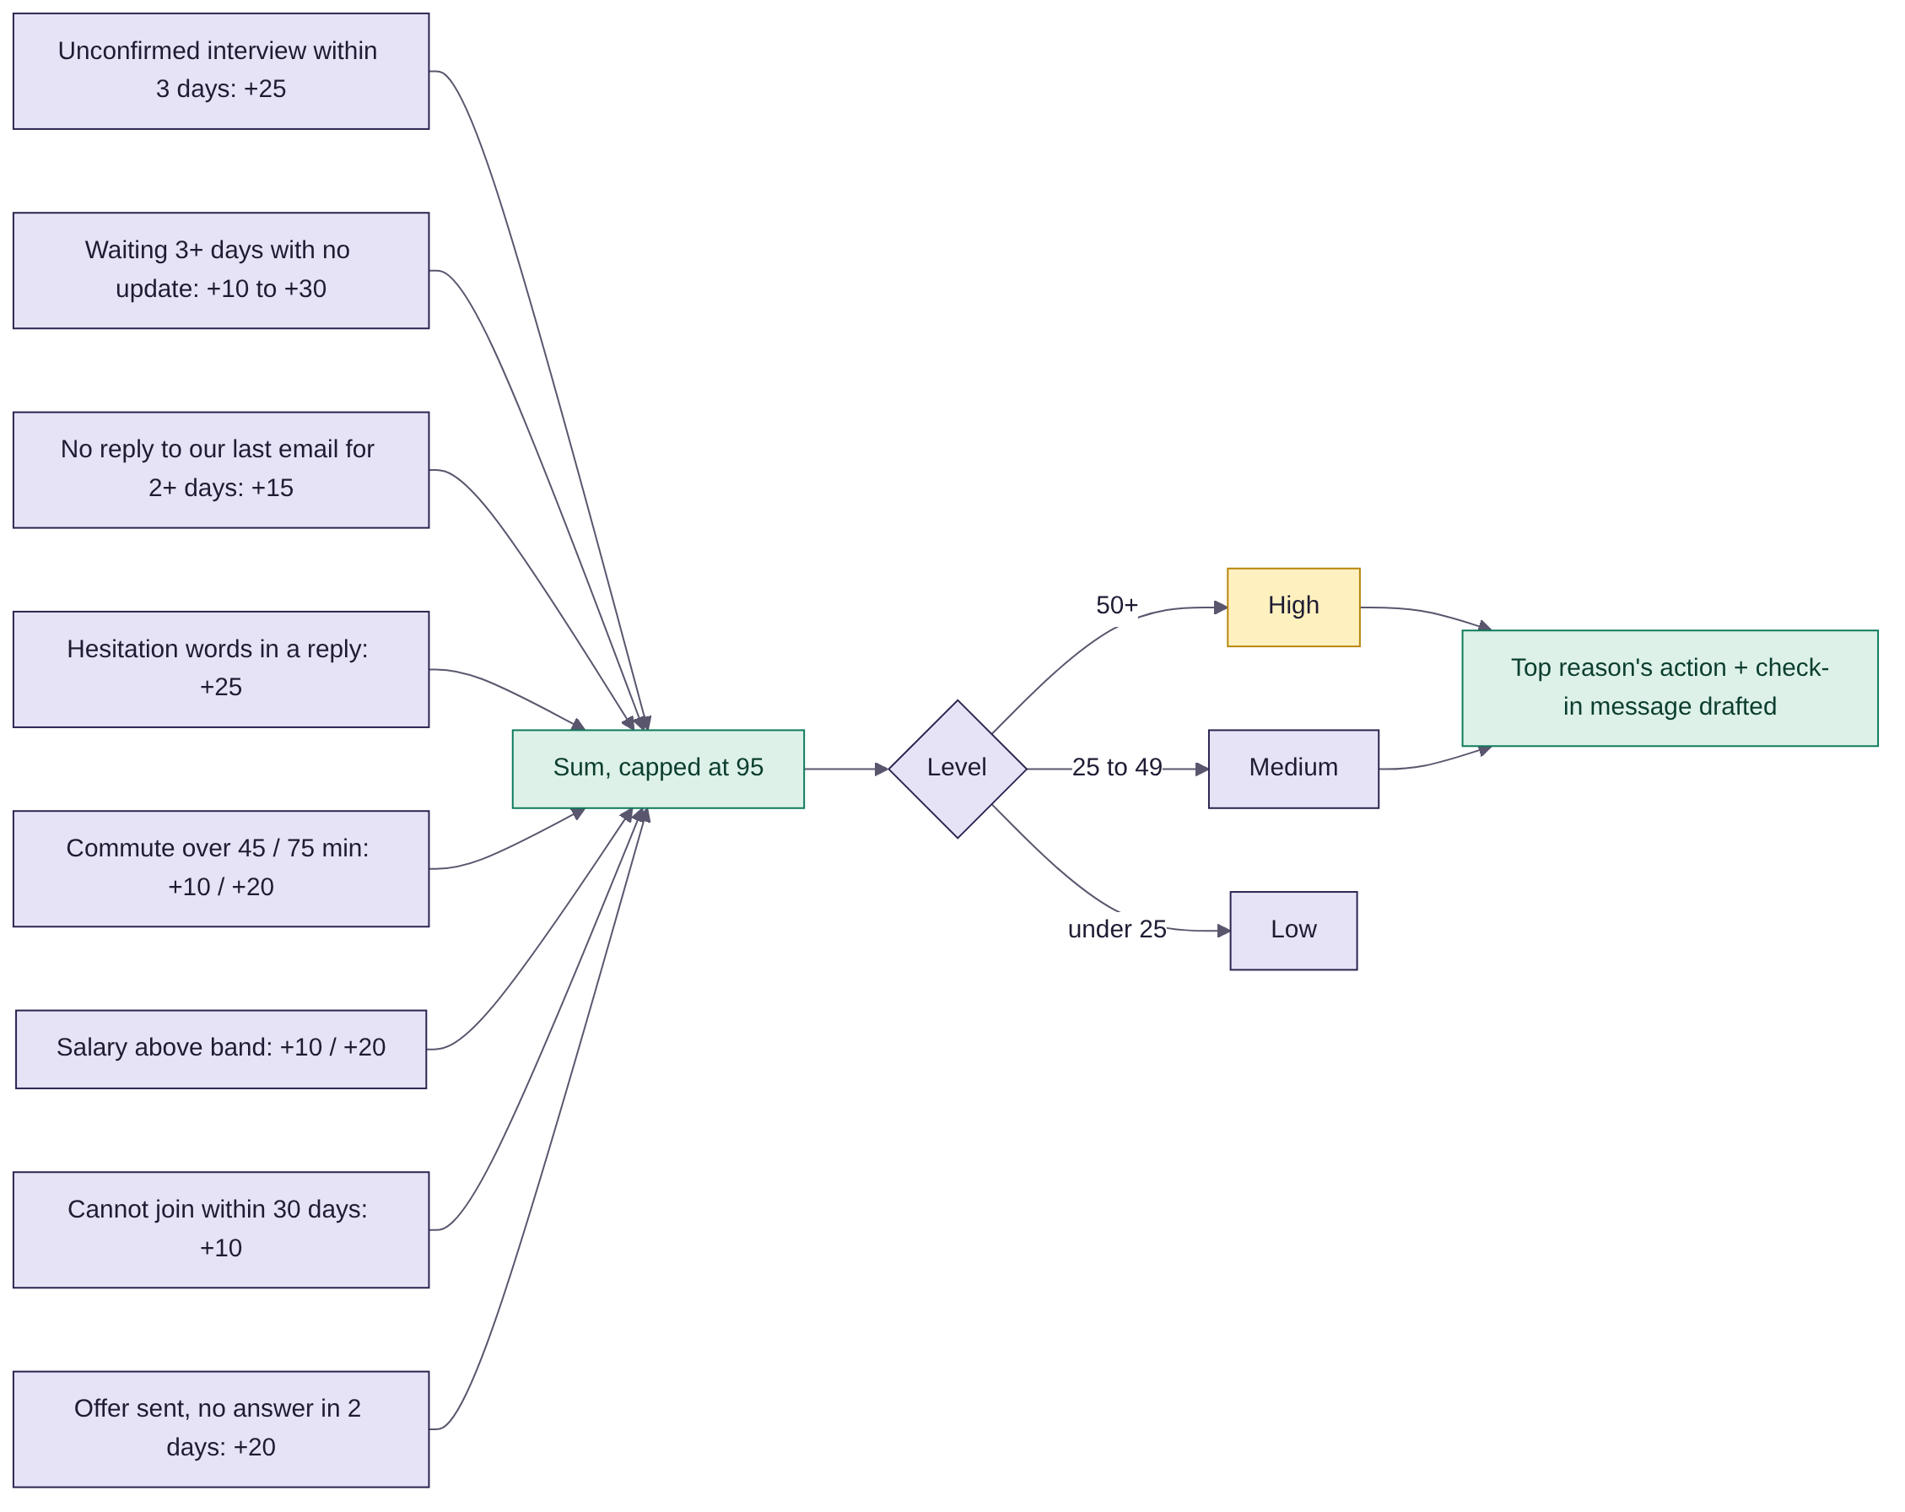
Figure 4: Dropout risk: signals, points and action

5.3 Candidate portal
# | Feature | How it works
10 | CV coach | Per job: add or prove each must-have, with an example sentence; basics (phone, dates, detail). No scores shown
11 | No CV? Answer 6 questions | Builds a structured CV (Role | Company | Mon YYYY – Present) from plain answers; LLM polishes without adding facts
12 | AI chat screening | 5 questions in a chat; each answer scored 1–5 (detail, own actions, numbers, on topic) or by the LLM rubric
13 | Pick your own interview slot | Shortlisted candidates choose from 6 free slots; booking is confirmed and the invite is drafted
14 | Honest status timing | Typical days per stage from real data vs today: "Usually 3 days. You're on day 2."
15 | Joining day checklist | After accepting the offer: upload Aadhaar, PAN, bank proof, photo; HR marks each checked
20 | Cashier billing test | 8 random sums (bill totals, change, discounts), regenerated from a stored seed so answers are checked on the server; timed
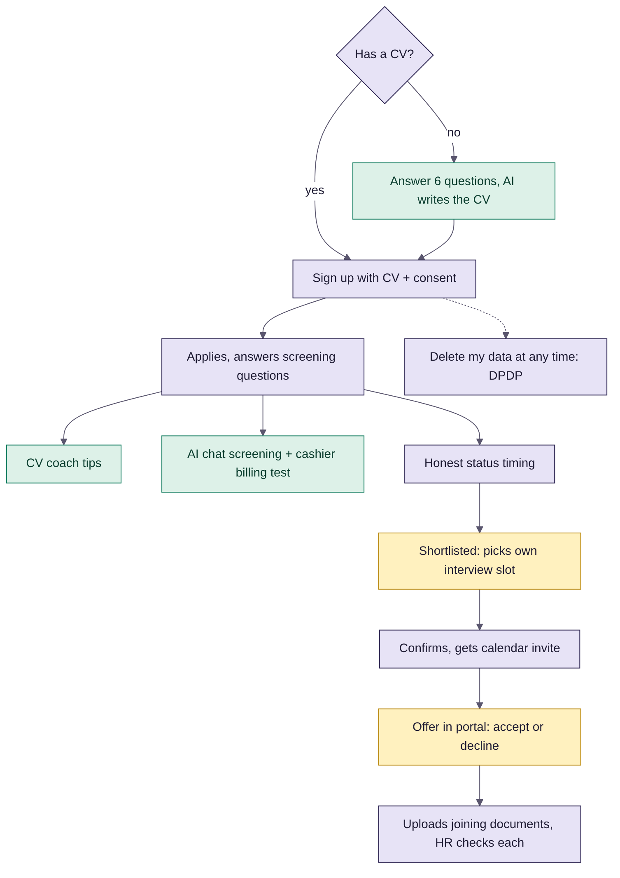
Figure 5: Candidate journey with Plus

5.4 Interviews, messages and HR's day
# | Feature | How it works
16 | 9 AM briefing | Interviews today, replies, high risks, longest wait, best fit, drafts; LLM rewrites the bullets without changing names or numbers
17 | Bring back runners-up | People from other jobs or the pool scoring 60%+ for this job; add them and draft notes in one click
18 | Job post writer | Naukri (formal), LinkedIn (hashtags), Apna (Hinglish), WhatsApp (emojis) from one JD and the pay band
19 | Notes to scorecard | Sentences per must-have skill + a positive/negative word lexicon → 1–5 rating with the quoted line; saves as feedback
21 | Question bank that learns | HR votes 👍/👎; ordered by net votes per role; feeds the live helper
22 | Hindi CV reading | LLM translation, or a 90-word Hindi→English dictionary, Devanagari digits and a transliteration engine (रमेश यादव → Ramesh Yadav)
23 | Recruiter performance | From the activity log per recruiter: CVs reviewed, interviews booked, emails sent, hires, days to hire
28 | Live interview helper | Tick questions, take notes; suggests the next question for any must-have not yet covered
29 | Panel agreement check | Flags a 2+ point gap between interviewers on the same skill
30 | Role-play scenarios | Store situations per skill, with what a good answer looks like and red flags
31 | Tone switch | Formal, Warm, Short, Hindi or Hinglish for any draft
32 | Answer candidate questions from policy | Splits the message into questions, retrieves policy text, quotes the best-matching sentence and names the source
33 | Bulk update, personal touch | One update for a whole stage; each message names that person's proven strength

5.5 Decisions, fairness and talent pool
# | Feature | How it works
34 | Decision journal | One line on why for each decision; lists hires and rejections with no reason yet
35 | Blind first look | Names and contact hidden everywhere until someone presses "I'm interested"; blind card shows skills, years and results
36 | Second opinion | If leaning yes: missing skills, risks, integrity flags. If leaning no: proven skills, trainability, hidden-gem signals
37 | Talent pool health | Per open job: in pipeline, ready (70%+) and close (50–69%) in the pool → healthy, thin, empty
38 | Re-engage silver list | Top 5 past candidates (55%+) with a ready message; duplicates removed by phone
39 | Skill demand board | Skills open jobs need vs % of the pool who prove them; red under 25%
40 | Duplicate and merge | Same phone, near-same email or same name and city; merge moves applications, notes and history

6. Technology stack

6.1 Architecture
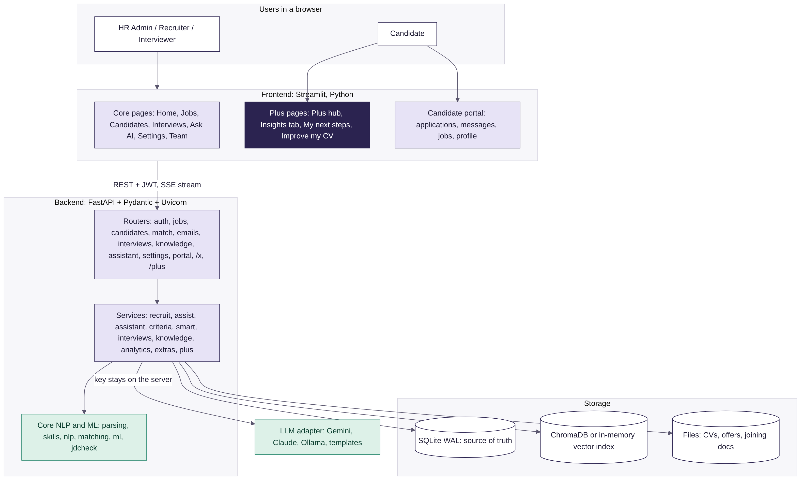
Figure 6: System architecture
Layer | Technology | Job
Frontend | Streamlit, pandas, Altair | Pages, tables, charts, chat, both portals
API | FastAPI, Pydantic v2, Uvicorn | About 180 REST endpoints, validation, roles, SSE streaming
Services | Python modules | recruit, assist, assistant, criteria, smart, interviews, knowledge, analytics, extras, portal, plus
Core NLP / ML | pdfplumber, python-docx, rank-bm25, scikit-learn, NumPy | Parsing, skills, similarity, matching, ML models
Data | SQLite (WAL), ChromaDB or in-memory index, file store | Records (source of truth), vectors, uploaded files
AI adapters | Gemini, Claude, Ollama (Qwen 2.5), templates | Writing and answering, swappable in Settings
Auth | bcrypt, PyJWT | Passwords, staff and candidate tokens, roles
Hosting | Docker, Render, GitHub | Online demo; run.bat / start.sh locally
Tests | pytest + FastAPI TestClient | 40 end-to-end API tests
Design pattern: layered architecture with ports and adapters. Streamlit only shows screens and calls the API; it never touches the database or AI keys. Each external dependency (LLM, embedder, vector store) sits behind an adapter with an automatic fallback, so the app always works, even offline.

6.2 Python libraries
Library | Version | What it does here | Where
fastapi | >=0.115 | Backend web API, dependency-injected auth, streaming responses | backend/app/main.py, routers/, plus/router.py
uvicorn[standard] | >=0.30 | ASGI server for FastAPI | start.sh, Dockerfile, run.bat
pydantic | >=2.7 | Request and response models, validation | routers/
python-multipart | >=0.0.9 | File uploads and form fields | routers/core.py, portal.py, plus/router.py
bcrypt | >=4.1 | Password hashing | security.py
PyJWT | >=2.8 | Signed login tokens (HS256) with role and kind | security.py
requests | >=2.31 | LLM HTTP calls; frontend → API client with a pooled session | adapters/llm.py, frontend/api.py
pdfplumber | >=0.11 | Text from PDF CVs and JDs | core/parsing.py
python-docx | >=1.1 | Read .docx CVs; write JDs and offer letters | core/parsing.py, services/files.py, extras.py
rank-bm25 | >=0.2.2 | BM25 keyword ranking (policies, Ask the CV) | core/nlp.py, plus/insights.py
scikit-learn | >=1.4 | TF-IDF, hashing vectors, Naive Bayes, Logistic Regression, KNN, K-Means, PCA | core/nlp.py, core/ml.py, adapters/embedder.py
numpy | >=1.26 | Vector maths, cosine similarity, score scaling | core/, adapters/
streamlit | >=1.50 | Whole web UI, navigation, chat, dialogs, theming | frontend/
pandas | >=2.2 | Tables and data frames for charts | frontend/views, frontend/plus
altair | >=5.3 | Charts: funnel, sources, skill demand, career timeline, talent map | frontend/views/analytics.py, frontend/plus
pytest | >=8 | Automated tests | tests/
chromadb (optional) | latest | Persistent vector store; in-memory store if missing | adapters/vectorstore.py
sentence-transformers (optional) | latest | bge-base-en-v1.5 embeddings; hashing fallback otherwise | adapters/embedder.py
sqlite3, csv, re, json (std lib) | Python | Database, CSV export, regex parsing, JSON | db.py, services/

6.3 Services outside Python
Service | Use
Google Gemini API | Default free LLM: generateContent, streamGenerateContent (SSE), ListModels to pick a working model
Anthropic Claude API | Optional paid model (Settings → AI model)
Ollama + Qwen 2.5 7B | Optional offline model on the same machine
SMTP (optional) | Real email in addition to the portal inbox
WhatsApp click-to-chat | wa.me links; no API account needed
Docker + Render | Free online hosting; Manual Deploy after each GitHub push
Google Fonts | Bricolage Grotesque and Figtree for the UI

6.4 Code layout
hr-chatbot/
backend/app/
main.py FastAPI app, startup (schema, seed, index)
config.py, db.py settings; SQLite schema + safe migrations
security.py bcrypt + JWT, roles
core/ parsing, skills, nlp, matching, ml, jdcheck (pure logic)
adapters/ llm, embedder, vectorstore (swappable)
services/ recruit, assist, assistant, criteria, smart, interviews,
knowledge, analytics, portal, extras, files, mailer
routers/ core, assist, portal, extras (/x)
plus/ insights, talent, hr_tools, portal_tools, router (/plus)
seed.py, sample_data.py synthetic demo data
frontend/
app.py login, navigation (staff and candidate menus)
ui.py, widgets.py, chat.py, api.py theme, components, Ask AI, API client
views/ one file per page
portal/ candidate portal pages
plus/ hub (Plus page), plus_ui, portal_steps, portal_cv
.streamlit/config.toml theme
tests/ test_api.py, test_extras.py, test_plus.py
docs/ this document, gap analysis, Plus guide, tracker
Dockerfile, render.yaml, start.sh, run.bat, requirements.txt

7. NLP: how HireMate reads text
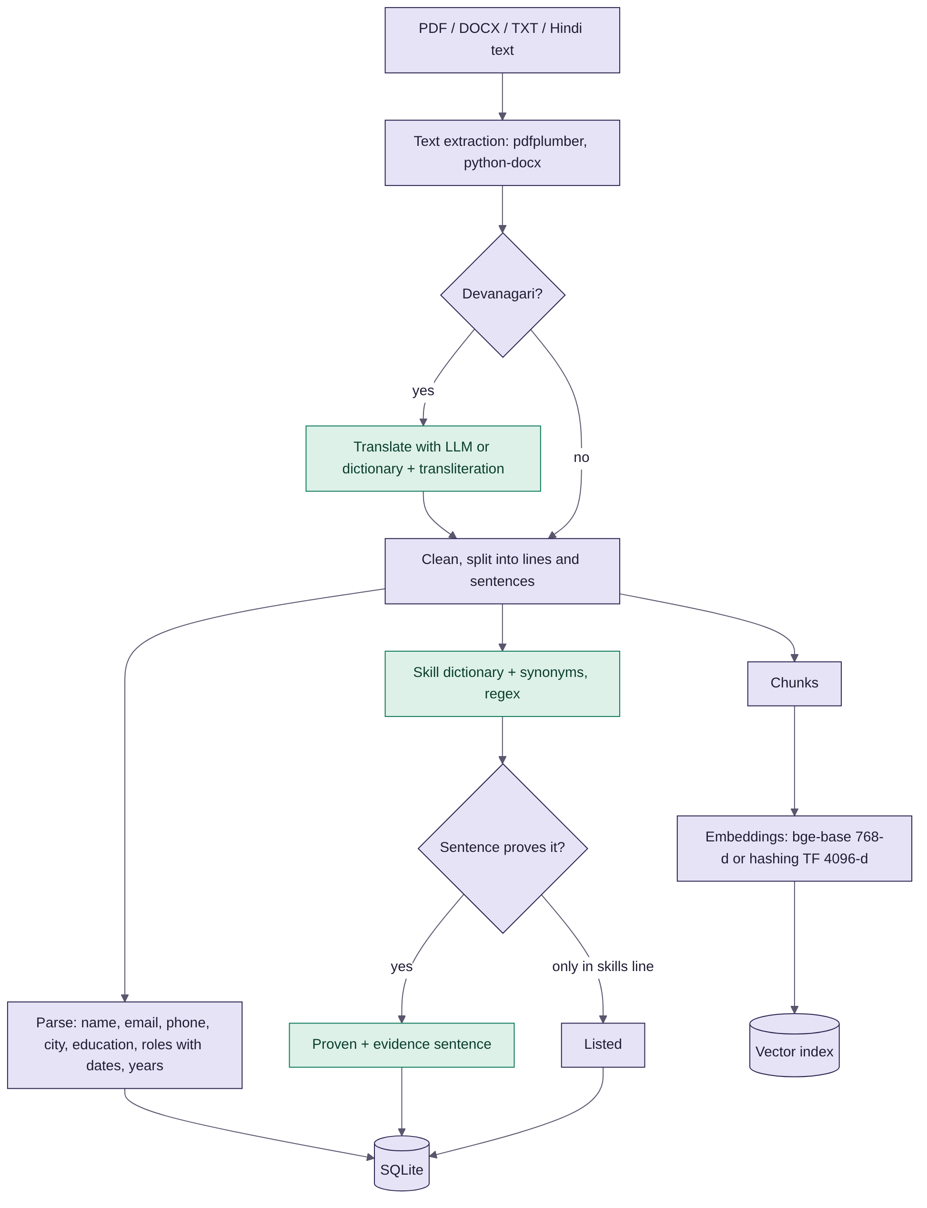
Figure 7: CV and JD reading pipeline (R1)

7.1 Text extraction
- PDF: pdfplumber extracts text page by page; scanned PDFs give a clear error with a paste-text fallback.
- Word: python-docx reads paragraphs and tables. TXT: read as UTF-8.
- Hindi: Devanagari is detected (more than 20% of letters) and translated: by the LLM if a key is set, otherwise by a dictionary, Devanagari-digit mapping and a rule-based transliterator with schwa deletion.

7.2 Parsing (information extraction)
- Regular expressions find email, phone, years, date ranges ("Mar 2021 – Present") and section headings.
- Each job line "Role | Company, City | dates" becomes a structured role; total years come from the date spans.
- Education level, city and headline are taken from labelled lines with fallbacks.
- A JD is split into must-have and nice-to-have skills by its headings; minimum years and location are read the same way.

7.3 Skill extraction with proof
A dictionary of 16 retail skills, each with synonyms and regex patterns (e.g. POS systems = "pos", "point of sale", "billing counter"), is matched against every CV sentence:
- Proven (credit 1.0): a real work sentence mentions it; that sentence is stored as evidence and highlighted in the CV.
- Listed (credit 0.5): it only appears in the Skills line.
- Missing (credit 0): not found. Unknown JD phrases become new skills automatically.

7.4 Tokenising and vectors
- Custom tokeniser: lower-case, letters only, stop-word list, light plural stemming ("cashiers" → "cashier"), "P&L" kept as one token.
- TF-IDF (scikit-learn, sublinear term frequency) with IDF learned from the whole corpus of JDs and CVs, so rare retail words count more.
- Embeddings: BAAI bge-base-en-v1.5 (768 dimensions) via sentence-transformers when installed; otherwise a 4,096-dimension hashing TF vectoriser that needs no download.
- BM25 (Okapi, k1 = 1.4, b = 0.75) with 6-letter prefix stemming so reschedule, rescheduling and rescheduled match.

7.5 Retrieval for answers (RAG)
Policies, FAQs, JDs and CVs are chunked and stored twice: the original in SQLite (source of truth) and the vectors in ChromaDB (or memory). A question is answered by hybrid retrieval:
- BM25 top 10 and vector top 10.
- Reciprocal rank fusion: score = Σ 1 / (60 + rank).
- Grounding gate: keep a hit only if its BM25 score is above 0.5, so unrelated text is never shown.
- Top 3 chunks go to the LLM with a rule to cite [1], [2] and to say "not in the data" otherwise.

7.6 Other NLP in the app
Task | Technique
JD check | Word lists for biased terms (age, gender, appearance), vague phrases, missing salary or location
Ask the CV | Sentence split + BM25 + skill-synonym matching; quotes only
Hesitation detection | Phrase list over candidate replies (offer at risk, dropout risk)
Notes to scorecard | Sentence-to-skill matching + positive / negative lexicon → 1–5
Policy auto-answer | Question splitting ("…, and should I…?") + retrieval + best-sentence selection by keyword overlap
CV builder | Date normalisation ("Jan 2021 to now" → "Jan 2021 – Present"), skill detection from free text

8. Machine learning and scoring

8.1 The match score (R2)
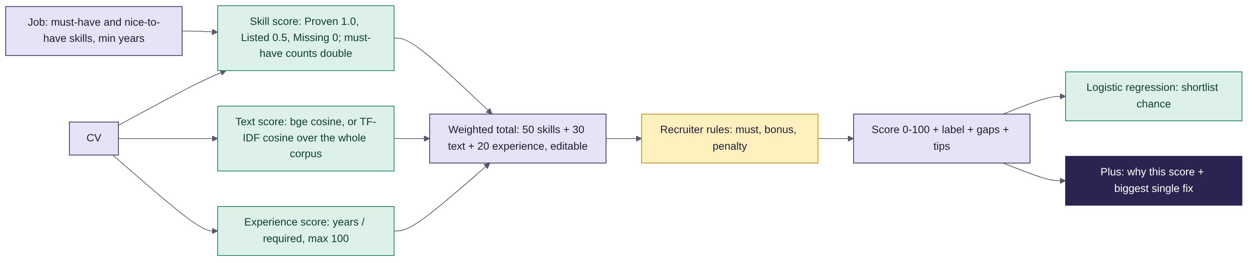
Figure 8: How the match score is built
skill = Σ(weight × credit) / Σ(weight) × 100
weight: must-have 2, nice-to-have 1
credit: Proven 1.0, Listed 0.5, Missing 0
text = bge cosine rescaled (cos − 0.55) / 0.35,
or TF-IDF cosine; clipped to 0..1, × 100
exp = min(100, years / required years × 100)
total = (50 × skill + 30 × text + 20 × exp) / 100
(weights editable in Settings)
label = Good fit 70+ · Okay 50–69 · Weak under 50
- Recruiter rules (plain English, stored as data) add bonus or penalty points; people who meet every "must" rule sort first. AI only helps check rules it cannot decide in code, and results are cached by CV hash.
- Every score shows its parts, the proof sentences and "what would raise the score".

8.2 Classic ML models (scikit-learn)
Model | Input | Output and use
Multinomial Naive Bayes | Word counts of a CV | Job family (store management, cashier & customer service, warehouse) with probabilities; picks the right assessment
Logistic Regression (C = 10, L2) | Skill score, text score, meets years | Shortlist chance shown as a hint next to the score
K-Nearest Neighbours (cosine) | TF-IDF of CVs | Similar candidates; near-duplicate CV detection in the integrity check
K-Means + PCA | TF-IDF of all CVs | Talent groups drawn on a 2-D map in Reports, with top terms per group
With small synthetic data the ML models are a method demonstration and are always shown as hints. The ranking itself is explainable rules + similarity, so a recruiter can always see why.

8.3 Plus algorithms
Feature | Algorithm
Dropout risk | Additive points model over 8 signals (capped at 95), 3 levels, action chosen from the highest-weighted reason
Commute | Haversine great-circle distance × 1.35 road factor ÷ 22 km/h + 10 min
Best fit elsewhere | Full candidate × open-job score matrix; gain ≥ 10 and score ≥ 60
Why this score? | Counterfactual re-scoring: the CV is re-scored with one change at a time, and the largest gain wins
Success profile | Majority vote of 5 binary traits over good hires (or top quartile)
Hidden gems | Signal counting: quantified results (regex), award words, promotions (seniority ladder), average tenure
Career path | Date-span parsing + seniority ladder (associate 1 … manager 5, head 6) → growth, hopping, gap, stable
Chat screening | Rubric: detail (25+ words), own actions, numbers, on-topic → 1–5; or LLM JSON rubric
Billing test | Seeded pseudo-random generator; the server regenerates the questions to mark answers
Duplicates | Phone digits, email local part, name + city, TF-IDF similarity over the whole pool

9. Generative AI (LLM) and Ask AI

9.1 LLM adapter
- One adapter for Gemini (free default), Claude (paid option), Ollama/Qwen (offline) and templates (no key). Admin switches in Settings → AI model and can test the connection; keys are stored on the server and shown masked.
- Resilience: models ranked from Google's ListModels (lite first); on 404, 429, 500, 503 or timeout the next model is tried and a busy model is skipped for 5 minutes. Timeouts: 5 s connect, 20 s read.
- Low temperature, short outputs (about 700 tokens, under 150 words for chat).

9.2 Where the LLM is used and how it is kept honest
Use | Grounding rule | Fallback
Candidate summary (R3) | Only CV, JD and match data; cite sources | Template summary
Interview questions (R3) | JSON array validated; checks proven sentences and gaps | 6 template questions
Emails (R4) | Only given facts; no invented salary, dates or names; AI line at the end | English / Hindi templates
Offer letter | Rewrite only; the CTC and candidate name must still be present or it is discarded | Template letter
Ask AI (R5) | Database snapshot + top 3 policy chunks; Answer / Why / Next step; "not in the data" | Insights engine and policy search
Plus text (briefing, tone, CV polish, Hindi, job posts) | Keep every name and number; no new facts | Rule-based text

9.3 Ask AI routing
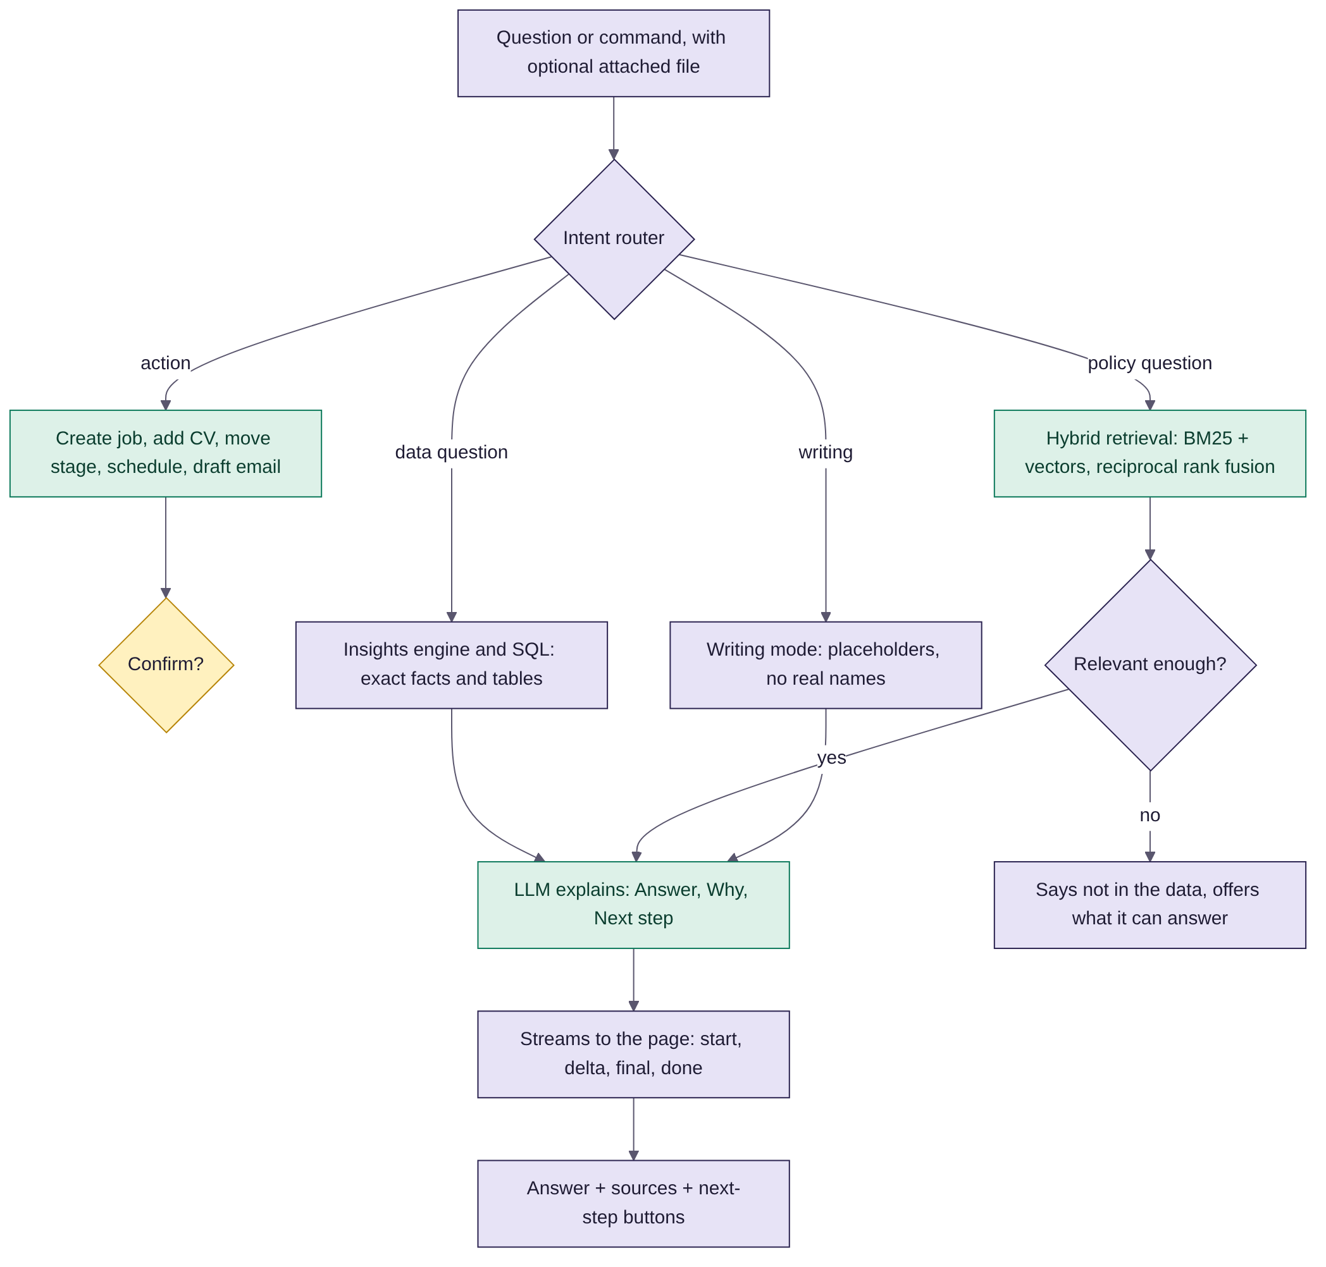
Figure 9: How Ask AI answers (R5)
- Actions (create job, add CV, move stage, schedule, draft email, add policy) always ask to confirm first.
- Data questions ("who is waiting too long", "who should I hire") are answered exactly from SQL by the insights engine, then explained by the LLM.
- Streaming: POST /assistant/chat/stream returns Server-Sent Events (start, delta, final, error, done); the page shows them with st.write_stream and falls back to a normal request if the stream fails.
- Memory: recent messages go into the prompt so short follow-ups work. Writing requests use placeholders like [Name].
- Next steps: the model ends with "NEXT: a | b | c", which the server turns into buttons.

10. Frontend: Streamlit
The whole interface is Python. Streamlit renders the pages; every action calls the FastAPI backend through a small API client with a pooled HTTP session.
Streamlit feature | How HireMate uses it
st.navigation + st.Page | Separate menus for staff and candidates; hidden pages (job, candidate, review) opened by buttons; role-based menu
st.session_state | Token, user, current job and candidate, chat history, undo bar, toasts
st.dialog | Add CVs, compare people, Ask AI window
st.segmented_control, st.tabs | Page sections (Candidates / Board / Job details / Screening questions …)
st.chat_message, st.chat_input, st.write_stream | Ask AI chat with streaming text and file attach; AI chat screening in the portal
st.form, st.file_uploader | Login, job and offer forms, CV and joining document uploads
st.download_button, st.link_button | Word offers, .ics invites, CSV export, shortlist page, WhatsApp links
st.altair_chart, st.dataframe | Reports, skill demand, career-path timeline, recruiter table
st.cache_resource, st.cache_data | One HTTP session; short-lived cache for blind-first-look state
config.toml theme + CSS | Store-aisle theme: aubergine menu #2B2350, till-green actions #0E7A5C, shelf-tag yellow #FFD23F; match scores shown as price tags; Bricolage Grotesque + Figtree

10.1 Design rules
- Plain words on screen (New, Reviewing, Hired) while the database keeps its own stage names.
- One clear next step on every page; Undo after every move.
- Every AI result says where it came from; nothing leaves the system without a human click.
- Keyboard focus is visible; reduced motion respected; works down to phone width.

11. Backend: FastAPI and data

11.1 API groups
Group | Main endpoints
auth | POST /auth/login, GET /auth/me
jobs | GET/POST /jobs, /upload, /preview, GET/PATCH/DELETE /jobs/{id}, /check
candidates | GET/POST /candidates, /upload, /preview, /{id}, /similar, /notes, /activity
applications + match | POST /applications, /bulk, PATCH /{id}; GET /match/job/{id}, /candidate/{cid}, /compare
ai, emails, interviews | GET /ai/summary, /questions, /assessment; /emails (draft, send, ai-reply, inbox, thread); /interviews, feedback
knowledge, assistant | /knowledge (CRUD, upload, ask); POST /assistant/chat and /chat/stream (SSE)
criteria, smart, settings | Recruiter rules; next action, slots, waiting, flags, book, move, undo; AI, weights, team, logs, reset
portal | Candidate sign-up, login, apply, applications, messages, reply, respond, offers, erase
/x (gap features) | Screening questions and answers, offers, WhatsApp, .ics, sources, metrics, CSV, privacy
/plus and /portal/plus | Briefing, candidate panel, best fit, dropout, talent tools, interview tools, messages tools, decisions, joining, CV builder, coach, screening, slots, billing test
About 180 endpoints in total; the interactive OpenAPI docs are at /docs when the backend runs.

11.2 Data model
Table | Holds
users, activity_logs, settings | Staff, roles, every action with who and when, app settings (weights, AI, pay bands)
jobs, job_skills | Job descriptions, must-have / nice-to-have skills, status
candidates, candidate_skills, candidate_accounts | Parsed CVs, skills with status and evidence, portal logins, consent and erasure dates
applications, match_results | Candidate × job, stage, source, referrer; cached scores and details
interviews, interview_feedback | Slots, mode, candidate response; scorecards, readiness, AI summary
emails, offers | Drafts, sent and received messages; offer letters and responses
screening_questions, screening_answers | Per-job questions and candidate answers
knowledge_docs, criteria, criteria_checks | Policies and FAQs; recruiter rules and cached checks
plus_screen, plus_tests, plus_joining, plus_panel, plus_decisions, plus_qbank, plus_revealed | Plus: chat screening, billing tests, joining documents, panel ratings, decision journal, question bank, blind-first-look reveals
- SQLite runs in WAL mode; new columns are added safely at start-up so older databases keep their data.
- Every JD, CV and policy is stored twice: original in SQLite, chunks and vectors in the search index (rebuilt automatically if the embedder changes).

12. Security, privacy and fairness
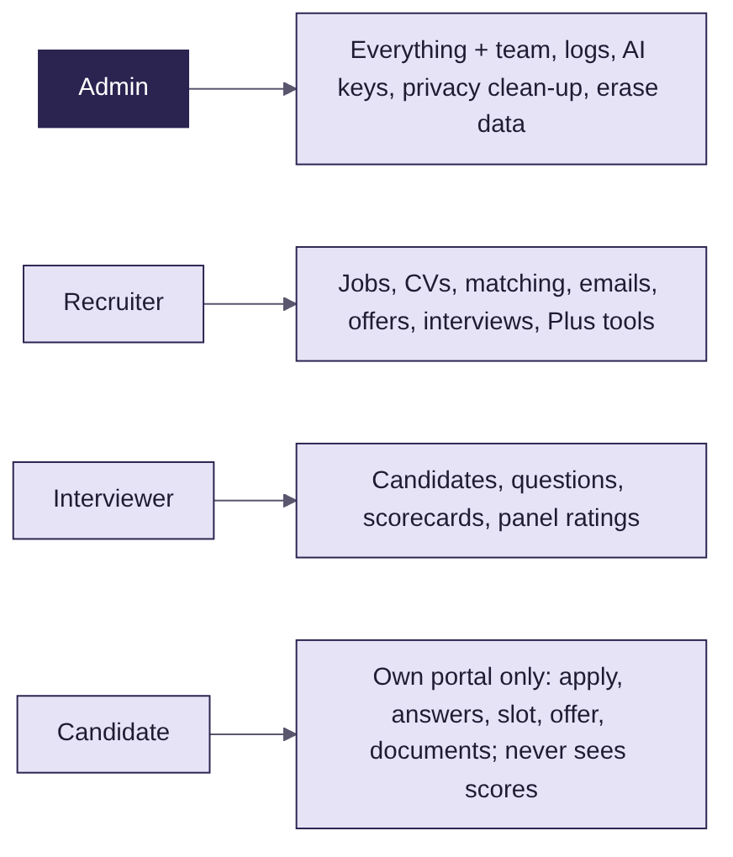
Figure 10: Roles
Area | How
Passwords | bcrypt hashes; 6+ characters
Sessions | JWT (HS256). Staff and candidate tokens are separate; a candidate token can never open a staff endpoint; turned-off accounts get 401
Roles | Checked on the server for every endpoint; Admin-only team, logs, privacy and erase
Secrets | GEMINI_API_KEY and JWT_SECRET only in the server environment; never in the browser or GitHub
Uploads | Type and size checks; candidates can only touch their own applications
Privacy (DPDP Act 2023) | Consent at sign-up; candidate "Delete my data"; admin retention clean-up (default 180 days, never-hired only); anonymisation keeps report counts
Fairness | Gaps never scored, JD bias check, blind review and blind first look, panel agreement check, second opinion, decision journal
AI safety | Drafts only, confirm before actions, grounded answers with sources, figure check on offers
Audit | Activity log for every sign-in and change; logs page with CSV export

13. Testing and quality
Test file | Tests | Covers
tests/test_api.py | 17 | Login and roles, parsing, ranking, JD/CV upload, duplicates, pipeline, interviews, feedback, emails and approval, knowledge and RAG, the full Ask AI flow, analytics, settings, candidate portal loop
tests/test_extras.py | 9 | Screening questions (flag, never reject), offer flow and figures, WhatsApp and calendar, sources, metrics and CSV, consent, erasure, admin-only privacy
tests/test_plus.py | 14 | Briefing and dropout risk, best fit, candidate panel, commute and pay band, Ask the CV, talent insights, duplicates and merge, interview tools, message tools, Hindi CV, decisions and blind look, runners-up, portal CV tools, screening, billing test, self-booking, joining
- All 40 tests pass. They run against a fresh synthetic database with LLM_PROVIDER=template, so no API key is needed.
- Every screen was also clicked through in a headless browser (Playwright) with no errors.

14. Setup and deployment

14.1 Run on a Windows PC
- Install Python 3.11 or newer.
- Double-click run.bat. The first run installs everything (3–5 minutes) and opens http://localhost:8501.
- Sign in with a one-click demo account (Admin, Recruiter or Interviewer; password recruit123), or as a candidate such as sana.khan@example.com / candidate123.
- Optional: Settings → AI model → Free → Gemini Flash, paste a free key from aistudio.google.com/apikey, Save, Test connection.

14.2 Manual steps (any OS)
pip install -r requirements.txt
pip install chromadb # optional vector store
pip install -r requirements-embeddings.txt # optional bge embeddings
uvicorn backend.app.main:app --port 8000 # API (docs at /docs)
cd frontend && streamlit run app.py # UI (http://localhost:8501)
pytest -q # 40 tests

14.3 Environment variables
Variable | Purpose
LLM_PROVIDER | auto | gemini | claude | ollama | template
GEMINI_API_KEY / ANTHROPIC_API_KEY | AI keys (or set them in Settings)
EMBEDDER, VECTOR_STORE | auto | bge | hashing; auto | chroma | memory
JWT_SECRET | Long random string for login tokens
SMTP_HOST, SMTP_PORT, SMTP_USER, SMTP_PASSWORD, SMTP_FROM | Optional real email
DATA_DIR, API_URL, PORT | Data folder, backend address, public port

14.4 Online (Render)
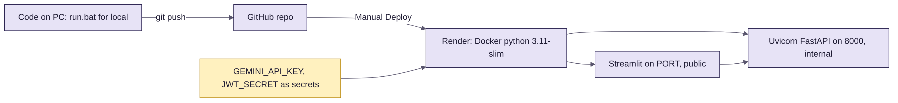
Figure 11: From code to the live site
- Docker image python:3.11-slim runs FastAPI (internal port 8000) and Streamlit (public PORT) via start.sh.
- Push to GitHub, then Render → Manual Deploy → Deploy latest commit. Keys go in Render's environment as secrets.
- The free tier sleeps after 15 minutes and resets data on redeploy; the demo data reloads automatically. Open the link a minute before a demo.

15. Demo script, risks and roadmap

15.1 Ten-minute demo
- Wake the site early. Sign in as Admin with one click.
- Home: the 9 AM briefing and To do today.
- Plus → Today: Priya might drop out ("another offer"); Deepak is a better fit for Warehouse → Add.
- Store Manager job: ranked list with price-tag scores, Board view, CSV export.
- Imran → Insights: why 43%, the biggest single fix, 68-minute commute, integrity flag, career path.
- Anjali: AI summary, questions, notes → scorecard, panel gap, Hire → offer letter → Send.
- Candidate portal as Anjali: accept the offer, upload PAN. As Sana: chat screening and billing test.
- Plus → Messages: answer Arjun's parking question from policy; switch a draft to Hinglish; job posts.
- Ask AI: "Who should I hire first and why?" and a policy question with sources.
- Reports and Settings: time to hire, sources, weights, privacy clean-up.

15.2 Risks and controls
Risk | Control
Bias | Reasons shown, human decides, blind first look, panel check, JD bias check
Wrong AI answer | Grounded with sources, relevance gate, "not in the data", figures checked in code
Messy or scanned PDFs | Clear error and paste-text fallback
LLM quota or downtime | Model rotation, templates, offline Ollama
Key leak | Server-side only
Wrong email sent | Drafts only; human Send; activity log
Small synthetic data makes ML weak | ML shown as hints; rules and similarity carry ranking

15.3 Roadmap
Phase | What
v2 (now) | R1–R5, both portals, competitor-gap features, HireMate Plus, new UI, 40 tests
v2.1 | Permanent database online, real email test mode, WhatsApp Business API
v3 | Job-board posting (Naukri, Apna, LinkedIn), OCR for scanned CVs, calendar sync, e-sign offers
v4 | HRMS hand-off, single sign-on, adverse-impact reporting on real consented data

15.4 Glossary
Term | Meaning
JD / CV | Job description / resume
Proven / Listed skill | Shown in a real work sentence / only named in a skills list
Gap | A must-have skill the CV does not show
TF-IDF | Word weights: frequent in this text, rare in others
BM25 | Keyword ranking formula used by search engines
Embedding | A list of numbers that captures meaning, for similarity
RAG | Retrieval-augmented generation: the AI answers from retrieved documents
RRF | Reciprocal rank fusion: merges keyword and vector results
SSE | Server-sent events: how answers stream word by word
JWT | Signed login token
DPDP Act 2023 | India's Digital Personal Data Protection Act

