HR TEAM
HireMate
Testing guide: how to run it, what to click, what you should see
AI recruiter assistant prototype · all data is synthetic (no real candidates)
Version: 31 October 2026

How to use this guide: follow Part 1 to start the app (10 minutes), Part 2 to switch on the free AI, then go page by page with Part 3 and tick the checklist in Part 5.

Contents

1. Start HireMate on your laptop
HireMate runs on your own computer. The page opens at http://localhost:8501. This link works only on the computer where HireMate is running.

Windows
- Install Python 3.11 or newer from python.org. During install, tick Add python.exe to PATH.
- Unzip HireMate_app.zip to a folder, for example Desktop\hiremate.
- Open the folder and double-click run.bat.
- First time only: it installs everything. This takes 3 to 5 minutes.
- Your browser opens http://localhost:8501 by itself. If not, type that address in the browser.
- Keep the black windows open while you test. Close them to stop HireMate.

Mac
- Install Python 3.11+ from python.org.
- Unzip the folder, then double-click run_mac.command. (If the Mac blocks it: right-click → Open.)
- The browser opens http://localhost:8501.

Sign in
Who | Email | Password | Can do
Admin (you) | admin@hiremate.demo | recruit123 | Everything, incl. AI key and team
Recruiter | recruiter@hiremate.demo | recruit123 | Jobs, candidates, emails, knowledge
Interviewer | interviewer@hiremate.demo | recruit123 | View, add interview feedback only
Start fresh any time: Settings → Demo data → Reset to the sample data. It reloads 3 jobs, 7 CVs and 8 policy documents. Your AI key is kept.

2. Turn on the free AI
Without a key, everything still works. The AI writing (summaries, emails, JDs, smart answers) then uses simple templates. With a free key, the writing becomes natural and the AI can answer any question about your data.

Get a free Gemini key (2 minutes)
- Go to aistudio.google.com/apikey and sign in with a Google account.
- Click Create API key. Copy it.
- In HireMate: Settings → AI model → Plan: Free → Gemini Flash (free key).
- Paste the key → Save. HireMate tests it and shows a green message.
- The badge at the top right of the AI model box changes from Using templates to AI on.
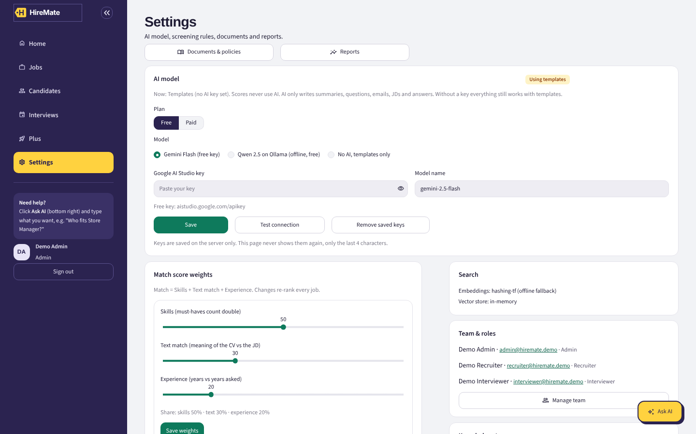
Settings → AI model. Free plan is the default. Paid (Claude or Gemini Pro) is optional.
Message you may see | What it means | What to do
The key is not valid (401) | Key copied wrong | Copy the key again, paste, Save
Free limit reached (429) | Too many questions in a minute | Wait 1 minute and try again
Model name may be wrong (404) | Model name changed | Use gemini-2.5-flash or gemini-2.0-flash
Couldn't reach the AI service | No internet | Check Wi-Fi
Paid plan (later, optional): Plan: Paid → Claude or Gemini Pro → paste your paid key → Save. Paid keys charge your own account per use. Remove saved keys takes you back to the free plan.

3. Page-by-page tour
Use the menu on the left. On every page there is a round Ask AI button at the bottom right.

3.1 Dashboard
- Top numbers: open roles, applications, people to screen, interviews ahead.
- Needs you: your to-do list, made from the data (decide, add feedback, schedule, screen). Click Open.
- Coming up: next interviews. Roles: each job with its best match.
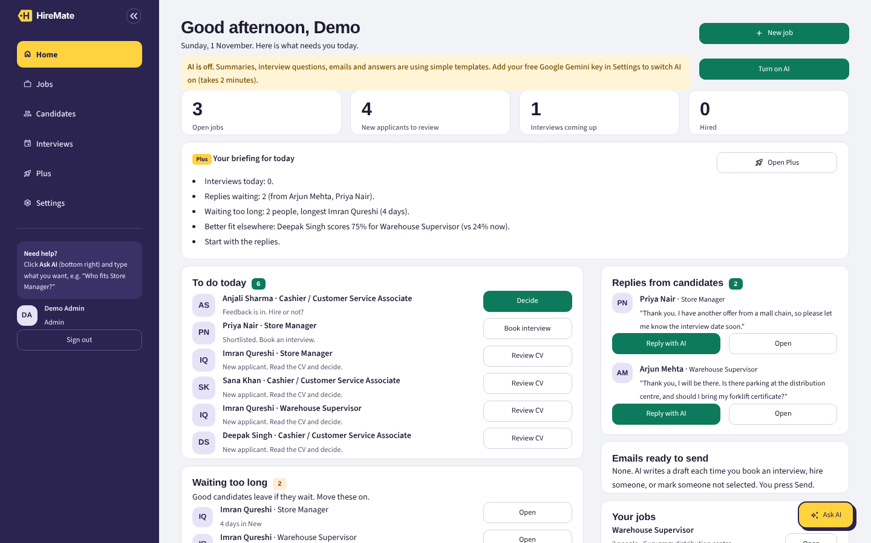
Dashboard. Note the round Ask AI button at the bottom right.

3.2 Jobs
- List of jobs with how many people are in each stage. Search and filter by status.
- Create job has 3 ways: upload a JD file, paste text, or let the AI write it from one line.
- Before saving, it shows what it found (must-haves, nice-to-haves, years) and a JD check for biased words like "young", "girls", "presentable".
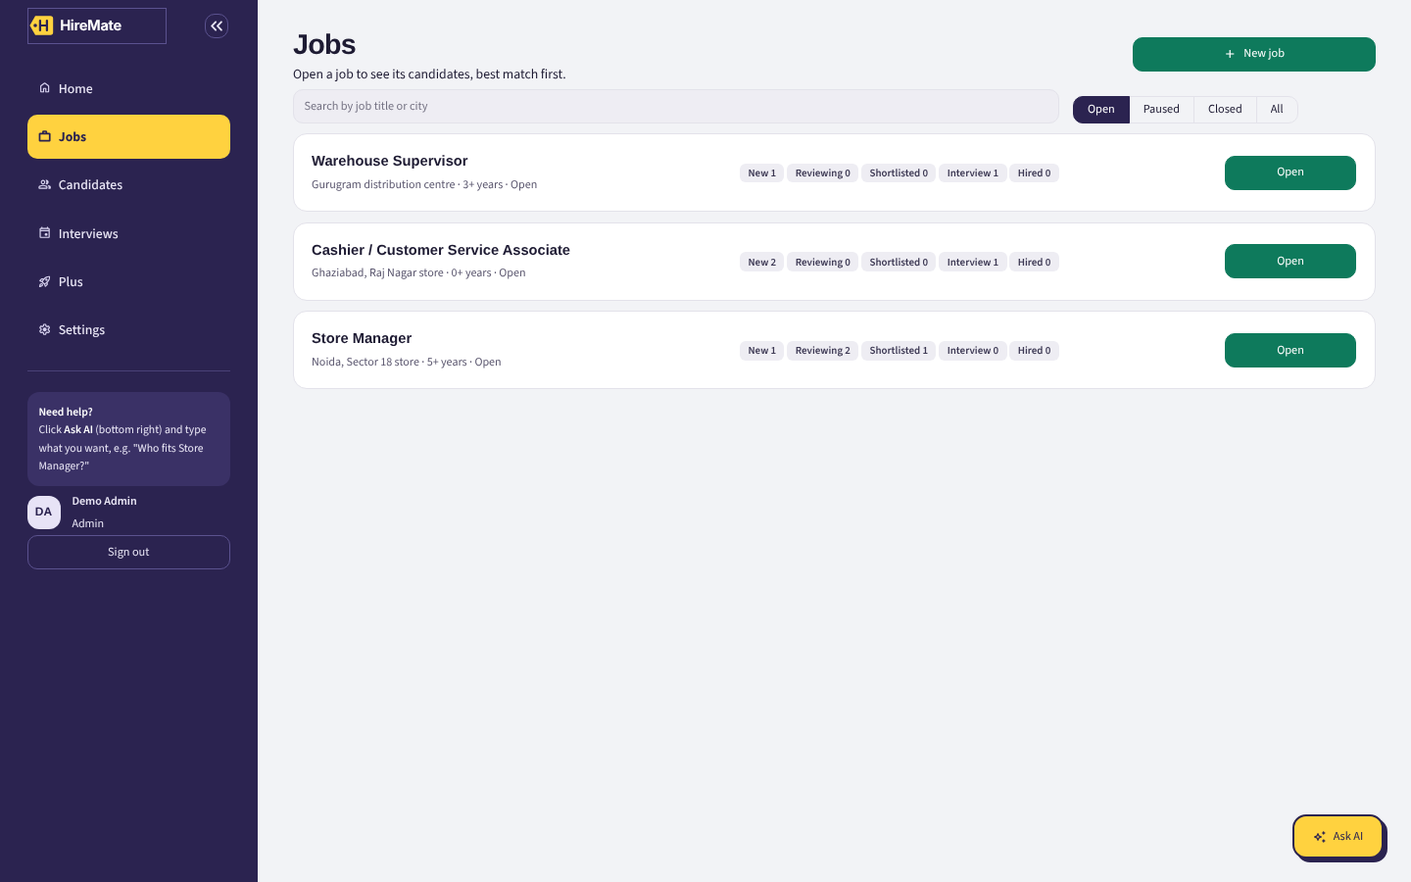
Jobs list

3.3 One job (click Open on a job)
- Pipeline: people in columns by stage. Move shifts a person to another stage.
- Ranked: everyone sorted by match %, with Skills, Text and Experience parts, missing must-haves and a shortlist chance. Tick rows to compare, move in bulk, or reject + draft emails.
- Requirements: edit must-haves, nice-to-haves and years. Save re-ranks everyone at once.
- From talent pool: people already in the system who fit this job but haven't applied. Click Add.
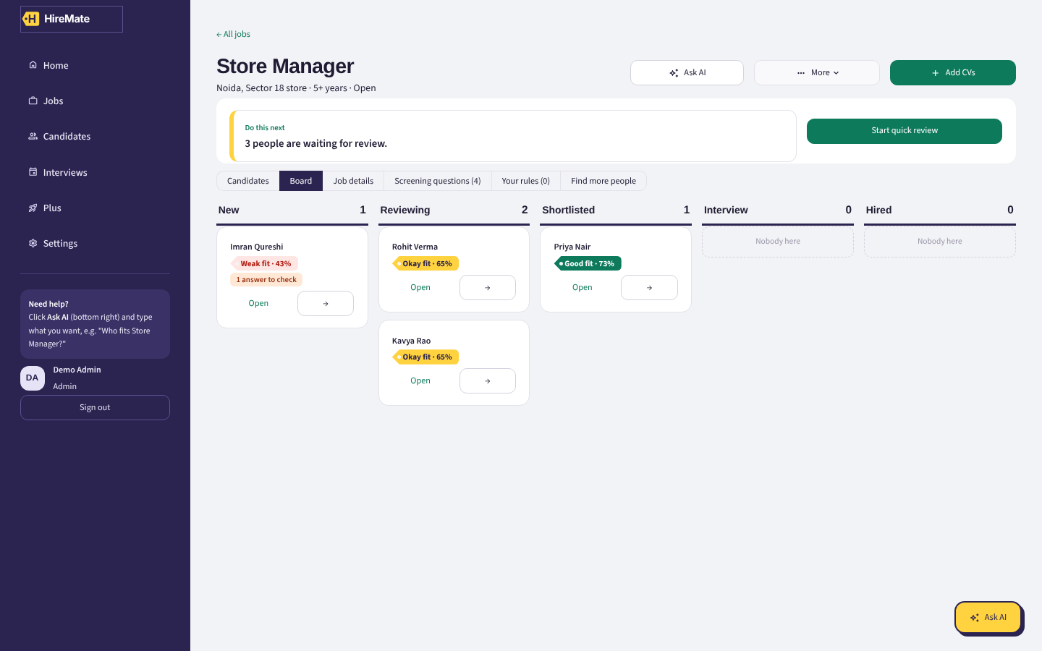
Job → Board
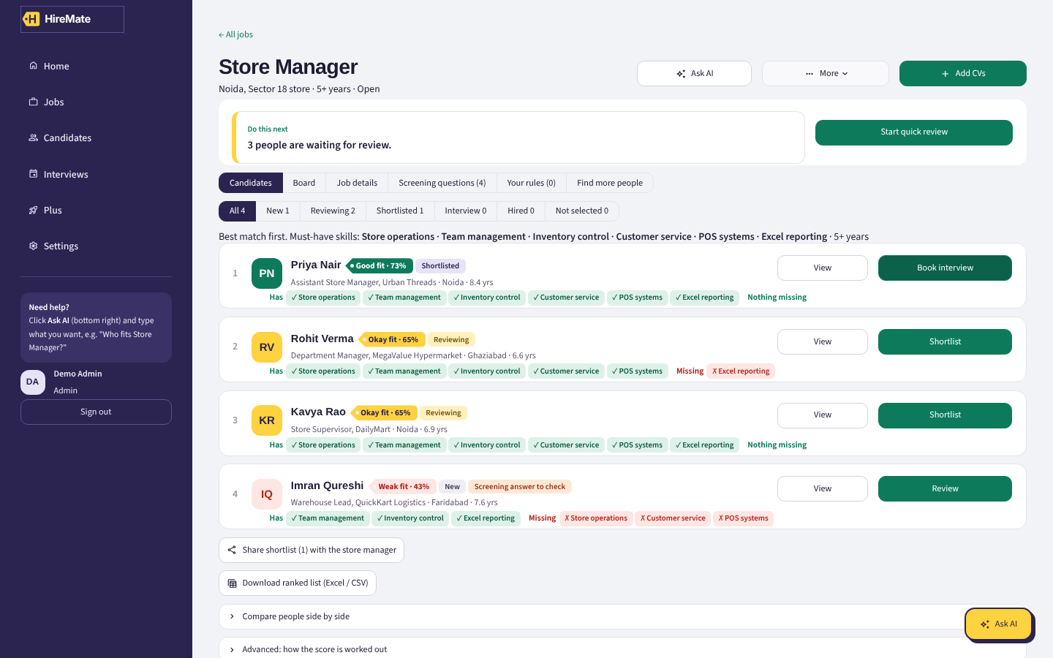
Job → Candidates, best match first, with skills and gaps

3.4 Candidates
- Everyone in the talent pool. Search any word in the CV, filter by skill, city, job, stage, years, education.
- Add candidates: upload many CVs at once (PDF, Word, text). It shows what it read and warns about duplicates (Skip / Add anyway / Use existing profile).
- Click a row to open the profile.
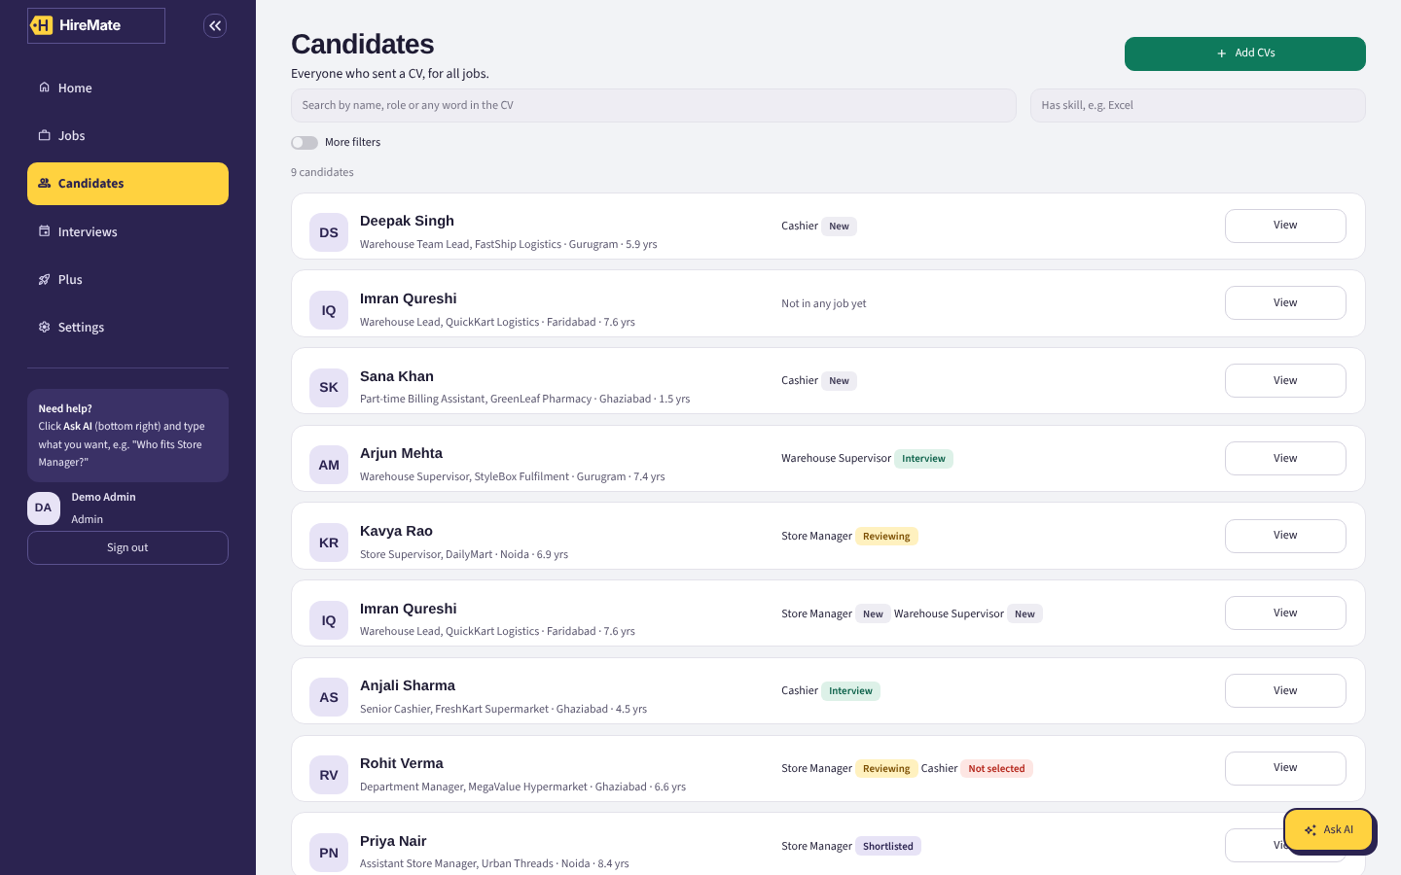
Candidates

3.5 Candidate profile
- Profile: resume on the left with proof lines highlighted. On the right: match %, skill chips, what would raise the score, AI summary, similar people.
- Skill colours: green = proven by a real CV sentence, gold = only listed in the skills line (counts half), dashed = missing. ★ = must-have.
- Interview: schedule, generate questions (technical, HR, verification of CV claims, gap questions), assessment task, scorecard and feedback, AI feedback summary.
- Emails: draft invite / reminder / follow-up / assessment / selection / rejection in English or Hindi. Edit, then Approve. Nothing is sent by the app.
- Notes & activity: team notes and a full history of every change.
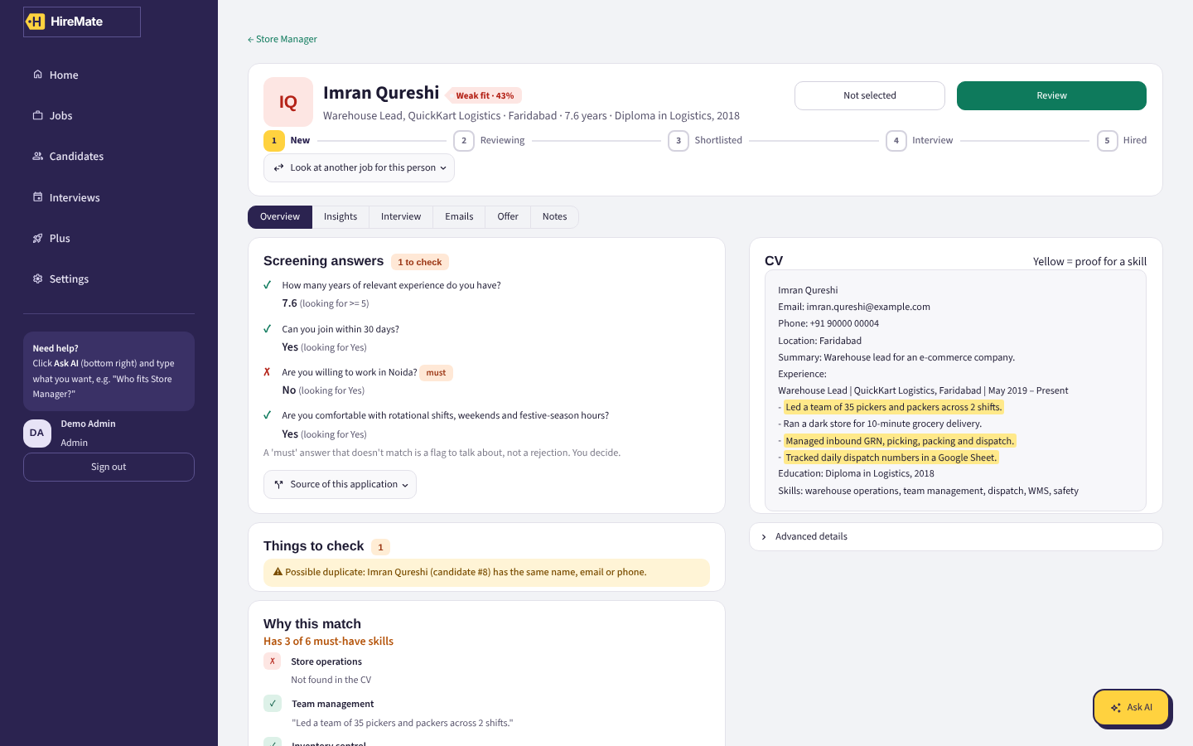
Candidate profile
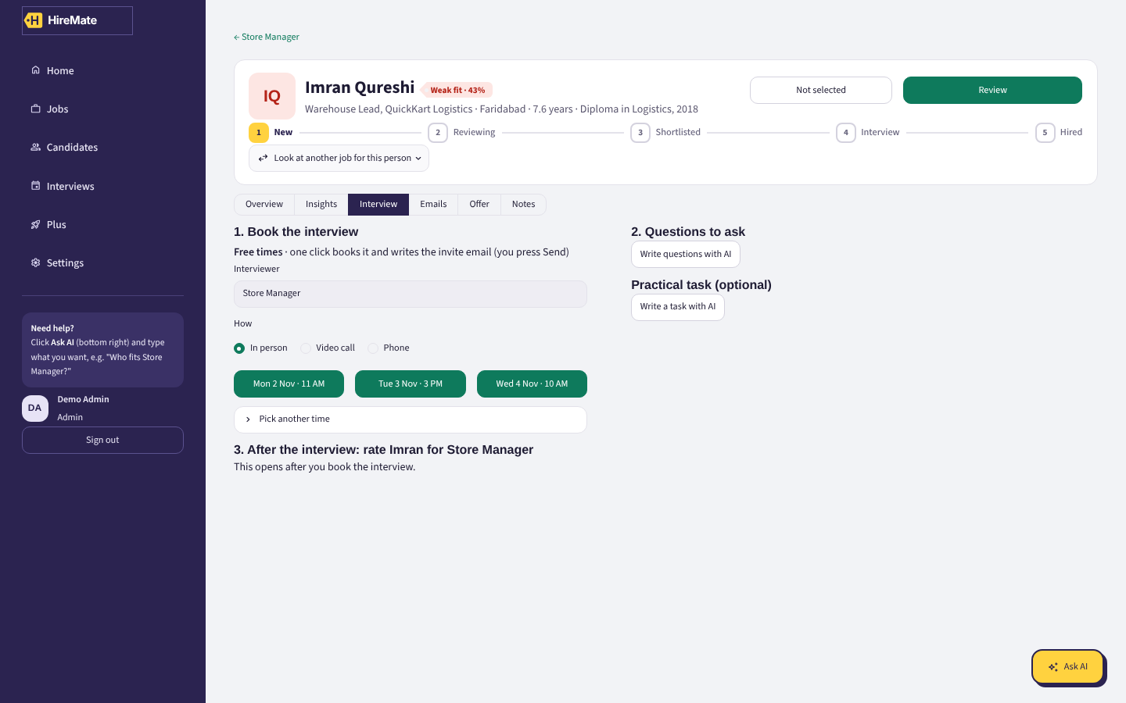
Candidate → Interview

3.6 Screening & Matching
- Pick a job. See every applicant (or the whole talent pool) with skill chips and the first tip. Tick 2–3 people → Compare.

3.7 Interviews
- Upcoming and past interviews. Past ones show Feedback due until feedback is added.

3.8 Knowledge
- Every JD, CV, policy and FAQ in one place. Upload (auto-sorted), create, edit, download as Word, delete.
- Ask the knowledge store: answers only from these documents, with numbered sources.
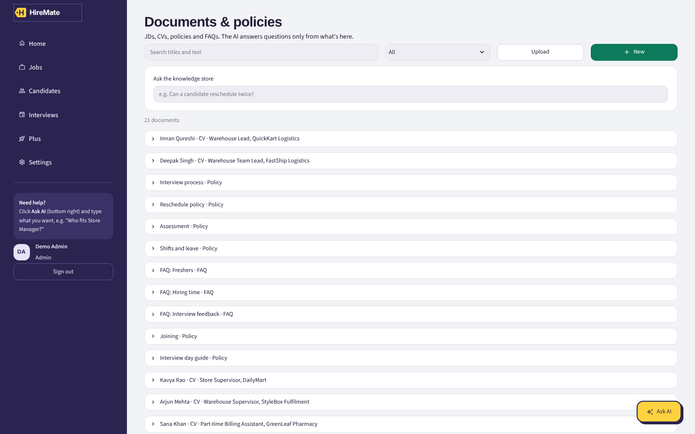
Documents & policies

3.9 Analytics
- Funnel, applications by job, average match, most-missing skills, talent groups (K-Means map).
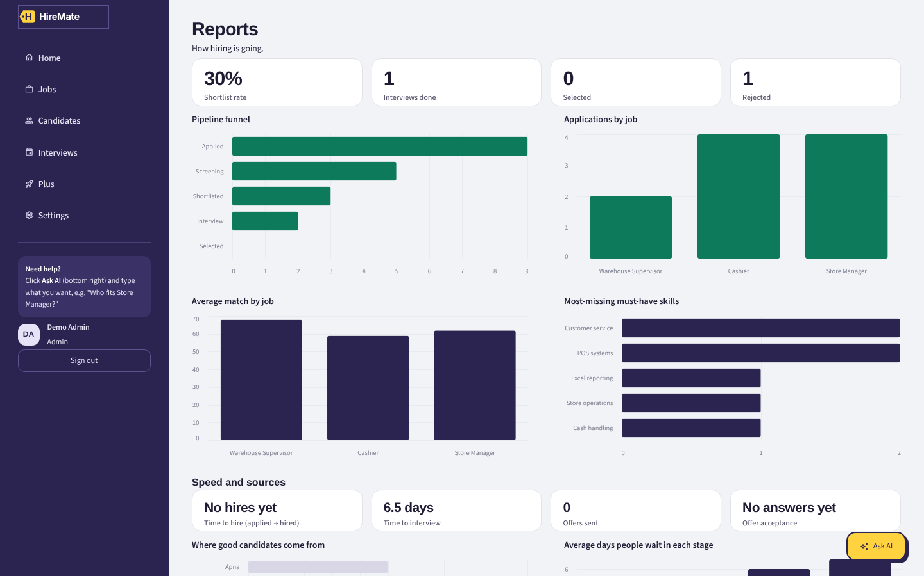
Reports

3.10 Screening rules (your own criteria)
Add your own shortlisting rules in plain English, for one job (Job → Criteria tab) or for every job (Settings → Screening rules for all jobs). You can also just tell Ask AI.
Type | What it does | Example
Must have | People who miss it are flagged and listed last. Never auto-rejected. | Must live in Delhi NCR
Bonus | Adds points to the match score when met | Prefer Hindi speakers +5 points
Penalty | Takes points away when met | Avoid less than 1 years +5 points
- HireMate reads your sentence and shows how it will check it: skill in the CV, city, years, education level, a word in the CV, or anything else (the AI reads the CV and must quote the line; without AI it does a keyword check).
- You can change the type, check, value and points before saving. Switch a rule off or delete it any time; scores update at once.
- Where you see the result: Ranked list (Rules column), candidate profile (Your rules ✓ / ✗ with the CV line), Ask AI ("Who doesn't meet the criteria for Store Manager?").
- Guidelines for the AI (Settings): plain instructions the AI follows in summaries, questions, emails and answers, e.g. "Always mention the store address in interview emails".
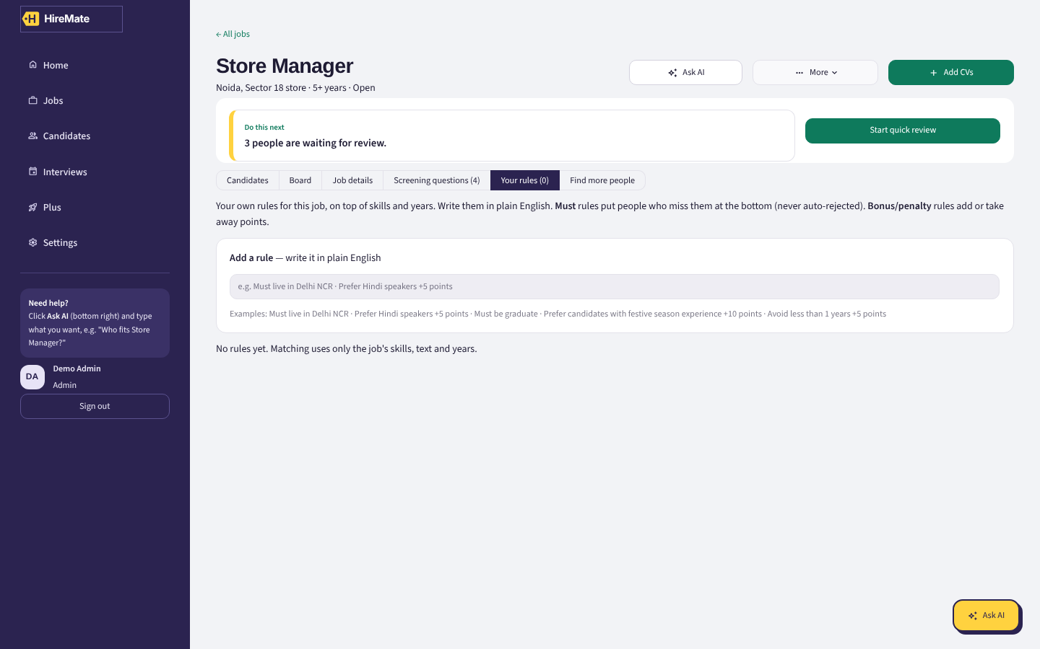
Job → Your rules

3.11 Settings
- AI model (free/paid), match score weights, blind review (hides names), team and roles, demo reset, how matching works, recent activity.

4. The Ask AI button
Click the round Ask AI button at the bottom right of any page. A chat window opens on top of the page. Close it with ✕ or Esc. Your chat is kept when you reopen it.
- It reads all of HireMate: every job, candidate, skill, gap, stage, interview, email, note and document. It does not matter which page you are on.
- If you open it on a job or candidate page, "this job" / "this candidate" means the one on screen.
- Attach files with + in the message box: a JD, one or more CVs, or a policy.
- It asks before creating, deleting, rejecting or approving. Reply "yes" or click the button.
- Under each answer you get next-step buttons. Click one instead of typing.
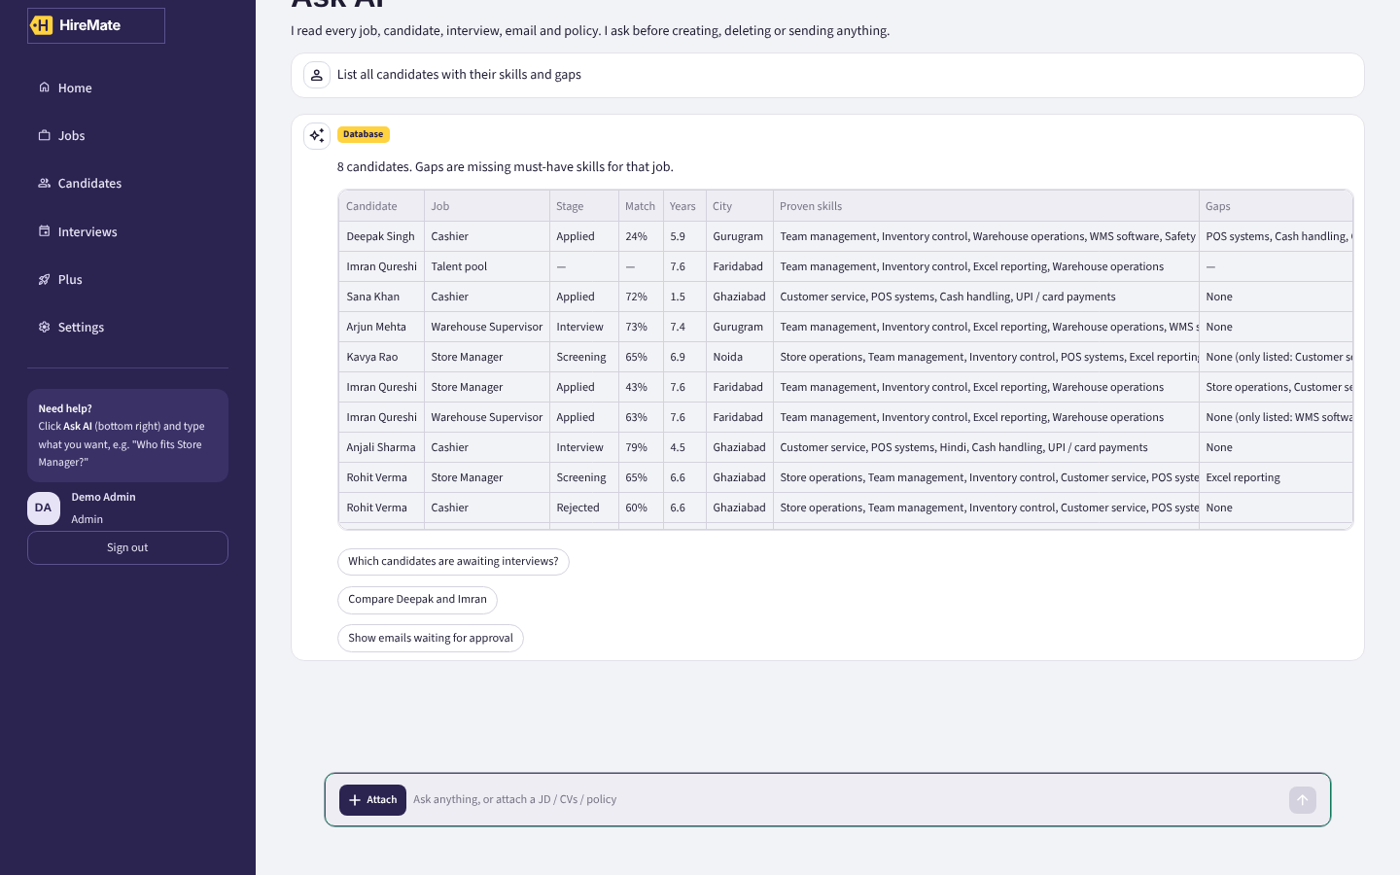
"List all candidates with their skills and gaps" — asked from the Dashboard
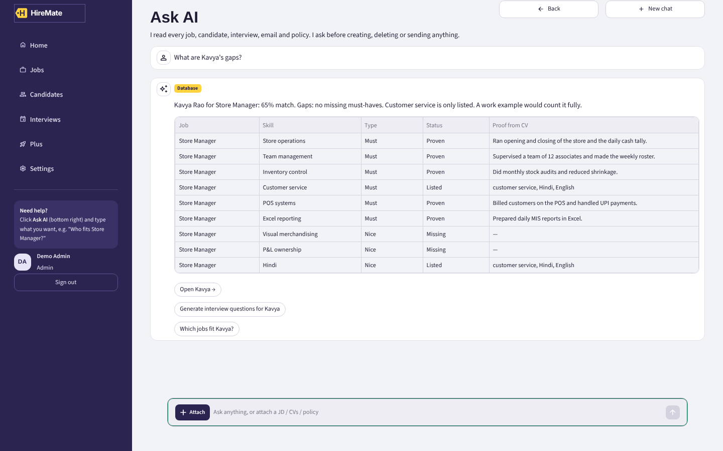
"What are Kavya's gaps?" — skill-by-skill with proof from the CV

Things to ask (copy and paste)
Area | Try this | What you should get
Everyone | List all candidates with their skills and gaps | Table: job, stage, match, years, city, proven skills, gaps
Filters | List all candidates in Noida with more than 5 years | Filtered table
One person | What are Kavya's gaps? | Each skill: proven / listed / missing + the CV line
One person | Tell me about Priya | Summary with match %
Fit | Which jobs fit Arjun? | All jobs with match % for him
Ranking | Who matches Store Manager? | Ranked table + talent-pool suggestions
Compare | Compare Priya and Rohit | Side-by-side table
Skills | Candidates with WMS | Everyone who has that skill + proof level
Pipeline | Which candidates are awaiting interviews? | Interview list incl. people with no slot yet
Pipeline | Who is waiting for screening? | Applied / Screening list
Emails | Show emails waiting for approval | Draft emails list
Policy | Can a candidate reschedule twice? | Answer + [1] source
Action | Shortlist Kavya for Store Manager | Moves her, suggests next step
Action | Schedule an interview for Kavya on Tuesday at 3pm | Booked + date shown
Action | Draft an invitation for Kavya → approve | Email card, then approved + logged
Action | Reject Imran for Store Manager | Asks you first. Reply yes
JD | Write a JD for a visual merchandiser in Noida with 2+ years | Draft + Download .docx; then "ok, create the job"
Files | Attach a JD → Who matches this JD? | Ranking; then "Yes, create the job"
Files | Attach a CV → Add to Store Manager | Candidate created and added
Knowledge | Add a policy: Notice period is 30 days for store staff | Saved to Knowledge
Knowledge | Delete the hiring time FAQ | Asks first, then deletes
Rules | Add rule for Store Manager: must live in Noida | Rule saved + how it is checked
Rules | Add rule for all jobs: prefer Hindi speakers +5 points | Rule for every job
Rules | Who doesn't meet the criteria for Store Manager? | Table: meets / misses each rule
Rules | Show the criteria for all jobs · Remove rule 2 | List; remove asks first
Rules | Add guideline: keep emails under 120 words | AI follows it from now on
Open AI (needs key) | Who has the most experience among applicants for Cashier? | Free-form answer from all the data
With the free key on, any question that isn't in the list above is answered by the AI from the full database plus documents (badge: Database + Documents). Without a key, you get the closest matching document and a note to switch the AI on.

5. Test checklist
Tick each line as you test. The five assignment requirements are R1–R5.
# | Req. | Do this | You should see | ✓
1 | R1 | Jobs → Create job → paste a JD with "young girls" | JD check shows 2 red flags
2 | R1 | Jobs → Create job → Upload JD (PDF/Word) | Title, must-haves, years filled in
3 | R1 | Candidates → Add candidates → 2 CVs | Preview of each, then added
4 | R1 | Upload the same CV again | Duplicate warning
5 | R2 | Open Store Manager → Ranked | Priya on top, score parts shown
6 | R2 | Requirements → remove a must-have → Save | Ranking changes
7 | R2 | Tick 2 people → Compare | Side-by-side window
8 | R2 | Settings → change weights → Save | Scores change on every job
9 | R3 | Profile → Write summary | 4 points with sources
10 | R3 | Profile → Interview → Generate questions | Technical, HR, Verification, Gap questions
11 | R3 | Scorecard + feedback → Summarize feedback | Strengths / Concerns / Recommendation
12 | R4 | Profile → Emails → Hindi selection email | Draft in Hindi
13 | R4 | Approve an email | "Sent by Demo Admin" + activity log
14 | R5 | Ask AI: List all candidates with skills and gaps | Full table, from any page
15 | R5 | Ask AI: Can a candidate reschedule twice? | Answer with [1] source
16 | R5 | Ask AI: a question not in the data | "That is not in the data"
17 | All | Ask AI: attach JD → match → create job | New job appears in Jobs
18 | All | Ask AI: write a JD → download .docx | Word file opens
19 | All | Sign in as interviewer → try to move a stage | Not allowed
20 | All | Settings → Blind review on | Names hidden in lists
21 | R2 | Job → Criteria → "Must live in Noida" | Ranked: non-Noida people flagged, listed last
22 | R2 | Add "Prefer festive season experience +10 points" | Priya's score goes up, CV line shown
23 | R5 | Ask AI: Who doesn't meet the criteria for Store Manager? | Table per candidate

6. Rules HireMate always follows
- Scores are worked out by code, not by the AI. The AI only explains and writes.
- Match = Skills (must-haves count double; proven 1, listed ½) + Text match + Experience. Default 50 / 30 / 20.
- The AI never rejects anyone. Rejecting needs your yes.
- Every email is a draft until a recruiter approves it. The app does not send emails.
- Employment gaps are never scored. JDs are checked for biased words. Blind review hides names.
- Keys stay on the server. The browser only sees the last 4 characters.
- All data is synthetic.

7. If something goes wrong
Problem | Fix
"Can't reach the HireMate server" | The server window was closed. Run run.bat / run_mac.command again.
Page doesn't open | Type http://localhost:8501 in the browser. Wait 20 seconds after starting.
"Python is not installed" | Install Python 3.11+ and tick Add to PATH (Windows).
Port already in use | HireMate is already running. Use the open tab, or restart the computer.
PDF says no readable text | It's a scanned image. Paste the text instead.
AI answers look like templates | Add the free key in Settings → AI model, then Test connection.
Messed up the data while testing | Settings → Reset to the sample data.

8. Share a link with the reviewer
localhost works only on your computer. To give the reviewer a link, put HireMate on Hugging Face Spaces (free):
- Create a free account at huggingface.co → New Space → SDK: Docker.
- Upload the HireMate folder (the README already has the settings).
- Space → Settings → Variables and secrets → add JWT_SECRET (any long random text) as a secret.
- Wait for the build. Your link looks like https://huggingface.co/spaces/<your-name>/hiremate.
- Open it once, sign in as Admin, add the free Gemini key in Settings. Then share the link.
Free Spaces sleep when not used and reset data on restart. Open the link a minute before the review.

