# Case Study : Pixogram

Spring boot : Microservices for pixogram

1. service-registry
2. cloud-config-server
3. cloud-gateway
4. hystrix-dashboard
5. media-service
6. user-service

Angular 8 : pixogram ui

1. pixogram-ui

Database : MySql

## Screens

### Eureka Server

### Home page

http://localhost:4200/home

### Login page

#### Login with invalid credentials

### Sign up page

#### Sign up with existing email address

### My Profile

### Dashboard

### My Media Files

### Media upload Feature

## MySQL Database

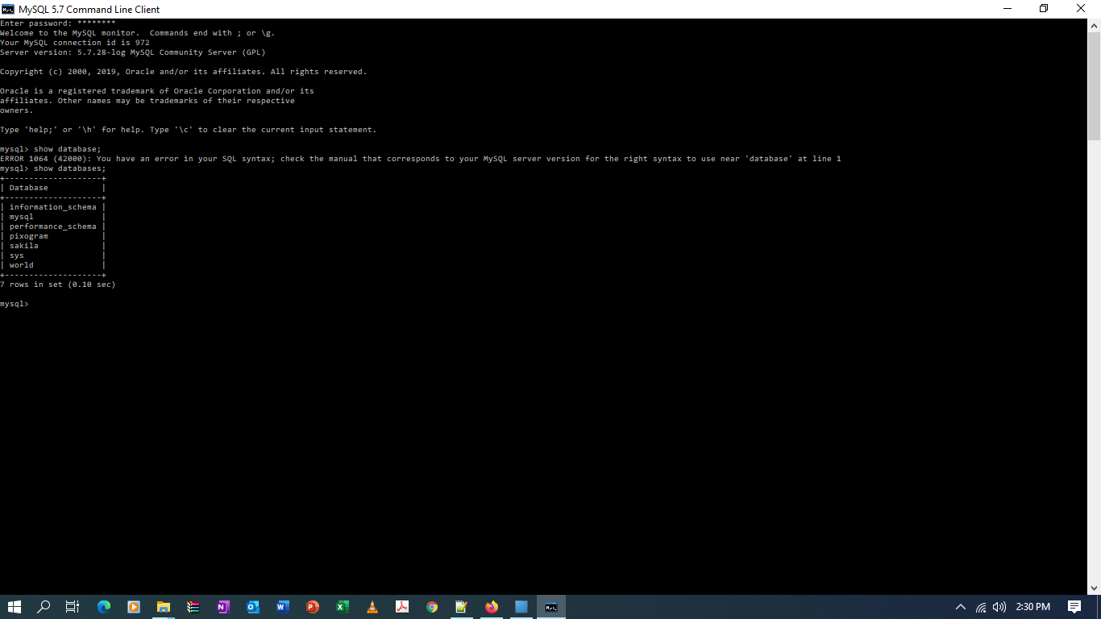 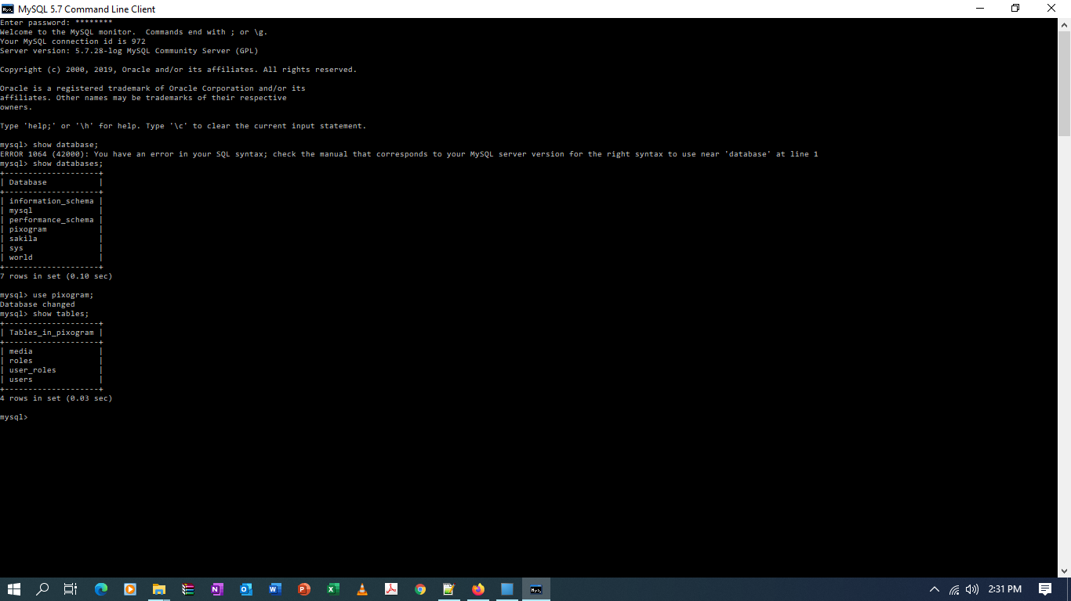

### Tables

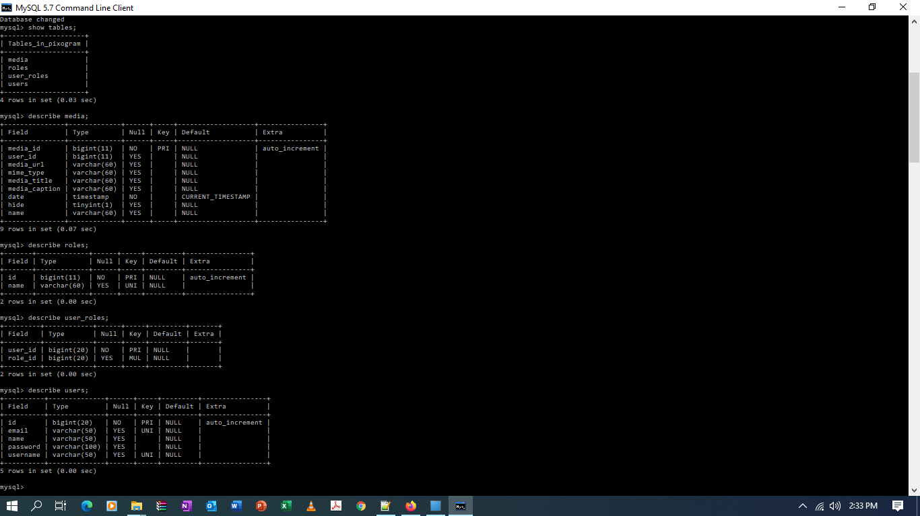

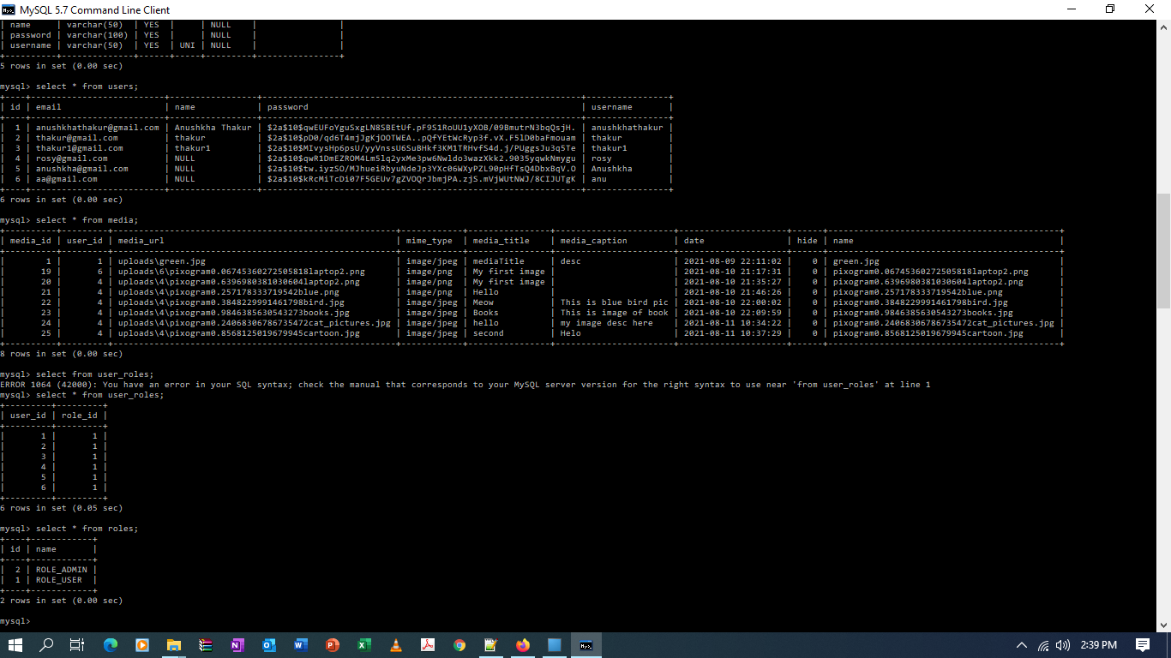

## Postman

### Sign in Rest API

http://localhost:9002/users/signin

#### With Valid Credentials

#### Invalid Credentials

### SignUp Rest API

<http://localhost:9002/users/signup>

#### creating new user with unique email id

#### Creating new user with same email id

## Single Media Upload API

http://localhost:9001/producer/media/singleFileUpload/

## Mutiple file upload API

## To fetch user media files details

http://localhost:9001/producer/media/userfiles/2

# Docker

### Deployment of Eureka Server (service-registry)

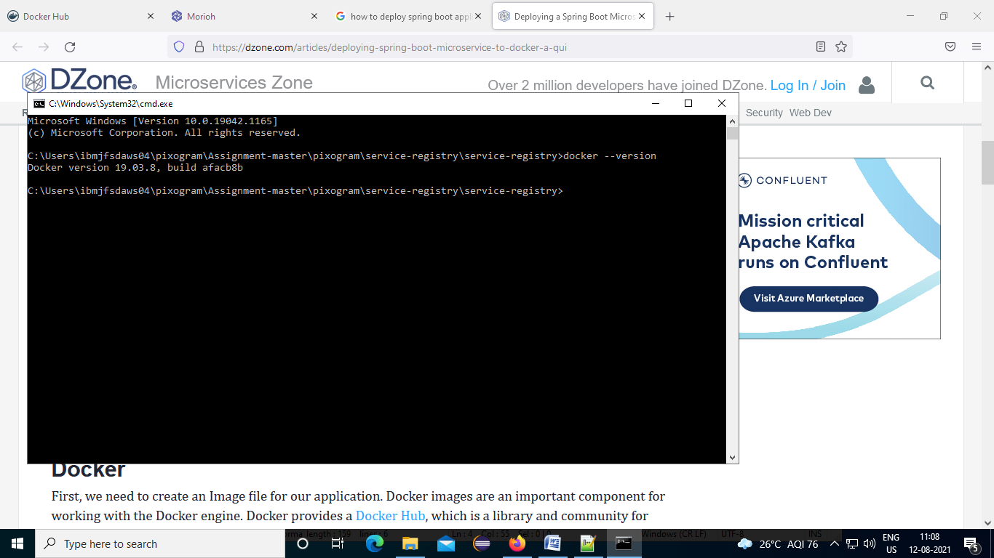

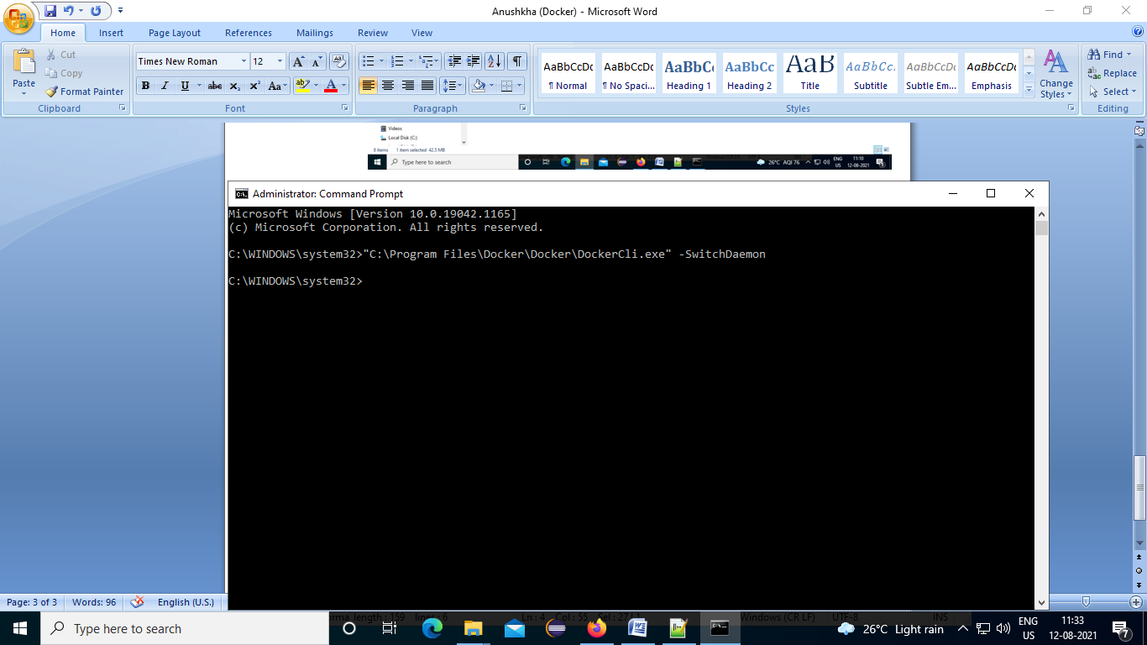

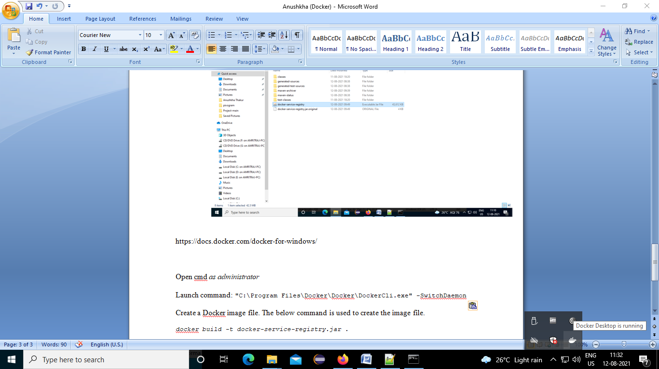

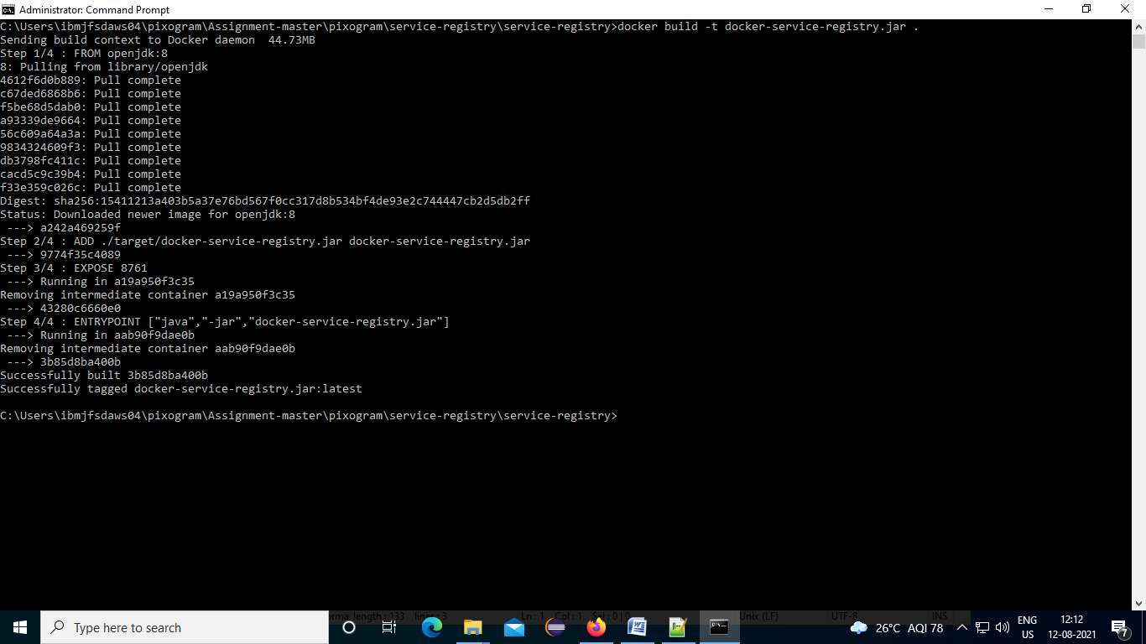

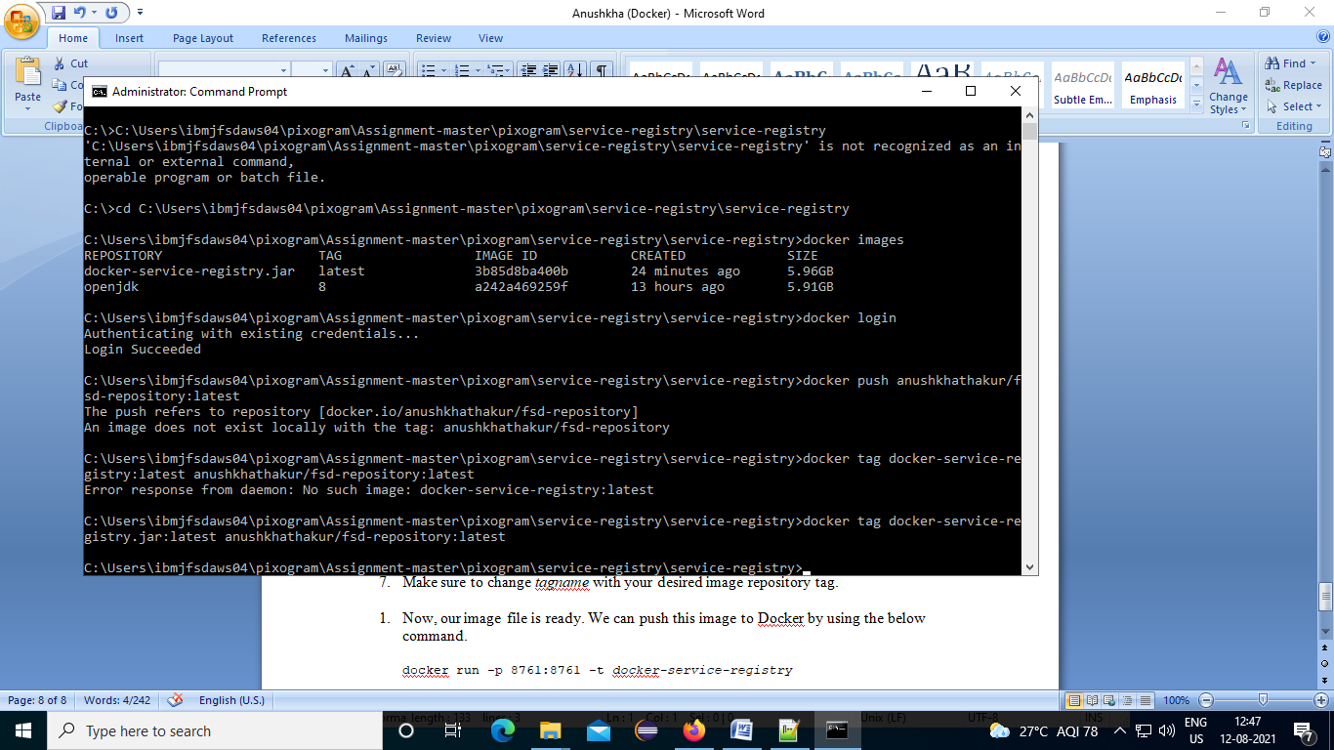

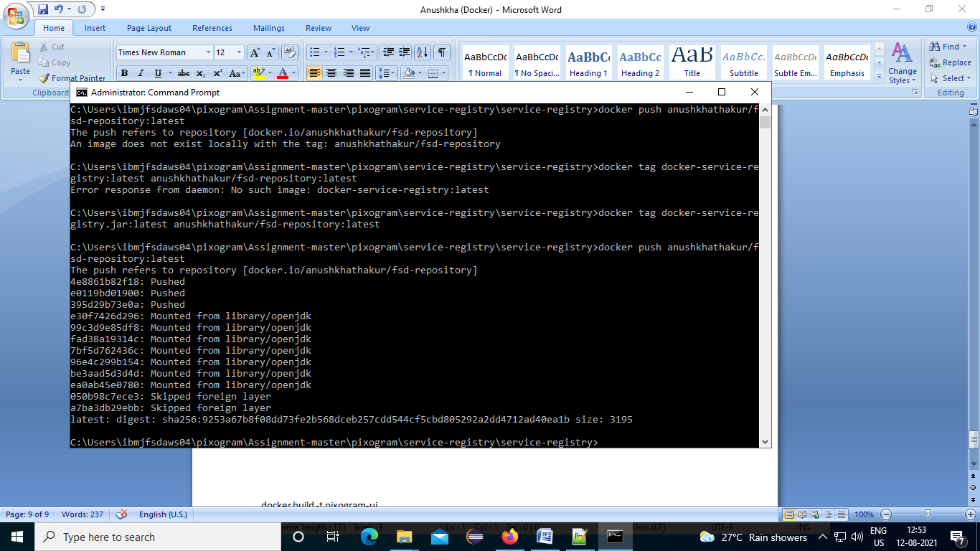

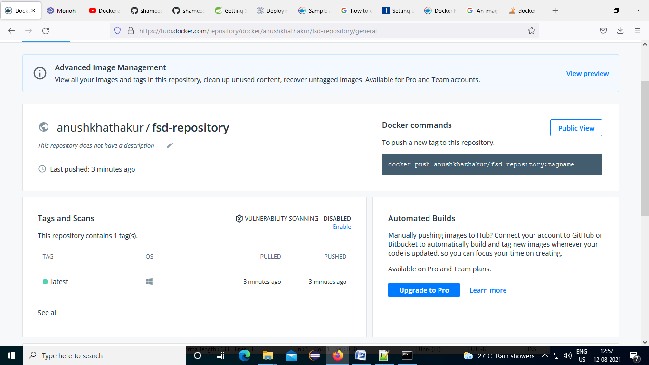

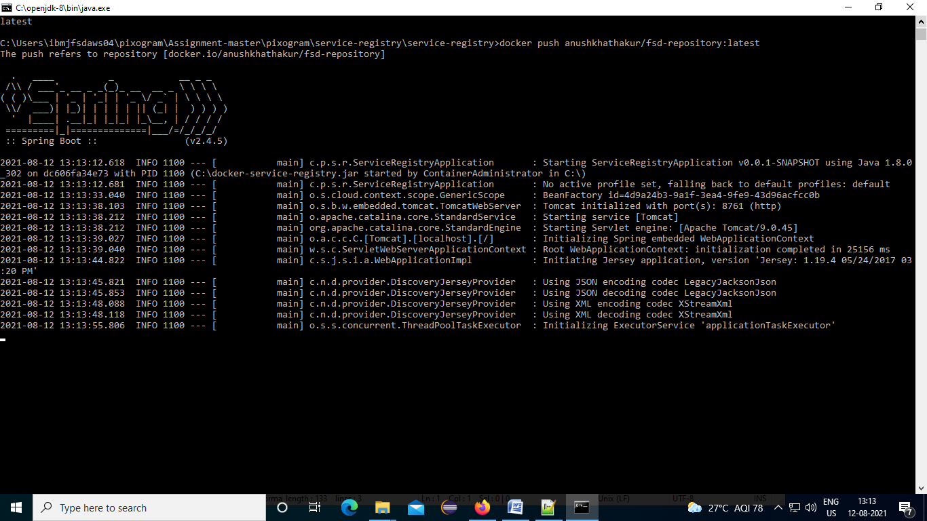

#### Eureka server (service-registry)

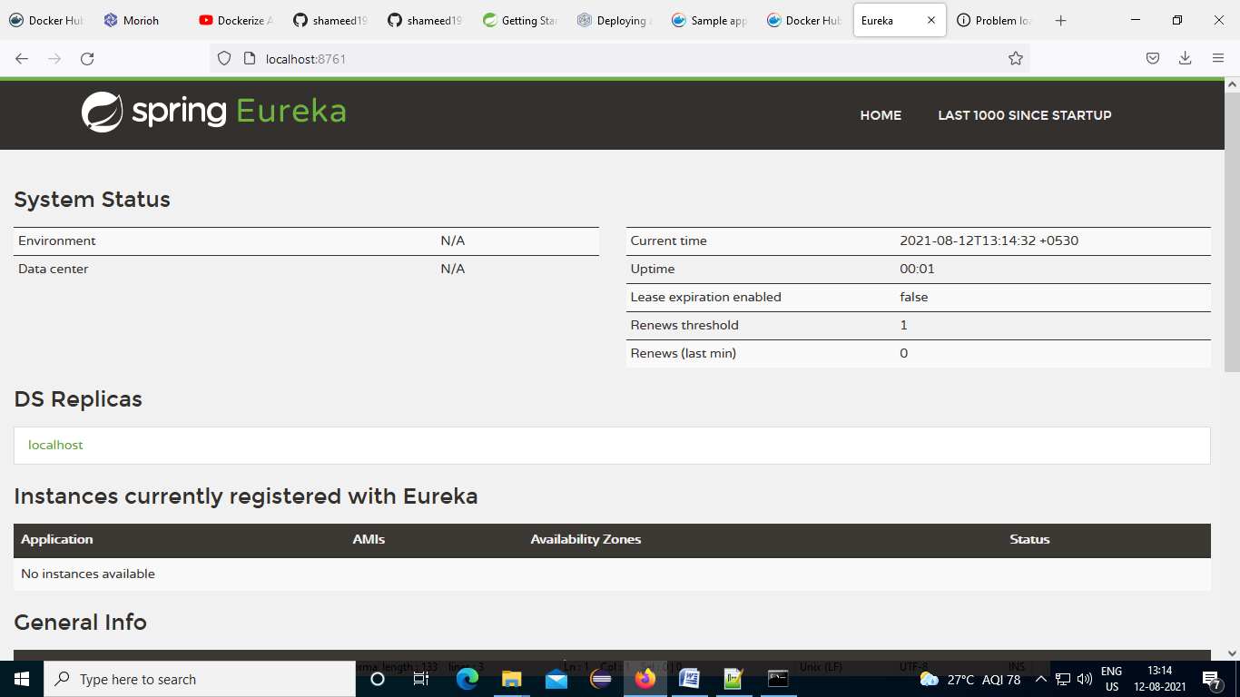

#### Docker Dashboard

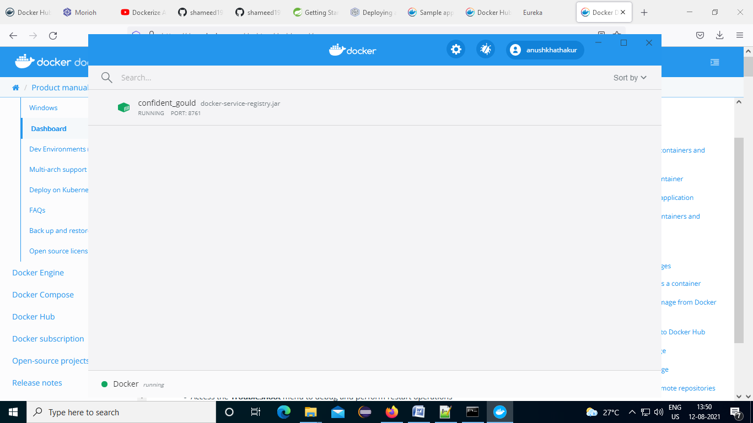

# Jenkins

## Service-registery in jenkins job: freestyle

