# Case Study : Pixogram

Spring boot : Microservices for pixogram

1. service-registry
2. cloud-config-server
3. cloud-gateway
4. hystrix-dashboard
5. media-service
6. user-service

Angular 8 : pixogram ui

1. pixogram-ui

Database : MySql

## Screens

### Home page

### Login page

### Sign up page

### My Profile

### Dashboard with My Media Files

### Dashboard with Media upload Feature

### MySQL Database

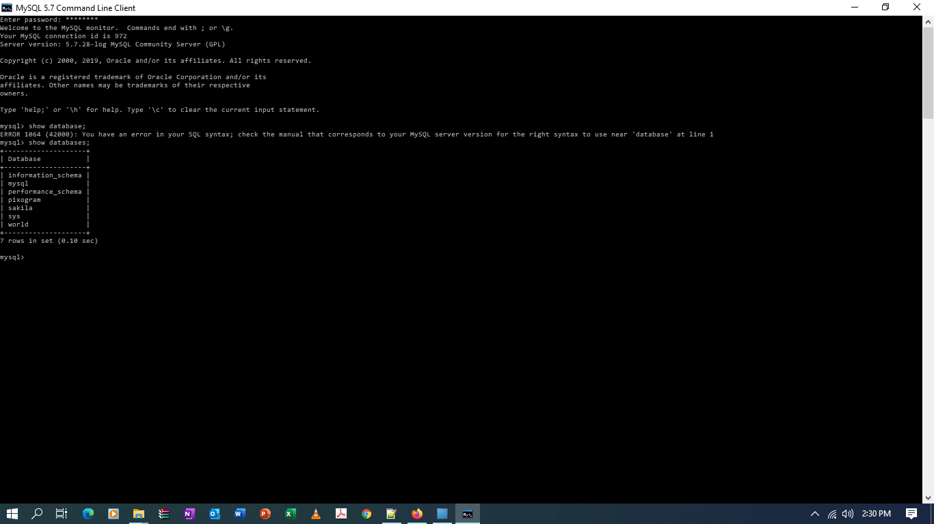 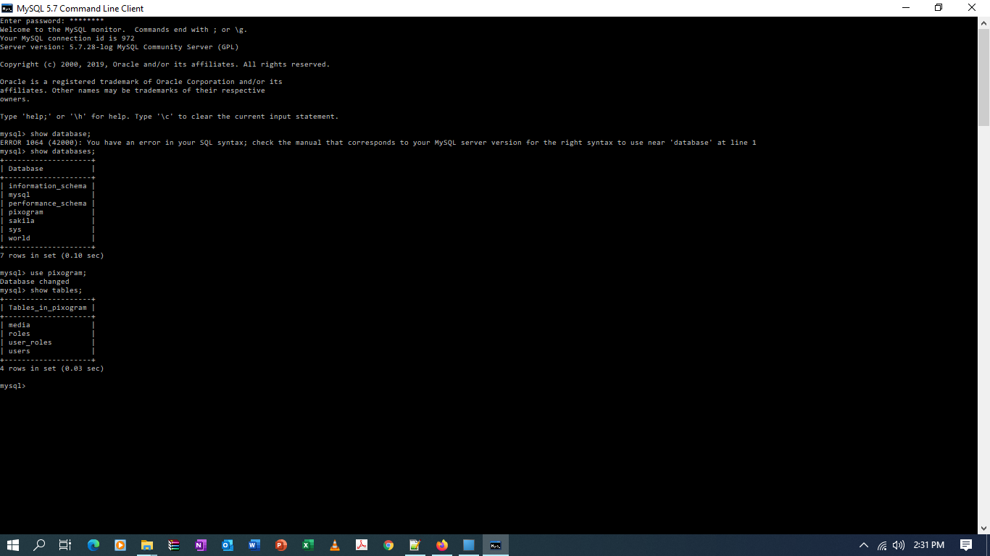

### Tables

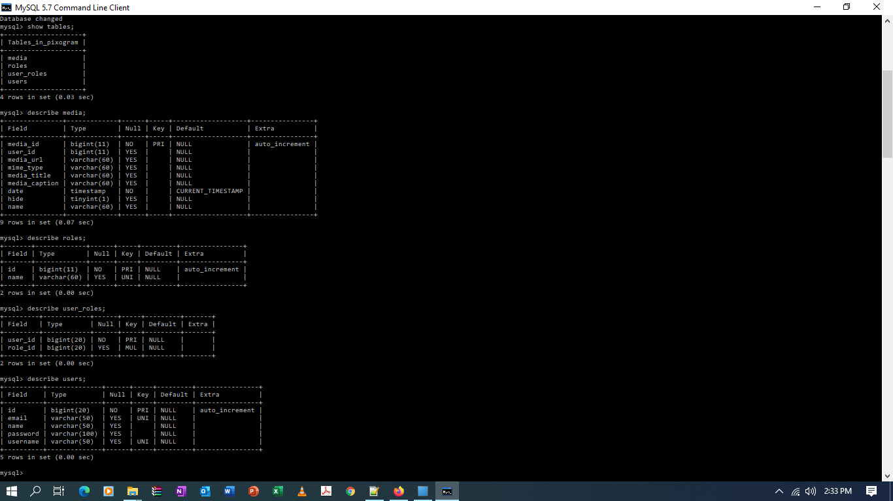

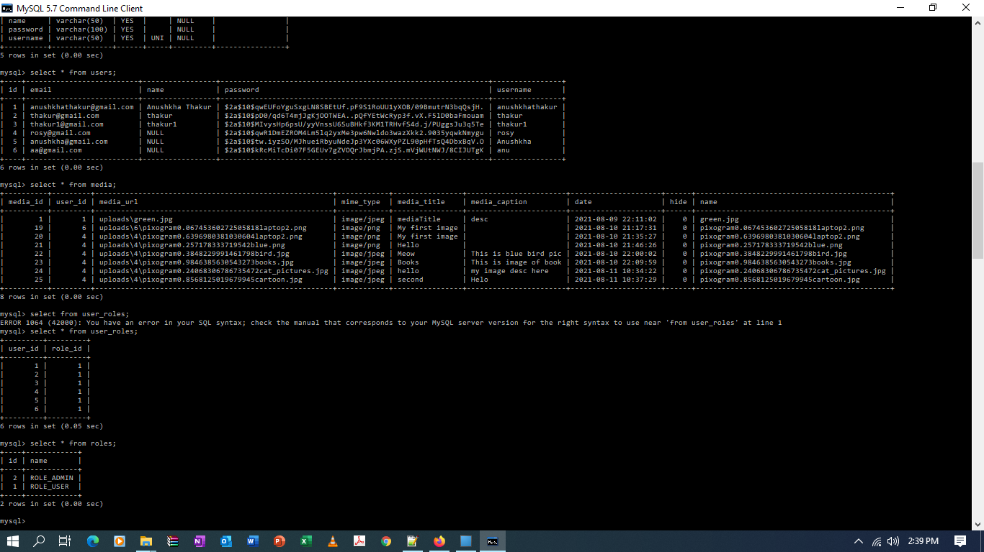

## Postman

### Sign in Rest API

#### With Valid Credentials

#### Invalid Credentials

### SignUp Rest API

<http://localhost:8080/api/auth/signup>

### Single Media Upload API

# Docker

### Deployment of Eureka Server (service-registry)

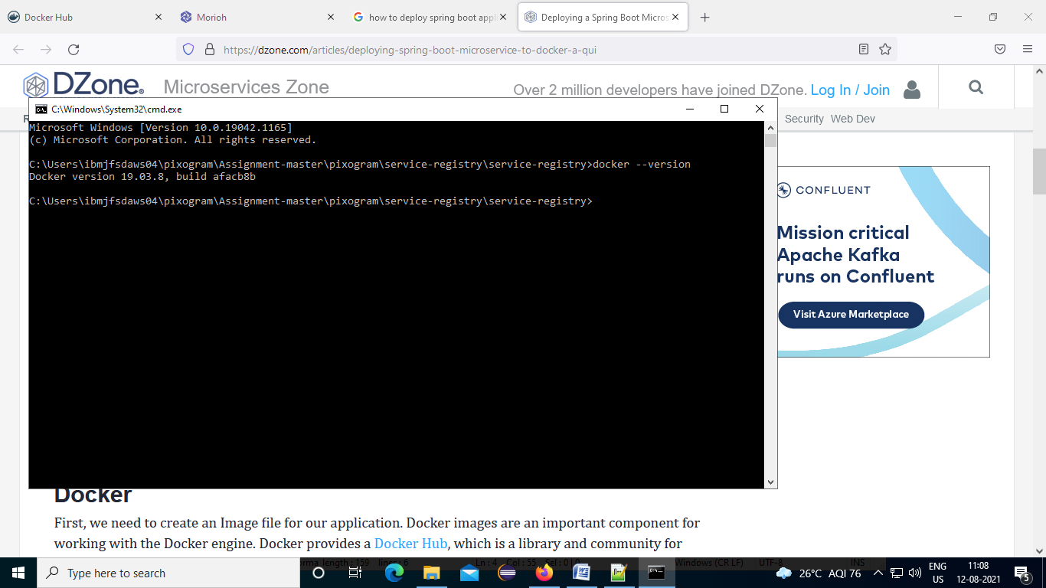

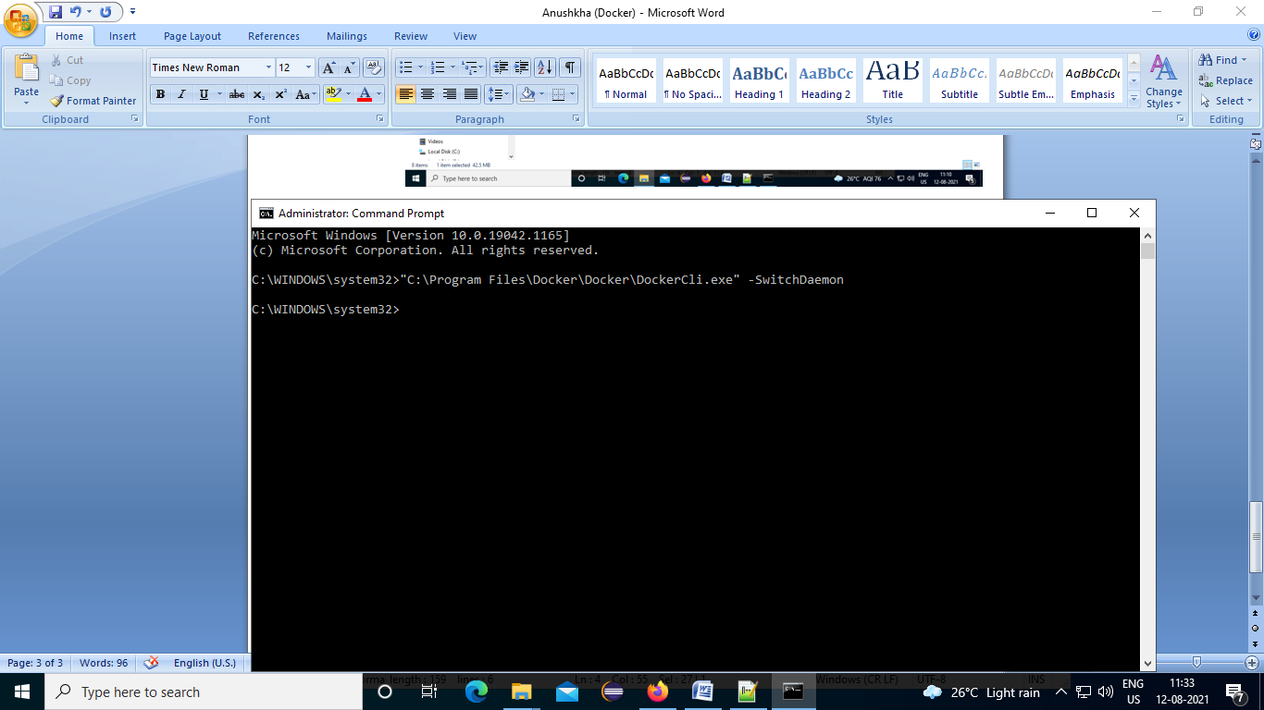

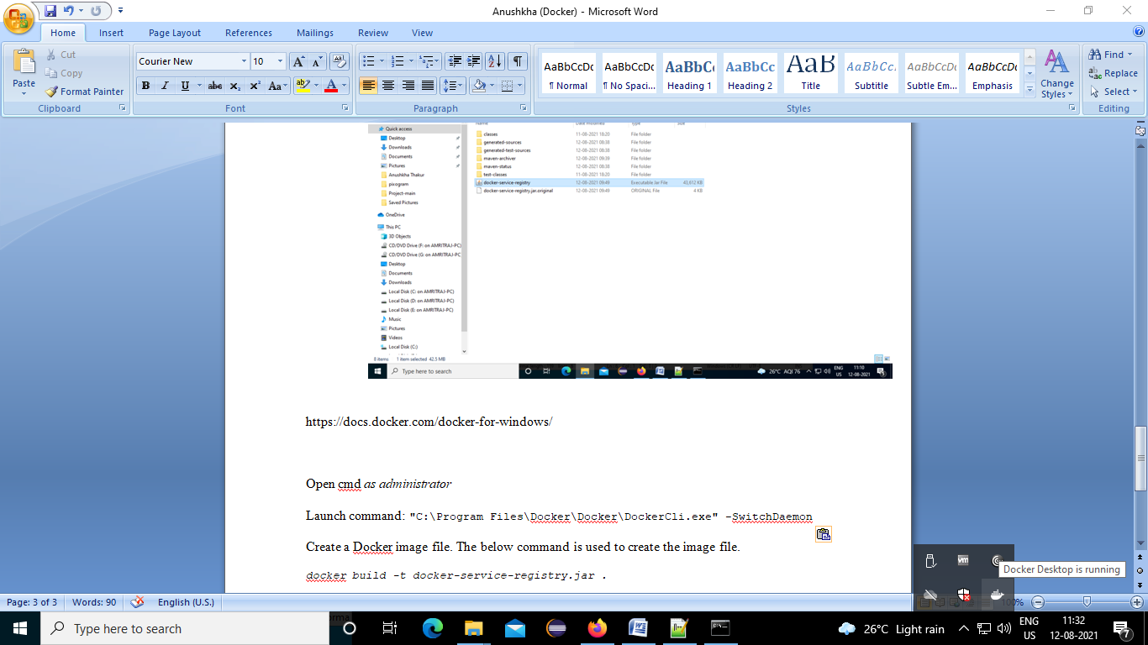

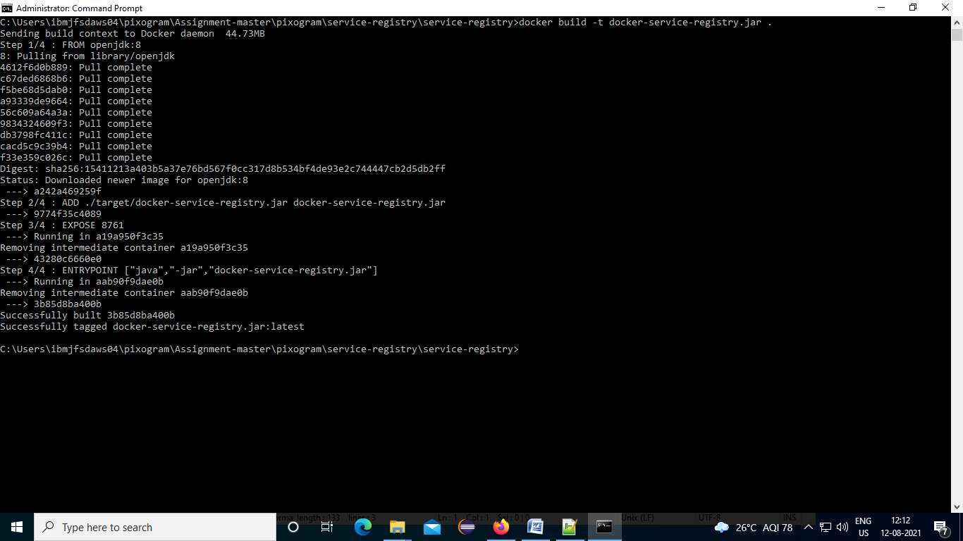

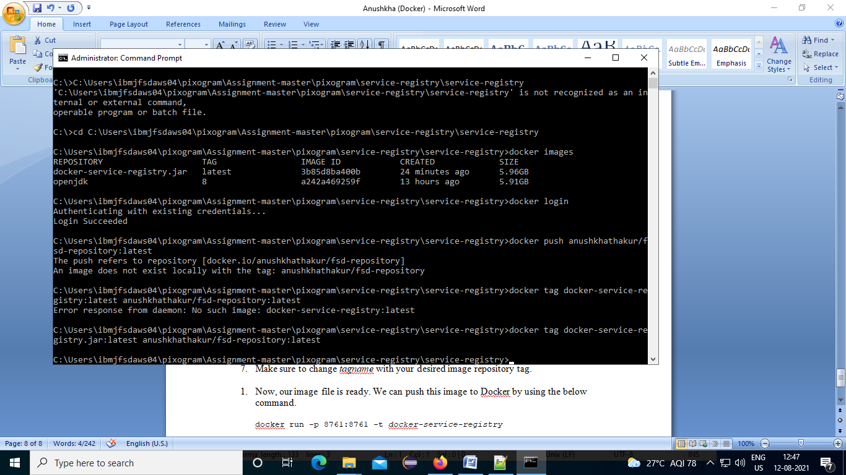

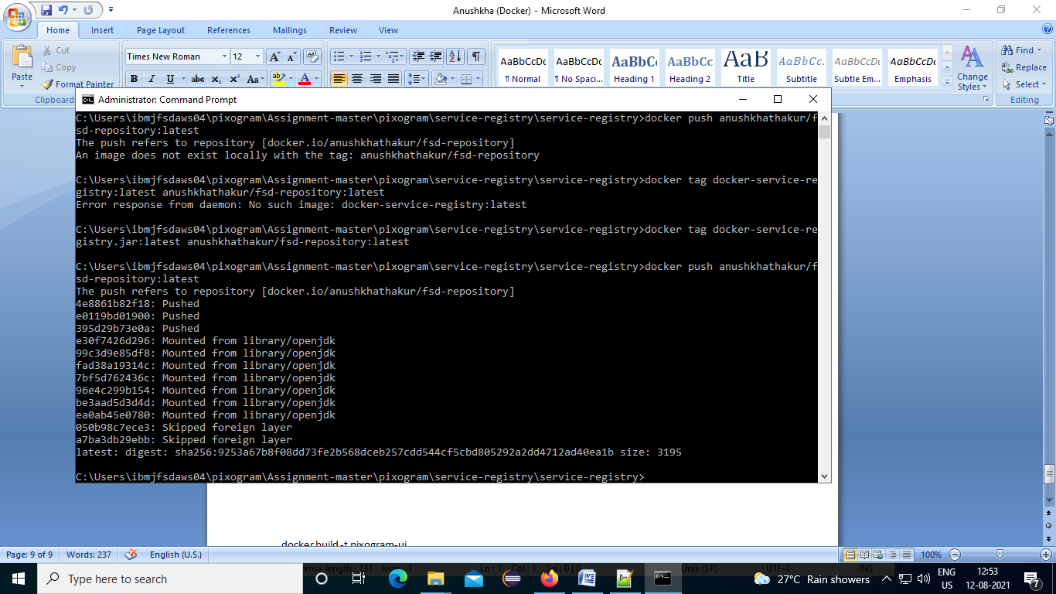

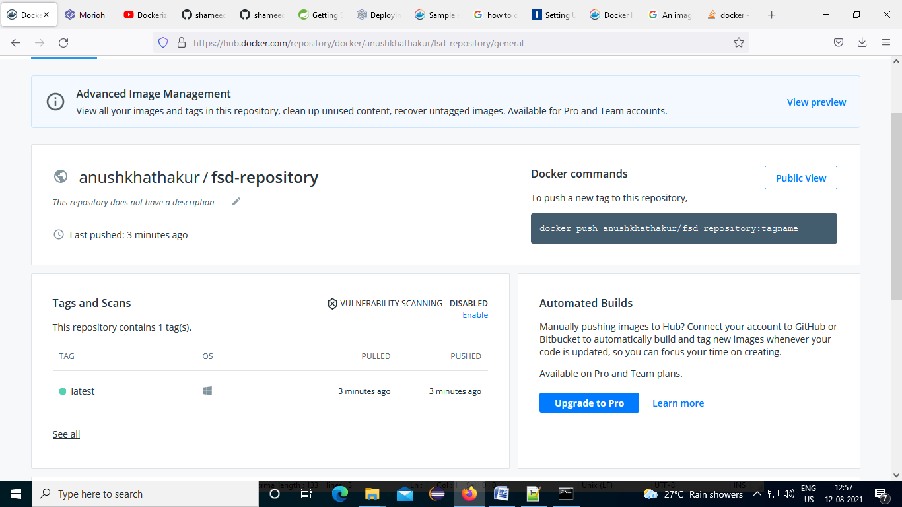

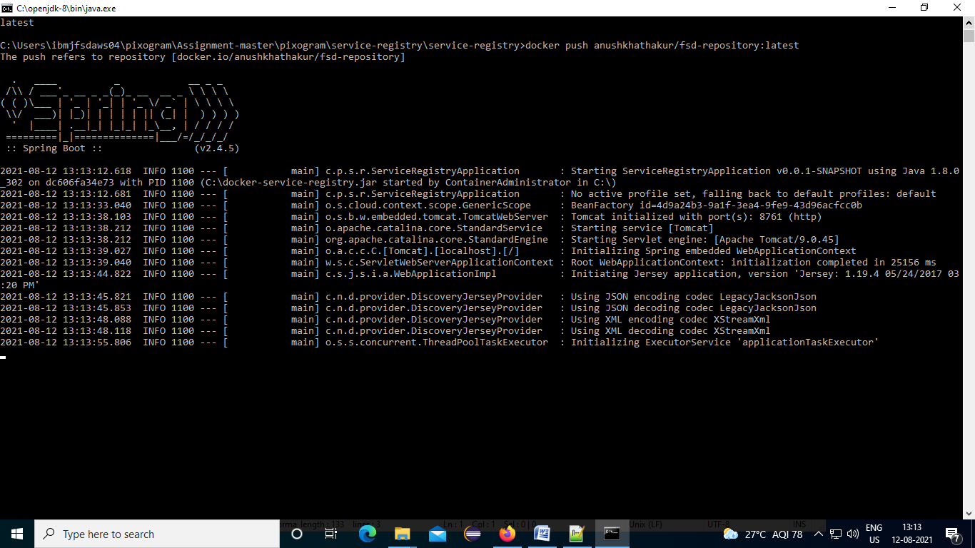

#### Eureka server (service-registry)

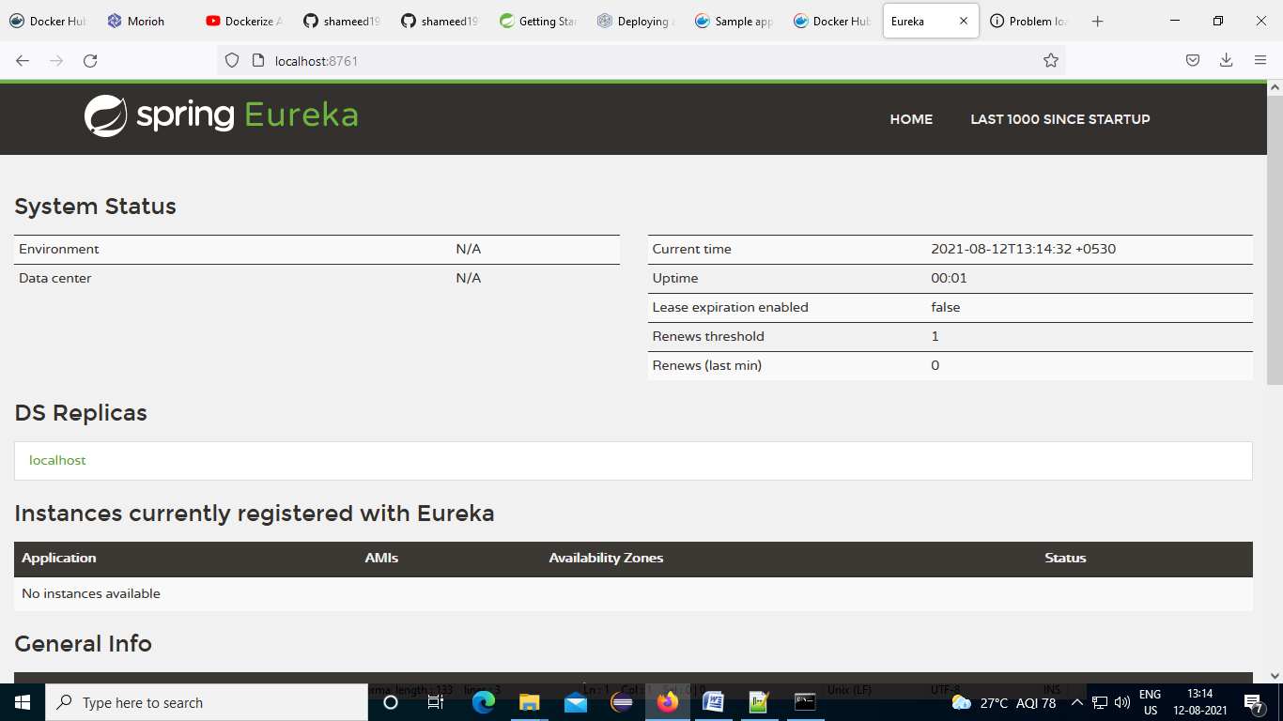

#### Docker Dashboard

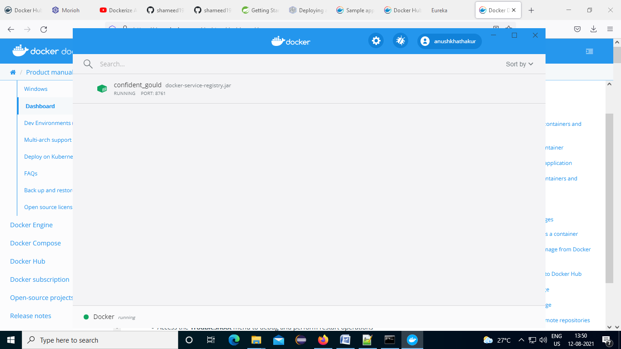

# Jenkins

#### Service-registery in jenkins job: freestyle

