Final Report

Fitness Fox App

**Website Link:** <http://fitnessfox.in/>

# 

# 

# Table of Contents

**Section 2: Fitness Fox Overview** **2**

**Section 3: Website Use & Guidelines** **3**

**Connecting User and Design Personas** **9**

**Section 4: Design Elements** **11**

**Section 5: Improvements Since Prototype** **13**

**Section 6: Database** **13**

**Section 7: Standard HTML/CSS Webform** **15**

**Section 8: Code Sample** **23**

**Section 9: Technologies Used** **24**

**Section 10: Project Outcomes** **24**

# 

# Section 2: Fitness Fox Overview



Meet Fitness Fox! This is the brand representative for our app and icon for the brand personality. Fitness Fox is here to encourage and support your fitness goals.

With an innocent cartoon appearance, Fitness Fox is non intimidating to even the most novice user. Making users feel supported and encouraged to a more mindful, healthy, sustainable lifestyle.

Fitness Fox uses this inherent likability to drive users to complete weekly fitness goals and track consistency over time. Fitness Fox provides a strong brand recognition element that will stick in the users minds. The chosen color scheme for the app relies on a hue of red-orange that is similar to the natural color of a fox. Combing with a slate grey and pop of green for accent buttons creates visual contrast that makes the app stand out. [1]

Fitness Fox is about tracking exercises to maintain or increase the overall health of a user. According to the Dept. of Health and Human Services, general guidelines for adults state:

“For substantial health benefits, adults should do at least 150 minutes (2 hours and 30 minutes) to 300 minutes (5 hours) a week of moderate-intensity, or 75 minutes (1 hour and 15 minutes) to 150 minutes (2 hours and 30 minutes) a week of vigorous-intensity aerobic physical activity, or an equivalent combination of moderate- and vigorous-intensity aerobic activity.” [3]

Our app will let the users log different durations of activity to meet these weekly goals. In this way a user can meet or exceed what is recommended to stay healthy. A side benefit of consistent exercise is reduced stress and anxiety that many people deal with. Combined with a sensible diet consisting of plenty of fresh fruits and vegetables, a user can improve their health overtime to live a longer, happier life.

# 

# Section 3: Website Use & Guidelines

This section includes site links and manager logins, as well as guidelines for each page and screenshots. [some desktop shots have been cut to partial view to save space.]

**Link**

**Site url:** [**http://fitnessfox.in/**](http://fitnessfox.in/)

**Manager url:** [**http://fitnessfox.in/admin/**](http://fitnessfox.in/admin/)

**Access Credentials**

Manager Login

Email: admin2019@gmail.com

Password: 123456

**Homepage**

When the user navigates to the link, they are presented with the homepage for the Fitness Fox web application. Here, a first time or returning user is greeted by the cheery Fitness Fox maskott and fun graphics that emote a fun fitness environment. This page includes overview of the site and why people should choose us, external resource links, about the company, and contact us. The user can select the button at the bottom of the homepage or from the top right of the navigation bar to login or register.

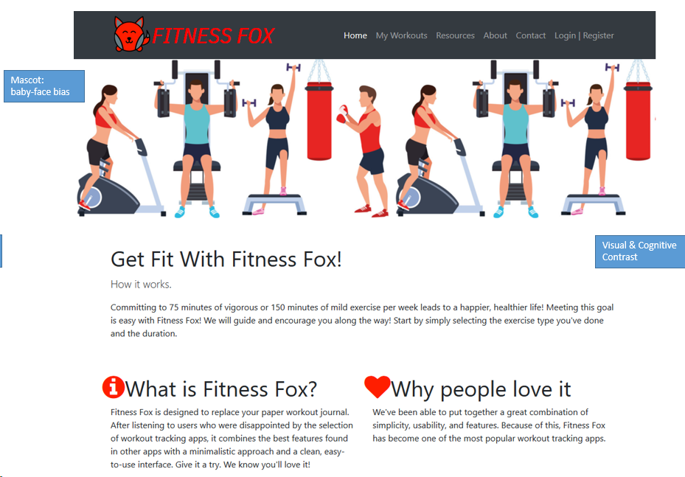

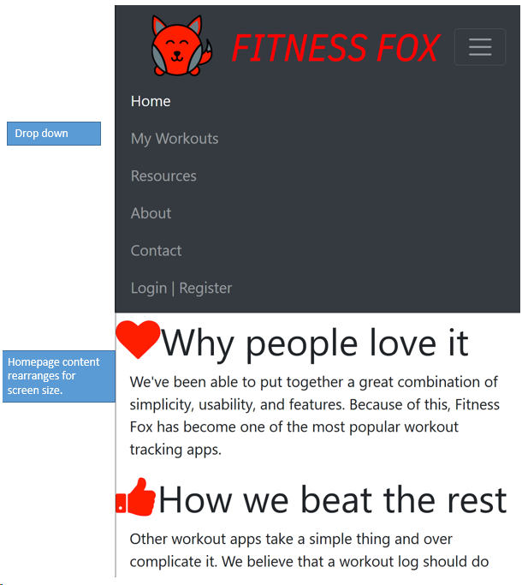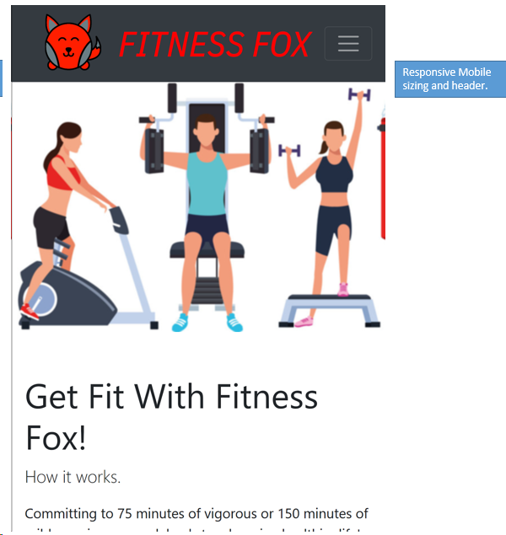

**Signup**

On the signup page, the user is asked for basic information including name, email, and password. To further build out their fitness profile the user includes birthday, weight, and gender. To confirm the user then selects the “Lets Get Fit” button and the information is logged in the database. Then the user needs to login with the newly created credentials. The form includes validation for proper email format, and enforcing the required fields.

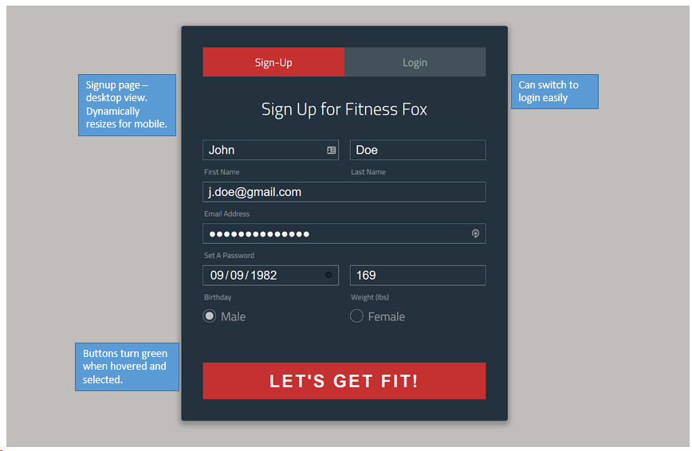

**Login**

After registering or for returning users, the user must input email and password and select “Login” button. After being authenticated, the user is redirected to their workout activity page which includes a chart of the user’s logged exercises.

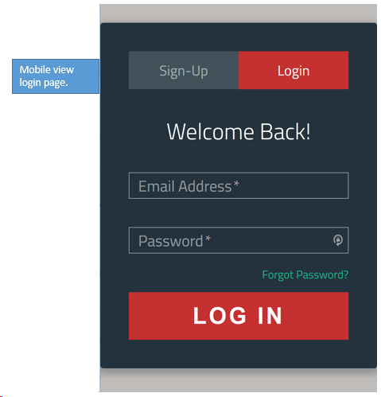

**View Workout - “Your Activity Log”**

This page displays the user’s workout activity they have submitted into the application as a line graph over time. There is an inviting green button labeled “Add Workout” indicating for the user to select to add a new workout.

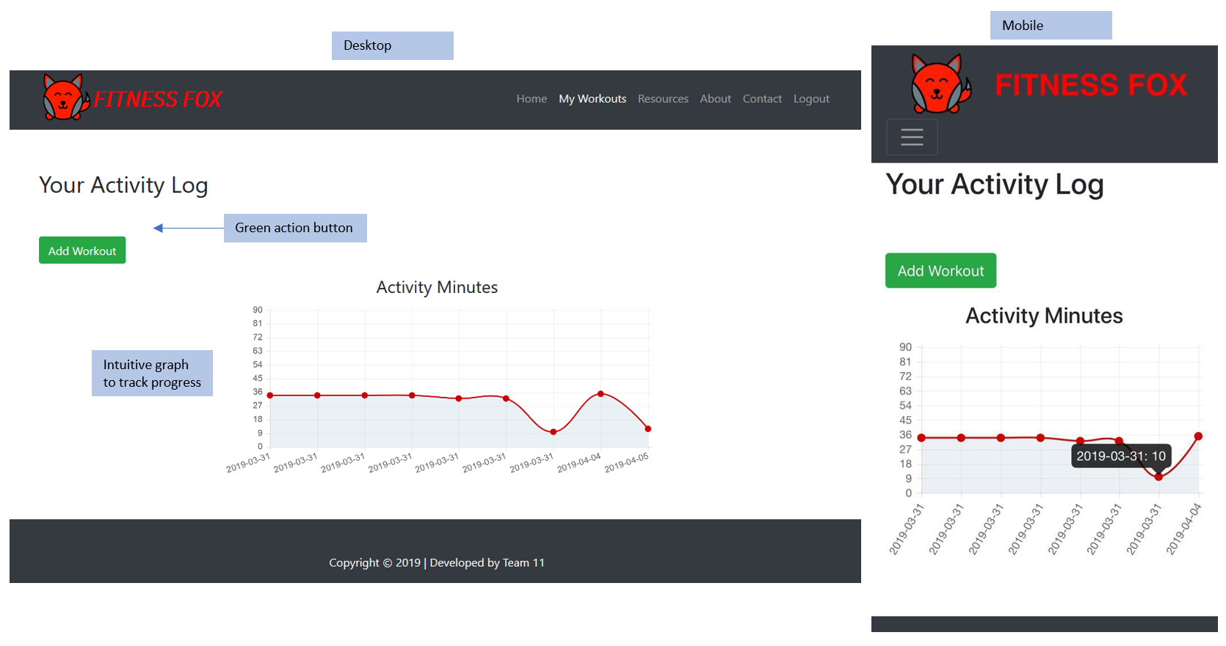

**Add Activity**

On this page the user first enters the time for the workout in format HH:MM:AM/PM, followed by date (mm/dd/yyyy). The “Activity Name” field is free text response allowing the user to uniquely identify different workouts. Lastly, the user enters the duration of the workout in minutes and selects “Create.” The fields are required to create a new activity.

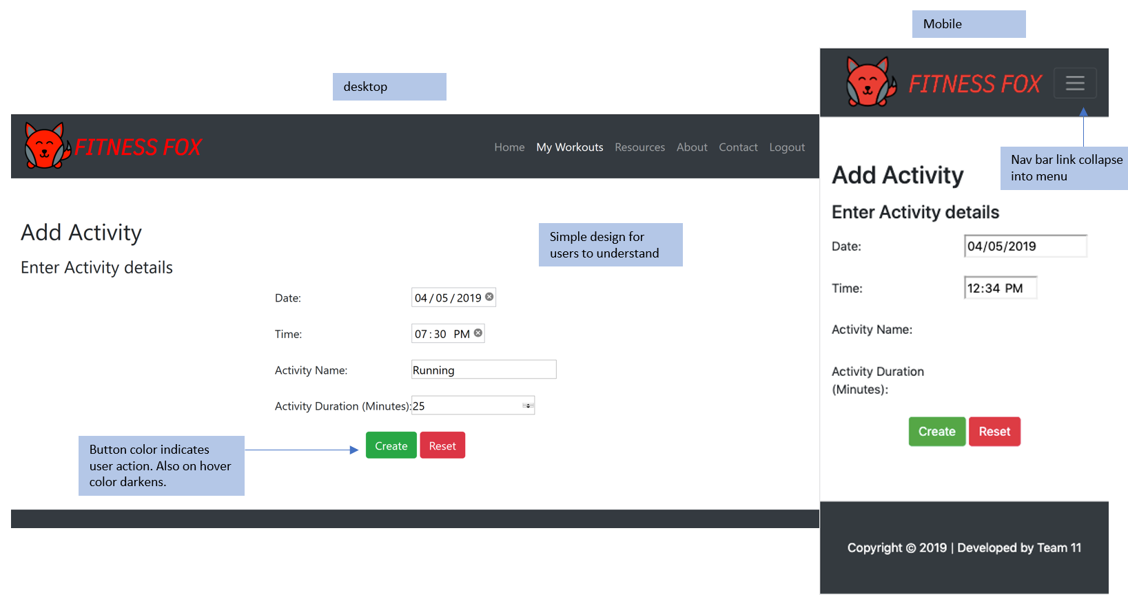

**Manager View**

Using the unique manager URL and login credentials, the manager is taken to a page that returns all users workout activity from the database. The manager can also set a date range and view only the logged workouts matching the query.

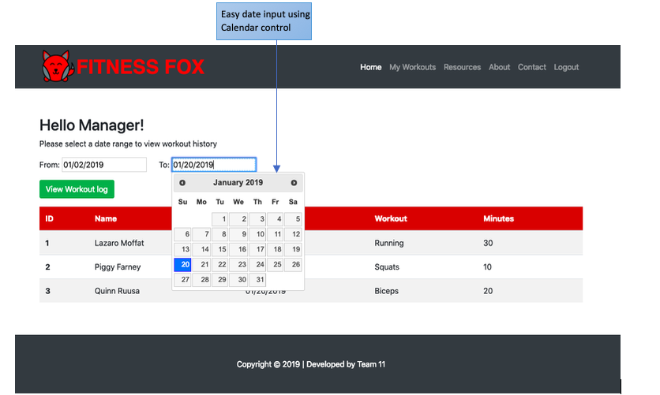

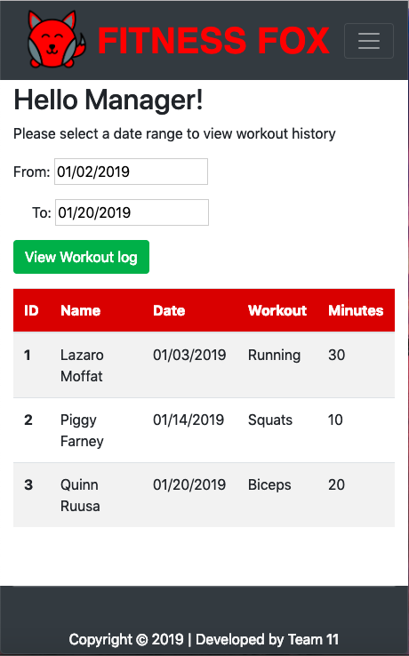

**Careers Page**

There is a link on the homepage that directs the user to the Fitness Fox Careers page. This section of the website has been created using no additional tools or plugins such as Bootstrap.

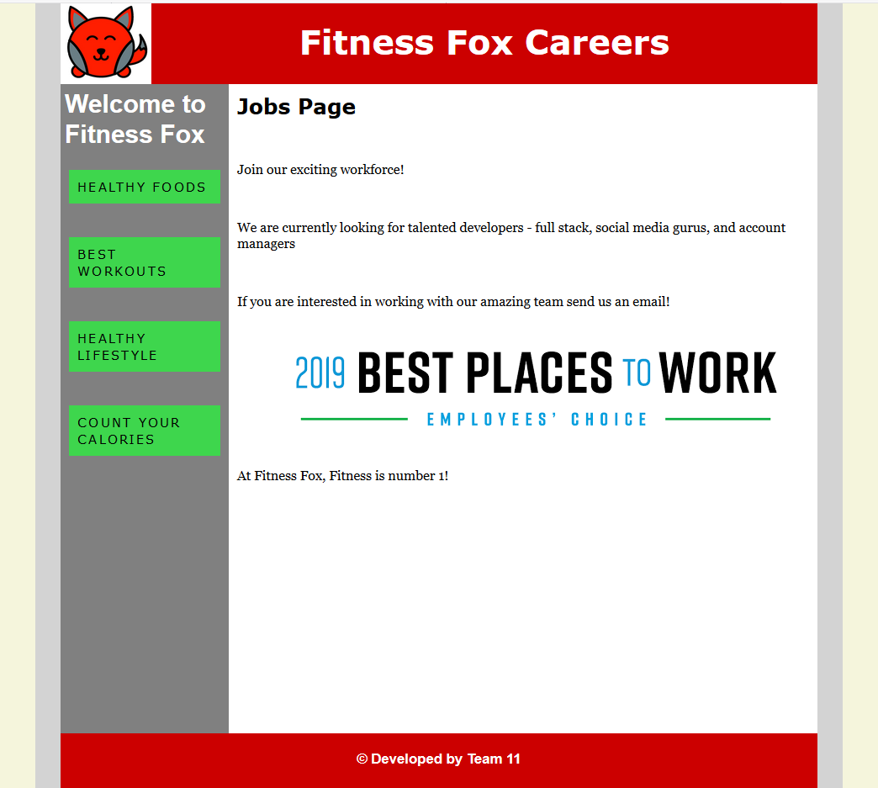

# 

# Connecting User and Design Personas

# Connection to User Personas

Fitness Fox caters to people in all age ranges and all fitness levels. To achieve this objective we have designed the interface in a simplistic way. The website is easy to navigate and has very small learning curve. In order to meet target user expectations of time saving, we have incorporated design where user is required to enter minimum number of inputs while adding activity. Moreover, website has minimum number of tabs which makes this a light- weight, high performance application. The mobile view of the application further aligns to the user expectations of being able to update activity on the go.

Incorporating the above measures allows Fitness Fox to serves the needs of all the users that were identified in the user personas document. Fitness Fox can be used by an elderly person who wants a simple and easy to use application to keep a tab on their health. Fitness Fox is appealing to corporate executives who place high value on time and want a less cluttered and focussed fitness app. The application will also be loved by youth who want a trendy User Interface with exercise tracking capabilities. Hence, we see that Fitness Fox fulfills the needs of the users defined in user persona.

# Connection to Design Personas

**Brand Traits**

Encouragement

By utilizing the mascot and other engagement methods, such as external resources and links, we can create an encouraging atmosphere that users will enjoy using. A challenge for many fitness apps for casual users is consistent engagement. Providing an encouraging atmosphere will drive users to more frequently log their fitness activity and reach their goals.

Health

Fitness Fox is about tracking exercises to maintain or increase the overall health of a user. Our app will let the users log different durations of activity to meet these weekly goals. In this way a user can meet or exceed what is recommended to stay healthy.

Motivation

Fitness Fox employs a dynamic graphic interface so the user can easily see their progress. Using visual elements that are “filling” to meet the weekly exercise goal will help motivate and keep the user accountable to themselves. Additionally, home page displays images of various workouts to keep the users motivated.

Fun

The combination of the mascot and user interface create a fun atmosphere for the users. The colors and typeface are also used to express the fun and non-intimidating nature of the Fitness Fox app.

Friendliness

The overall vibe of the app is very user friendly. This app is aimed at users who want a simple, uncomplicated way to track their exercises. The use of calendar control for date input saves user time and simplifies the task. Graphical representation of user workout history makes workout tracking user-friendly. The presence of navigation links on the top of the website helps users navigate through the website easily. Use of Add Workout button in My Workouts page helps users easily access Add Workout page.

# 

# Section 4: Design Elements

Design Overview

Fitness Fox caters to people in all age ranges and all fitness levels. To achieve this objective we have designed the interface in a simplistic way. The website is easy to navigate and has very small learning curve. In order to meet target user expectations of time saving, we have incorporated design where user is required to enter minimum number of inputs while adding activity. Moreover, website has minimum number of tabs which makes this a light- weight, high performance application. The mobile view of the application further aligns to the user expectations of being able to update activity on the go.

## Emotional Design: Baby Face Bias

The baby like features of the fox helps user form a connection to the mascot. Round face, small body, small nose, are all the characteristics of a baby. These characteristics help in creating baby face bias. This emotional connection compels the user to keep coming back to the application. Baby faced bias is being leveraged in the design of this website. Baby face bias help people perceive the website as honest, fun, and inclusive.

**Motivation**

Fitness Fox employs a dynamic graphic interface so the user can easily see their progress. Using visual elements including images of various workouts on the homepage to keep the users motivated. Throughout the website various motivational banners or phrases like “Get Fit with Fitness Fox,” “Powerful Yet Simple,” and “Helping You Achieve a Healthier Lifestyle.” The graph on the Activity Log page shows users their progress thus motivating them to maintain a consistency in activity overtime.

**Popup Messages**

At various points in the user’s experience of the website, the user is presented with a confirmation popup message confirming an action. When the user inputs login credentials and enters “Log In” they receive a popup message “Login Successful.” When the user adds a workout on the “Add Activity” page, there is a success popup “Activity Successfully Added.” This way the user is assured that the data has been committed to the database.

## 

## Visual & Cognitive Contrast

The fox as a mascot grips the audience’s attention. It helps in creating a unique brand name for Fitness Fox. This also helps Fitness Fox to be distinguished from other competitors. The contrast of red/grey/green also helps emphasise visual contrast.The visual contrast helps make the website appealing to the aesthetic senses.

**Layout: Graphics & Golden Ratio**

We have incorporated many design themes and techniques discussed in class to create a responsive, visually appealing site. On the homepage we have used illustrations of people working out throughout as the user scrolls. Also, bright red icons such as “i”, “heart”, “thumbs up”, and “speed dial” have been added to homepage sections to emphasize the content there. The template layout of the homepage and other pages as well as the content spacing follows the golden ratio rules for aesthetics.

**Visual Lexicon**

Base color: White color is used for the canvas. Black text on white background enhances clarity and simplicity in reading the site content.

Main color: Red and grey are used as main colors of the user interface. Since, red and grey are the colors of Fitness Fox’s logo, use of these colors in the website help in better brand recognition. Moreover, the colors red and grey align with the purpose of the website. Red color is a powerful and energetic shade which radiates enthusiasm, making it a perfect color for a fitness website to exude high energy and excitement. Gray color signifies focus and will highlight the seriousness of the website.

Accent color: Green color is used for buttons in the website design. Green color associated with health and fitness and therefore, aptly conveys the message of the website.

Typography: The typography of Fitness Fox defines website simplicity and focus. The selected typeface makes the website look clean and confident. Typography hierarchy has been implemented in the website content to make it easier for the user to navigate through the content.

**Responsive Design**

The website is made to be mobile responsive using responsive web design principles like viewport width and media queries. As seen in the screenshots the navigation links across the top of the desktop version collapse into a ‘hamburger’ menu on a mobile phone. Similarly, the content of the screens dynamically rearranges in proportion to the screen, like the activity graph. In the above screenshots, we see that the website elements fit in the restricted screen size of the mobile.

# 

# Section 5: Improvements Since Prototype

Since the prototype submission for Fitness Fox we have completed linking all HTML/CSS content pages (Homepage, My Workouts, Login) with the navbar links at the top. Further, we have completed backend development on the login and registration page so the user information is successfully added to the database. We have completed the manager view page to return entries from the database and included the date filter query. Finally, we have added a Career page link from the homepage to show information about joining Fitness Fox as an employee (built using only HTML/CSS by team, not Bootstrap).

# 

# Section 6: Database

## ERD

1. **User**

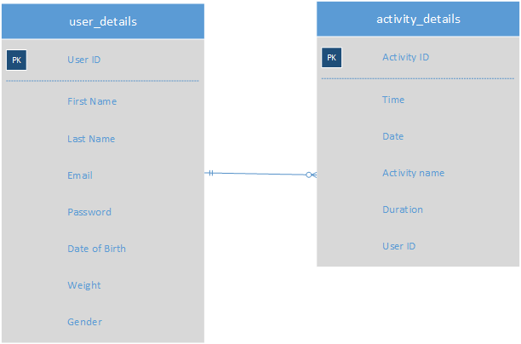

1. **Manager**

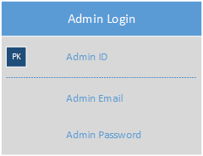

**Sample Database Tables**

These database tables were returned from MySQL with data from the application.

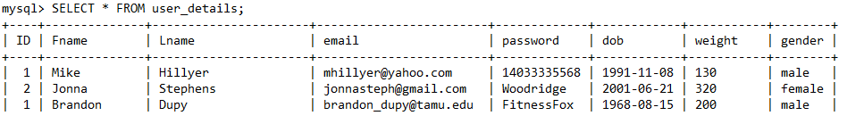

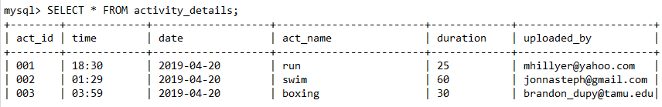

# 

# Section 7: Standard HTML/CSS Webform

**Fitness Fox Careers Webpage**

**HTML code**

<html>

<head>

<title>Fitness Fox</title>

<link rel= "stylesheet" type="text/css" href="jobs.css"/>

<meta name="viewport" content="width=device-width, initial-scale=1.0" />

</head>

<body>

<div id="page">

<div class="page_container">

<div id="header">

<div class="logo">

<img src="logo.png" alt="logo">

</div>

<h1>Fitness Fox Careers</h1>

</div>

<div id ="aside_section">

<div class= "aside">

<h4>Welcome to Fitness Fox</h4>

<a href="https://www.healthline.com/nutrition/50-super-healthy-foods"> Healthy Foods</a>

<br />

<a href="https://www.mensjournal.com/health-fitness/best-workout-ever-according-science/">Best Workouts</a>

<br />

<a href="https://www.health.harvard.edu/blog/healthy-lifestyle-5-keys-to-a-longer-life-2018070514186">Healthy Lifestyle</a>

<br />

<a href="https://www.healthline.com/nutrition/how-many-calories-per-day">Count your Calories</a>

</div>

<div class="section">

<h2>Jobs Page</h2>

<p>Join our exciting workforce! </p>

<p>We are currently looking for talented developers - full stack, social media gurus, and account managers</p>

<p>If you are interested in working with our amazing team send us an email! </p>

<div class="bestplacetowork">

<p>

<img src="bestplacestowork.png" alt="Best Place to Work" />

</p>

</div>

<p>At Fitness Fox, Fitness is number 1!</p>

</div>

</div>

<div class= "footer">

<h6> &copy Developed by Team 11</h6>

</div>

</div>

</body>

</html>

**CSS code**

* {

Margin: 0 auto;

Padding: 0;

}

Body{

background-color: beige;

font-family: Helvetica, Arial, sans-serif;

width:1140px;

}

#page{

background-color: lightgray;

/* margin: 36 auto; */

width: 960px;

}

.page_container {

background-color: lightcoral;

width: 900px;

margin-left: auto;

margin-right: auto;

clear:both;

}

#header {

background-color: #cc0000;

Color:white;

text-align:center;

height:100px;

/* header height is 10% of the page container hei*/

height:10%;

}

#header h1{

padding-top: 20px;

font-family: Verdana;

font-size: 40px;

}

.aside {

width: 200px;

/* Calculated percentage 200/900

900 is the width of page container*/

width: 22.222222222222222222222%;

height:800px ;

/* height of aside is 80% of page height*/

height: 80%;

background-color: gray;

float: left;

}

.aside h4{

font-size: 30px;

padding: 5px;

color: white;

}

.aside a {

display: block;

background-color: #3ED64D;

color:#000;

text-decoration:none;

margin-top: 20px;

padding: 5%;

width: 80%;

font-size: 15px;

letter-spacing: 0.15em;

text-transform: uppercase;

font-family: Verdana;

}

.aside a:hover {

background-color:#cc0000;

color:#fff;

font-size: 20px;

font-family: Verdana;

}

a {

text-decoration: none;

color: red;

}

h1,h2,h3 {

margin:0 auto;

margin-bottom: 30px;

}

.logo img {

/* height of logo is 100% of header and width is 12% of header */

Width: 100px;

width:12%;

Height: 100px;

height: 100%;

float: left;

}

.aside_section {

padding:0px;

background-color: lightgreen;

width: 70%;

}

.section

{

width: 700px;

/* Calculated percentage 700/900

900 is the width of page container*/

width: 77.7777777777777777777%;

height: 800px;

/* height of section is 80% of page height*/

height: 80%;

float: right;

background-color:white;

}

.section h2{

padding-top: 20px;

font-family: Verdana;

font-size: 25px;

padding: 10px;

}

.bestplacetowork

{

width: 560px;

/* image width is 80% of section width

560/700*/

width:80%;

height:auto;

align: center;

}

.footer

{ clear:both; /*Clear of any floating element to avoid overlapping*/

padding-top:20px;

background-color:#cc0000;

height: 100px;

/* footer is 10% of the page container*/

height: 10%;

color:white;

text-align: center;

font-size: 25px;

}

p {

margin-bottom:30px;

padding: 10px;

font-family: Georgia;

}

@media screen and (max-width: 680px){

/* Making the website responsive */

Body{

width: auto;

}

#page{

width: auto;

}

.page_container{

width: auto;

}

.aside{

float: none;

width: 100%;

/*Aside occupies 100% of width;

Aside is 680px/ 680px*/

}

.section{

float: none;

width: 100%;

/* section occupies 100% of width;

Aside section is 680px/ 680px*/

}

.bestplacetowork img{

width: 544px;

/* image occupies 80% of section width;

image width is 544px/ 680px */

width: 80%;

align: left;

}



# 

# 

# Section 8: Code Sample

**Add Activity Webpage**

**HTML**

<section class="py-5">

<div class="container">

<a name="about"></a>

<h1>Add Activity </h1>

<p class="lead">Entry Activity Details</p>

<form method="post" action="" class="acty">

Select a time: <input type="time" name="usr_time">

Date: <input type="date" name="bday">

Activity Name: <input type="text" name="actname">

Activity Duration (Minutes): <input type="text" name="duration">

<input type="submit" name="create" class="buttonsd" value="Create">

</form>

**CSS**

.form {

background: rgba(19, 35, 47, 0.9);

padding: 40px;

max-width: 600px;

margin: 40px auto;

border-radius: 4px;

/*enhancing the form by giving shadow*/

box-shadow: 0 4px 10px 4px rgba(19, 35, 47, 0.3);

}

input, textarea {

font-size: 22px;

display: block;

width: 100%;

height: 100%;

padding: 5px 10px;

background: none;

background-image: none;

border: 1px solid #a0b3b0;

color: #ffffff;

border-radius: 0;

/*using transition to animate changes rather than having them occur immediately*/

**transition: border-color .25s ease, box-shadow .25s ease;**

}

input:focus, textarea:focus {

/*changing input and textarea border color on hover*/

outline: 0;

border-color: #1ab188;

}

textarea {

border: 2px solid #a0b3b0;

resize: vertical;

}

.buttonsd {

background-color: #4CAF50; /* Green */

border: none;

color: white;

padding: 15px 32px;

text-align: center;

text-decoration: none;

display: inline-block;

font-size: 16px;

margin: 4px 2px;

/*indicating the cursor is a pointer and indicates a link*/

**cursor: pointer;**

}

input, time{

font-size: 22px;

display: block;

width: 100%;

height: 100%;

padding: 5px 10px;

background: none;

background-image: none;

border: 1px solid #a0b3b0;

color: #000;

border-radius: 0;

/*using transition to animate changes rather than having them occur immediately*/

**transition: border-color .25s ease, box-shadow .25s ease;**

}

form.acty {

/*making form to cover 50% width*/

width: 50%;

}

# 

# Section 9: Technologies Used

**Software and Tools**

We will employ the below softwares and tools while creating the web application -

* Front-end: HTML, CSS, JavaScript (Bootstrap and JQuery)
* Programming Language: PHP
* Database: MySQL
* Version control: GitHub

**Hosting**

The site is hosted through linux supercloud, a simple web hosting service.

<https://linuxsupercloud.com:2083/>

Username - fitnessfox

Password - TY5{$Il,vG

# 

# Section 10: Project Outcomes

This project provided an opportunity to explore the web application development domain enabling us to design and develop an information system. The team learned and gained experience in use of various tools and technologies that were used during the course of this project, for example, Git for version control, and use of JavaScript library for enhanced User Interface (UI). The website has been designed to be emotional, engaging and interactive, thereby enabling the team to understand and implement various aspects of web design and development.

# Section 11: Full Code

This section contains embedded .zip of all the code files used to create Fitness Fox.



# Section 12: Appendix

This section shows the file tree for the website code

Admin – contains code for admin page

CSS – contains bootstrap CSS code and custom code for homepage

Images – all images and icons used in website.

JobsPage – contains career page HTML/CSS without use of bootstrap or other tools.

Js – contains JavaScript files

Activity.php – php (HTML/CSS) for add activity page

Connection.php – sets connection to the mySQL database

Index.php – homepage code

Loginregister.php – login and register page code

Logout.php – kills connection to database and logs out user – returns to homepage

My-workout.php – view workout page with the graph

Fitnessfox_workspace.sql – code for generating the MySQL database and tables