Name: Anushree Badarinath Kasal

Student Id: 1001624311

Net Id: abk4311

Step 1: Click on ServerWindow.java -> Run as -> Java Application.

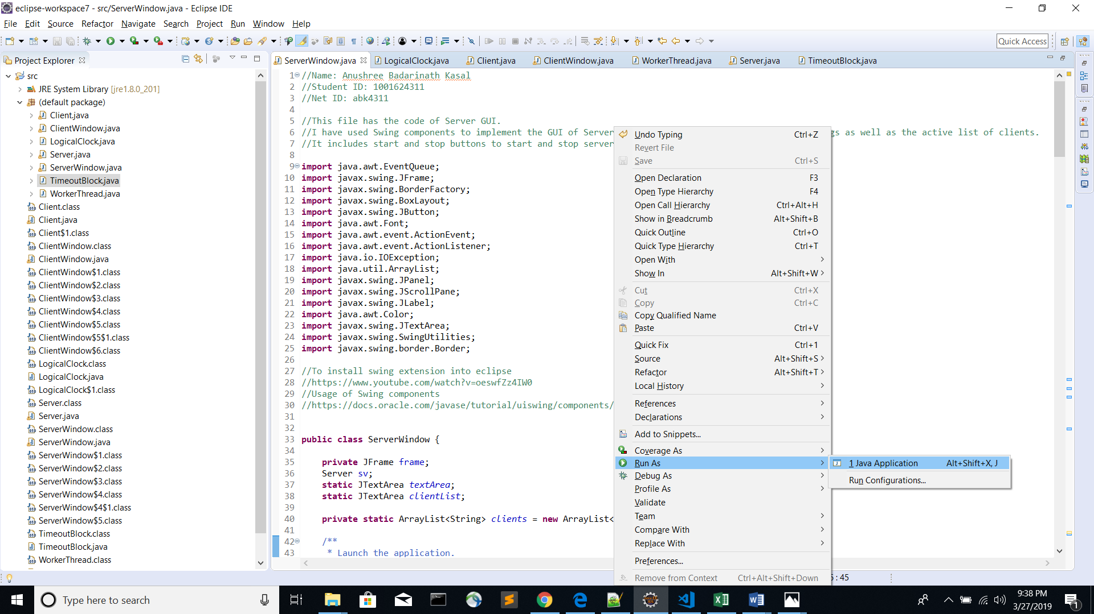

Server window will open. Click on Start Button.

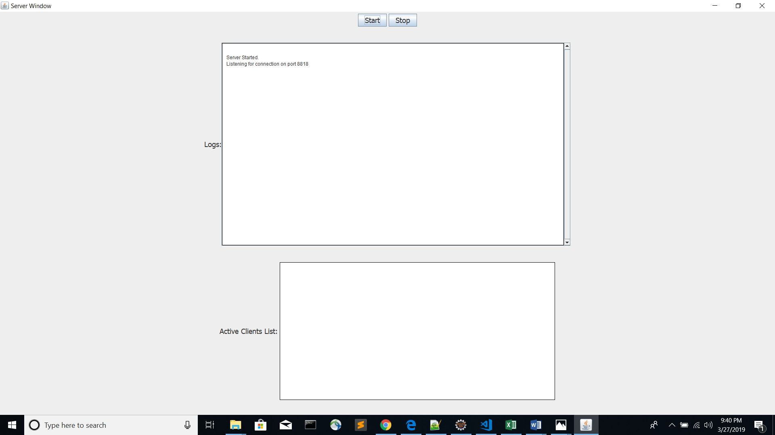

Step 2:

Click on ClientWindow.java -> Run as -> Java Application.

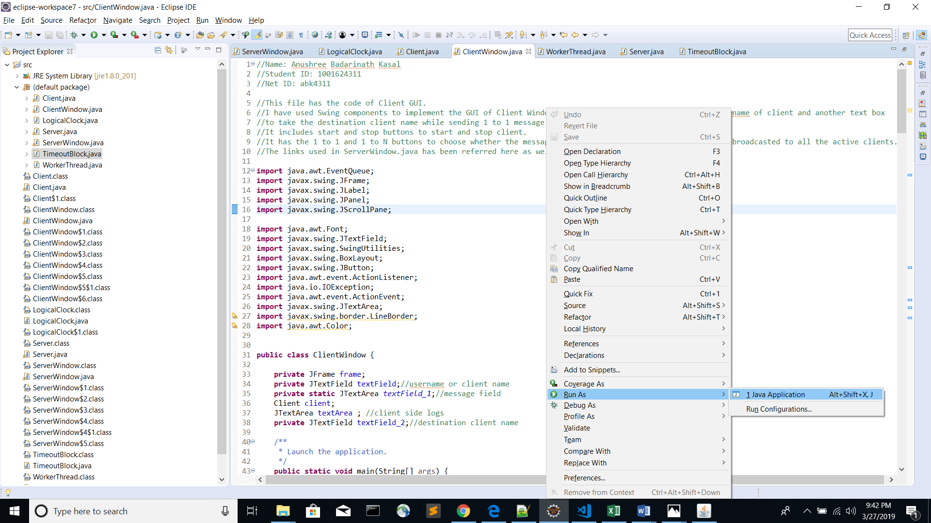

Client Window will open ->click on maximize window

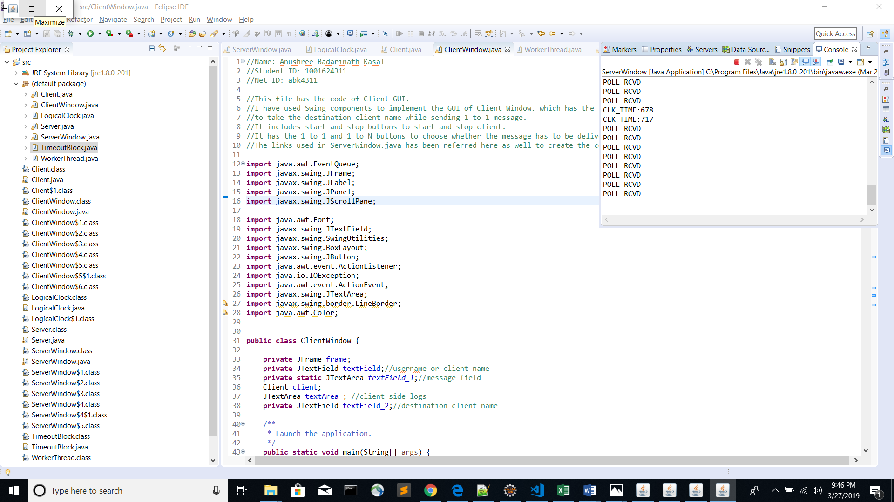

Enter the client name first and then click on start.

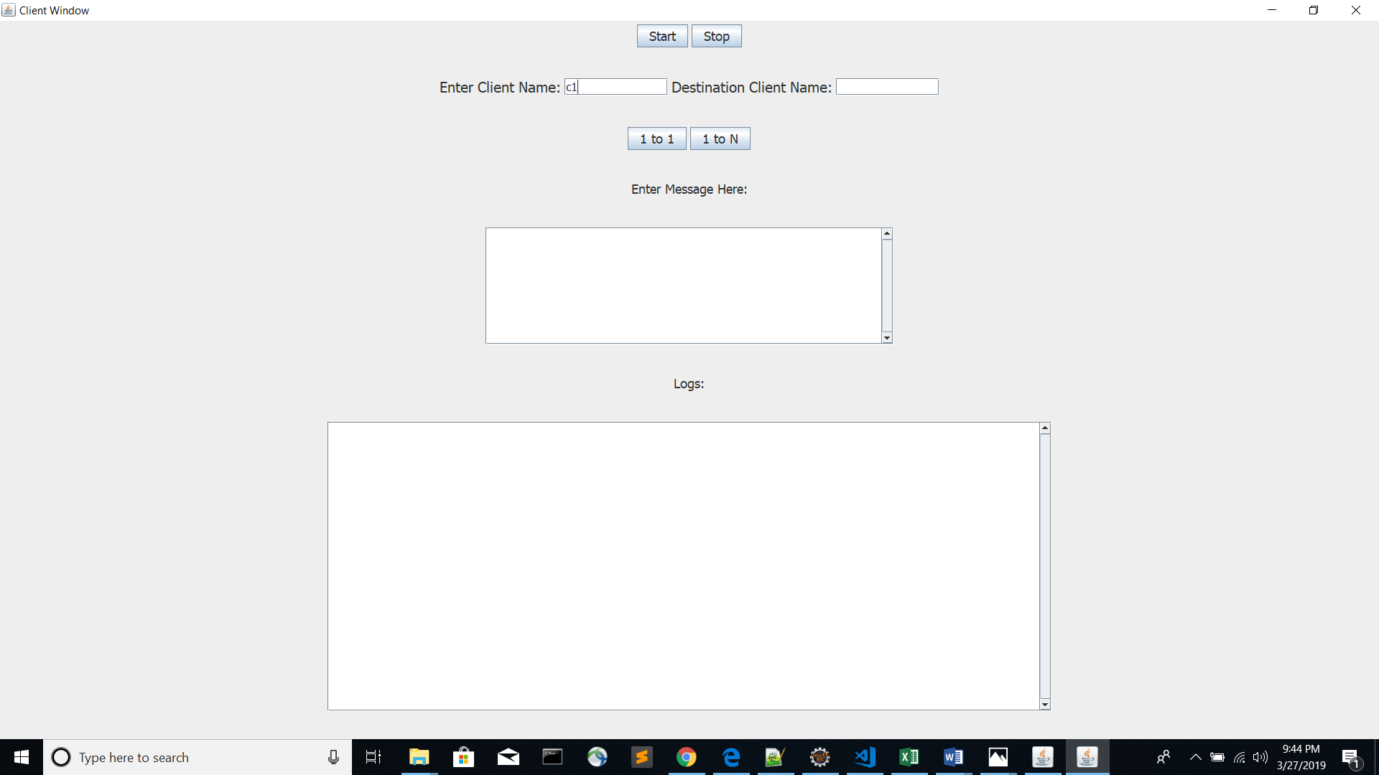

Step 3:

Repeat the step 2 two more times to open two more client windows.( ClientWindow - > Run As - > Run Configurations)

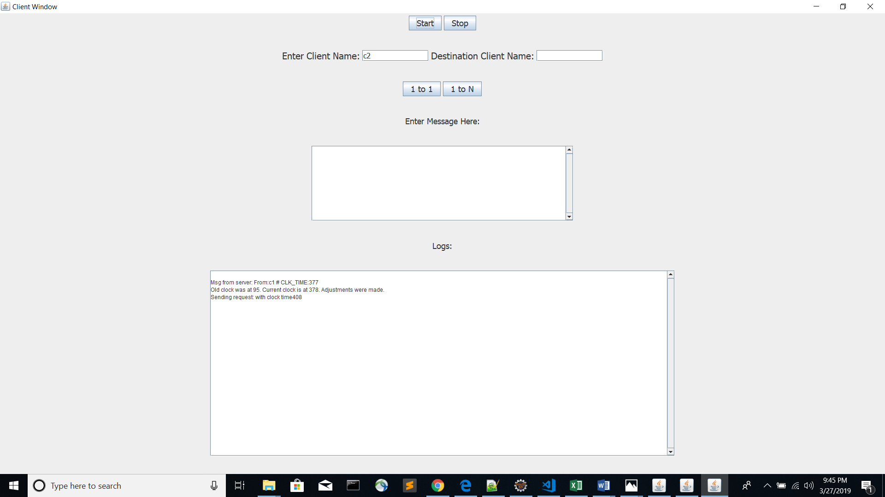

Step 4: Clock time is exchanged and adjusted automatically between the three clients.

