Student Name: Anushree Badarinath Kasal

Student Id: 1001624311

Net Id: abk4311

Step 1: Click on Server->Run As ->Java Application

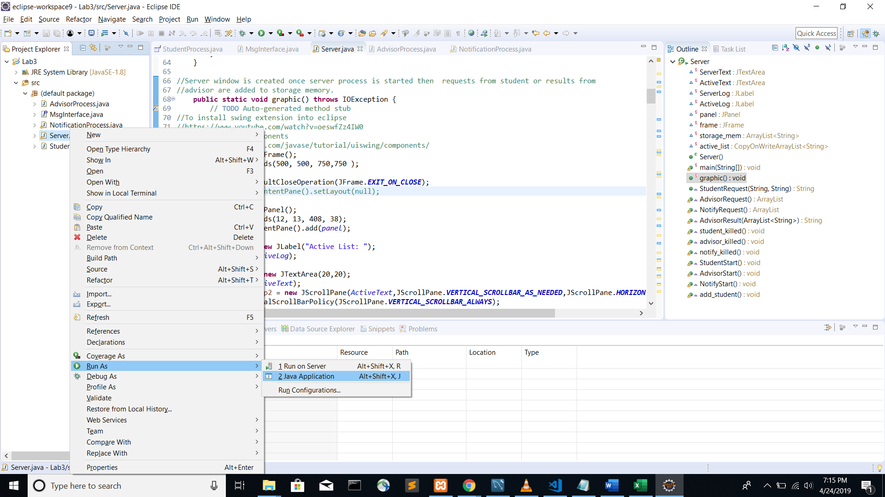

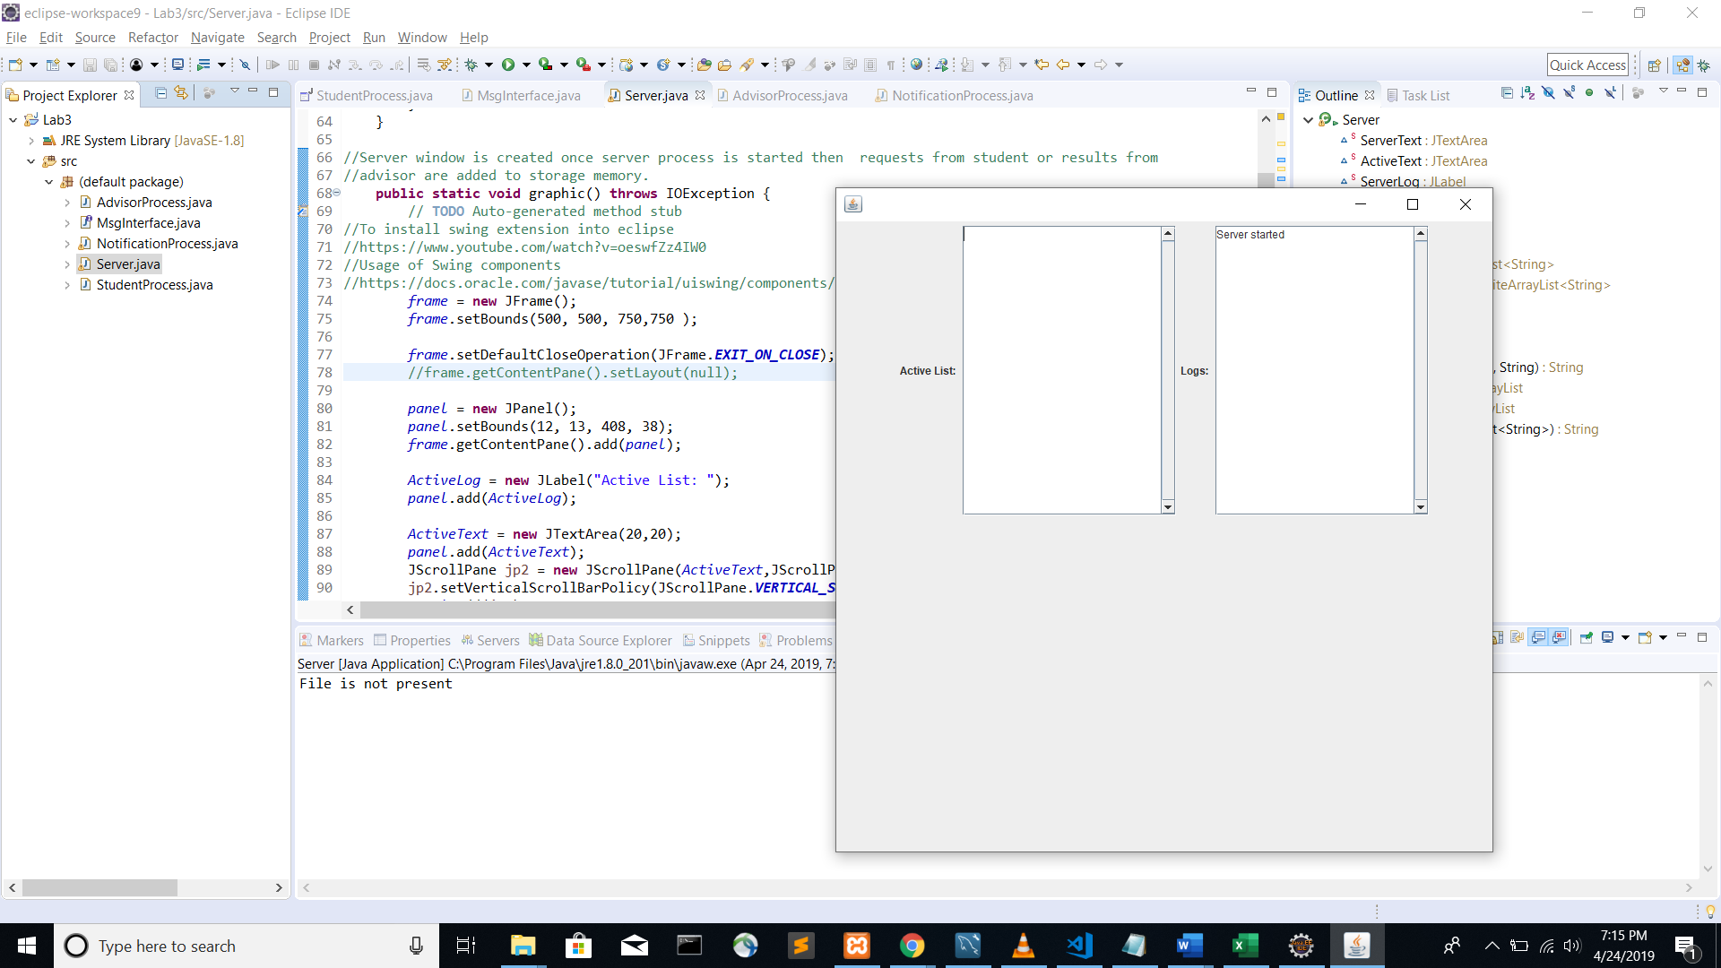

After starting server Step 2, Step 3, Step 4 can be executed in any order.

Step2: Click on StudentProcess ->Run As ->Java Application

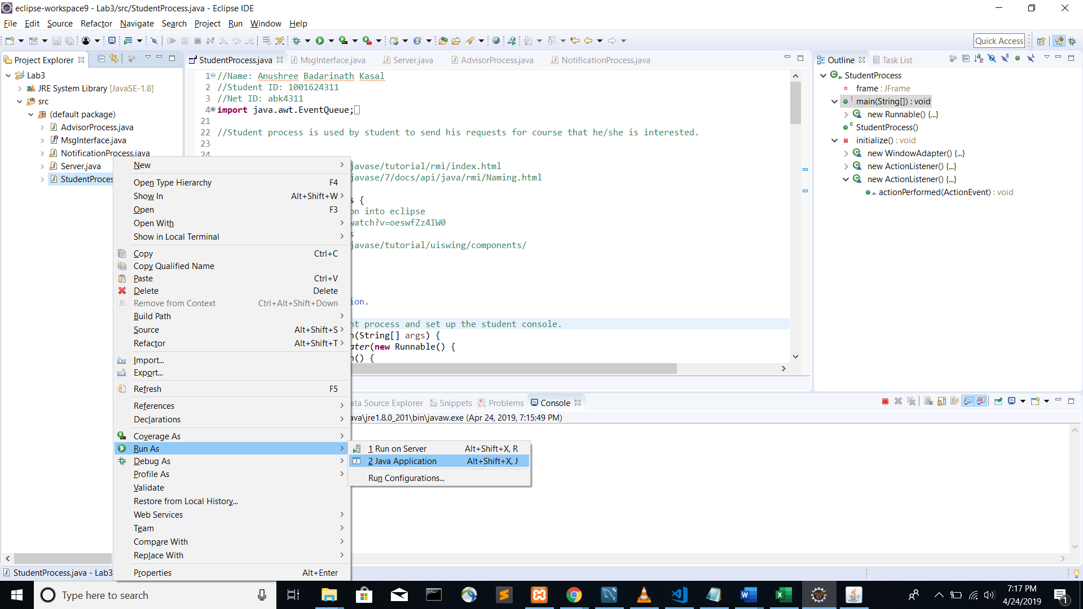

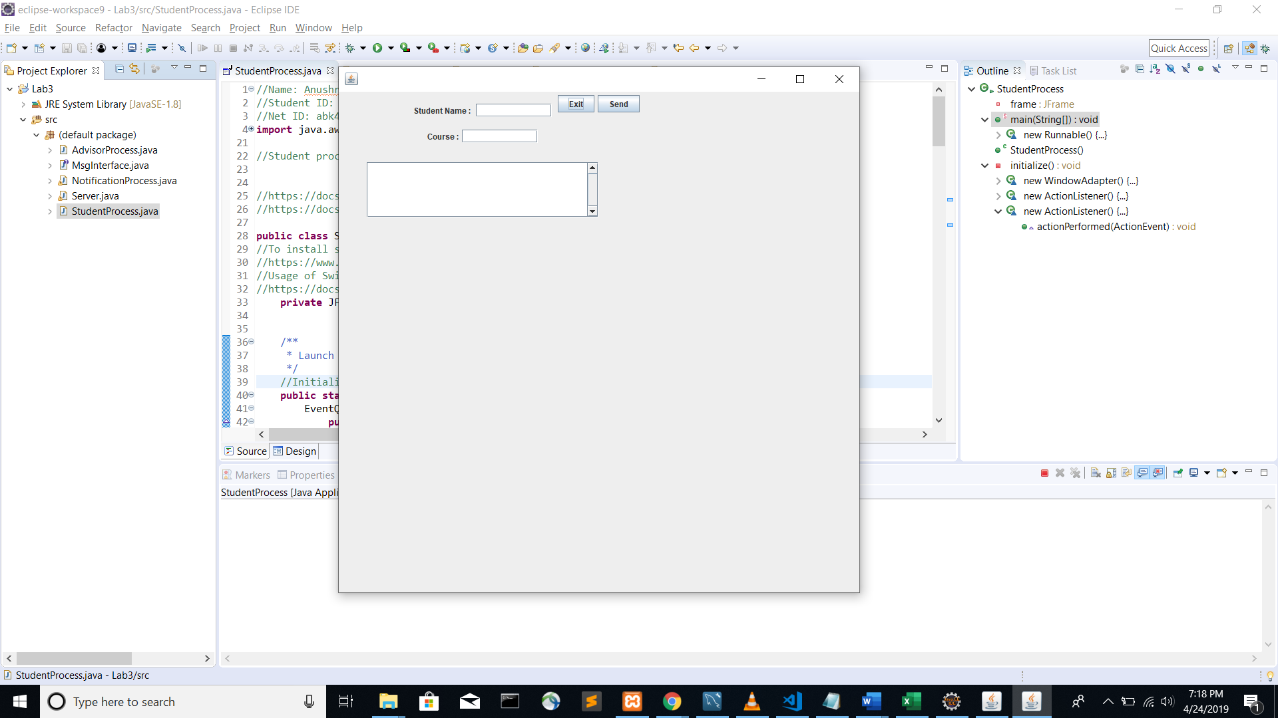

Enter student name and course number and click on send button.

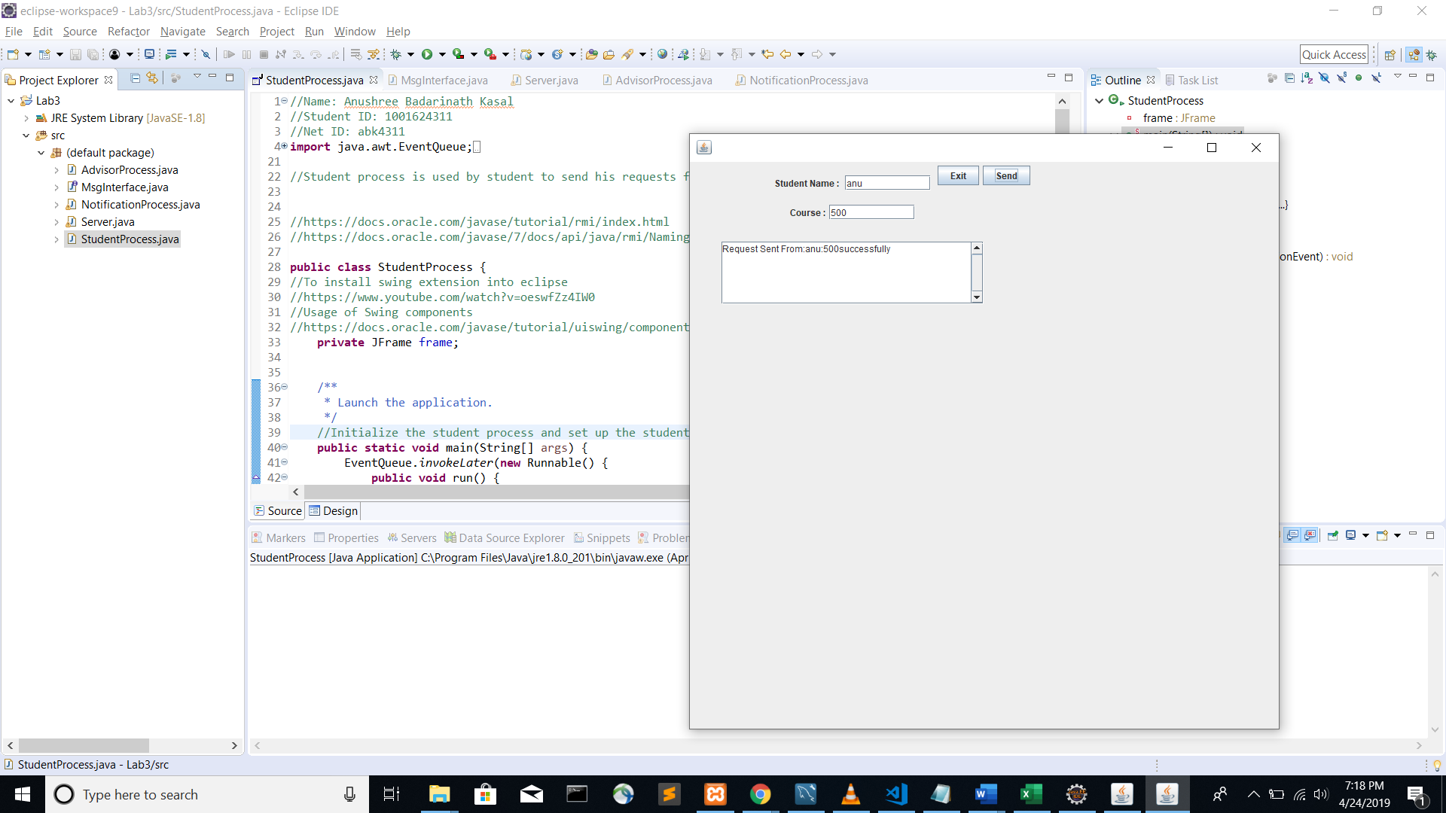

Step 3: Click on AdvisorProcess ->Run As ->Java Application

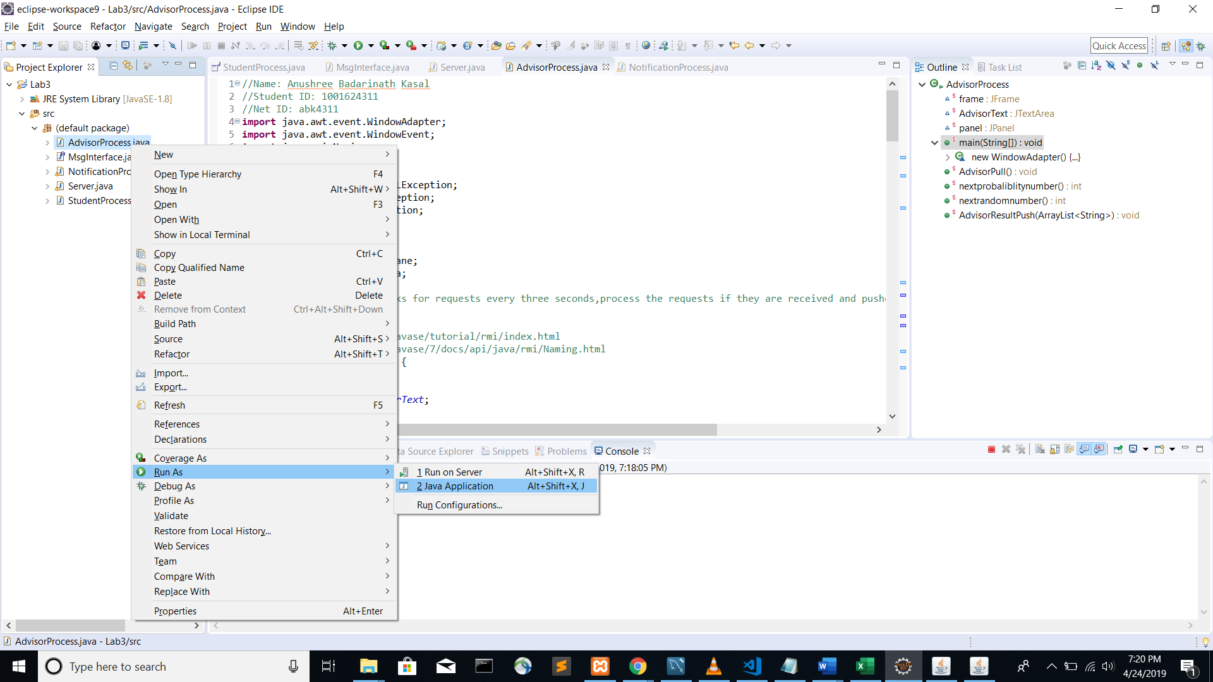

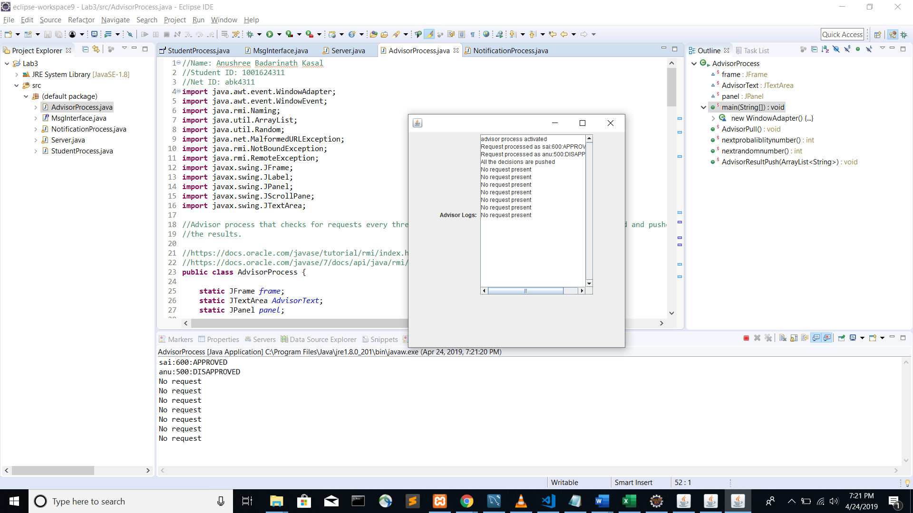

Step 4: Click on NotificationProcess ->Run As ->Java Application

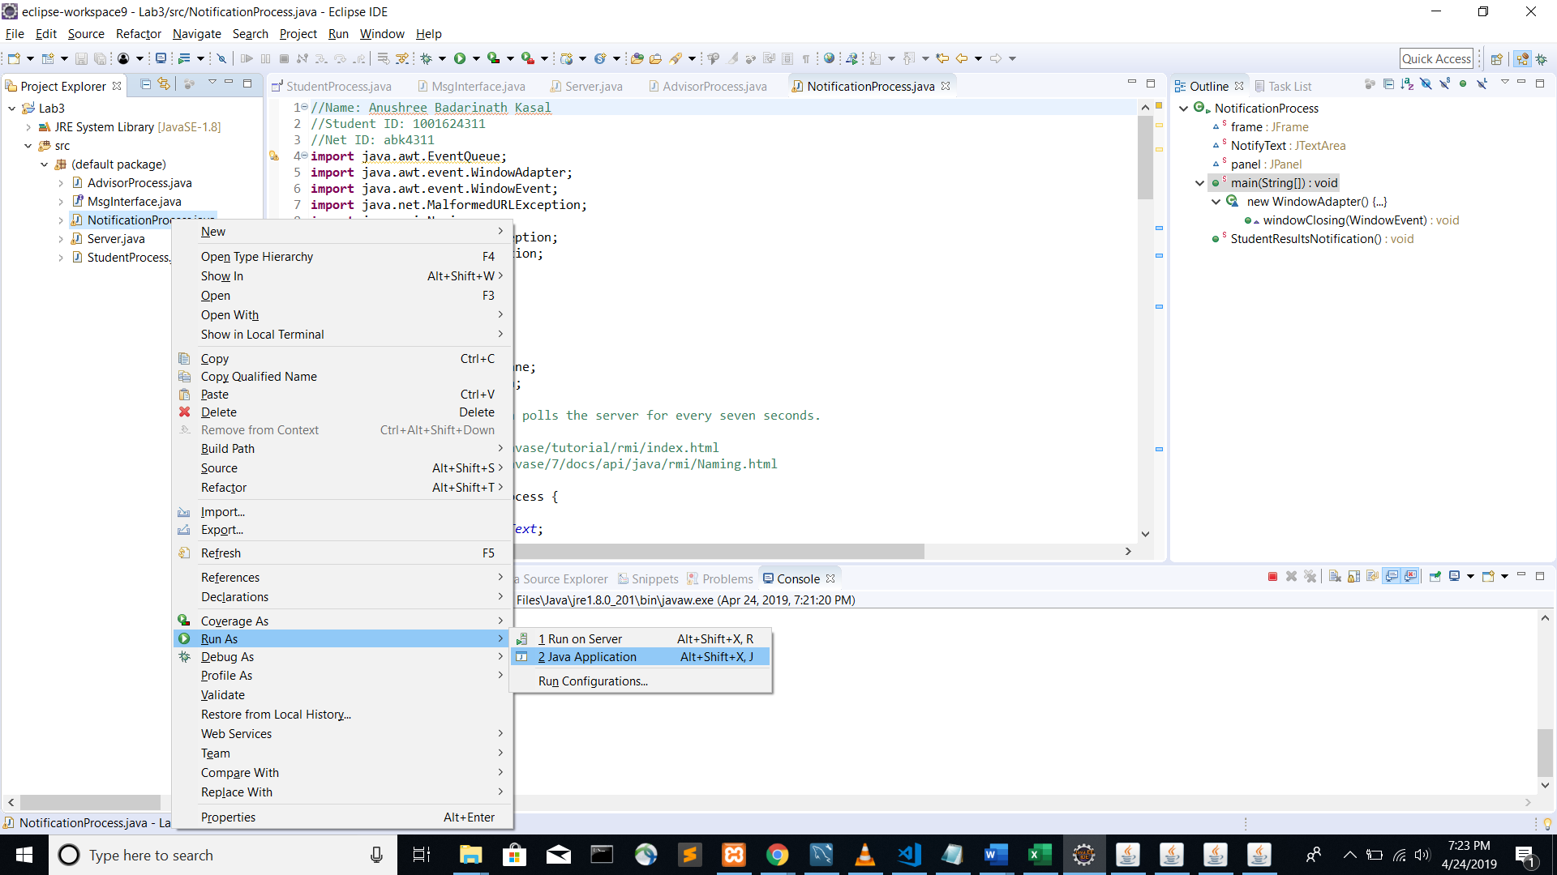

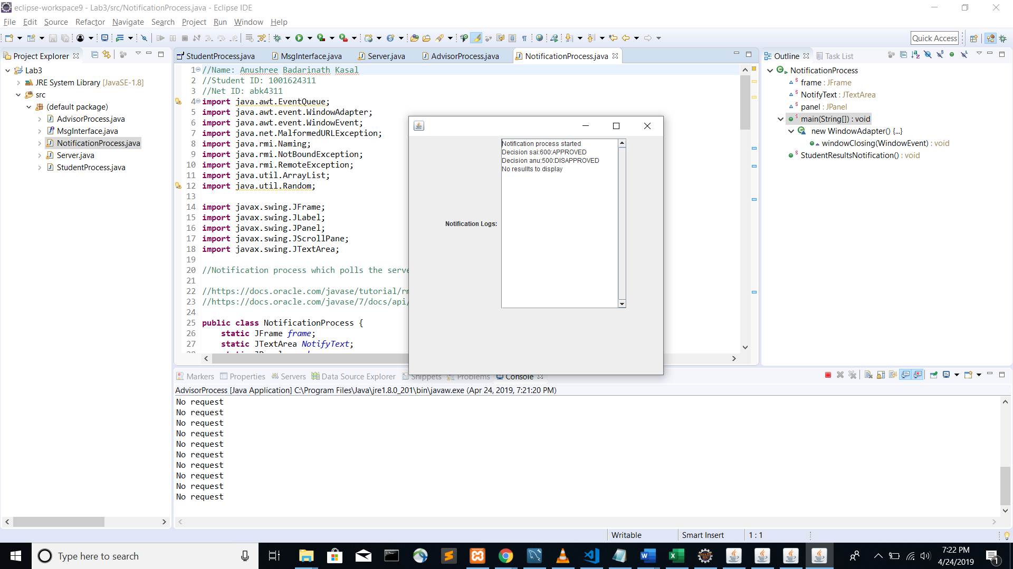

Now all the processes are running.

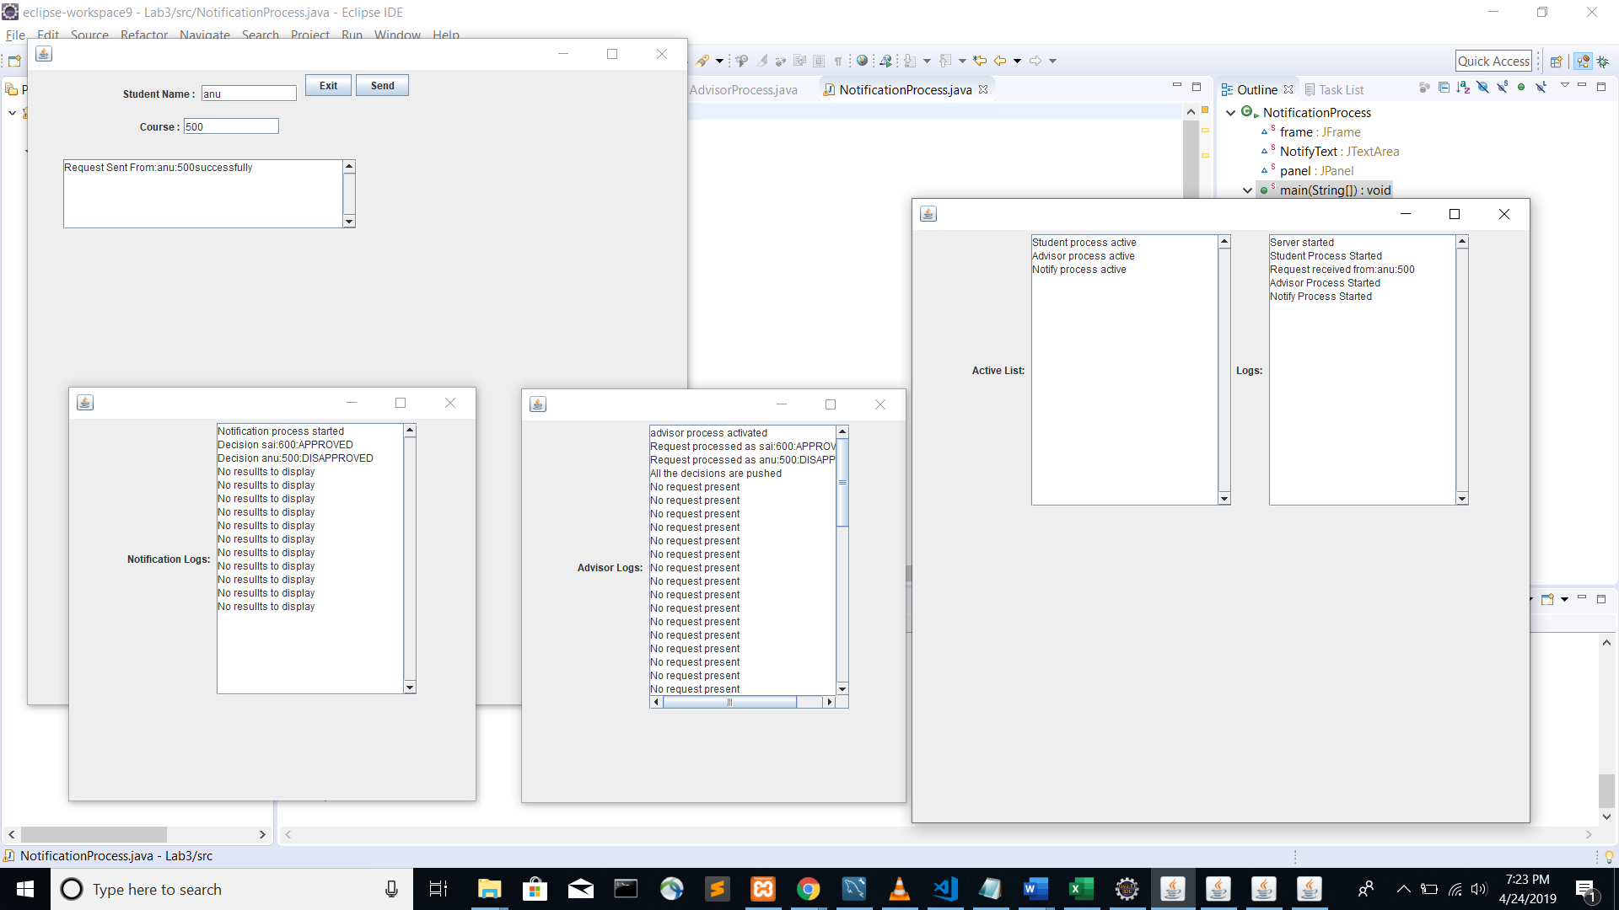

The server displays any requests received from student in Logs and it also displays Active list of processes in Active List.

The Notification Process will display the decisions made by the advisor every 7 seconds and prints messages accordingly.

The Advisor Process will display the decisions made every 3 seconds and prints messages accordingly.