There are three projects :

## When Was the Golden Age of Video Games?

Video games are big business: the global gaming market is projected to be worth more than $300 billion by 2027 according to [Mordor Intelligence](https://www.mordorintelligence.com/industry-reports/global-gaming-market). With so much money at stake, the major game publishers are hugely incentivized to create the next big hit. But are games getting better, or has the golden age of video games already passed?

In this project, we'll explore the top 400 best-selling video games created between 1977 and 2020. We'll compare a dataset on game sales with critic and user reviews to determine whether or not video games have improved as the gaming market has grown.

The database contains two tables. Its limited each table to 400 rows for this project, but you can find the complete dataset with over 13,000 games on [Kaggle](https://www.kaggle.com/holmjason2/videogamedata).

**game_sales**

| **column** | **type** | **meaning** |
| --- | --- | --- |
| game | varchar | Name of the video game |
| platform | varchar | Gaming platform |
| publisher | varchar | Game publisher |
| developer | varchar | Game developer |
| games_sold | float | Number of copies sold (millions) |
| year | int | Release year |

**reviews**

| **column** | **type** | **meaning** |
| --- | --- | --- |
| game | varchar | Name of the video game |
| critic_score | float | Critic score according to Metacritic |
| user_score | float | User score according to Metacritic |

## Analyzing American Baby Name Trends

## 

Photo Illustration by Michela Buttignol

How have American baby name tastes changed since 1920? Which names have remained popular for over 100 years, and how do those names compare to more recent top baby names? These are considerations for many new parents, but the skills we'll practice while answering these queries are broadly applicable. After all, understanding trends and popularity is important for many businesses, too!

This data was originally provided by the United States Social Security Administration but the preprocessed data has been taken from Izzy Weber at Data Camp. It lists first names along with the number and sex of babies they were given to in each year. For processing speed purposes, we've limited the dataset to first names which were given to over 5,000 American babies in a given year. Our data spans 101 years, from 1920 through 2020.

**baby_names**

| **column** | **type** | **meaning** |
| --- | --- | --- |
| year | int | year |
| first_name | varchar | first name |
| sex | varchar | sex of babies given first_name |
| num | int | number of babies of sex given first_name in that year |

1. **The World Bank's international debt data**

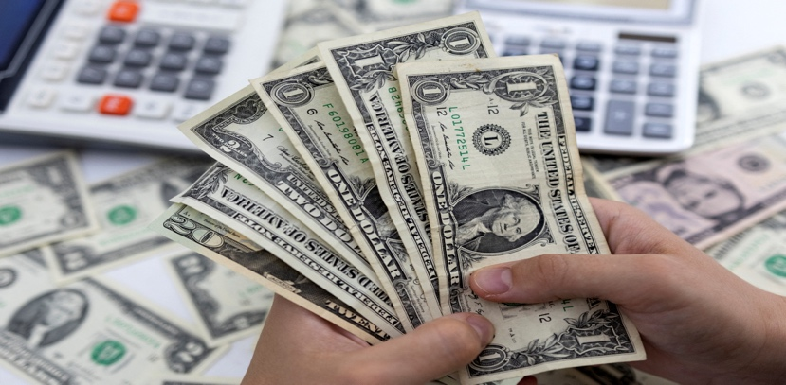

Photo Illustration by Dado Reuvic,Reuters

It's not that we humans only take debts to manage our necessities. A country may also take debt to manage its economy. For example, infrastructure spending is one costly ingredient required for a country's citizens to lead comfortable lives. [The World Bank](https://www.worldbank.org/) is the organization that provides debt to countries.

I analyzed the international debt data collected by The World Bank. The dataset(taken from Sayak Paul at Data Camp) contains information about the amount of debt (in USD) owed by developing countries across several categories. We are going to find the answers to questions like:

* What is the total amount of debt that is owed by the countries listed in the dataset?
* Which country owns the maximum amount of debt and what does that amount look like?
* What is the average amount of debt owed by countries across different debt indicators?

|  |  |  |  |  |
| --- | --- | --- | --- | --- |
| **country_name** | **country_code** | **indicator_name** | **indicator_code** | **debt** |
| Afghanistan | AFG | Disbursements on external debt, long-term (DIS, current US$) | DT.DIS.DLXF.CD | 72894453.700000003 |
| Afghanistan | AFG | Interest payments on external debt, long-term (INT, current US$) | DT.INT.DLXF.CD | 53239440.10000000 |