Department of Computer Science & Information Technology


Name: Anushree Dahiya
PRN: 22070122023
Div: CSE-A1
Date: 24/01/2024

DBMS Lab Assignment - 1
ER to Relational Model Conversion
The ER Model is intended as a description of real-world entities. Although it is constructed in such a way as to allow easy translation to the relational schema model, this is not an entirely trivial process. The ER diagram represents the conceptual level of database design meanwhile the relational schema is the logical level for the database design. We will be following the simple rules:

1. Entities and Simple Attributes:
An entity type within ER diagram is turned into a table. You may preferably keep the same name for the entity or give it a sensible name but avoid DBMS reserved words as well as avoid the use of special characters. Each attribute turns into a column (attribute) in the table. The key attribute of the entity is the primary key of the table which is usually underlined. It can be composite if required but can never be null.
It is highly recommended that every table should start with its primary key attribute conventionally named as TablenameID.
Taking the following simple ER diagram:
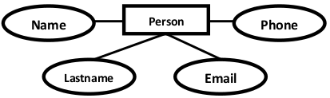
The initial relational schema is expressed in the following format writing the table names with the attributes list inside a parentheses as shown below for
Persons( personid , name, lastname, email )
Persons and Phones are Tables. name, lastname, are Table Columns (Attributes).
personid is the primary key for the table : Person

2. Multi-Valued Attributes
A multi-valued attribute is usually represented with a double-line oval.
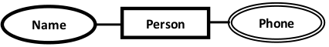
If you have a multi-valued attribute, take the attribute and turn it into a new entity or table of its own. Then make a 1:N relationship between the new entity and the existing one. In simple words. 1. Create a table for the attribute. 2. Add the primary (id) column of the parent entity as a foreign key within the new table as shown below:
Persons( personid , name, lastname, email )
Phones ( phoneid , personid, phone )
personid within the table Phones is a foreign key referring to the personid of Persons

3. 1:1 Relationships
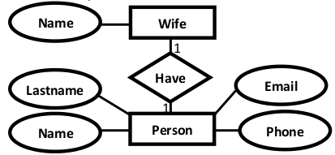
To keep it simple and even for better performances at data retrieval, I would personally recommend using attributes to represent such relationship. For instance, let us consider the case where the Person has or optionally has one wife. You can place the primary key of the wife within the table of the Persons which we call in this case Foreign key as shown below.
Persons( personid , name, lastname, email , wifeid )
Wife ( wifeid , name )
Or vice versa to put the personid as a foreign key within the Wife table as shown below:
Persons( personid , name, lastname, email )
Wife ( wifeid , name , personid)
For cases when the Person is not married i.e. has no wifeID, the attribute can set to NULL

4. 1:N Relationships
This is the tricky part ! For simplicity, use attributes in the same way as 1:1 relationship but we have only one choice as opposed to two choices. For instance, the Person can have a House from zero to many , but a House can have only one Person. To represent such relationship the personid as the Parent node must be placed within the Child table as a foreign key but not the other way around as shown next:
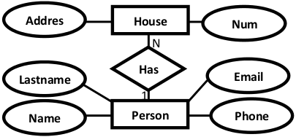
It should convert to :
Persons( personid , name, lastname, email )
House ( houseid , num , address, personid)

5. N:N Relationships
We normally use tables to express such type of relationship. This is the same for N − ary relationship of ER diagrams. For instance, The Person can live or work in many countries. Also, a country can have many people. To express this relationship within a relational schema we use a separate table as shown below:
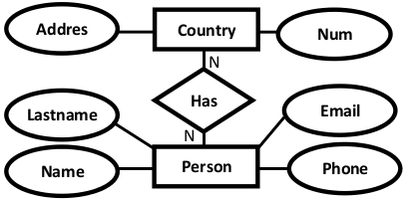
It should convert into :
Persons( personid , name, lastname, email )
Countries ( countryid , name, code)
HasRelat ( hasrelatid , personid , countryid)

Relationship with attributes:
It is recommended to use table to represent them to keep the design tidy and clean regardless of the cardinality of the relationship.

Practice Example
Convert the following ER diagram into database relational schema:
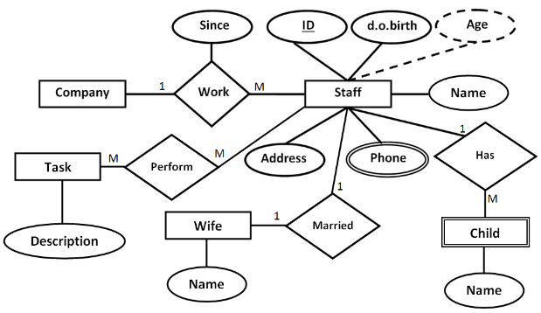
The relational schema for the ER Diagram is given below as:
Company( CompanyID , name , address )
Staff( StaffID , dob , address , WifeID)
Child( ChildID , name , StaffID )
Wife ( WifeID , name )
Phone(PhoneID , phoneNumber , StaffID)
Task ( TaskID , description)
Work(WorkID , CompanyID , StaffID , since )
Perform(PerformID , StaffID , TaskID )

Assignment 1 Lab Questions
Theory Questions
- What are ER Diagrams? What is their significance in DBMS?
When designing databases, ER diagrams—graphical representations of a database's structure—are employed. They provide a visual depiction of the entities and relationships within a system. Entities are concepts or real-world objects, and relationships are the connections between them. Attributes, or the characteristics or properties of entities, are also displayed in ER diagrams.
In Database Management Systems (DBMS), ER diagrams are essential for a number of reasons.
  - Visualization: They provide a clear and straightforward approach to display the structure of a database, making it easier for designers to grasp and convey the database architecture.
  - ER diagrams are a useful tool for communication between stakeholders, developers, and designers. They aid in successfully communicating the requirements and database structure.
  - Database Schema Blueprint: In a DBMS, the actual database schema is designed using ER diagrams as a guide.

- Explain the conversion process from ER to Relational.
  - Determine Entities: In the relational model, entities in the ER diagram correspond to tables. Every entity is transformed into a table with properties-corresponding attributes.
  - Determine Relationships: In the relational model, relationships between entities are converted into foreign keys. The relationship is established when the primary key of one table (corresponding to one entity) becomes a foreign key in another table.
  - Convert Attributes: In the appropriate tables, attributes of entities are transformed into columns. Make sure that the attribute data types match the relational model's column sizes.
  - Handle Multivalued Attributes: Make a separate table for each multivalued attribute that an entity possesses, and link the original entity and the new table together.
  - Normalize the Schema: To guarantee that the relational schema is in a normalized form and reduce redundancy and dependency problems, apply normalization techniques.
  - Assign main Keys: Determine which tables' main keys are and give them to them. Records in a table are uniquely identified by their primary keys.
  - Define limitations: To preserve data integrity, apply limitations like foreign key constraints.
  - Examine and Adjust: Look for any irregularities in the relational schema and make any necessary adjustments.
  - Record the Relational Schema: Record the relational schema in its final form, with tables, columns, constraints, and relationships.
------------------------------------------------------------------------------------------------------------
Implementation Question:- Draw an ER diagram for the following problem statements and then convert them into database relational schema
- CAR Rental Management
- One customer can rent one car.
- Each car has one manufacturer.
- Each manufacturer can manufacture many types of cars.
- Each car has its own maintenance schedule.
- The revenue is generated based on number of days the car was rented.
- The company has branches in 5 major cities.
- The companies also have 5 employees per branch.
- Initial rental requests are handled by employees.

- SIU Library Management System.
- SIU library there can be individual institute libraries.
- Library has members.
- Library buys books of many publishers.
- Sellers sell books of many publishers.
- Library contains books
- Books are written by one/many authors.
- Authors’ books are published by publishers.

- Online Grocery Ordering System
- Customer must orders one or more items. Each customer is identified by his/her name. The postal address and email address of the customer are also required for the correct placement of order.
- Items have their name and price to be shown to the customers.
- Shopping carts are created by the orders of the customers.
- Shopping carts contain at least one item.
- An order must have at least one requested item.
- Not all items have customers.
- Distinct companies produce distinct items which are differentiated by the company’s name.
- Payment must be made via credit cards. The payment process has to be done after the credit card’s verification.
Common Instructions for Implementation Questions:
For Each Question:
- Draw Hand written ER Diagram
- Create tables with valid 4-5 values for each column
- Typed Relational Schema
---------------------------------------------------------------------------------------------------------------------
- Car rental management

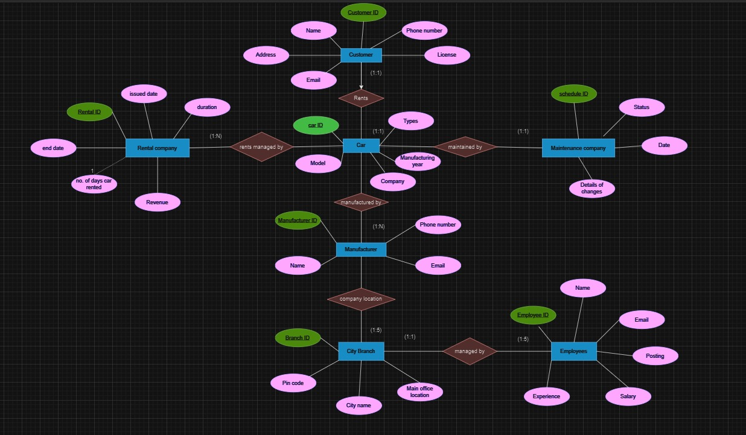

Relational schema:
customer(customer ID, name, email, phone number, license, address)
car(car ID, type, model, company, manufacturing year)
rental company(rental ID, issue date, end date, duration, no.of days car rented, revenue)
manufacturer(manufacturer ID, name, phone number, email)
city branch(branch ID, pin code, city name, main office location)
employee(employee ID, name, email, posting, salary, experience)
maintenance company(schedule ID, status, date, details of changes)

Table:

- Customer

customer_id | name | email | phone_number | license | address
1 | John Doe | john@example.com | 123-456-7890 | DL123456 | 123 Main St
2 | Jane Smith | jane@example.com | 987-654-3210 | DL654321 | 456 Oak St
3 | Bob Johnson | bob@example.com | 111-222-3333 | DL111222 | 789 Pine St

- car
car_id | type | model | company | manufacturing_year
101 | Sedan | Civic | Honda | 2022
102 | SUV | Explorer | Ford | 2021
103 | Hatchback | Golf | Volkswagen | 2023

- rental
rental_id | issue_date | end_date | duration | days_rented | revenue
201 | 2023-01-15 | 2023-01-20 | 6 | 5 | 250.00
202 | 2023-02-10 | 2023-02-15 | 5 | 4 | 200.00
203 | 2023-03-05 | 2023-03-10 | 6 | 5 | 275.00
- manufacturer
manufacturer_id | name | phone_number | email
301 | Honda | 123-456-7890 | info@honda.com
302 | Ford | 987-654-3210 | info@ford.com
303 | Volkswagen | 111-222-3333 | info@vw.com
- city branch
branch_id | pin_code | city_name | main_office_location
401 | 12345 | New York | Times Square
402 | 54321 | Los Angeles | Hollywood Blvd
403 | 67890 | Chicago | Magnificent Mile
- employee
employee_id | name | email | posting | salary | experience
501 | Alice Johnson | alice@example.com | Manager | 60000.00 | 5
502 | Bob Smith | bob@example.com | Sales Representative | 45000.00 | 3
503 | Charlie Brown | charlie@example.com | Mechanic | 55000.00 | 7
- maintenance company
schedule_id | status | date | details_of_changes
601 | Completed | 2023-01-25 | Oil Change and Brake Inspection
602 | In Progress | 2023-02-15 | Tire Rotation and Engine Check
603 | Pending | 2023-03-10 | Scheduled Maintenance

2)SIU library system

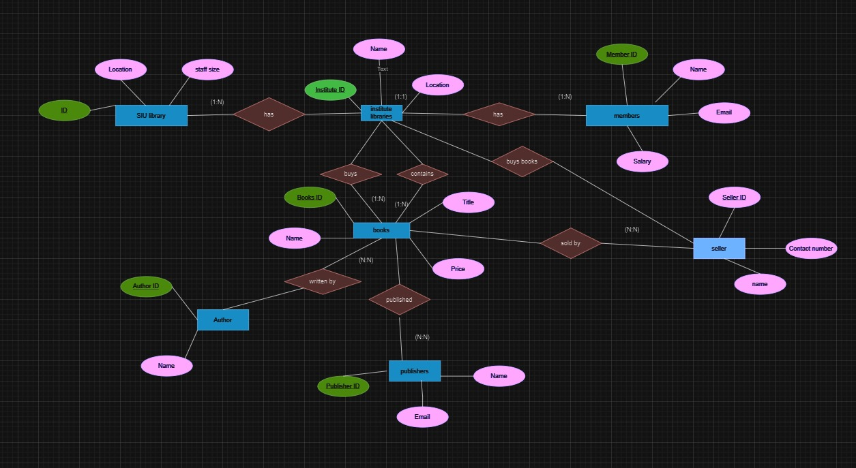

Relational schema:
SIU library(ID, Location, staff size)
Institute library(institute ID, Name, location)
Members(member ID, name, email, salary)
Seller(seller ID, name, contact number)
Publisher(publisher ID, name, email)
Author(author ID, name)
Books(book ID, name, title, genre, price)

Table:
- SIU library
ID | Location | Staff Size
1 | Main Campus | 10
2 | Downtown Branch | 8
3 | North Campus | 12
- Institute library
Institute ID | Name | Location
101 | School of Business | West Campus
102 | College of Arts | East Campus
103 | School of Science | South Campus
- Member4
Member ID | Name | Email | Salary
201 | John Doe | john@example.com | 50000.00
202 | Jane Smith | jane@example.com | 45000.00
203 | Robert Johnson | robert@example.com | 55000.00
- seller
Seller ID | Name | Contact Number
301 | ABC Books | 123-456-7890
302 | XYZ Bookstore | 987-654-3210
303 | ReadItAll Books | 111-222-3333
- publisher
Publisher ID | Name | Email
401 | ABC Publishing | info@abcpublishing.com
402 | XYZ Publishers | info@xyzpublishers.com
403 | ReadItAll Publishers | info@readitall.com
- author
Author ID | Name
501 | Mark Twain
502 | Jane Austen
503 | J.K. Rowling
- books
Book ID | Name | Title | Genre | Price
601 | The Adventures... | The Adventures of Tom | Adventure | 20.00
602 | Pride and Prejudice | Pride and Prejudice | Romance | 15.00
603 | Harry Potter | Harry Potter Series | Fantasy | 25.00

---------------------------------------------------------------------------------------------------------------------
3) online grocery ordering system
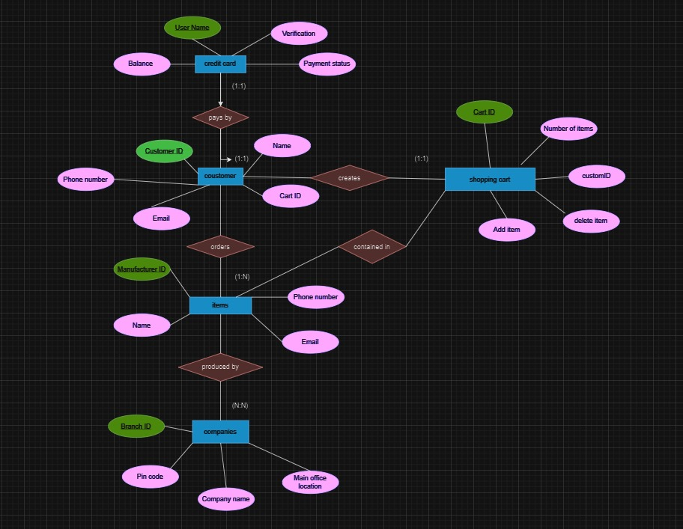

Relational schema:
Credit card(user name, verification, payment status, balance)
Customer(customer ID, name, cart ID, email, phone number)
Shopping cart(cart ID, number of items, customer ID, delete item, add item)
Items(item ID, name, price)
Company(branch ID, pin code, company name, main office location)

Table:
- credit card
User Name | Verification | Payment Status | Balance
Alice | 1234 | Paid | 500.00
Bob | 5678 | Pending | 1000.00
Carol | 9876 | Paid | 200.00
- customer
Customer ID | Name | Cart ID | Email | Phone Number
101 | Alice | 201 | alice@email.com | 123-456-7890
102 | Bob | 202 | bob@email.com | 987-654-3210
103 | Carol | 203 | carol@email.com | 111-222-3333
- shopping cart
Cart ID | Number of Items | Customer ID | Delete Item | Add Item
201 | 3 | 101 | Yes | Yes
202 | 2 | 102 | Yes | Yes
203 | 1 | 103 | Yes | Yes
- items
Item ID | Name | Price
301 | Laptop | 800.00
302 | Smartphone | 500.00
303 | Headphones | 100.00
- company
Branch ID | Pin Code | Company Name | Main Office Location
401 | 12345 | Tech Solutions | Silicon Valley
402 | 54321 | Fashion World | New York City
403 | 67890 | Electronics Empire | Tokyo

