Name: Anushree Dahiya
PRN: 22070122023
Division: CSE-A1
Date: 20-03-24
DBMS Lab Assignment -10
SQL Views

Assignment 10 Lab Questions
Perform a study assignment on SQL Views which should include following details:
Q-1 Need of SQL Views
Ans: SQL View is a way to represent data from one or more tables in a virtual table form. There are many benefits which are offered by SQL view in database management system:-
- Data Abstraction: By hiding extraneous features from consumers, views enable users to abstract away intricate table structures and present data in a more basic format.
- Data Security: By restricting the data that users may view, it adds an extra degree of security by only allowing access to specific columns or rows of a table.
- Simplify questions: By offering a more user-friendly interface, views can capture complex questions and make it simpler for users to construct and comprehend queries.
- Data Integrity: By applying restrictions or computations to the data, views can guarantee data integrity and produce accurate and consistent results.
- Performance Optimisation: By eliminating the need to run complex queries repeatedly, it can be used to precompute and store the results of frequently used queries which improves the query performance.

Q-2 How to implement and use views in MYSQL.
Ans: Following are the ways to implement and use views in SQL:-
- Create View: To create a view, we use the CREATE VIEW statement followed by the view name and the AS keyword, along with the SELECT query that defines the view.
SYNTAX:-
CREATE VIEW view_name AS
SELECT column1, column2, ...
FROM table_name
WHERE condition;
- Using the View: Once the view is created, we can run queries on it as we do on a regular table.
EXAMPLE:- SELECT * FROM view_table_name;
The above example will return all the rows and column that is present in the view table that was created by us with some condition applied on it.
- Modifying and Dropping a View: Views can be modified or dropped using the ALTER VIEW and DROP VIEW statements respectively.
- To modify a view, you use the ALTER VIEW statement followed by the view name and the new SELECT query.
SYNTAX:
ALTER VIEW view_name AS
SELECT new_column1, new_column2, ...
FROM new_table
WHERE new_condition;

- To drop a view, you use the DROP VIEW statement followed by the view name.
SYNTAX:
DROP VIEW view_name;

Q-3 Write a view to select all books of SIT library whose cost is less than 1000/-
mysql> CREATE VIEW Affordable_Books AS
-> SELECT BOOKS.* FROM BOOKS
-> JOIN library ON library.Lid=BOOKS.Lid
-> WHERE BOOKS.Price < 1000 AND library.Iname='SITLib';
Query OK, 0 rows affected (0.03 sec)
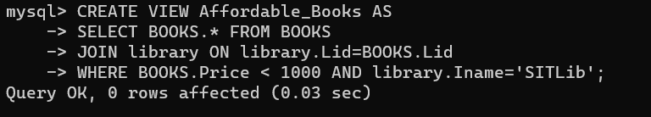
mysql> SELECT * FROM Affordable_Books;
