Name: Anushree Dahiya
PRN: 22070122023
Division: CSE-A1
Date: 29-01-24
DBMS Lab Assignment -2
Conversion of EER Model into Relational Model
Assignment 2 Lab Questions

Theory Questions:-
Q.1 Explain the need of EER diagrams
-> An Entity-Relationship (ER) diagram, often known as an ER model, is a graphic representation of the data schema of a database.
- It makes complex relationship easy to be presented and easy to understand and shows a variety of relationship like one-to-one, one-to-many, etc.
- EER models makes it easy to represent inheritance and hierarchies, making the diagrams easy it understand.
- EER diagrams support a wide variety of attributes which makes it easy to represent multivalued and complicated attributes.
- EER diagrams has superclass and subclass which makes the diagram more enhanced and easy to understand.
- EER diagram has a variety of constraints which are helpful in maintaining the data integrity and some rules.
- EER diagrams makes data visually appealing and enhances the communication of the data among the people and delivers the idea in a more enhanced way.
----------------------------------------------------------------------------------------------------------------------
Q.2 Explain in detail Generalization, specialization and Aggregation and how do we convert them into relational model.
-> Generalization is a bottom- up strategy in which lower level entities can be combined to form a higher level entity. Even we can join a higher level entity with its lower entities to form a more higher level entity.
Specialization is top-down approach in which higher entities can be broken into smaller or lower entities. It is the opposite of generalization. It may occur that some higher level entities don’t have lower level entities.
In aggregation, the relation between two entities is treated as a single entity. In this, one table is treated as a whole while the other is treated as the part of that table. The aggregation is treated as an entity set whose main key is the primary key of the table for R in order to describe a relationship set using an aggregate of R.
Conversion of Generalization and Specialization into a Relational Schema:-
- Create a table which contain all the entities of the higher level.
- Similarly, create for the lower level entities.
- Now, add primary keys of higher level entities in the table of lower level entities.
- In lower level tables, add all other attributes of lower level entities.
- Declare the primary key of the higher level table and the primary key of the lower level table.
- Declare foreign key constraints also.

--------------------------------------------------------------------------------------------------------------------
Implementation Question:-
Q.1 Draw the EER for SIU library management and convert into relational model.
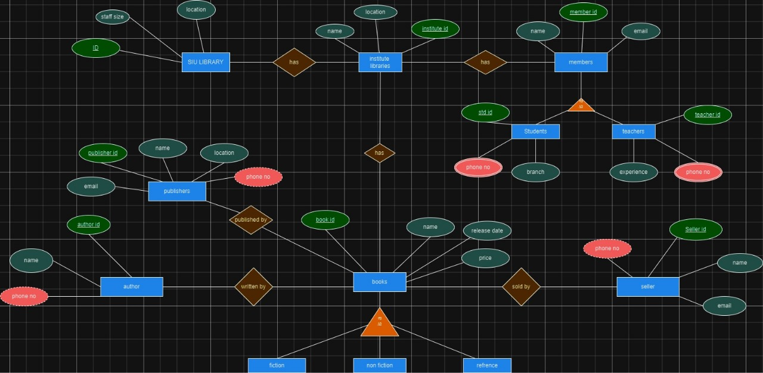

RELATIONAL SCHEMA:-

SIU_LIBRARY (ID, Staff_size, location)
INSTITUTE_LIBRARIES (institute_id, name, location)
MEMBER (member_id, name, email)
STUDENT ( std_id, branch, name, email, phone_no, member_id)
TEACHER ( teacher_id, experience, name, email, phone_no, member_id)
PUBLISHER (publisher_id, name, email, location, phone_no)
AUTHOR ( author_id, name, phone_no)
BOOK (book_id, name, release date, price)
SELLER (seller_id, name, email, phone_no)
FICTION (book_id, name, release date, price)
NON-FICTION (book_id, name, release date, price)
REFERENCE (book_id, name, release date, price)

TABLES:-
SIU LIBRARY
ID | Staff size | Location
123889 | 20 | Hill top
228854 | 43 | Hill base
143789 | 21 | Hyderabad
346612 | 33 | Nagpur

INSTITUTE LIBRARIES
Institute ID | Name | Location
101 | SIHS | Hill top
210 | SIBS | Hill top
143 | SIT | Hill base
346 | SSCA | Hill base

MEMBER
Member ID | Name | Email
222 | Ram | ram@gmail.com
223 | Sham | Sham20@gmail.com
224 | Lucy | Lucy556@gmail.com
225 | Leo | Leoo300@gmail.com

STUDENT
STD ID | Name | Branch | Email | Phone No | Member ID
101 | Min ho | CSE | min.ho@gmail.com | 8787896756 | 228
102 | Shann | AIML | shann@gmail.com | 9876548970 | 229
103 | Goku | CSE | goku@gmail.com | 2388765456 | 230
104 | Nonen | CE | nonen@gmail.com | 2312456789 | 231

TEACHER
Teacher ID | Name | Experience | Email | Phone No | Member ID
101 | Sonh | 10 | sonh@gmail.com | 9866332345 | 232
102 | Jack | 5 | jack@gmail.com | 9876587880 | 233
103 | Jill | 7 | Jill@gmail.com | 2388765890 | 234
104 | Eggy | 2 | eggy@gmail.com | 2312456799 | 235

PUBLISHER
Publisher_Id | Name | Email | Location | Phone no
889 | Min shan | Min.shan@gmail.com | Pune | 3423567895
880 | Okhi | Okhi@gmail.com | Chennai | 4423378678
887 | Shuna | shuna@gmail.com | Mumbai | 9876543210
886 | Jacky | jacky@gmail.com | Delhi | 8878906656
AUTHOR
Author ID | Name | Phone
401 | Bhanu | 9988776655
402 | Golu | 8877669900
403 | Daksh | 8899556644
404 | Yahnu | 5533778899
BOOK
Book ID | Name | Release Date | Price
2345 | Pride and Preduice | 26.02.2023 | 540
2346 | Hello world | 05.06.2020 | 980
2347 | Ok not to be ok | 04.09.2019 | 998
2349 | No worries | 09.12.2007 | 350

SELLER
Seller ID | Name | Email | Phone no
5433 | Minika | minika@gmail.com | 9988776655
5546 | Rachel | rachel@gmail.com | 9898767656
5543 | Luna | luna@gmail.com | 9765434567
5467 | Lammy | lammy@gmail.com | 9087989090

FICTION
Book ID | Name | Release Date | Price
235 | What is happening | 26.03.2023 | 550
246 | Hello what | 05.05.2020 | 900
247 | Quick worries | 04.02.2019 | 650
239 | No no no | 09.10.2007 | 450

NON- FICTION
Book ID | Name | Release Date | Price
889 | Revolutionary | 02.02.2023 | 545
766 | Mahatma Gandhi | 30.06.2020 | 900
547 | World Dominance | 19.09.2019 | 999
349 | Learn to speak | 10.12.2007 | 355

REFERENCE
Book ID | Name | Release Date | Price
001 | C++ | 16.02.2009 | 340
002 | Java | 25.06.2019 | 780
003 | Know your skills | 14.09.2018 | 498
004 | Money Heist | 29.12.2007 | 750

-------------------------------------------------------------------------------------------------------------------
Q.2 Convert following EER to relational model

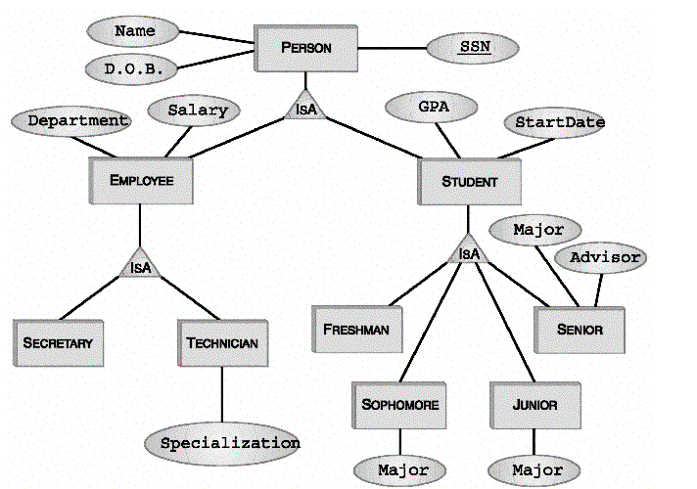

RELATIONAL SCHEMA:-

PERSON (SSN, Name, D.O.B)
EMPLOYEE (SSN, Name, D.O.B, Department, Salary)
SECRETARY(SSN, Name, D.O.B, Department, Salary)
TECHNICIAN( SSN, Name, D.O.B, Department, Salary , Specialization)
STUDENT( SSN, Name, D.O.B, GPA, StartDate)
FRESHMAN(SSN, Name, D.O.B, GPA, StartDate)
SOPHOMORE( SSN, Name, D.O.B, GPA, StartDate, Major)
JUNIOR( SSN, Name, D.O.B, GPA, StartDate, Major)
SENIOR(SSN, Name, D.O.B, GPA, StartDate, Major, Advisor)

TABLES:-

PERSON:-
SSN | Name | D.O.B
101 | Anu | 26.02.2004
102 | Pinu | 05.06.2004
103 | Lucy | 04.09.2004
104 | Leo | 09.12.2004

EMPLOYEE:-
SSN | Name | D.O.B | Department | Salary
201 | Lion | 02.06.2001 | Marketing | 90000
202 | Tiger | 09.05.1999 | Finance | 89000
203 | Ji-won | 25.09.1998 | Assistant Manager | 55000
204 | Man-hyunk | 30.02.2002 | Media | 32800

STUDENT:-
SSN | Name | D.O.B | GPA | Start Date
001 | Shinny | 09.07.2005 | 7.81 | 12.10.2020
002 | Pearcy | 12.07.2005 | 9.01 | 30.10.2020
003 | Suzumi | 03.09.2005 | 8.98 | 04.09.2020
004 | Sammy | 26.11.2005 | 7.45 | 05.11.2020

SECRETARY:-
SSN | Name | D.O.B | Department | Salary
556 | Sam | 09.07.1997 | Marketing | 68000
908 | DBRoa | 12.07.1998 | Media | 44000
453 | Ji-Yan | 30.02.2000 | Assistant Manager | 98000
667 | Min-shan | 26.11.2001 | Finance | 33800

TECHNICIAN:-
SSN | Name | D.O.B | Department | Salary | Specialization
503 | Ram | 30.02.2001 | Media | 65000 | Streaming
907 | Rom | 12.08.1995 | Computer | 42000 | Coding
454 | John-gin | 31.01.2000 | Networking | 64000 | Communication
654 | Mannin | 26.11.1999 | Finance | 31800 | Calculation

FRESH MAN:-
SSN | Name | D.O.B | GPA | Start Date
001 | Ram-oh | 09.07.2004 | 8.56 | 12.10.2019
002 | Sammi | 12.07.2003 | 8.46 | 30.08.2020
003 | John-gon | 03.09.2005 | 6.87 | 04.10.2020
004 | Mannin-in | 26.11.2002 | 7.45 | 05.11.2019

SOPHOMORE:-
SSN | Name | D.O.B | GPA | Start Date | Major
555 | Rin-ohn | 09.04.2004 | 8.06 | 12.10.2019 | CSE
556 | Samoi | 12.06.2003 | 6.36 | 11.08.2020 | AIML
557 | Jon-gon | 03.12.2005 | 5.87 | 12.10.2020 | CSE
558 | Manin-in | 26.11.2002 | 7.45 | 30.11.2019 | EnTC

JUNIOR:-
SSN | Name | D.O.B | GPA | Start Date | Major
006 | Rin-onh | 09.12.2003 | 8.34 | 12.11.2019 | AIML
008 | Samoioni | 12.04.2003 | 9.12 | 11.09.2020 | CSE
009 | Jon-gonhn | 03.11.2002 | 8.70 | 12.01.2020 | CE
010 | Manin-inn | 26.10.2001 | 7.30 | 30.09.2019 | RnA

SENIOR:-
SSN | Name | D.O.B | GPA | Start Date | Major | Advisor
015 | Shan | 17.12.2003 | 7.34 | 11.11.2019 | CE | Ramu
016 | Qwertz | 20.04.2003 | 5.12 | 05.09.2020 | RnA | Pinky
017 | Jack | 25.11.2002 | 8.70 | 09.01.2020 | CSE | Shammu
018 | Jill | 30.10.2001 | 3.30 | 03.09.2019 | EnTC | Shonu

