Name: Anushree Dahiya
PRN: 22070122023
Division: CSE-A1
Date: 05-02-24
DBMS Lab Assignment -3
Introduction to DDL and DML commands and its execution
Assignment 3 Lab Questions

Section- 1 DDL Commands

Q-1 Explain DDL commands and their syntax.
- DDL commands are used to describe a database schema and is used to modify and create the structure of database objects in the database. By DDL commands we can either create or modify or delete the database schema but can’t alter the data.
Following are some DDL commands:-
- CREATE: It is used to create a new database or its objects like tables, indexes, etc.
Syntax:
CREATE TABLE table_name (
Column_name1 datatype(size),
Column_name2 datatype(size),
Column_name3 datatype(size),
…..);

- ALTER: It is used to alter the database of pre-existing table.
Syntax:-
ALTER TABLE table_name ADD (
Column_name1 datatype(size),
Column_name2 datatype(size),
Column_name3 datatype(size),
…);

- TRUNCATE: It is used to remove all the data present in the table, including the spaces, only the structure of database is preserved.
Syntax:-
TRUNCATE TABLE table_name;

- DROP: It is used to delete the table or whole database.
Syntax:-
DROP object object_name;
Syntax to drop a table:-
DROP TABLE table_name;
Syntax to drop a database:-
DROP DATABASE database_name;

- RENAME: It is used to rename an already created table.
Syntax to rename a table:-
ALTER TABLE table_name RENAME TO new_table_name ;
Syntax to rename a column:-
ALTER TABLE table_name RENAME COLUMN old_name TO new_name;

- COMMENT: It is used to add comments to the data dictionary.
Syntax for single line comment:-
-single line comment
-another comment
SELECT * FROM Customers;
Syntax for multi-line comment:-
/*multi-line comment
another comment*/
SELECT * FROM Customers;
Syntax for in-line comment:-
SELECT * FROM /* Customers; */

Q-2 Create tables for the following relational model of library management. Apply constraints on the columns and also alter the structure according to your requirements.
- SIULIBRARY (Slid,lname,location,noofbranches)
CODE:-
mysql> CREATE TABLE library(
-> SLID INT PRIMARY KEY,
-> Iname VARCHAR(50) NOT NULL,
-> location VARCHAR(50) NOT NULL,
-> noofbranches INT NOT NULL
-> );
Query OK, 0 rows affected (0.08 sec)
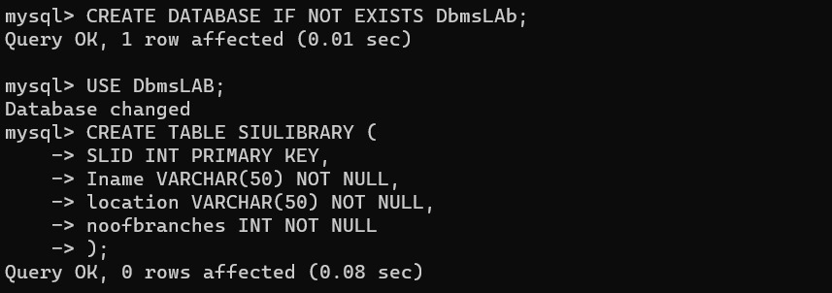

- Ilibrary(Lid, lname, city, area, slid)
CODE:-
mysql> CREATE TABLE library(
-> Lid INT PRIMARY KEY,
-> Iname VARCHAR(50) NOT NULL,
-> city VARCHAR(20) NOT NULL,
-> area VARCHAR(20),
-> slid INT,
-> FOREIGN KEY(slid) REFERENCES SIULIBRARY (SLID)
-> );
Query OK, 0 rows affected (0.09 sec)
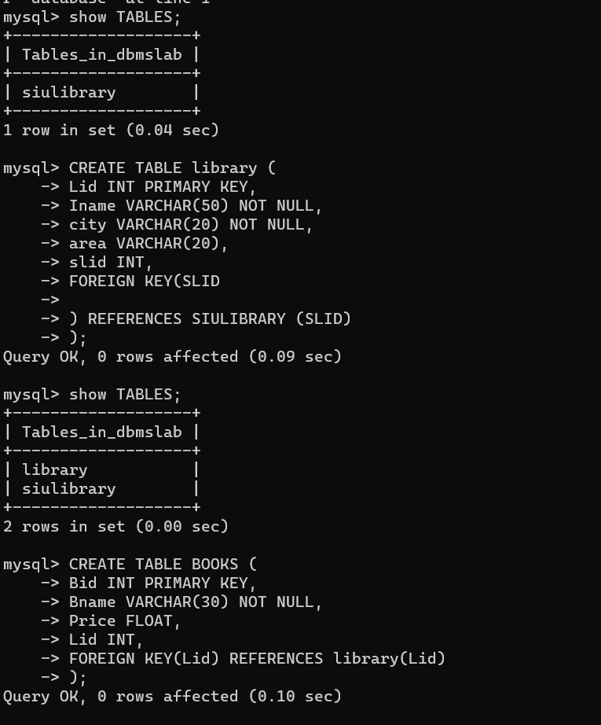

- BOOKS(Bid, Bname, Price , Lid)
CODE:-
mysql> CREATE TABLE BOOKS(
-> Bid INT PRIMARY KEY,
-> Bname VARCHAR(30) NOT NULL,
-> Price FLOAT,
-> Lid INT,
-> FOREIGN KEY(Lid) REFERENCES library(Lid)
-> );
Query OK, 0 rows affected (0.10 sec)

- Noofcopies(bnid,bid, lid)
CODE:-
mysql> CREATE TABLE Noofcopies(
-> bnid INT PRIMARY KEY,
-> bid INT,
-> FOREIGN KEY(bid) REFERENCES BOOKS(Bid),
-> lid INT,
-> FOREIGN KEY(lid) REFERENCES library(Lid)
-> );
Query OK, 0 rows affected (0.06 sec)
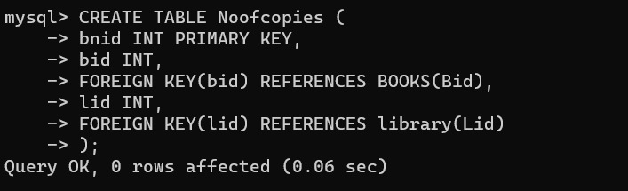

- AUTHOR(Aid, Aname,email,phoneno)
CODE:-
mysql> CREATE TABLE AUTHOR(
-> Aid INT PRIMARY KEY,
-> Aname VARCHAR(50) NOT NULL,
-> email VARCHAR(40),
-> phoneno VARCHAR(15)
-> );
Query OK, 0 rows affected (0.03 sec)
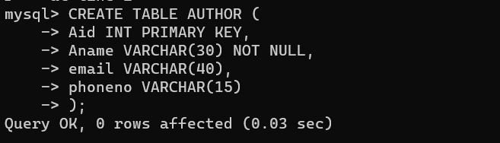

- Writes(Bid, Aid, pid)
CODE:-
mysql> CREATE TABLE Writes (
-> Bid INT,
-> Aid INT,
-> Pid INT,
-> FOREIGN KEY(Bid) REFERENCES BOOKS(Bid),
-> FOREIGN KEY(Aid) REFERENCES AUTHOR(Aid),
-> FOREIGN KEY(Pid) REFERENCES PUBLISHER(Pid)
-> );
Query OK, 0 rows affected (0.08 sec)
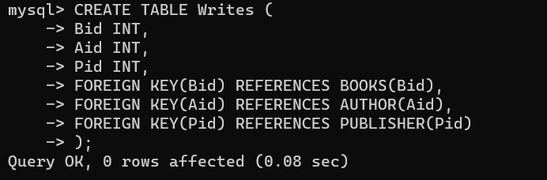

- PUBLISHER(Pid, Pname)
CODE:-
mysql> CREATE TABLE PUBLISHER(
-> Pid INT PRIMARY KEY,
-> Pname VARCHAR(50)
-> );
Query OK, 0 rows affected (0.02 sec)
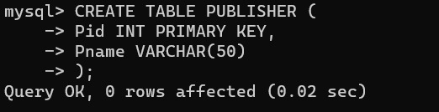

- SELLER(Sid, slname, city)
CODE:-
mysql> CREATE TABLE SELLER(
-> Sid INT PRIMARY KEY,
-> slname VARCHAR(50),
-> city VARCHAR(50)
-> );
Query OK, 0 rows affected (0.03 sec)
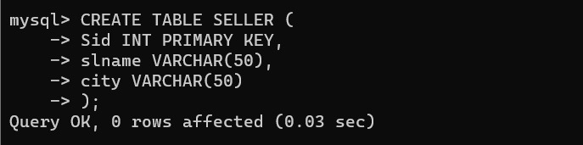

- DEPARTMENT (Deptid,deptname, Iname,lid)
CODE:-
mysql> CREATE TABLE DEPARTMENT (
-> Deptid INT PRIMARY KEY,
-> deptname VARCHAR(50),
-> Iname VARCHAR(50),
-> lid INT,
-> FOREIGN KEY(lid) REFERENCES library(Lid)
-> );
Query OK, 0 rows affected (0.04 sec)
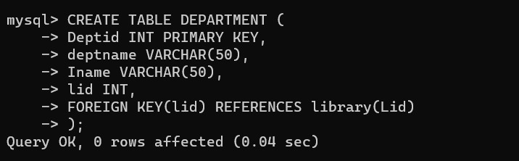

- STUDENT(Stuid, Sname, email,memid deptid)
CODE:-
mysql> CREATE TABLE STUDENT(
-> Stuid INT PRIMARY KEY,
-> Sname VARCHAR(50),
-> email VARCHAR(50),
-> memid INT,
-> deptid INT,
-> FOREIGN KEY(memid) REFERENCES Member(memid),
-> FOREIGN KEY(deptid) REFERENCES DEPARTMENT(Deptid)
-> );
Query OK, 0 rows affected (0.06 sec)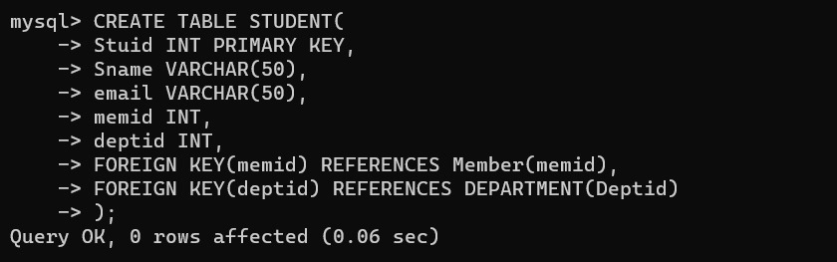

- STAFF(Stid, stname, email, deptid,memid)
CODE:-
CREATE TABLE STAFF(
-> Stid INT PRIMARY KEY,
-> stname VARCHAR(50),
-> email VARCHAR(50),
-> deptid INT,
-> memid INT,
-> FOREIGN KEY(deptid) REFERENCES DEPARTMENT(Deptid),
-> FOREIGN KEY(memid) REFERENCES Member(memid)
-> );
Query OK, 0 rows affected (0.05 sec)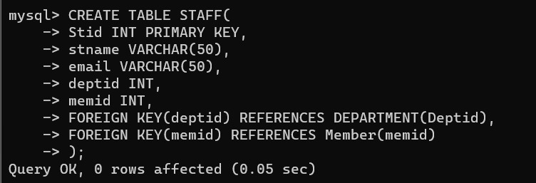

- PURCHASE(prid , lid, sid, pid, bid, quantity ,date, totalcost)
CODE:-
mysql> CREATE TABLE PURCHASE(
-> prid INT PRIMARY KEY,
-> lid INT,
-> sid INT,
-> pid INT,
-> bid INT,
-> quantity INT,
-> date DATE,
-> totalcost DECIMAL(10, 2),
-> FOREIGN KEY(sid) REFERENCES SELLER(Sid),
-> FOREIGN KEY(pid) REFERENCES PUBLISHER(Pid),
-> FOREIGN KEY(bid) REFERENCES BOOKS(Bid),
-> FOREIGN KEY(lid) REFERENCES library(Lid)
-> );
Query OK, 0 rows affected (0.07 sec)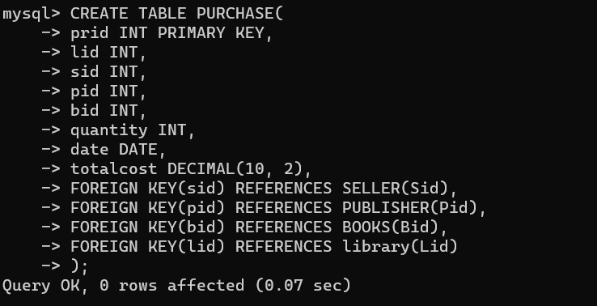

- ISSUE(lssueid, memid, bid, lid, issuedate, returndate)
CODE:-
mysql> CREATE TABLE ISSUE(
-> Issueid INT PRIMARY KEY,
-> memid INT,
-> bid INT,
-> bnid INT,
-> lid INT,
-> issuedate DATE,
-> returndate DATE,
-> FOREIGN KEY(bid) REFERENCES BOOKS(Bid),
-> FOREIGN KEY(bnid) REFERENCES Noofcopies(bnid),
-> FOREIGN KEY(lid) REFERENCES library(Lid),
-> FOREIGN KEY(memid) REFERENCES Member(memid)
-> );
Query OK, 0 rows affected (0.07 sec)
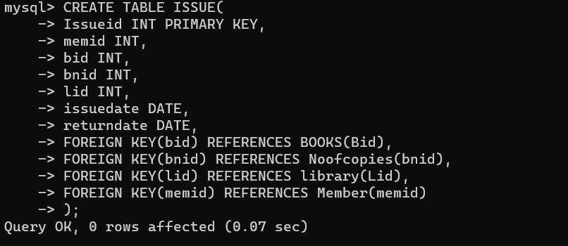

- SELLS (sid, bid,pid)
CODE:-
mysql> CREATE TABLE SELLS(
-> sid INT,
-> bid INT,
-> pid INT,
-> FOREIGN KEY(sid) REFERENCES SELLER(Sid),
-> FOREIGN KEY(bid) REFERENCES BOOKS(Bid),
-> FOREIGN KEY(pid) REFERENCES PUBLISHER(Pid)
-> );
Query OK, 0 rows affected (0.05 sec)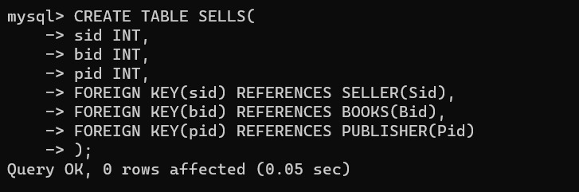

- Employee(eid,empname,email,salary,lid)
CODE:-
mysql> CREATE TABLE Employee(
-> eid INT PRIMARY KEY,
-> empname VARCHAR(50),
-> email VARCHAR(50),
-> salary DECIMAL(10, 2),
-> lid INT,
-> FOREIGN KEY(lid) REFERENCES library(Lid)
-> );
Query OK, 0 rows affected (0.05 sec)
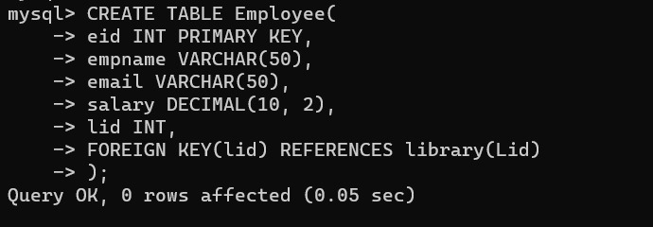

- A_specialization(spec_id,spec_name,Aid)
CODE:-
mysql> CREATE TABLE A_specialization(
-> spec_id INT PRIMARY KEY,
-> spec_name VARCHAR(50),
-> Aid INT,
-> FOREIGN KEY(Aid) REFERENCES AUTHOR(Aid)
-> );
Query OK, 0 rows affected (0.05 sec)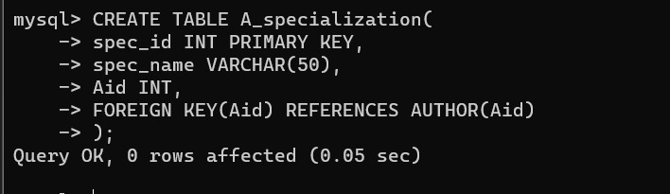

- Member(memid,lid)
CODE:-
mysql> CREATE TABLE Member(
-> memid INT PRIMARY KEY,
-> lid INT,
-> FOREIGN KEY(lid) REFERENCES library(lid)
-> );
Query OK, 0 rows affected (0.05 sec)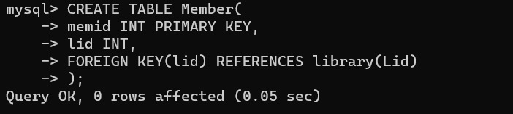
------------------------------------------------------------------------------------------------------------------------

DATABASE:-
mysql> show tables;
+-------------------+
| Tables_in_dbmslab |
+-------------------+
| a_specialization |
| author |
| books |
| department |
| employee |
| issue |
| library |
| member |
| noofcopies |
| publisher |
| purchase |
| seller |
| sells |
| siulibrary |
| staff |
| student |
| writes |
+-------------------+
17 rows in set (0.00 sec)

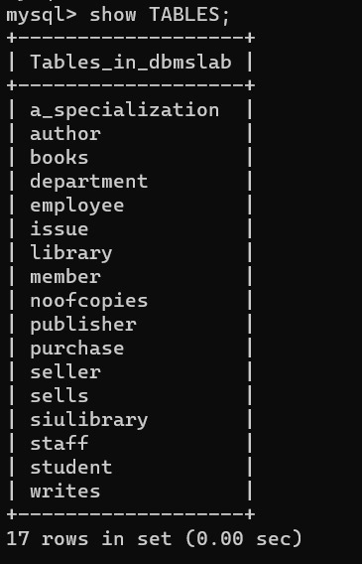

-----------------------------------------------------------------------------------------------------------------
Section- 2 DML Command execution

Q-1. Explain DML commands and their syntax.
- The Data Manipulation Language(DML) deals with those SQL commands that are used to manipulate the data present in the database.
Following are some of the DML commands:-
- INSERT:- It is used to insert data into the table.
Syntax:-
INSERT INTO table_name (column1, column2, …column_n) VALUES (value1, value2…..value_n);

- UPDATE: It is used to update the data of an existing table database.
Syntax:
UPDATE table_name SET column1=value1, column2=value2,…..WHERE condition;

- SELECT: It is used to retrieve data back from the table.
Syntax:-
SELECT * FROM table_name;
Syntax:-
SELECT colimn_name1, column_name2,…. FROM table_name WHERE condition;

- DELETE:- It is used to remove one or more rows from the table.
Syntax:-
DELETE FROM table_name WHERE condition;

- MERGE: It is used to perform insert, update, or delete operation based on specified condition given.
Syntax:-
MERGE INTO target_table_name USING source_table
ON (condition)
WHEN MATCHED THEN
UPDATE SET column1=value1, column2=value2,…
WHEN NOT MATCHED THEN
INSERT (colummn1, column2, …) VALUES( value1, value2,…)
WHEN NOT MATCHED BY SOURCE THEN
DELETE;

Q-2. Insert 5 tuples in each of the created tables.
mysql> INSERT INTO SIULIBRARY(SLID, Iname, location, noofbranches) VALUES (1, 'Pune Central Library', 'Pune', 10);
Query OK, 1 row affected (0.01 sec)
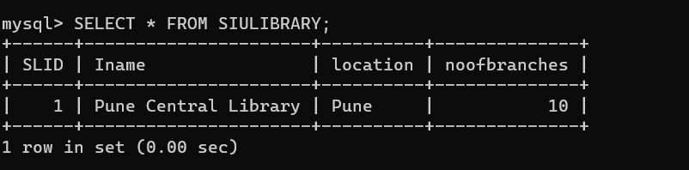
------------------------------------------------------------------------------------------------------------------
mysql> INSERT INTO library(Lid, Iname,city, area, slid) VALUES
-> (1, 'SITLib', 'Pune', 'Lavale', 1),
-> (2, 'SIBMLib', 'Pune', 'Lavale', 1),
-> (3, 'SSACLib', 'Nagpur', 'Ramnagar', 1),
-> (4, 'SSLALib', 'Pune', 'Vimannagar', 1),
-> (5, 'SIBMBLib', 'Bangalore', 'Jaynagar', 1),
-> (6, 'SITMHLib', 'Hyderabad', 'Banjara hills', 1),
-> (7, 'SIOMLib', 'Pune', 'S.B.Road', 1),
-> (8, 'SITMNLib', 'Noida', 'Golf Course Area', 1),
-> (9, 'SILAHLib', 'Hyderabad', 'Gacchibowli', 1),
-> (10, 'SSBSLib', 'Pune', 'Tithnagar', 1);
Query OK, 10 rows affected (0.01 sec)
Records: 10 Duplicates: 0 Warnings: 0
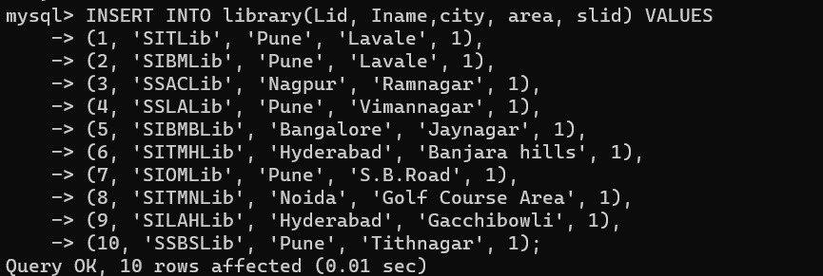
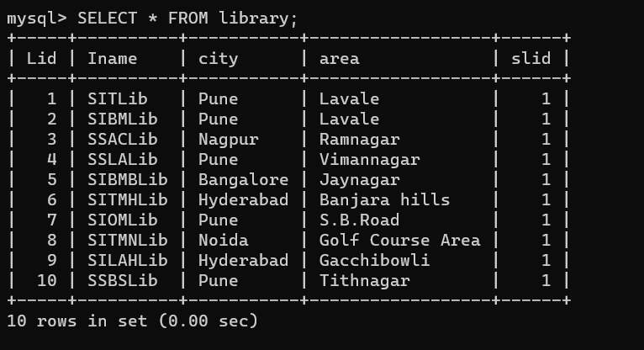
--------------------------------------------------------------------------------------------------------
mysql> INSERT INTO BOOKS(Bid, Bname, Price, Lid) VALUES
-> (1, 'Operating System', 1000, 1),
-> (2, 'Management System', 2500, 2),
-> (3, 'Supply Chain Management', 500, 8),
-> (4, 'Bioinformatics', 780, 10),
-> (5, 'Tele Informatics', 4567, 10),
-> (6, 'IP and Patents formation', 345, 4),
-> (7, 'engineering Graphics', 2456, 1),
-> (8, 'Customer Management', 3467, 5),
-> (9, 'Buying Pattern Analysis', 456, 8),
-> (10, 'Digital Finance', 600, 8),
-> (11, 'Telecommunication', 1500, 6),
-> (12, 'Algorithms', 6754, 1),
-> (13, 'Child Law', 1800, 4),
-> (14, 'Multimanagers', 2345, 2),
-> (15, 'MicroEconomics', 267, 5),
-> (16, 'Electronics', 2341, 1),
-> (17, 'Structure foundations', 1700, 3),
-> (18, 'Ecohomes', 1234, 3)
-> ;
Query OK, 18 rows affected (0.01 sec)
Records: 18 Duplicates: 0 Warnings: 0
mysql> INSERT INTO BOOKS(Bid, Bname, Price, Lid) VALUES
-> (19, 'Mobile Communication', 456, 6),
-> (20,'Labor Laws', 3452, 9),
-> (21,'Copyrights',2789,9),
-> (22,'Research Laws',1100,9),
-> (23,'DBMS',700,1),
-> (24,'Computer networks',3451,1);
Query OK, 6 rows affected (0.02 sec)
Records: 6 Duplicates: 0 Warnings: 0
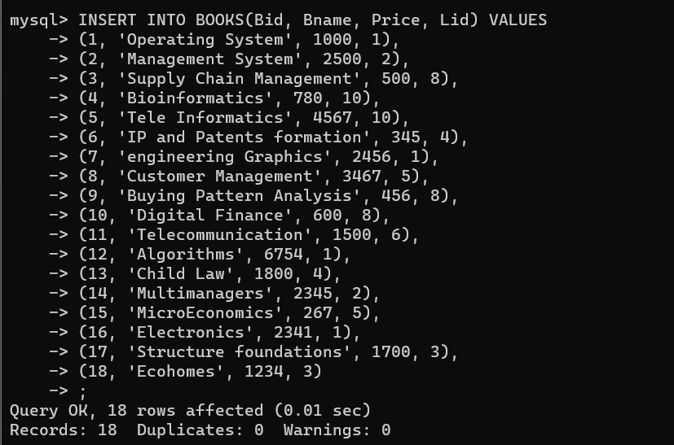
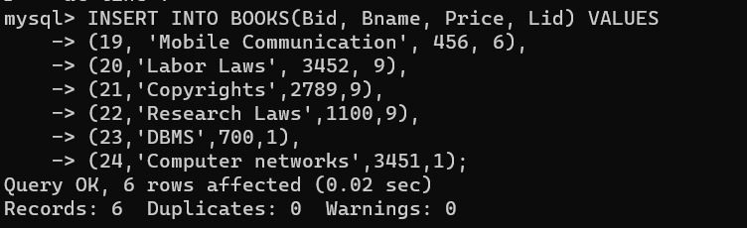
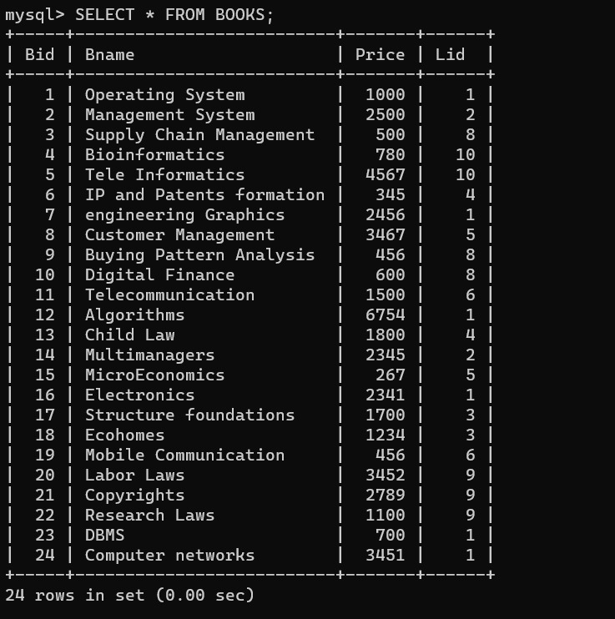
----------------------------------------------------------------------------------------------------------------
mysql> INSERT INTO Noofcopies(bnid,bid,lid) VALUES
-> (1,1,1),
-> (2,1,2),
-> (3,1,3),
-> (4,3,1),
-> (5,3,2),
-> (6,3,3),
-> (7,2,1),
-> (8,2,2),
-> (9,4,1),
-> (10,4,2),
-> (11,4,3),
-> (12,5,1),
-> (13,5,2),
-> (14,6,1),
-> (15,7,1),
-> (16,8,1),
-> (17,8,2),
-> (18,9,1),
-> (19,10,1),
-> (20,11,1),
-> (21,12,1),
-> (22,12,2),
-> (23,13,1),
-> (24,13,2),
-> (25,14,1),
-> (26,14,2),
-> (27,14,4),
-> (28,15,1),
-> (29,15,2),
-> (30,16,1),
-> (31,16,2),
-> (32,17,1);
Query OK, 32 rows affected (0.01 sec)
Records: 32 Duplicates: 0 Warnings: 0
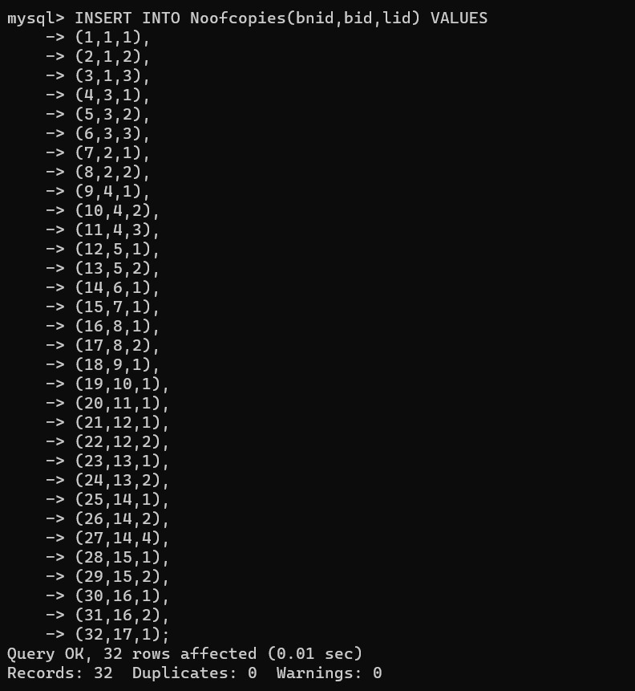
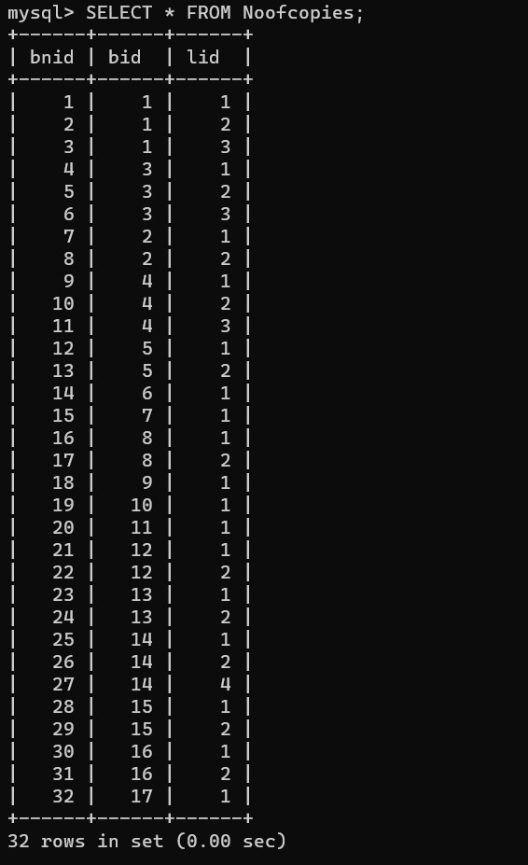
--------------------------------------------------------------------------------------------------------------
mysql> INSERT INTO AUTHOR(Aid,Aname,email,phoneno) VALUES
-> (1, 'Shruti', 'abc@gmail.com', '6447896542'),
-> (2, 'Shivam Kapoor', 'adf@gmail.com', '2345778998'),
-> (3, 'Ameya', 'ert@gmail.com', '23456789087'),
-> (4, 'Pooja Pai', 'edr@gamil.com', '32554565678'),
-> (5, 'Brian Kernighan', 'rtyu@gmail.com', '2143454657'),(6, 'Ken Thompson', 'errt@gmail.com', '2343454565');
Query OK, 6 rows affected (0.04 sec)
Records: 6 Duplicates: 0 Warnings: 0
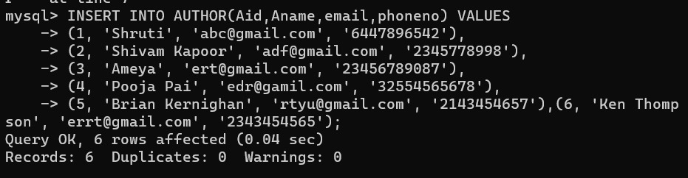
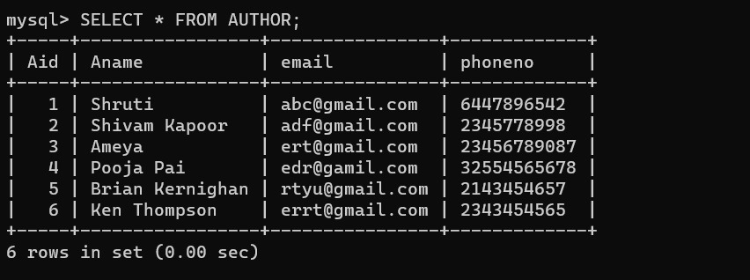
-----------------------------------------------------------------------------------------------------------------
mysql> INSERT INTO PUBLISHER (Pid,Pname) VALUES
-> (1, 'Tata Macgraw hill'),
-> (2, 'Pragati book store'),
-> (3, 'Prentice Hall'),
-> (4, 'OReilly'),
-> (5, 'Emrald publishing');
Query OK, 5 rows affected (0.05 sec)
Records: 5 Duplicates: 0 Warnings: 0
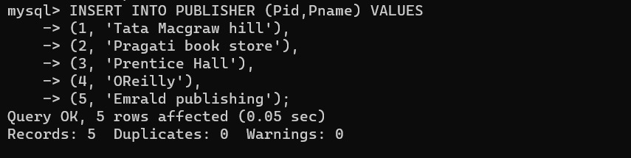
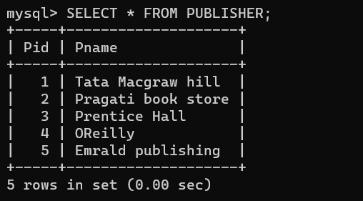
--------------------------------------------------------------------------------------------------------------
mysql> INSERT INTO Writes(Bid, Aid, Pid) VALUES(1,1,2),
-> (2,2,3),
-> (3,5,2),
-> (4,6,4),
-> (5,1,5),
-> (6,1,2),
-> (7,4,1),
-> (8,2,2),
-> (9,5,5),
-> (10,6,4),
-> (11,1,1),
-> (12,4,2),
-> (13,5,5),
-> (14,6,2),
-> (15,3,1),
-> (16,4,2),
-> (17,6,5),
-> (18,2,4),
-> (19,5,1),
-> (20,1,2),
-> (21,3,5),
-> (22,5,2),
-> (23,6,1),
-> (24,3,3);
Query OK, 24 rows affected (0.05 sec)
Records: 24 Duplicates: 0 Warnings: 0
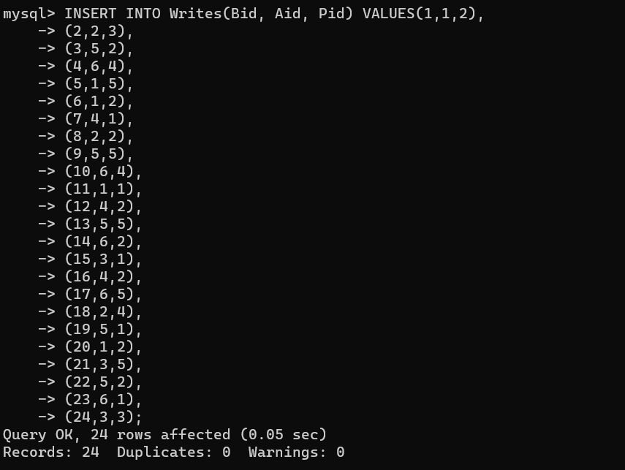
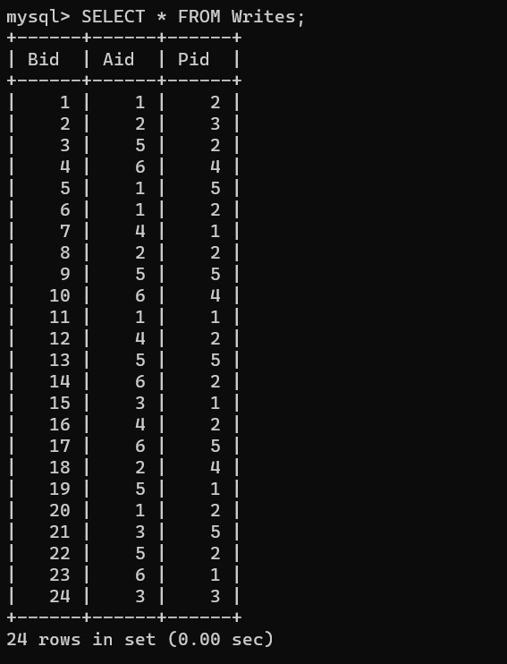
------------------------------------------------------------------------------------------------------------------------
mysql> INSERT INTO SELLER(Sid, slname,city) VALUES
-> (1, 'Kohinoor', 'Pune'),
-> (2, 'Shiksha', 'Pune'),
-> (3, 'ABP', 'Noida'),
-> (4, 'Technical', 'Hyderabad'),
-> (5, 'Timenowta', 'Bangalore'),
-> (6, 'Kirti', 'Pune');
Query OK, 6 rows affected (0.01 sec)
Records: 6 Duplicates: 0 Warnings: 0
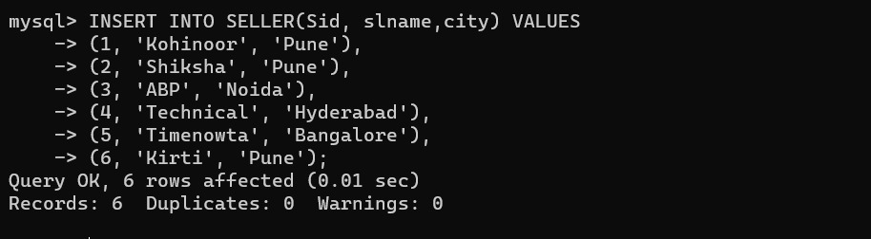
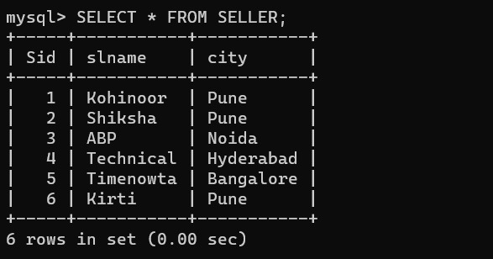
-------------------------------------------------------------------------------------------------------------------------
mysql> INSERT INTO DEPARTMENT(Deptid, deptname,Iname,lid) VALUES
-> (1, 'Civil', 'SIT', 1),
-> (2, 'E&TC', 'SIT', 1),
-> (3, 'Biology', 'SSBS', 10),
-> (4, 'Law', 'SSLA', 4),
-> (5, 'Structure', 'SSAC', 3),
-> (6, 'Finance Management', 'SIBM', 2),
-> (7, 'Digital Telecommunications', 'SITMH', 6),
-> (8, 'Clinical Research', 'SSBS', 10);
Query OK, 8 rows affected (0.05 sec)
Records: 8 Duplicates: 0 Warnings: 0
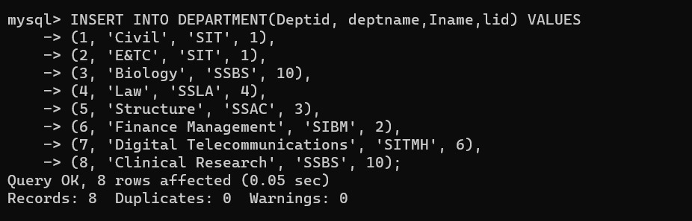
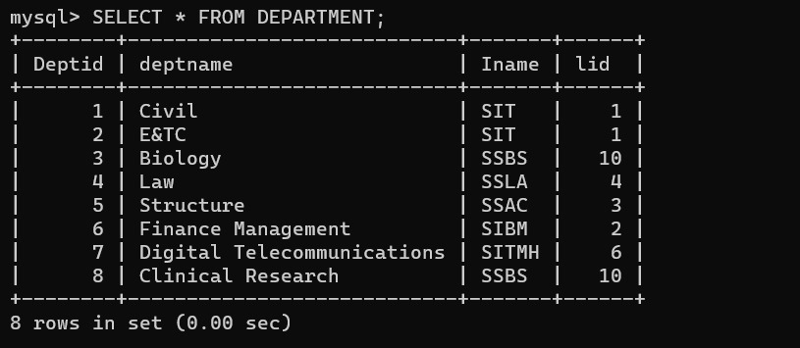
-----------------------------------------------------------------------------------------------------------
mysql> INSERT INTO Member(memid, lid) VALUES
-> (1,1),
-> (16,1),
-> (13,1),
-> (44,1),
-> (35,1),
-> (26,10),
-> (45,1),
-> (23,10),
-> (12,3),
-> (78,1),
-> (49,4),
-> (50,1);
Query OK, 12 rows affected (0.05 sec)
Records: 12 Duplicates: 0 Warnings: 0
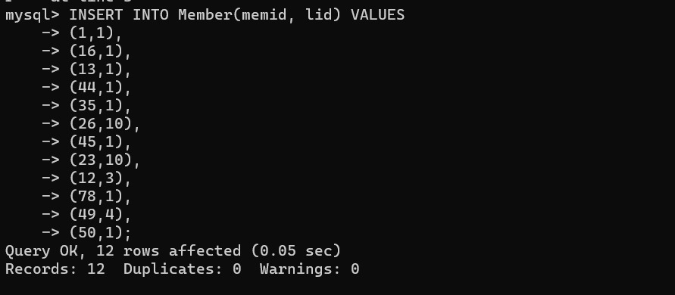
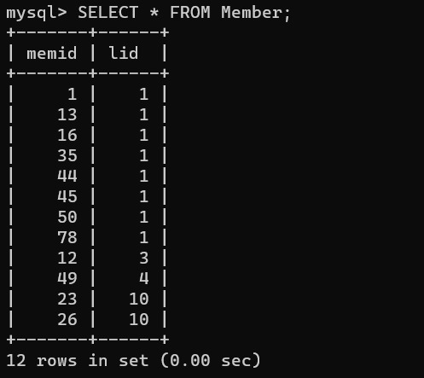
----------------------------------------------------------------------------------------------------------
mysql> INSERT INTO STUDENT(Stuid, Sname, email,memid,deptid) VALUES
-> (1, 'Pooja', 'aswq@gmail.com', 1, 1),
-> (2, 'Satish', 'azsx@gmail.com', 16, 1),
-> (3, 'Amar', 'cvnn@gmail.com', 13, 2),
-> (4, 'Meera', 'lkio@gmail.com', 44, 2),
-> (5, 'Ravi', 'fghj@gmail.com', 35, 2),
-> (6, 'Adit', 'cfgb@gmail.com', 26, 3);
Query OK, 6 rows affected (0.03 sec)
Records: 6 Duplicates: 0 Warnings: 0
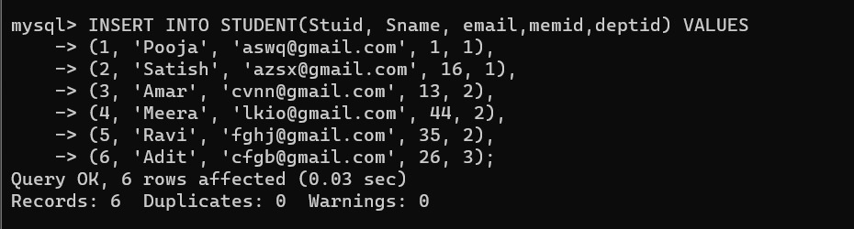
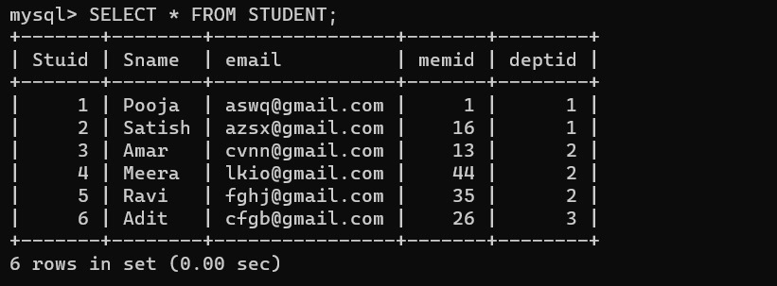
-----------------------------------------------------------------------------------------------------------------
mysql> INSERT INTO STAFF(Stid, stname, email, memid, deptid) VALUES
-> (1, 'Satish', 'sddf@gmail.com', 45, 1),
-> (2, 'Rachit', 'zxzxc@gmail.com', 23, 3),
-> (3, 'Seema', 'lkklk@gmail.com', 12, 5),
-> (4, 'Sayali', 'xzcxc@gmail.com', 78, 2),
-> (5, 'Aditya', 'cvvcb@gmail.com', 49, 4),
-> (6, 'Archit', 'gfdfg@gmail.com', 50, 1);
Query OK, 6 rows affected (0.02 sec)
Records: 6 Duplicates: 0 Warnings: 0
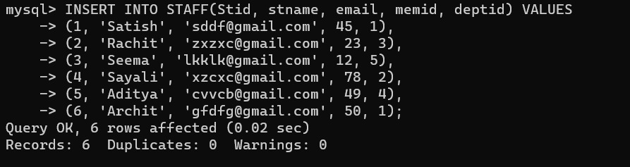
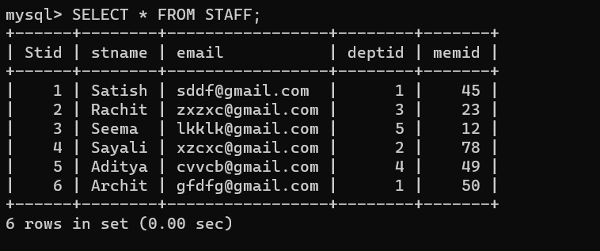
--------------------------------------------------------------------------------------------------------------------- mysql> INSERT INTO PURCHASE (prid, lid, sid,pid,bid, quantity, date, totalcost) VALUES
-> (1001, 1, 1, 3, 1, 100, '2015-07-12', 70000),
-> (1002, 2, 3, 4, 2, 1000, '2015-04-10', 80000),
-> (1003, 1, 4, 2, 5, 45, '2016-08-01', 4500),
-> (1004, 4, 1, 5, 6, 34, '2016-02-06', 23000),
-> (1005, 3, 4, 1, 9, 20, '2017-03-15', 1200),
-> (1006, 1, 2, 4, 10, 89, '2017-04-20', 4500),
-> (1007, 2, 5, 2, 12, 67, '2018-07-25', 5600),
-> (1008, 3, 2, 4, 15, 45, '2018-03-27', 50000),
-> (1009, 4, 3, 1, 16, 340, '2019-02-12', 7800),
-> (1010, 1, 1, 2, 17, 23, '2020-07-11', 10000);
Query OK, 10 rows affected (0.02 sec)
Records: 10 Duplicates: 0 Warnings: 0
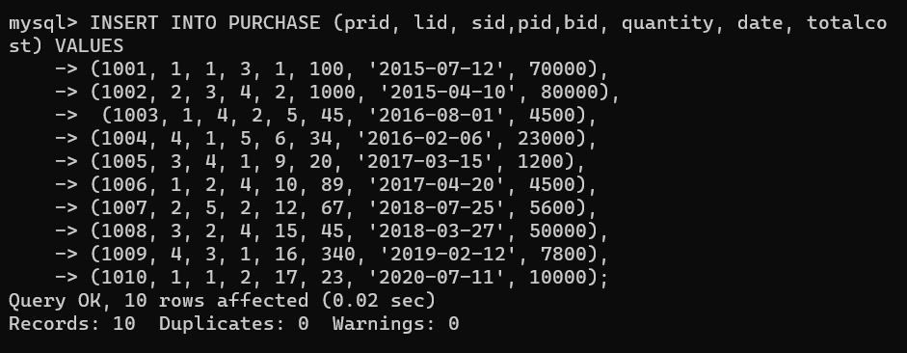
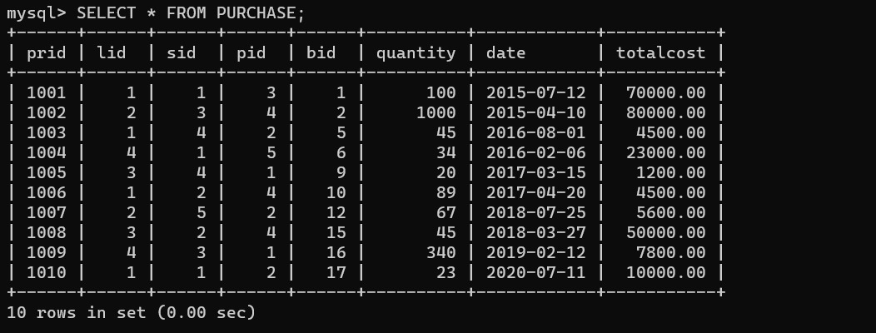
-----------------------------------------------------------------------------------------------------------------------
mysql> INSERT INTO ISSUE(Issueid, memid, bid, bnid,lid,issuedate,returndate)VALUES
-> (205, 44, 2, 1, 2, '2020-03-12', '2020-04-12'),
-> (206, 12, 7, 1, 1, '2020-05-10', NULL),
-> (207, 78, 4, 3, 10, '2019-03-05', '2019-08-05'),
-> (208, 13, 10, 1, 8, '2019-04-09', '2019-06-09'),
-> (209, 35, 12, 2, 1, '2020-10-07', '2020-12-07'),
-> (210, 45, 2, 2, 2, '2020-04-06', NULL);
Query OK, 6 rows affected (0.01 sec)
Records: 6 Duplicates: 0 Warnings: 0
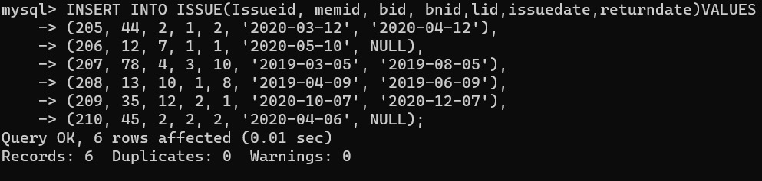
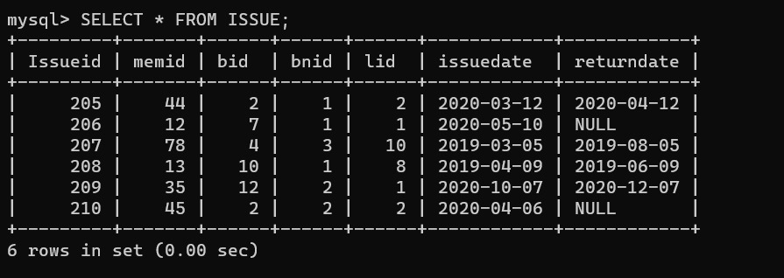
-------------------------------------------------------------------------------------------------------------------
mysql> INSERT INTO SELLS(sid,bid,pid) VALUES
-> (1, 1, 2),
-> (5, 3, 2),
-> (3, 2, 3),
-> (2, 6, 5),
-> (1, 10, 5),
-> (4, 14, 1);
Query OK, 6 rows affected (0.02 sec)
Records: 6 Duplicates: 0 Warnings: 0
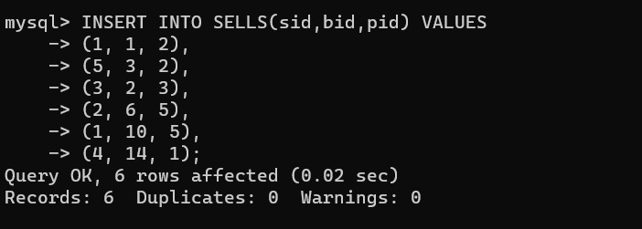
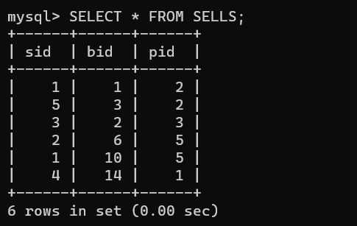
-----------------------------------------------------------------------------------------------------------------
mysql> INSERT INTO Employee(eid,empname,email,salary,lid) VALUES
-> (111, 'Shilpa', 'sdfdsf@gmail.com', 10000, 1),
-> (222, 'Shivani', 'sadsf@gmail.com', 20000, 1),
-> (333, 'Hemani', 'ertet@gmail.com', 50000, 2),
-> (444, 'Rekha', 'scdsf@gmail.com', 35000, 3),
-> (555, 'Anil', 'asd@gmail.com', 45000, 5),
-> (666, 'Suhas', 'fdgfg@gmail.com', 20000, 2);
Query OK, 6 rows affected (0.02 sec)
Records: 6 Duplicates: 0 Warnings: 0
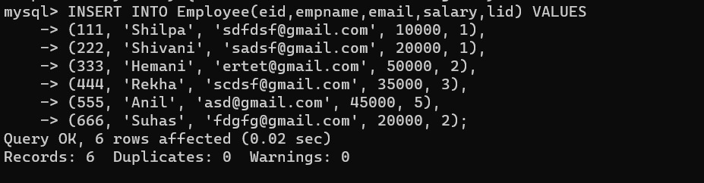
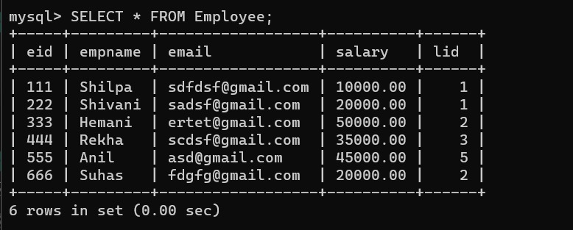
-----------------------------------------------------------------------------------------------------------------------
mysql> INSERT INTO A_specialization(spec_id, Aid ,spec_name) VALUES
-> (101, 1, 'Technical'),
-> (201, 1, 'Fiction'),
-> (301, 2, 'Non_Fiction'),
-> (401, 3, 'Autobiographies'),
-> (501, 2, 'Technical'),
-> (601, 4, 'Real life stories');
Query OK, 6 rows affected (0.01 sec)
Records: 6 Duplicates: 0 Warnings: 0
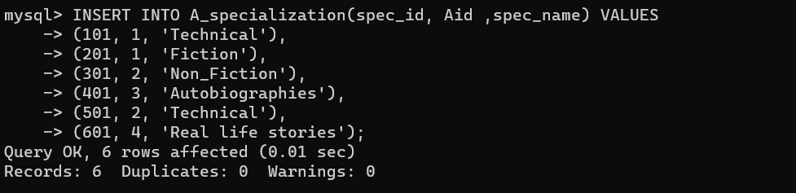
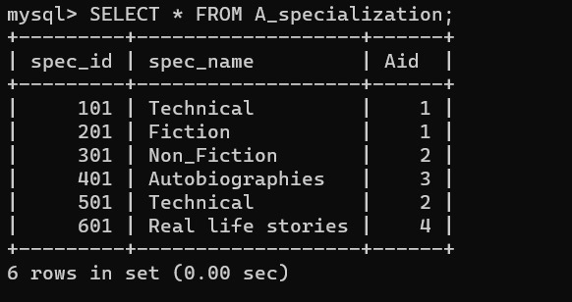
--------------------------------------------------------------------------------------------------------------------------
-------------------------------------------------------------------------------------------------------------------------

Q-3 Execute following queries on the library database
- Which institute libraries are located in pune city?
- mysql> SELECT Iname FROM library WHERE city='Pune';
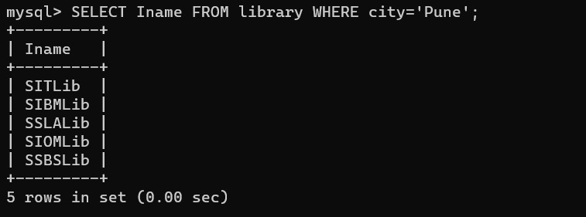
- To which institute CS department belongs to?
- mysql> SELECT Iname FROM DEPARTMENT WHERE deptname='CS';

- Find all the books whose price is between 800 to 12000?
- mysql> SELECT Bname, Price FROM BOOKS WHERE Price BETWEEN 800 AND 12000;
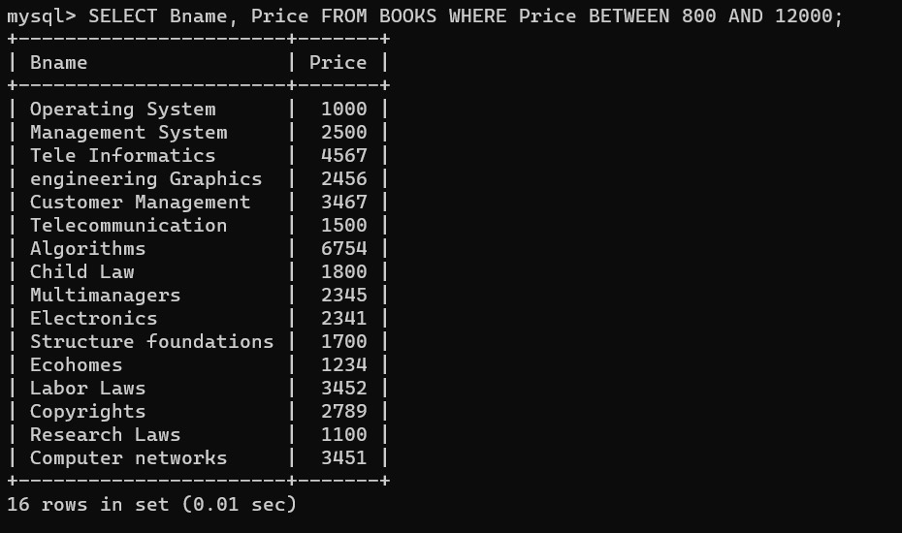
- Find out such employees who’s salaries are not greater than 50,000/-
- mysql> SELECT empname, salary FROM Employee WHERE salary<50000;
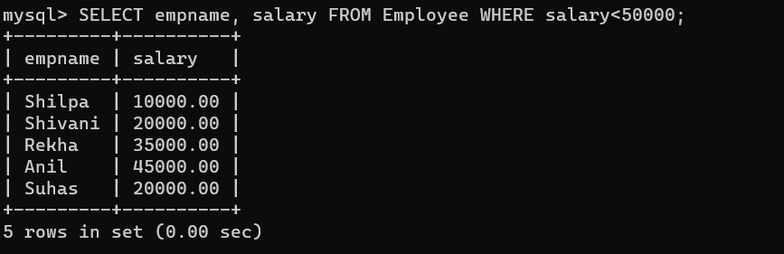

- Find out such sellers who’s name end with “ta”
- mysql> SELECT slname FROM SELLER WHERE slname LIKE '%ta';
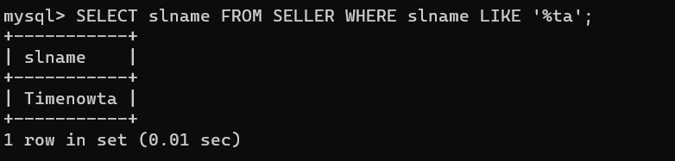
- Find out such institute libraries where their area information is missing.
- mysql> SELECT Iname FROM library WHERE area='NULL';
Empty set (0.00 sec)
- Find out such staff members who’s name doesn’t starts with “A”
- mysql> SELECT stname FROM STAFF WHERE stname NOT LIKE 'A%';
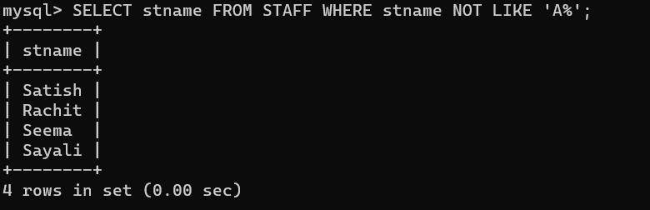
- Find out such SIU libraries which have institute libraries located in Bangalore.
- mysql> SELECT Iname FROM library WHERE city='Bangalore';
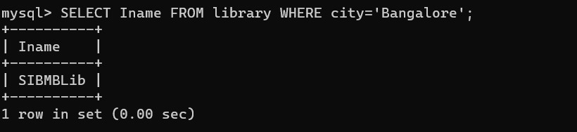
- Which students belong to civil department?
- mysql> SELECT Stuid, Sname, deptid FROM STUDENT WHERE Deptid IN (SELECT Deptid FROM DEPARTMENT WHERE deptname='Civil');
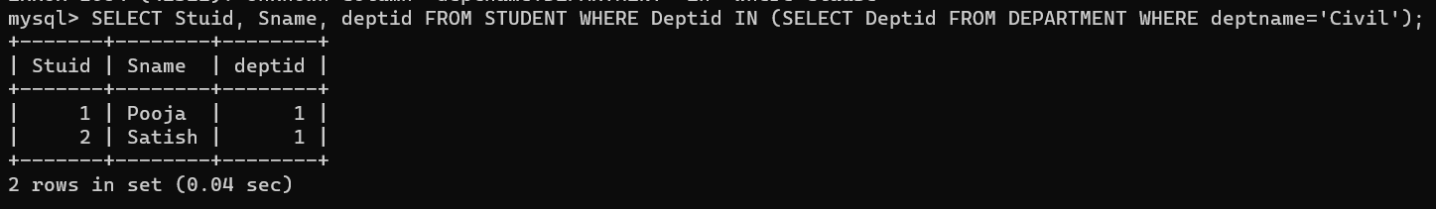
- Find out books which are written by “shruti” and published by Mcgraw hill
- mysql> SELECT BOOKS.Bname FROM BOOKS
-> JOIN Writes ON BOOKS.Bid = Writes.Bid
-> JOIN AUTHOR ON Writes.Aid = AUTHOR.Aid
-> JOIN PUBLISHER ON Writes.Pid = PUBLISHER.Pid
-> WHERE AUTHOR.Aname='Shruti' AND PUBLISHER.Pname='Tata Macgraw hill';
