Name: Anushree Dahiya
PRN: 22070122023
Division: CSE-A1
Date: 14-02-24
DBMS Lab Assignment -4
SQL Functions and its types

Assignment 4 Lab Questions
Q-1 Perform following queries using SQL functions:
- Find the cheapest book of SIBM library.
mysql> SELECT Bname, Price FROM BOOKS
-> WHERE Price=(SELECT MIN(Price) FROM BOOKS WHERE Lid=(SELECT Lid FROM library WHERE Iname='SIBMLib'));
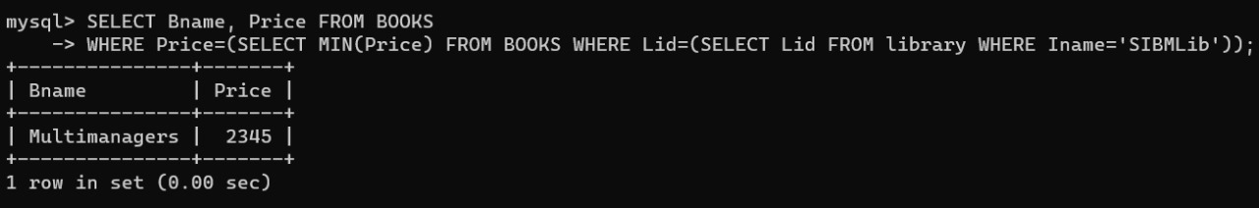

- Which library has the costliest book?
mysql> SELECT Iname FROM library
-> JOIN BOOKS ON library.Lid=BOOKS.Lid
-> WHERE Price=(SELECT MAX(Price) FROM BOOKS);
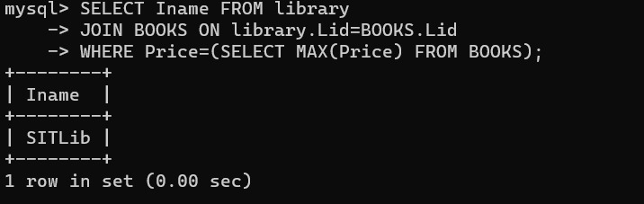

- How many students from SIT issued the book?
mysql> SELECT COUNT(DISTINCT memid) FROM ISSUE WHERE lid=(SELECT Lid FROM library WHERE Iname='SITLib');
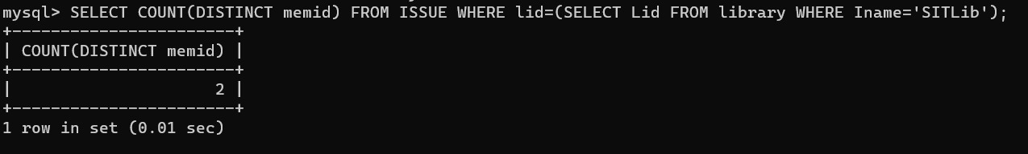

- What is the average cost of books in SITMN library?
mysql> SELECT AVG(Price) AS avg_price FROM BOOKS WHERE Lid=(SELECT Lid FROM library WHERE Iname='SITMNLib');
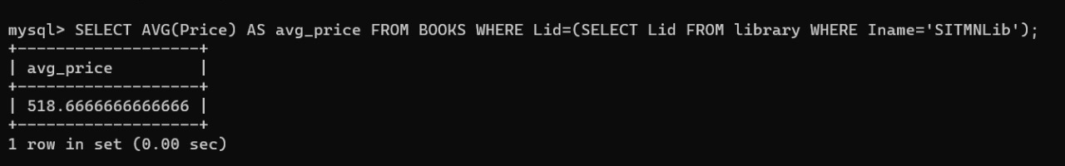

- What is the total cost of purchase made by SIT in the month of January to June?
mysql> SELECT SUM(totalcost) AS total_cost FROM PURCHASE
-> WHERE lid=(SELECT Lid FROM library WHERE Iname='SITLib')
-> AND MONTH(date) BETWEEN 1 AND 6;
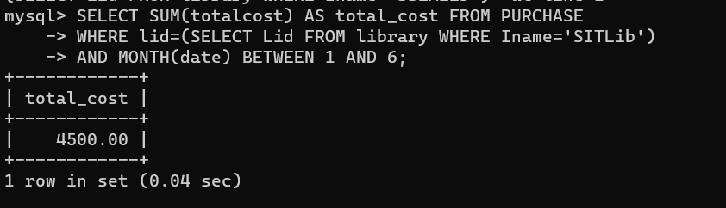

- How many books are written by “Shruti”
mysql> SELECT COUNT(*) FROM WRITES JOIN AUTHOR ON AUTHOR.Aid=Writes.Aid WHERE Aname='Shruti';
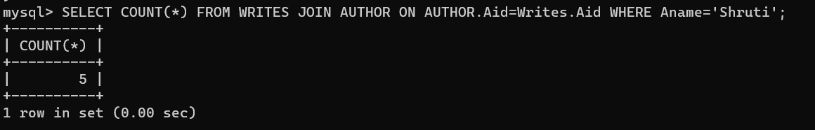

- What is the costliest book published by “Pragati Book Store”
mysql> SELECT Bname, Price AS highest_price FROM BOOKS
-> JOIN Writes ON Writes.Bid=BOOKS.Bid
-> JOIN PUBLISHER ON PUBLISHER.Pid= Writes.Pid
-> WHERE PUBLISHER.Pname='Pragati book store'
-> ORDER BY BOOKS.Price DESC
-> LIMIT 1;
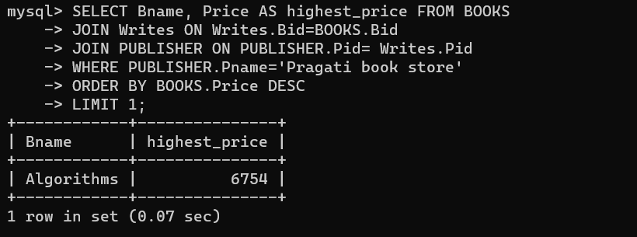

- How many total copies of books do SIT has?
mysql> SELECT COUNT(Noofcopies.bnid) AS total_books
-> FROM Noofcopies
-> JOIN BOOKS ON Noofcopies.bid=BOOKS.Bid
-> JOIN library ON BOOKS.Lid=library.Lid
-> WHERE library.Iname='SITLib';
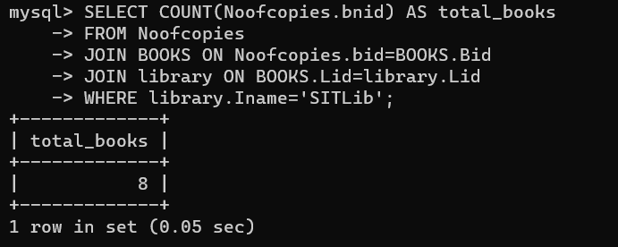

- What is the average cost of books written by “Shivam Kapoor”?
mysql> SELECT AVG(Price) AS average_cost
-> FROM BOOKS
-> JOIN Writes ON BOOKS.Bid = Writes.Bid
-> JOIN AUTHOR ON Writes.Aid = AUTHOR.Aid
-> WHERE Aname = 'Shivam Kapoor';
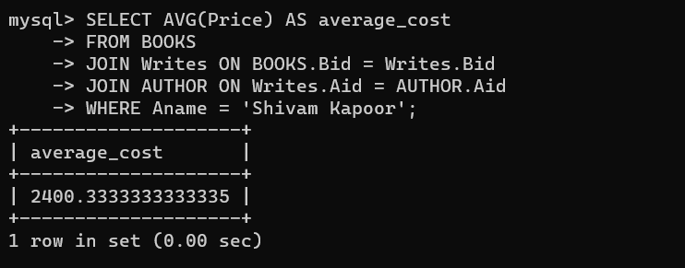

- How many books are sold by seller living in Pune?
mysql> SELECT COUNT(DISTINCT SELLS.Bid) AS no_of_books_sold
-> FROM SELLER
-> JOIN SELLS ON SELLER.Sid=SELLS.sid
-> WHERE SELLER.city='Pune';
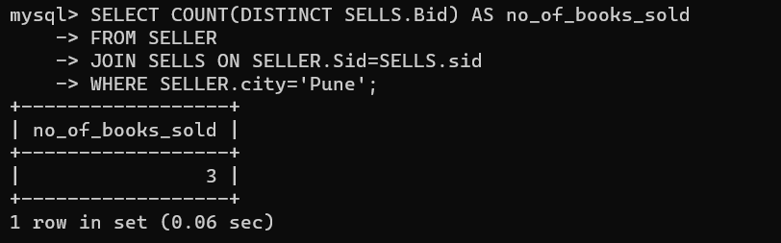

- Print the student name in capital who belongs to SSBS
mysql> SELECT UPPER(Sname) AS capitalised_name
-> FROM STUDENT
-> JOIN DEPARTMENT ON STUDENT.deptid=DEPARTMENT.Deptid
-> WHERE DEPARTMENT.Iname='SSBS';
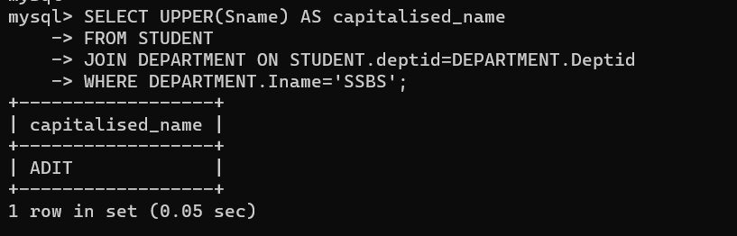

- Add two months to the issue date of book written by “Shivam Kapoor”
mysql> UPDATE ISSUE
-> SET issuedate = DATE_ADD(issuedate, INTERVAL 2 MONTH)
-> WHERE bid IN (SELECT bid FROM BOOKS WHERE Bid IN (SELECT Bid FROM WRITES WHERE Aid IN (SELECT Aid FROM AUTHOR WHERE Aname = 'Shivam Kapoor')));
Query OK, 2 rows affected (0.02 sec)
Rows matched: 2 Changed: 2 Warnings: 0

ORIGINAL TABLE:-
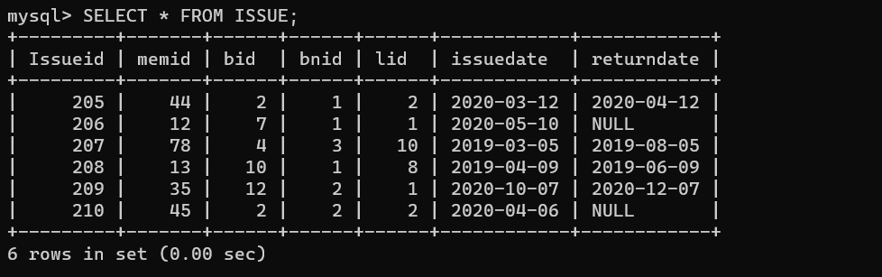

UPDATED TABLE:-
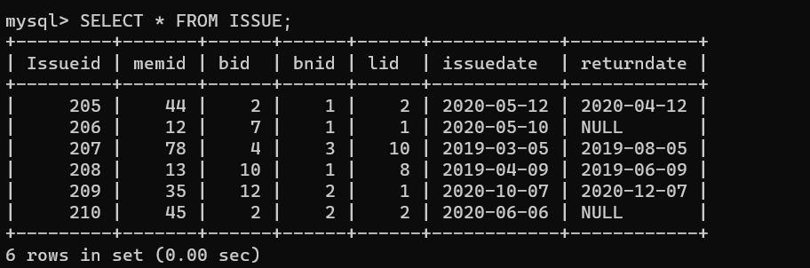

- What was the last day of the month when Satish issued the book?
mysql> SELECT LAST_DAY(issuedate) AS Last_Day
-> FROM ISSUE
-> JOIN STAFF ON STAFF.memid=ISSUE.memid
-> WHERE STAFF.Stname='Satish';
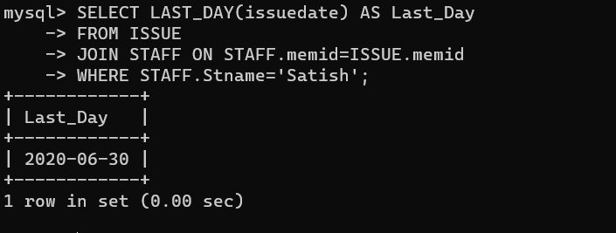

- How many books are issued from January to march 2010 & 2020?
mysql> SELECT COUNT(Bid) FROM ISSUE
-> WHERE MONTH(issuedate) BETWEEN 1 AND 3
-> AND (YEAR(ISSUEDATE) BETWEEN 2010 AND 2020);
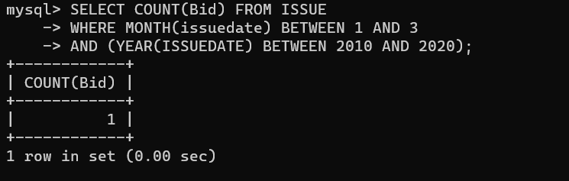

- How many books have copies less than 5 available in the SIBM library?
mysql> SELECT COUNT(Noofcopies.bnid) AS NumberOfCopies, BOOKS.Bid, BOOKS.Bname
-> FROM BOOKS
-> JOIN Noofcopies ON BOOKS.Bid = Noofcopies.Bid
-> JOIN library ON BOOKS.Lid = library.Lid
-> WHERE library.Iname = 'SIBMLib'
-> GROUP BY BOOKS.Bid
-> HAVING COUNT(Noofcopies.bnid) < 5;
