Name: Anushree Dahiya
PRN: 22070122023
Division: CSE-A1
Date: 26
-02-24
DBMS Lab Assignment -5
SQL Functions and its types

Assignment 5 Lab Questions
Q1 Perform following queries using Group by, having and Order By:-
- Give library wise book details.
mysql> SELECT library.Lid, library.Iname, BOOKS.Bname, BOOKS.Price
-> FROM library
-> JOIN BOOKS ON library.Lid=BOOKS.Lid
-> ORDER BY library.Lid;
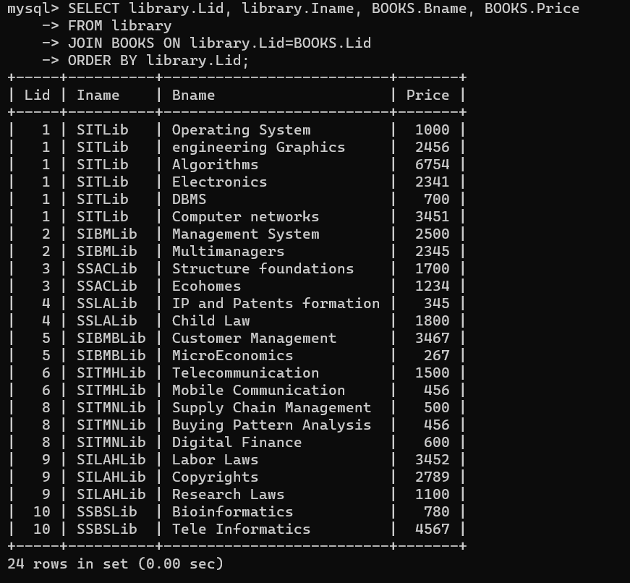

- Give bookwise total copies which are available.
mysql> SELECT BOOKS.Bname AS BookName,
-> COUNT(Noofcopies.bid) AS NumberOfCopiesAvailable
-> FROM BOOKS
-> JOIN Noofcopies ON BOOKS.Bid=Noofcopies.bid
-> GROUP BY BOOKS.Bname
-> ORDER BY NumberOfCopiesAvailable DESC;
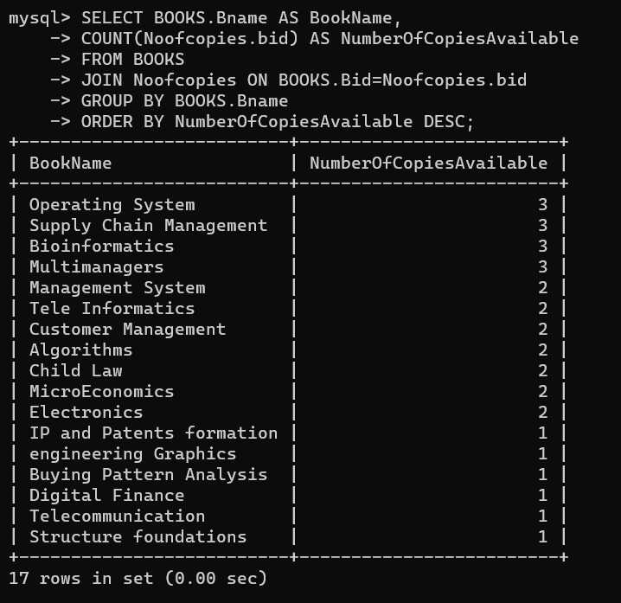

- Which library has total copies more than 5?
mysql> SELECT Iname AS LibraryName,
-> COUNT(Noofcopies.bid) AS NumberOfBooks
-> FROM library
-> JOIN Noofcopies ON library.Lid=Noofcopies.lid
-> GROUP BY library.Iname
-> HAVING NumberOfBooks> 5;
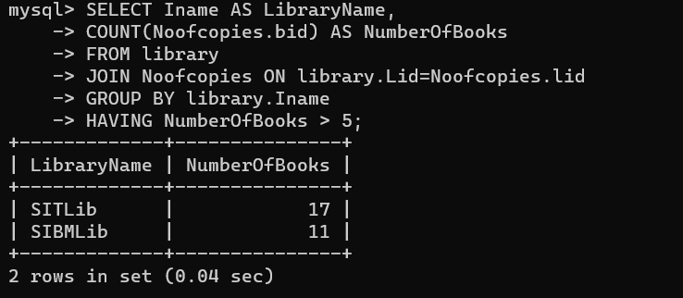

- Give institute wise department details.
mysql> SELECT Iname, deptname, Deptid
-> FROM DEPARTMENT
-> ORDER BY Iname;
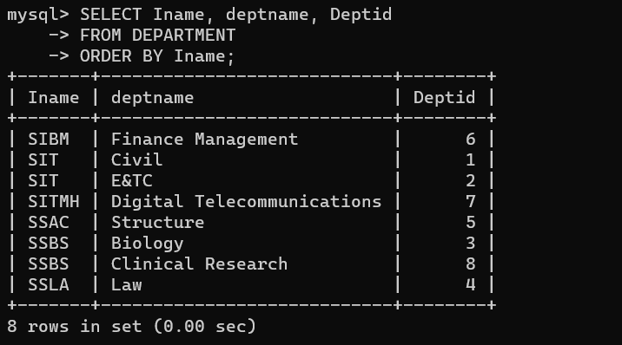

- Give citywise seller details.
mysql> SELECT city AS City, slname AS Seller_Name
-> FROM SELLER
-> GROUP BY city, slname;
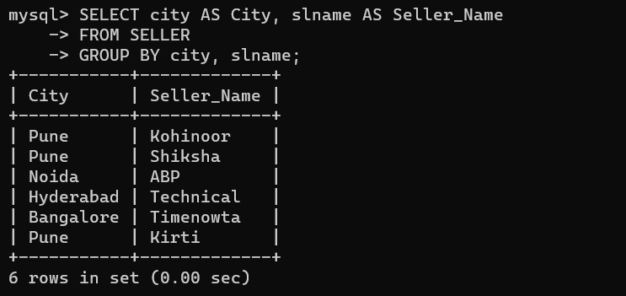

- Give author wise book details that have authored more than 2 books.
mysql> SELECT AUTHOR.Aname, BOOKS.Bid, BOOKS.Bname, BOOKS.Price
-> FROM AUTHOR
-> JOIN Writes ON AUTHOR.Aid=Writes.Aid
-> JOIN BOOKS ON Writes.Bid=BOOKS.Bid
-> GROUP BY AUTHOR.Aname, BOOKS.Bid
-> HAVING BOOKS.Bid > 2
-> ORDER BY AUTHOR.Aname;
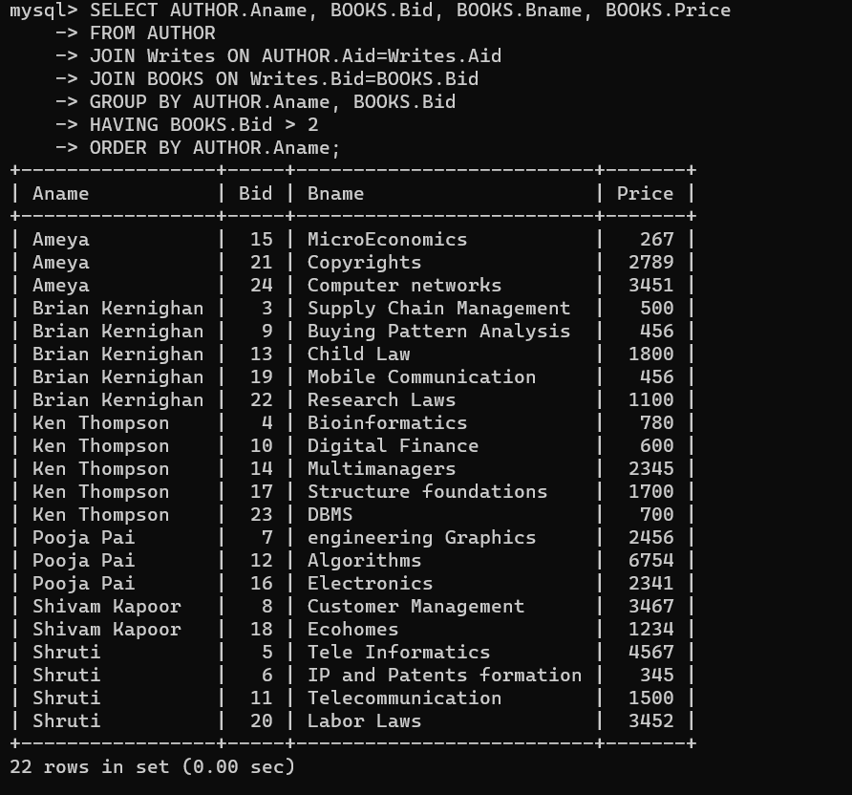

- Give book details library wise whose price is less than 1000
mysql> SELECT library.Iname, BOOKS.Bname, BOOKS.Price, library.Lid
-> FROM library
-> JOIN BOOKS ON library.Lid=BOOKS.Lid
-> GROUP BY library.Iname, library.Lid, BOOKS.Bid
-> HAVING BOOKS.Price < 1000;
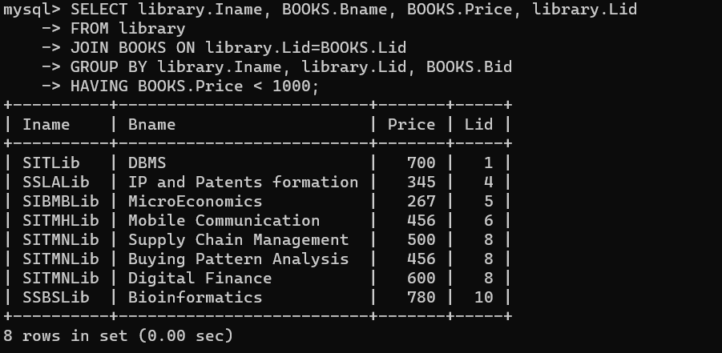

- Give department wise staff details.
mysql> SELECT DEPARTMENT.deptname AS DepartmentName, STAFF.stname AS StaffName, STAFF.Stid AS StaffId
-> FROM DEPARTMENT
-> JOIN STAFF ON DEPARTMENT.Deptid = STAFF.deptid
-> GROUP BY STAFF.Stid;
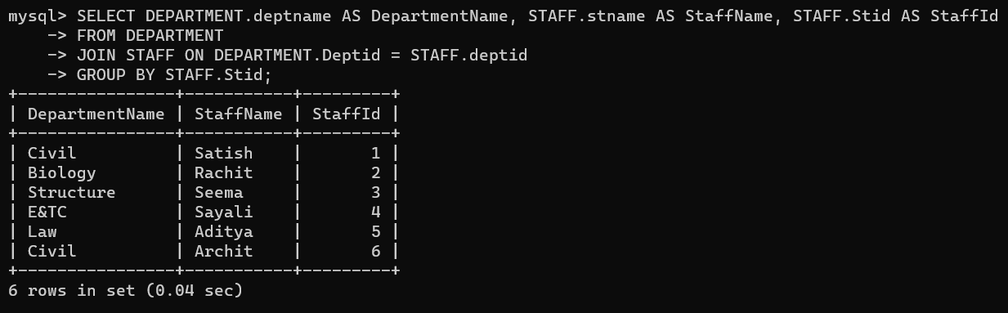

- How many books are issued library wise.
mysql> SELECT library.Iname AS LibraryName,
-> COUNT(ISSUE.bid) AS TotalBooksIssues
-> FROM library
-> JOIN ISSUE ON library.Lid = ISSUE.lid
-> GROUP BY library.Iname;
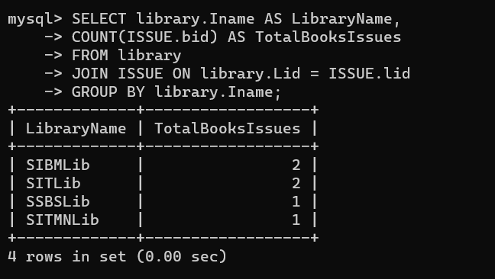

- Give purchase details publisher wise.
mysql> SELECT PUBLISHER.Pname, PURCHASE.prid, PURCHASE.quantity, PURCHASE.date, PURCHASE.totalcost
-> FROM PUBLISHER
-> JOIN PURCHASE ON PUBLISHER.Pid=PURCHASE.pid
-> GROUP BY PUBLISHER.Pname, PURCHASE.prid
-> ORDER BY PUBLISHER.Pname;
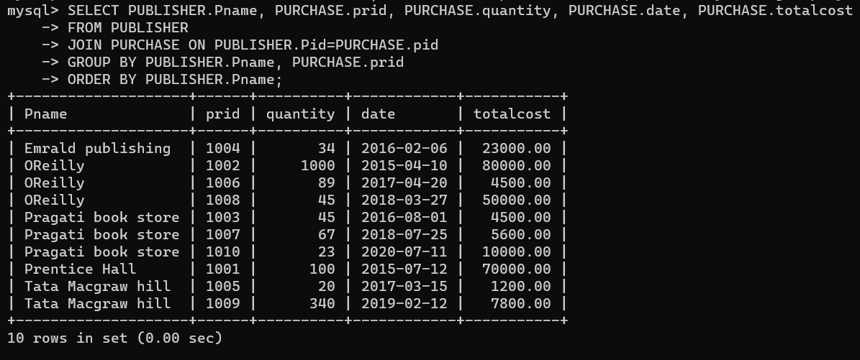

- Display books in a descending order of their cost.
mysql> SELECT Bname, Price FROM BOOKS
-> ORDER BY Price DESC;
