Name: Anushree Dahiya
PRN: 22070122023
Division: CSE-A1
Date: 06-03-24
DBMS Lab Assignment -6
SQL Joins

Assignment 6 Lab Questions
Q-1 Using SQL joins, obtain the following information from SIU Library Database
- Students in the Civil department.
mysql> SELECT Stuid, Sname FROM STUDENT
-> JOIN DEPARTMENT ON DEPARTMENT.Deptid=STUDENT.deptid
-> WHERE DEPARTMENT.Deptname='Civil';
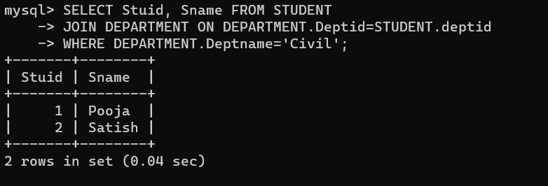

- Books in SIT library.
mysql> SELECT * FROM BOOKS
-> JOIN library ON BOOKS.Lid=library.Lid
-> WHERE library.Iname='SITLib';
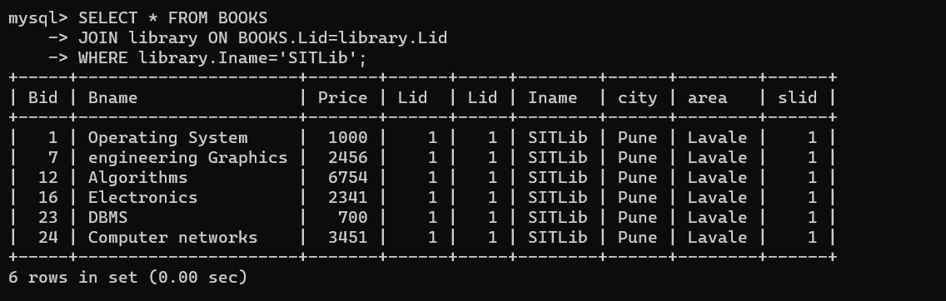

- Books with less than 3 copies in SIT Library.
mysql> SELECT BOOKS.Bid, BOOKS.Bname, COUNT(Noofcopies.bnid) AS NumberOfCopies
-> FROM BOOKS
-> JOIN Noofcopies ON BOOKS.Bid = Noofcopies.bid
-> JOIN library ON library.Lid = BOOKS.Lid
-> WHERE library.Iname = 'SITLib'
-> GROUP BY BOOKS.Bid, BOOKS.Bname
-> HAVING COUNT(*) < 3;
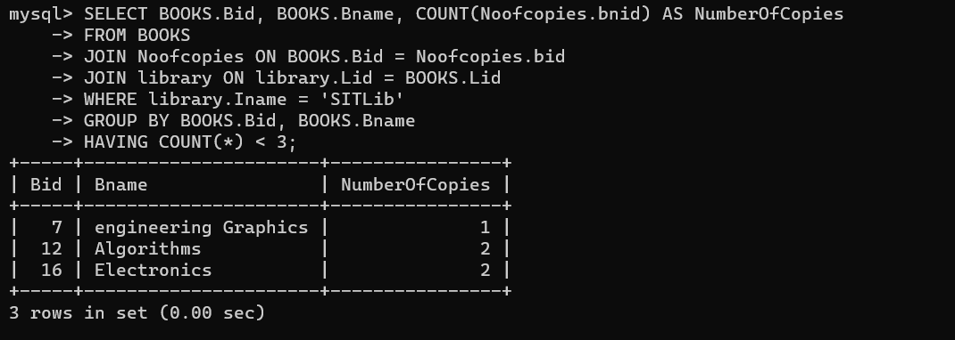

- Sellers in the same city as SIT.
mysql> SELECT * FROM SELLER
-> JOIN library ON SELLER.city=library.city
-> WHERE library.Iname='SITLib';
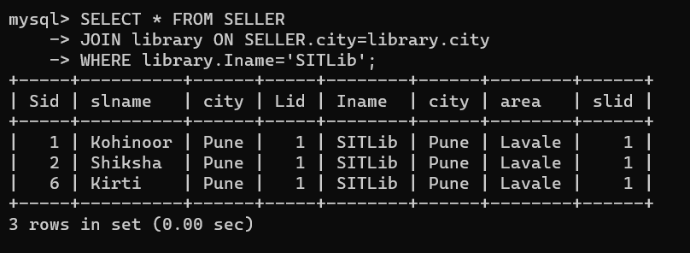

- Sellers selling books to SIT.
mysql> SELECT DISTINCT s.* FROM SELLER s
-> JOIN PURCHASE ON s.Sid = PURCHASE.sid
-> JOIN library ON PURCHASE.lid = library.Lid
-> WHERE library.Iname = 'SITLib';
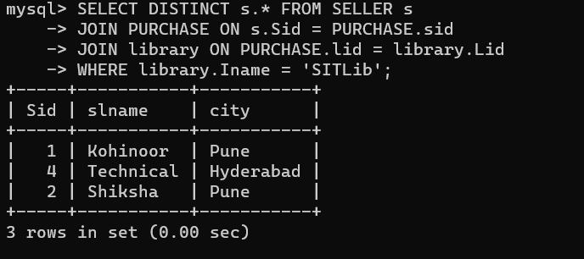
- Books authored by Brian Kernighan, and published by Tata McGraw Hill.
mysql> SELECT BOOKS.Bid, BOOKS.Bname, AUTHOR.Aname, PUBLISHER.Pname
-> FROM BOOKS
-> JOIN Writes On BOOKS.Bid=Writes.Bid
-> JOIN AUTHOR ON AUTHOR.Aid=Writes.Aid
-> JOIN PUBLISHER ON Writes.Pid=PUBLISHER.Pid
-> WHERE AUTHOR.Aname = 'Brian Kernighan' AND PUBLISHER.Pname = 'Tata Macgraw hill';
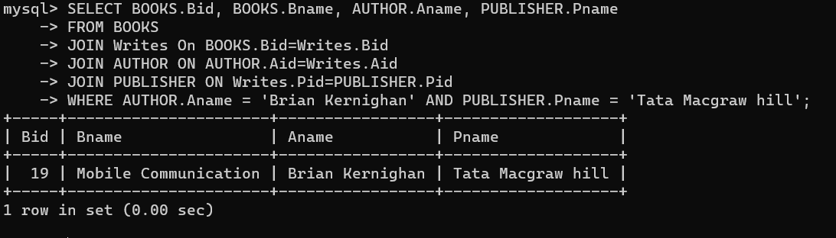

- Books authored by Ken Thompson.
mysql> SELECT BOOKS.*
-> FROM BOOKS
-> JOIN Writes ON BOOKS.Bid = Writes.Bid
-> JOIN AUTHOR ON Writes.Aid = AUTHOR.Aid
-> WHERE AUTHOR.Aname = 'Ken Thompson';
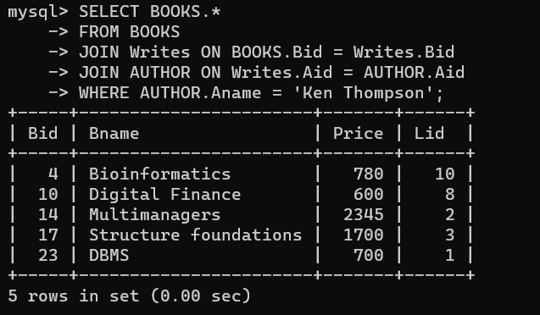

- Books issued by Meera.
mysql> SELECT BOOKS.* FROM BOOKS
-> JOIN ISSUE ON BOOKS.Bid = ISSUE.Bid
-> JOIN Member ON ISSUE.memid = Member.Memid
-> JOIN STUDENT ON STUDENT.Memid= Member.Memid
-> WHERE STUDENT.Sname='Meera';
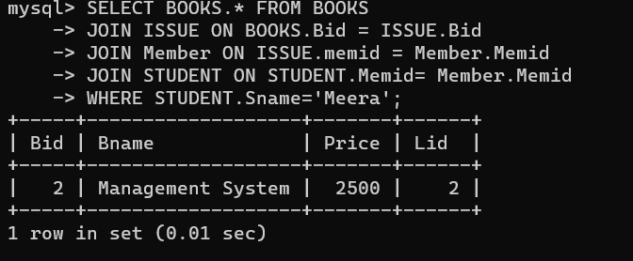

- Books issued by SSBS staff.
mysql> SELECT * FROM BOOKS
-> JOIN ISSUE ON BOOKS.Bid=ISSUE.Bid
-> JOIN STAFF ON ISSUE.memid=STAFF.memid
-> WHERE STAFF.deptid = (SELECT Deptid FROM DEPARTMENT WHERE deptname = 'SSBS');
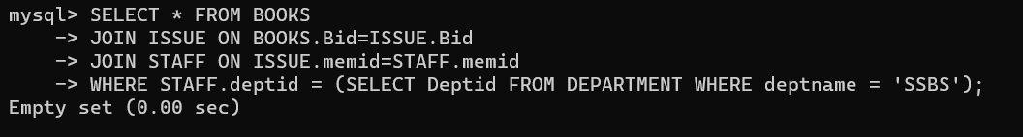

- Publisher that provides books to SSLA through Shiksha.
mysql> SELECT PUBLISHER.*
-> FROM PUBLISHER
-> JOIN Writes ON Writes.Pid=PUBLISHER.Pid
-> JOIN BOOKS ON BOOKS.Bid=Writes.Bid
-> JOIN library ON library.Lid=BOOKS.Lid
-> JOIN DEPARTMENT ON DEPARTMENT.lid=library.Lid
-> JOIN SELLS ON BOOKS.Bid=SELLS.bid
-> JOIN SELLER ON SELLS.sid=SELLER.Sid
-> WHERE SELLER.slname='Shiksha' AND DEPARTMENT.Iname='SSLA';
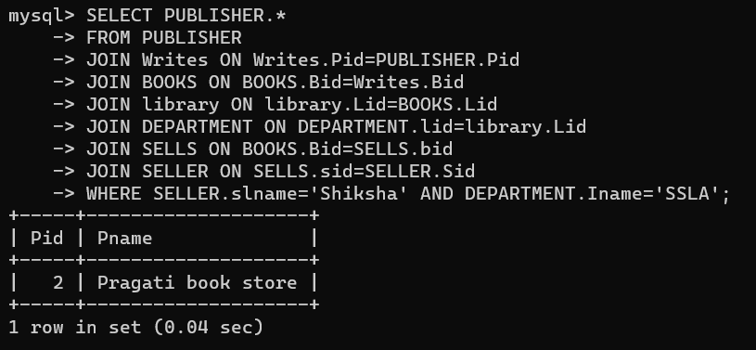

- Institutes whose staff and students have issued book with bid 4.

- Sellers selling to libraries in the same city.

- Authors with books costing more than rs 500.

