Name: Anushree Dahiya
PRN: 22070122023
Division: CSE-A1
Date: 06-03-24
DBMS Lab Assignment -6
SQL Joins

Assignment 6 Lab Questions
Q-1 Using SQL joins, obtain the following information from SIU Library Database
- Students in the Civil department.
mysql> SELECT Stuid, Sname FROM STUDENT
-> JOIN DEPARTMENT ON DEPARTMENT.Deptid=STUDENT.deptid
-> WHERE DEPARTMENT.Deptname='Civil';
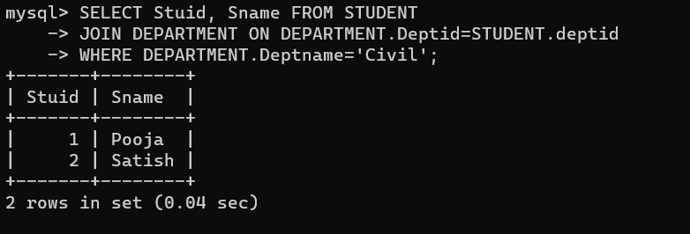

- Books in SIT library.
mysql> SELECT * FROM BOOKS
-> JOIN library ON BOOKS.Lid=library.Lid
-> WHERE library.Iname='SITLib';
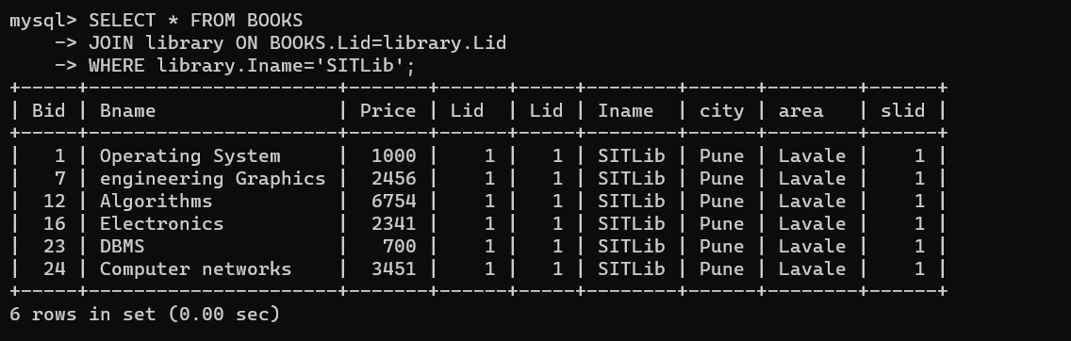

- Books with less than 3 copies in SIT Library.
mysql> SELECT BOOKS.Bid, BOOKS.Bname, COUNT(Noofcopies.bnid) AS NumberOfCopies
-> FROM BOOKS
-> JOIN Noofcopies ON BOOKS.Bid = Noofcopies.bid
-> JOIN library ON library.Lid = BOOKS.Lid
-> WHERE library.Iname = 'SITLib'
-> GROUP BY BOOKS.Bid, BOOKS.Bname
-> HAVING COUNT(*) < 3;
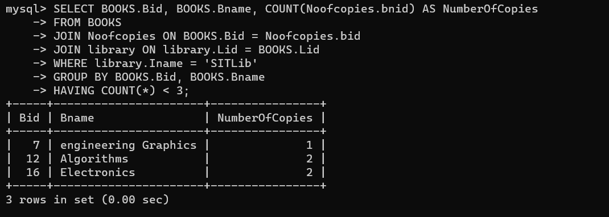

- Sellers in the same city as SIT.
mysql> SELECT * FROM SELLER
-> JOIN library ON SELLER.city=library.city
-> WHERE library.Iname='SITLib';
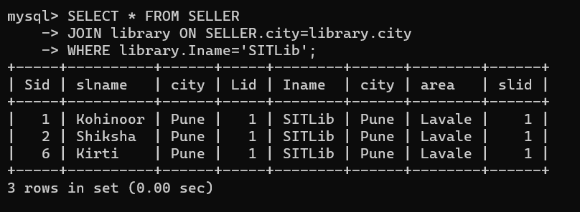

- Sellers selling books to SIT.
mysql> SELECT DISTINCT s.* FROM SELLER s
-> JOIN PURCHASE ON s.Sid = PURCHASE.sid
-> JOIN library ON PURCHASE.lid = library.Lid
-> WHERE library.Iname = 'SITLib';
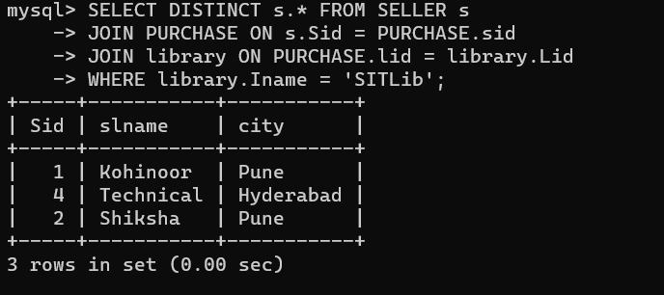
- Books authored by Brian Kernighan, and published by Tata McGraw Hill.
mysql> SELECT BOOKS.Bid, BOOKS.Bname, AUTHOR.Aname, PUBLISHER.Pname
-> FROM BOOKS
-> JOIN Writes On BOOKS.Bid=Writes.Bid
-> JOIN AUTHOR ON AUTHOR.Aid=Writes.Aid
-> JOIN PUBLISHER ON Writes.Pid=PUBLISHER.Pid
-> WHERE AUTHOR.Aname = 'Brian Kernighan' AND PUBLISHER.Pname = 'Tata Macgraw hill';
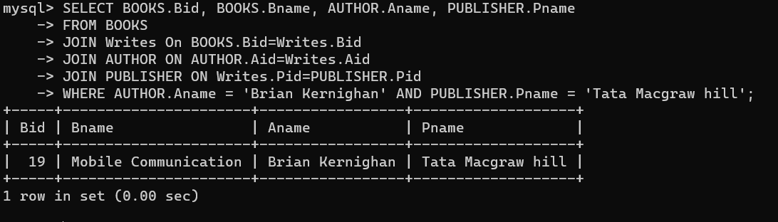

- Books authored by Ken Thompson.
mysql> SELECT BOOKS.*
-> FROM BOOKS
-> JOIN Writes ON BOOKS.Bid = Writes.Bid
-> JOIN AUTHOR ON Writes.Aid = AUTHOR.Aid
-> WHERE AUTHOR.Aname = 'Ken Thompson';
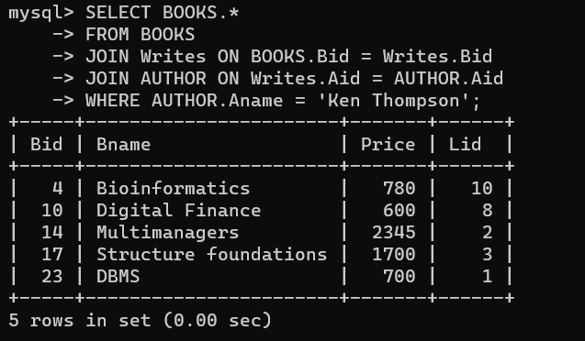

- Books issued by Meera.
mysql> SELECT BOOKS.* FROM BOOKS
-> JOIN ISSUE ON BOOKS.Bid = ISSUE.Bid
-> JOIN Member ON ISSUE.memid = Member.Memid
-> JOIN STUDENT ON STUDENT.Memid= Member.Memid
-> WHERE STUDENT.Sname='Meera';
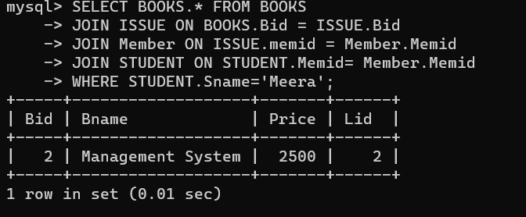

- Books issued by SSBS staff.
mysql> SELECT * FROM BOOKS
-> JOIN ISSUE ON BOOKS.Bid=ISSUE.Bid
-> JOIN STAFF ON ISSUE.memid=STAFF.memid
-> WHERE STAFF.deptid = (SELECT Deptid FROM DEPARTMENT WHERE deptname = 'SSBS');
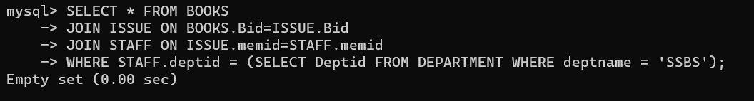

- Publisher that provides books to SSLA through Shiksha.
mysql> SELECT PUBLISHER.*, DEPARTMENT.deptname, BOOKS.Bname
-> FROM PUBLISHER
-> JOIN Writes ON Writes.Pid=PUBLISHER.Pid
-> JOIN BOOKS ON BOOKS.Bid=Writes.Bid
-> JOIN library ON library.Lid=BOOKS.Lid
-> JOIN DEPARTMENT ON DEPARTMENT.lid=library.Lid
-> JOIN SELLS ON BOOKS.Bid=SELLS.bid
-> JOIN SELLER ON SELLS.sid=SELLER.Sid
-> WHERE SELLER.slname='Shiksha' AND DEPARTMENT.Iname='SSLA';
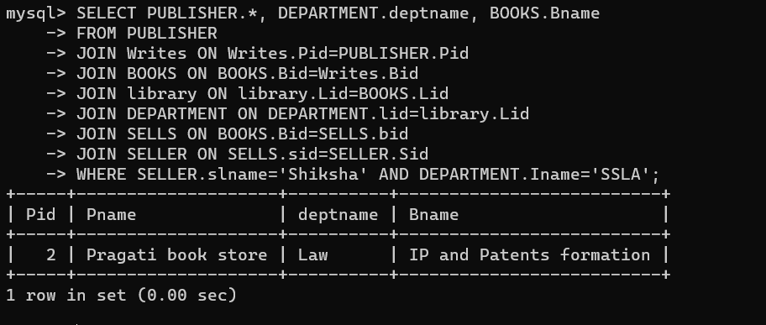

- Institutes whose staff and students have issued book with bid 4.
mysql> SELECT DEPARTMENT.Iname
-> FROM ISSUE
-> JOIN Member ON ISSUE.Memid = Member.Memid
-> LEFT JOIN STUDENT ON Member.Memid = STUDENT.Memid
-> LEFT JOIN STAFF ON Member.Memid = STAFF.memid
-> LEFT JOIN DEPARTMENT ON STUDENT.deptid = DEPARTMENT.Deptid OR STAFF.deptid = DEPARTMENT.Deptid
-> WHERE ISSUE.Bid = 4;
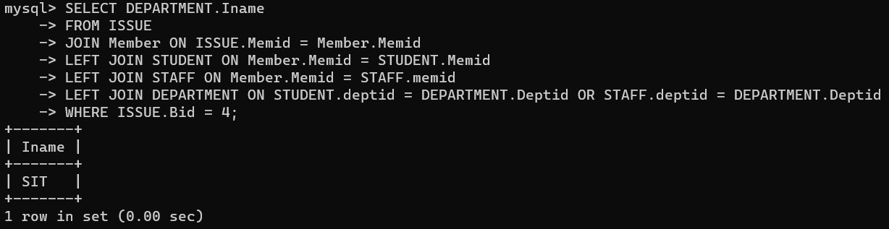

- Sellers selling to libraries in the same city.
mysql> SELECT SELLER.slname
-> FROM SELLER
-> JOIN library ON SELLER.city=library.City
-> WHERE SELLER.city=library.City;
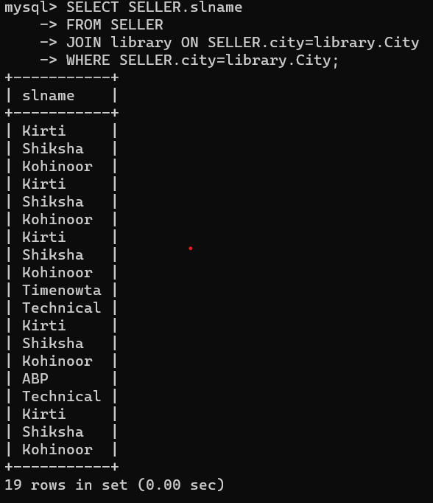

- Authors with books costing more than rs 500.
mysql> SELECT AUTHOR.Aname, BOOKS.Bname, BOOKS.Price
-> FROM BOOKS
-> JOIN Writes ON BOOKS.Bid = Writes.Bid
-> JOIN AUTHOR ON AUTHOR.Aid = Writes.Aid
-> WHERE BOOKS.Price > 500;
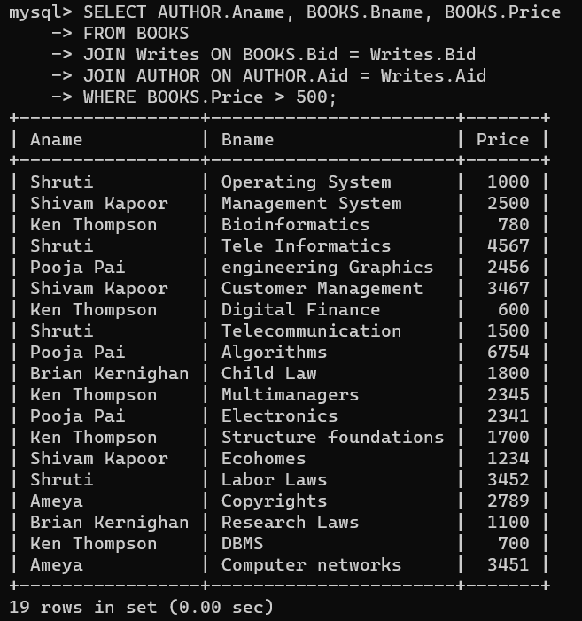

--------------------------------------------------------------------------------------------------------------------------
Remaining Part of Assignment 3:-
- Which members have issued books that belongs to E&TC department of SIT.
mysql> SELECT DISTINCT Member.memid, Member.lid, ISSUE.Issueid
-> FROM Member
-> JOIN ISSUE ON Member.memid=ISSUE.memid
-> JOIN BOOKS ON BOOKS.Bid=ISSUE.bid
-> JOIN DEPARTMENT ON DEPARTMENT.lid=BOOKS.lid
-> WHERE DEPARTMENT.deptname='E&TC' AND DEPARTMENT.Iname='SIT';
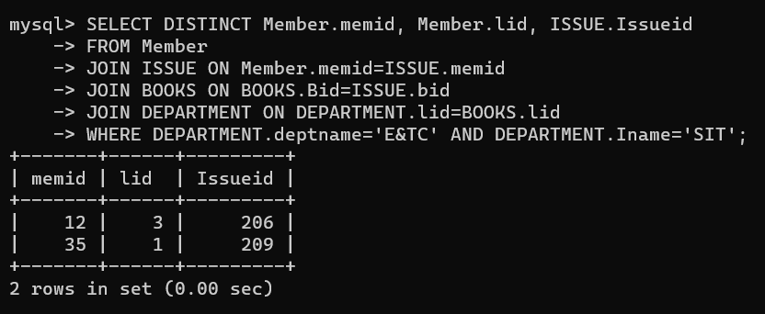

- List the books of SIT library
mysql> SELECT DISTINCT Bid, Bname
-> FROM BOOKS
-> JOIN library ON BOOKS.Lid=library.Lid
-> WHERE library.Iname='SITLib';
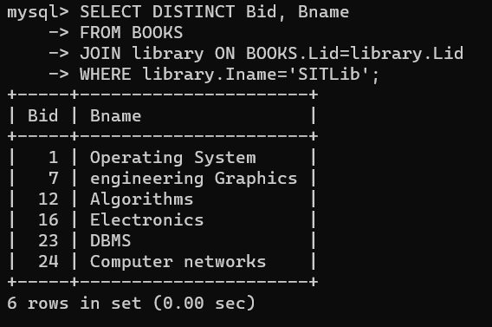

- Which books are written by “ Ken Coel”
mysql> SELECT DISTINCT BOOKS.Bid, BOOKS.Bname
-> FROM BOOKS
-> JOIN Writes ON BOOKS.Bid=Writes.Bid
-> JOIN AUTHOR ON AUTHOR.Aid=Writes.Aid
-> WHERE AUTHOR.Aname='Ken Coel';
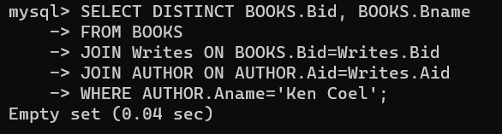

- Find the staff members whose salaries are less than at least one employee
mysql> SELECT DISTINCT S.Stid, S.stname
-> FROM STAFF S
-> JOIN Employee E ON E.salary < E.salary;
Empty set (0.00 sec)
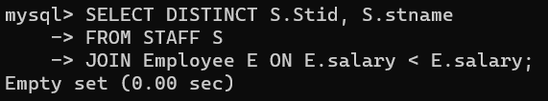

- Find the books who’s price is greater than at least one book in the library.
mysql> SELECT DISTINCT B.Bid, B.Bname, B.Price
-> FROM BOOKS B
-> JOIN BOOKS B2 ON B.Price > B2.Price;
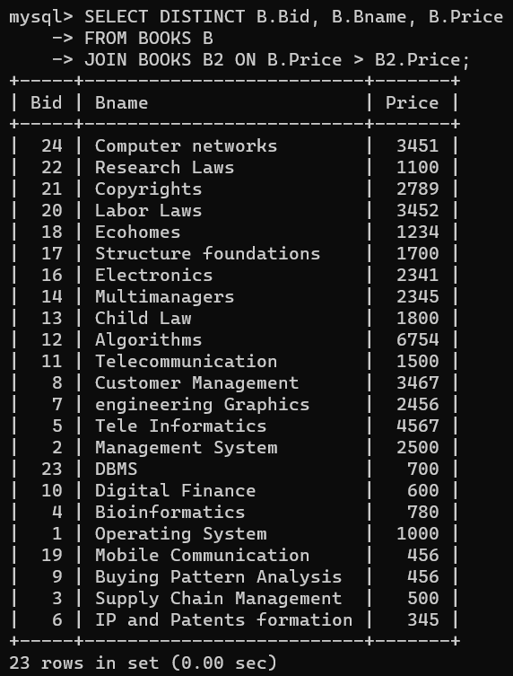

- Find the employees whose salary is greater than all the employees of Civil department.
mysql> SELECT e.*
-> FROM Employee e
-> JOIN library ON e.Lid = library.Lid
-> JOIN DEPARTMENT ON DEPARTMENT.Lid = library.Lid
-> JOIN Employee E2 ON e.salary > E2.salary AND DEPARTMENT.deptname = 'Civil';
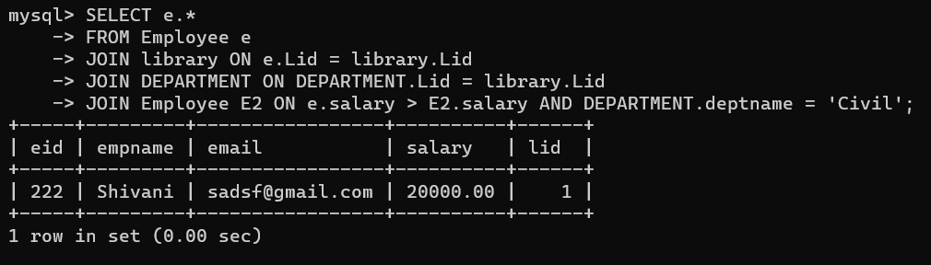

- Find such purchases who’s total cost is greater than all the purchases which are done by “SIT library”.
mysql> SELECT *
-> FROM PURCHASE P
-> WHERE P.totalcost > ALL (
-> SELECT totalcost
-> FROM PURCHASE
-> WHERE lid = (SELECT Lid FROM library WHERE Iname = 'SITLib')
-> );
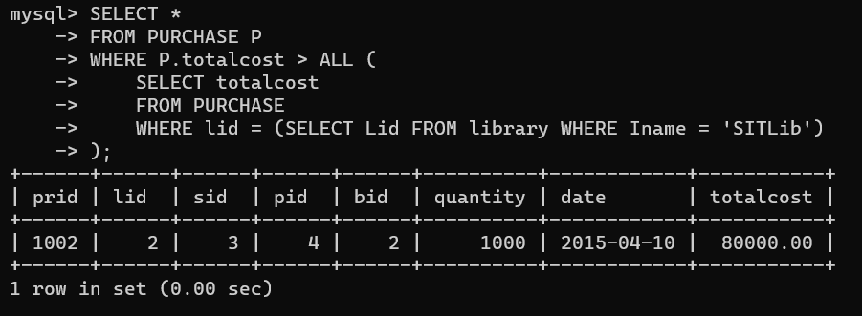

- Find name of such SIU library which is located in Nashik and has Ilibrary named as “SIOM library”(solve using exists)
mysql> SELECT *
-> FROM library L1
-> WHERE city = 'Nashik'
-> AND EXISTS (
-> SELECT *
-> FROM library L2
-> WHERE L1.SLID = L2.slid AND L2.Iname = 'SIOMLib'
-> );
Empty set (0.00 sec)
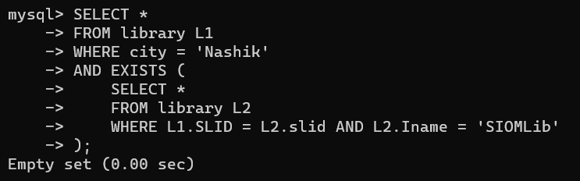

- Find such staff members whose name starts with “S” and do not work for “CS” department. (solve using not exists)
mysql> SELECT *
-> FROM STAFF
-> WHERE LEFT(STAFF.stname, 1) = 'S'
-> AND NOT EXISTS (
-> SELECT *
-> FROM DEPARTMENT
-> WHERE DEPARTMENT.deptid = STAFF.deptid AND DEPARTMENT.deptname = 'CS'
-> );
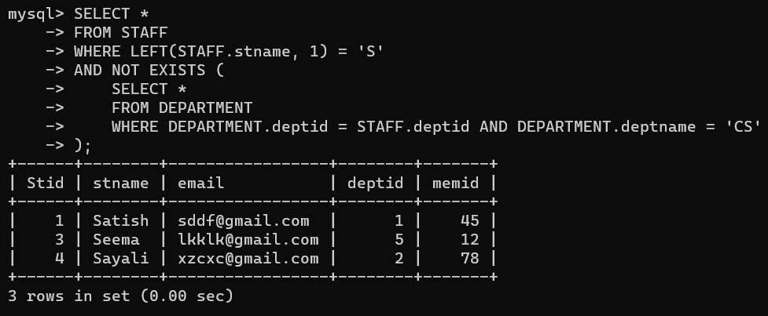

- Which books are issued by student Meera?
mysql> SELECT B.Bid, B.Bname
-> FROM BOOKS B
-> JOIN ISSUE I ON B.Bid = I.bid
-> JOIN STUDENT S ON I.memid = S.memid
-> WHERE S.Sname = 'Meera';
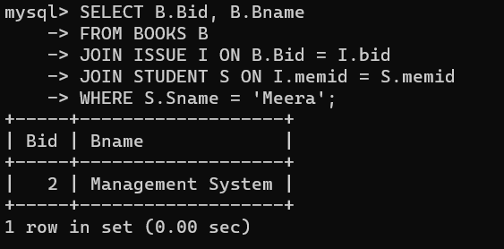

- From which seller did SIT library purchases books of “Technical publications”?
mysql> SELECT slname
-> FROM SELLER
-> JOIN SELLS ON SELLS.sid = SELLER.Sid
-> JOIN BOOKS ON SELLS.bid = BOOKS.Bid
-> JOIN library ON BOOKS.Lid = library.Lid
-> WHERE BOOKS.Bname = 'Technical publications' AND library.Iname = 'SIT';
Empty set (0.00 sec)
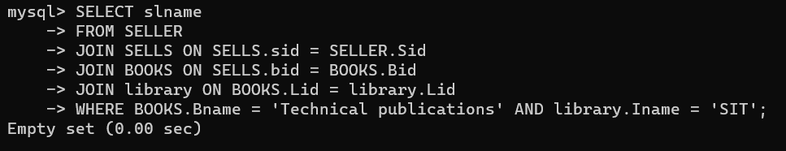

- Which books are issued by staff of SSAC Structure department?
mysql> SELECT DISTINCT BOOKS.*
-> FROM BOOKS
-> JOIN ISSUE ON BOOKS.Bid=ISSUE.bid
-> JOIN STAFF ON ISSUE.memid=STAFF.memid
-> JOIN DEPARTMENT ON STAFF.deptid = DEPARTMENT.Deptid
-> WHERE DEPARTMENT.deptname = 'Structure' AND DEPARTMENT.Iname='SSAC';
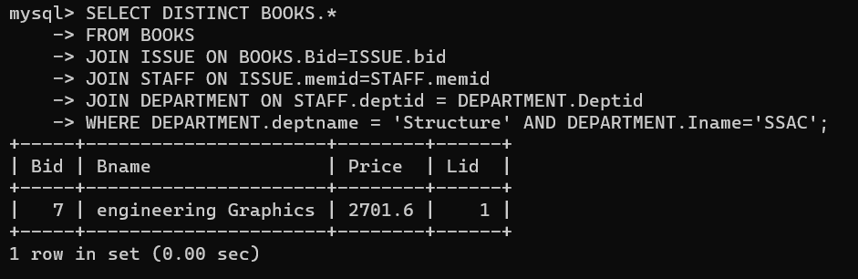

- Which sellers reside in the same city in which SIT library resides?
mysql> SELECT Sid, slname
-> FROM SELLER
-> JOIN library ON SELLER.city = library.city
-> WHERE library.Iname = 'SITLib';
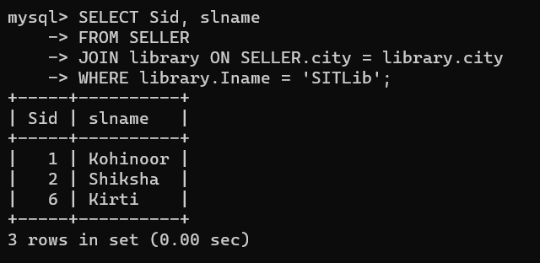

- Find out the publishers whose books are provided by the seller “pragati books store” to SSBS library.
mysql> SELECT DISTINCT P.Pname
-> FROM PUBLISHER P
-> JOIN Writes W ON P.Pid = W.Pid
-> JOIN BOOKS B ON W.Bid = B.Bid
-> JOIN SELLS S ON B.Bid = S.bid
-> JOIN SELLER SE ON S.sid = SE.Sid
-> JOIN library L ON SE.city = L.city
-> WHERE SE.slname = 'Pragati book store' AND L.Iname = 'SSBSLib';
Empty set (0.00 sec)
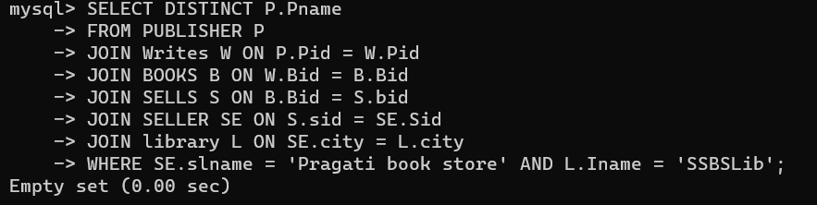

- Which books are published by “Shivam Kapoor” with the publishing house Prentice Hall publications?
mysql> SELECT BOOKS.Bid, BOOKS.Bname
-> FROM BOOKS
-> JOIN Writes ON Writes.bid=BOOKS.Bid
-> JOIN AUTHOR ON AUTHOR.Aid=Writes.Aid
-> JOIN PUBLISHER ON PUBLISHER.Pid=Writes.Pid
-> WHERE AUTHOR.Aname='Shivam Kapoor' AND PUBLISHER.Pname='Prentice Hall';
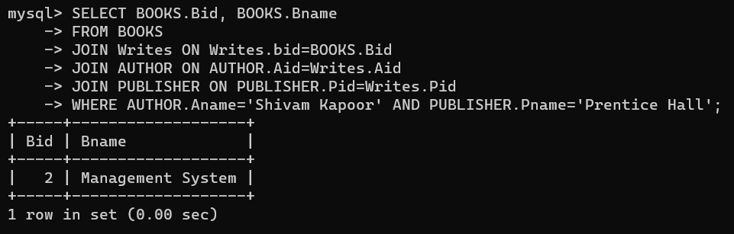

- What are the purchase details of the SSAC library for the month of March?
mysql> SELECT * FROM PURCHASE
-> JOIN library ON library.Lid=PURCHASE.lid
-> WHERE library.Iname='SSACLib' AND MONTH(PURCHASE.date)=3;
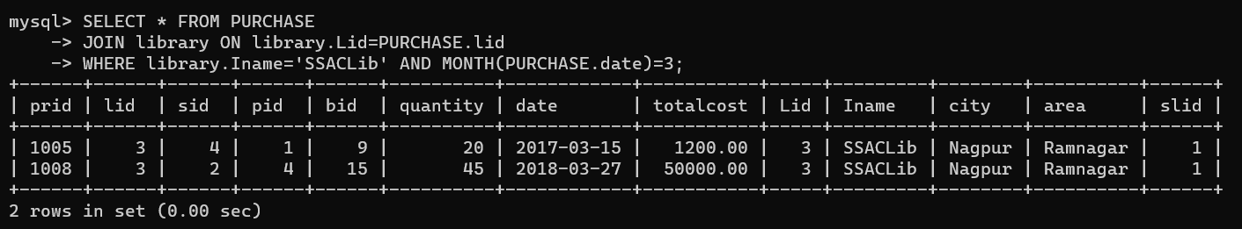

- Which institute does the member belong who have issued book number 453?
mysql> SELECT M.memid, L.Iname
-> FROM Member M
-> JOIN library L ON L.Lid = M.lid
-> WHERE M.memid IN (
-> SELECT memid
-> FROM ISSUE
-> WHERE bid = '453'
-> );
Empty set (0.00 sec)
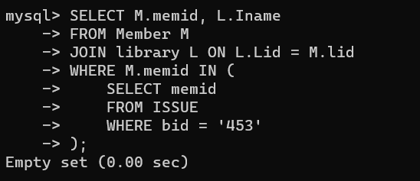

- Increase the price of all the books by 10%.
mysql> UPDATE BOOKS
-> SET Price = Price + (Price * 0.1);
Query OK, 24 rows affected (0.04 sec)
Rows matched: 24 Changed: 24 Warnings: 0

Updated table:-
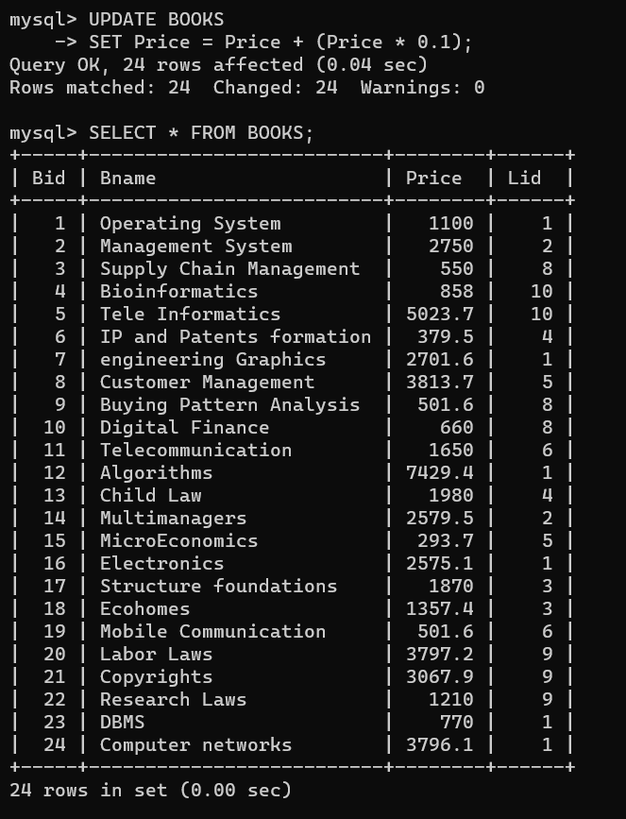

Original Table:-
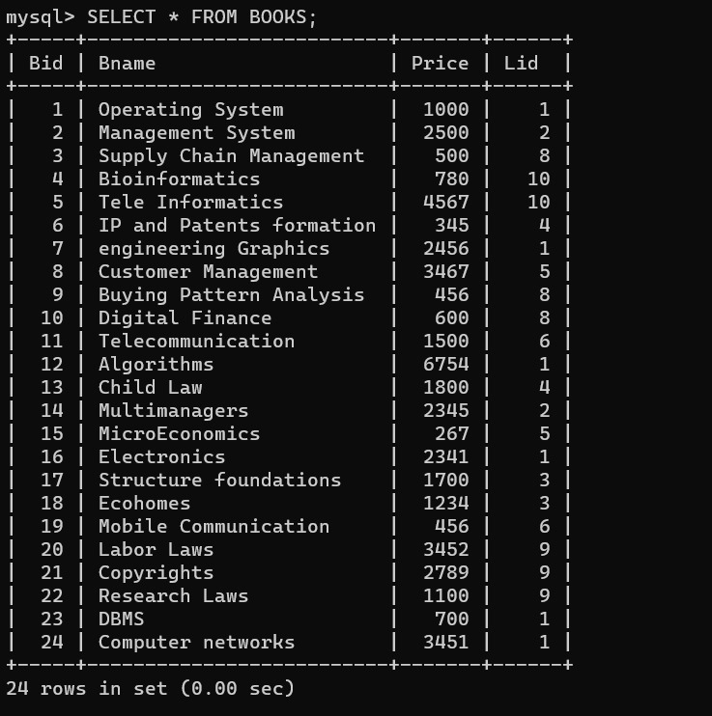

- Change the institute name to SSBS of “Biology department”
mysql> UPDATE DEPARTMENT
-> SET Iname = 'SSBS'
-> WHERE deptname = 'Biology';
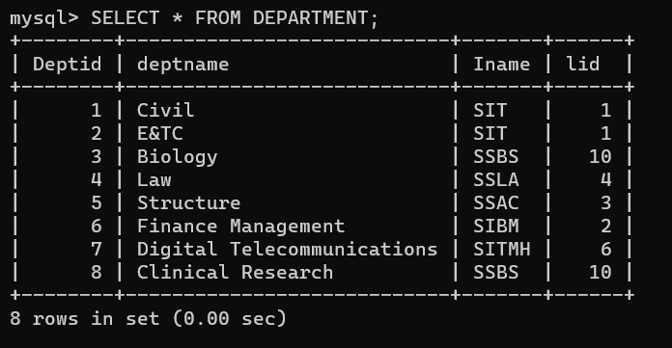

- Provide 25% Diwali bonus to SIT staff.
mysql> UPDATE Employee
-> SET salary = salary * 1.25
-> WHERE lid = (SELECT Lid FROM library WHERE Iname = 'SITLib');
Query OK, 2 rows affected (0.01 sec)
Rows matched: 2 Changed: 2 Warnings: 0

Updated table:-
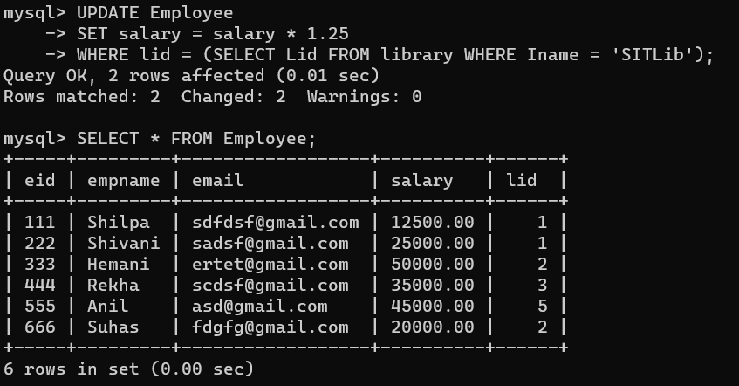

Original table:-
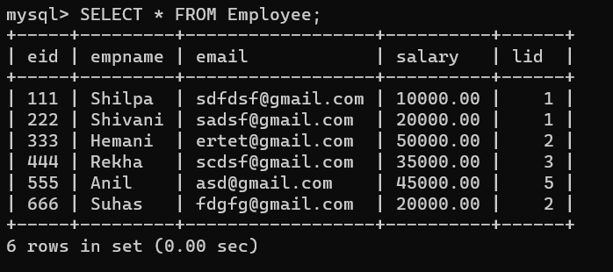

- Delete the purchase details which are happened in 2016.
mysql> DELETE FROM PURCHASE
-> WHERE YEAR(date) = 2016;
Query OK, 2 rows affected (0.01 sec)

Updated table:-
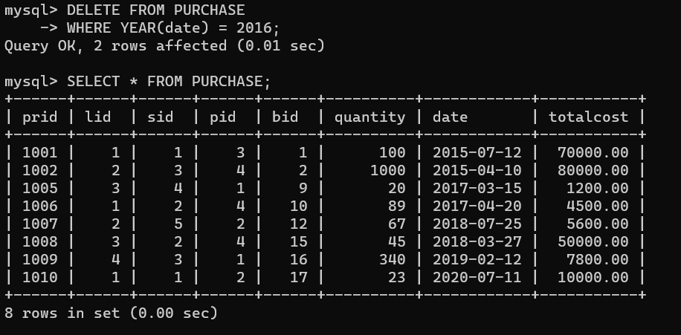

Original table:-
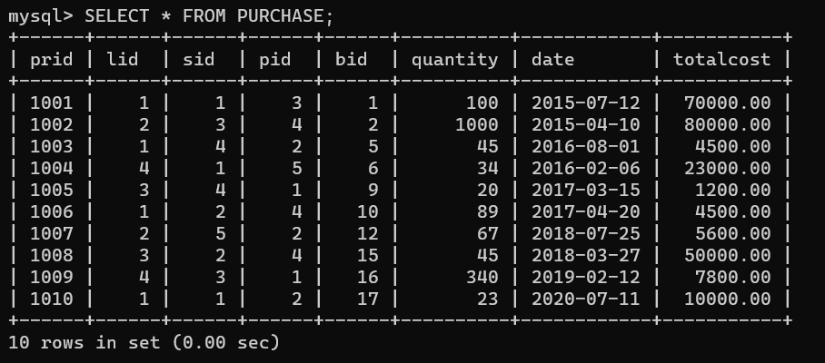

- Delete such issues where books are already returned in 2017.
mysql> DELETE FROM ISSUE
-> WHERE returndate IS NOT NULL AND YEAR(returndate) = 2017;
