Name: Anushree Dahiya
PRN: 22070122023
Division: CSE-A1
Date: 27-03-24
DBMS Lab Assignment -07
PL/SQL Functions

Assignment 07 Lab Questions
- Write a PL/SQL function to multiply 2 numbers
CREATE OR REPLACE FUNCTION multiply_numbers (
num1 IN NUMBER,
num2 IN NUMBER
) RETURN NUMBER
IS
result NUMBER;
BEGIN
result := num1 * num2;
RETURN result;
END;
/
--calling the function
DECLARE
result NUMBER;
BEGIN
result:=multiply_numbers(5,9);
DBMS_OUTPUT.PUT_LINE('Result: ' || result);
END;
/
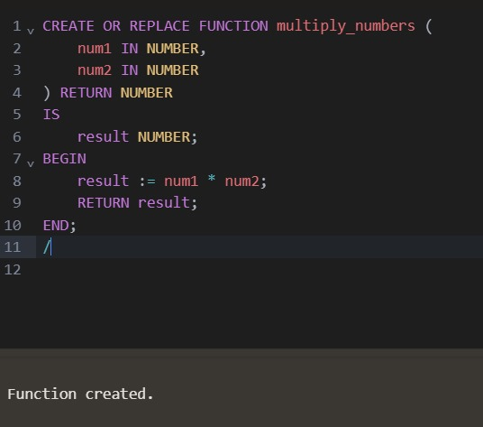
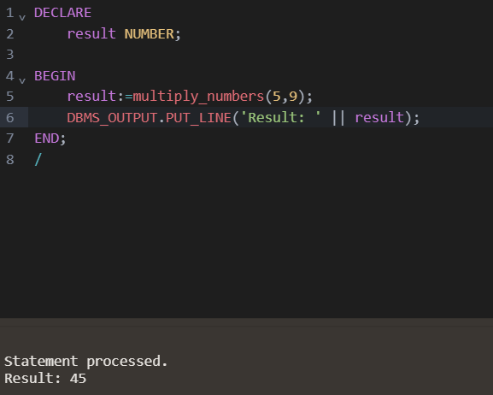

- Write a PL/SQL function to find maximum of 2 numbers.
CREATE OR REPLACE FUNCTION find_maximum (
num1 IN NUMBER,
num2 IN NUMBER
) RETURN NUMBER
IS
max_num NUMBER;
BEGIN
IF num1 > num2 THEN
max_num := num1;
ELSE
max_num := num2;
END IF;
RETURN max_num;
END;
/
--calling the function
DECLARE
result NUMBER;
BEGIN
result := find_maximum(23, 28);
DBMS_OUTPUT.PUT_LINE('Maximum number= ' || result);
END;
/
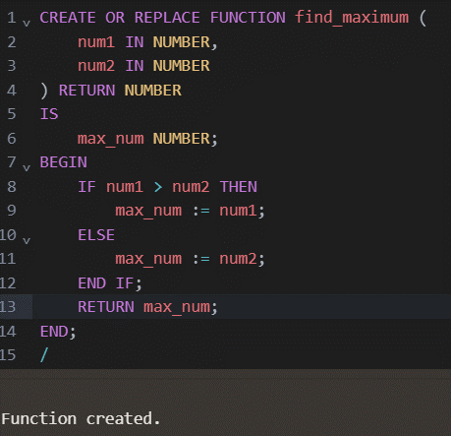
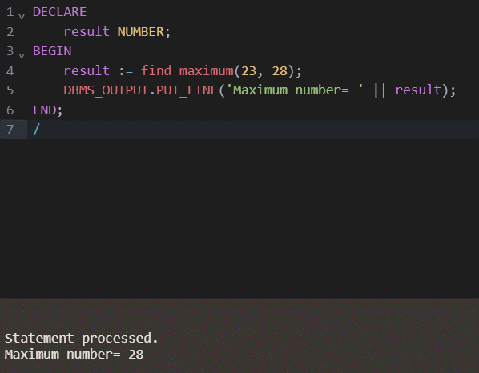

- Write a PL/SQL function to define total number of books in SIU Library
CREATE OR REPLACE FUNCTION total_books_in_library RETURN INT IS
total_books INT;
BEGIN
SELECT COUNT(*)
INTO total_books
FROM BOOKS;
RETURN total_books;
END total_books_in_library;

--calling the function
DECLARE
total_books INT;
BEGIN
total_books := total_books_in_library();
DBMS_OUTPUT.PUT_LINE('Total number of books in SIU Library: ' || total_books);
END;
/
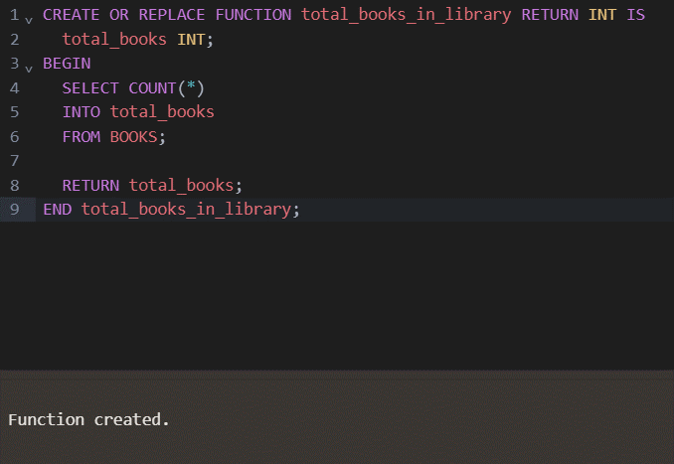
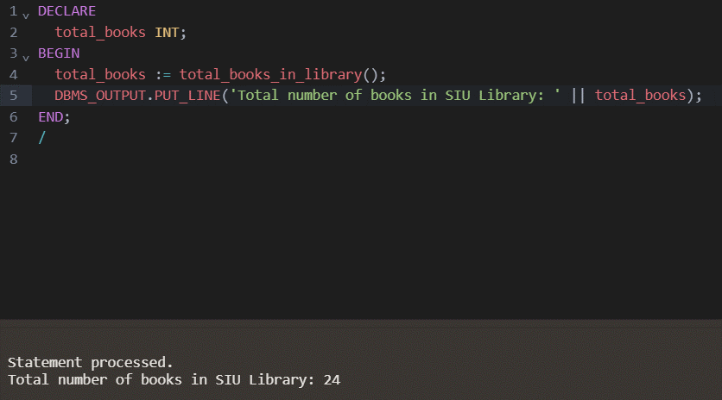

- Write a PL/SQL function to find average of 4 numbers.
CREATE OR REPLACE FUNCTION average (
num1 IN NUMBER,
num2 IN NUMBER,
num3 IN NUMBER,
num4 IN NUMBER
) RETURN NUMBER
IS
avg_num NUMBER;
BEGIN
avg_num := (num1 + num2 + num3 + num4) / 4;
RETURN avg_num;
END;
/
--calling the function
DECLARE
result NUMBER;
BEGIN
result := average(7, 3, 8, 9);
DBMS_OUTPUT.PUT_LINE('Average = ' || result);
END;
/
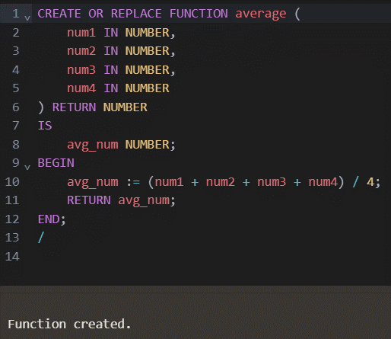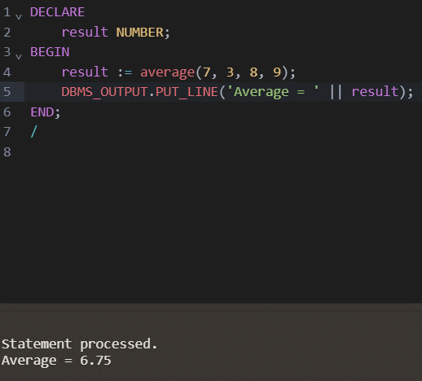
- Write a PL/SQL function to find factorial.
CREATE OR REPLACE FUNCTION factorial (
num IN NUMBER
) RETURN NUMBER
IS
fact NUMBER := 1;
BEGIN
FOR i IN 1..num LOOP
fact := fact * i;
END LOOP;
RETURN fact;
END;
/
--calling the function
DECLARE
result NUMBER;
BEGIN
result := factorial(5);
DBMS_OUTPUT.PUT_LINE('Factorial = ' || result);
END;
/
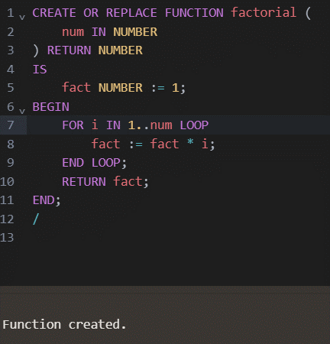
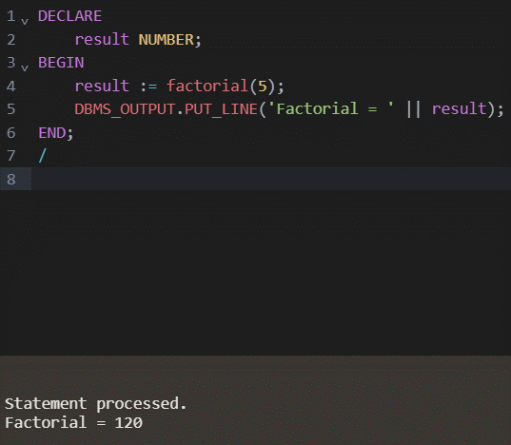
- Write a PL/SQL function to find the name of the library which has the cheapest books.
CREATE OR REPLACE FUNCTION cheaplib_name RETURN VARCHAR2 IS
cheapest_library_name VARCHAR2(50);
BEGIN
SELECT Iname
INTO cheapest_library_name
FROM (
SELECT l.Iname, MIN(b.Price) AS min_price
FROM BOOKS b
JOIN library l ON b.Lid = l.Lid
GROUP BY l.Iname
ORDER BY MIN(b.Price) ASC
)
WHERE ROWNUM = 1;
RETURN cheapest_library_name;
END cheaplib_name;
/
--calling the function
DECLARE
cheapest_library_name VARCHAR2(50);
BEGIN
cheapest_library_name := cheaplib_name();
DBMS_OUTPUT.PUT_LINE('Library with the cheapest books: ' || cheapest_library_name);
END;
/
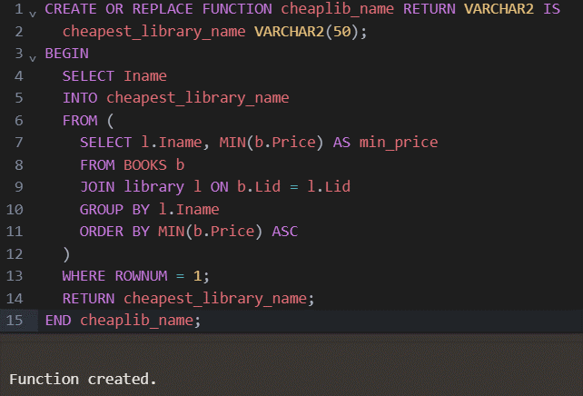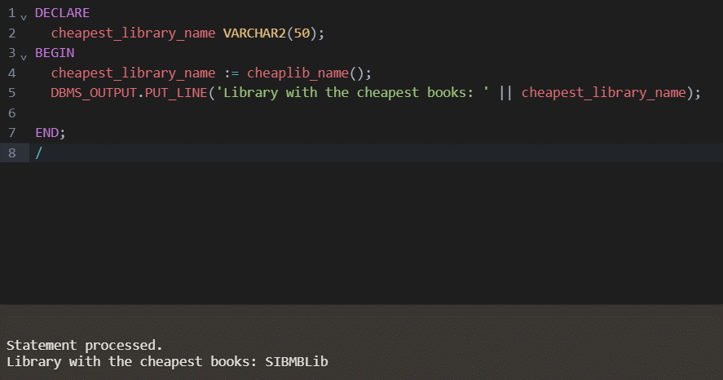
- Write a PL/SQL function to find total no. of books issued by SIT Staff.
CREATE OR REPLACE FUNCTION bissued_sitstaff RETURN INT IS
total_books_issued INT;
BEGIN
SELECT COUNT(*)
INTO total_books_issued
FROM ISSUE i
JOIN STUDENT s ON i.memid = s.memid
JOIN DEPARTMENT d ON s.deptid = d.Deptid
WHERE d.Iname = 'SIT';

RETURN total_books_issued;
END bissued_sitstaff;
/
--calling the function
DECLARE
total_books_issued INT;
BEGIN
total_books_issued := bissued_sitstaff();
DBMS_OUTPUT.PUT_LINE('Total number of books issued by SIT Staff: ' || total_books_issued);
END;
/
