Name: Anushree Dahiya
PRN: 22070122023
Division: CSE-A1
Date: 01-04-24
DBMS Lab Assignment -08
PL/SQL Procedures

Assignment 08 Lab Questions
- Write a procedure to find details of books of a given library.
CREATE OR REPLACE PROCEDURE book_details(
library_id IN NUMBER
) IS
BEGIN
FOR book_rec IN (
SELECT b.Bname, b.Price, b.Bid, a.Aname, p.Pname, l.Iname
FROM BOOKS b
JOIN library l ON l.Lid=b.Lid
JOIN Writes w ON w.Bid=b.Bid
JOIN AUTHOR a ON w.Aid = a.Aid
JOIN PUBLISHER p ON w.Pid = p.Pid
WHERE b.Lid = library_id
)
LOOP
DBMS_OUTPUT.PUT_LINE('Library Name: ' || book_rec.Iname);
DBMS_OUTPUT.PUT_LINE('Book Name: ' || book_rec.Bname);
DBMS_OUTPUT.PUT_LINE('Author: ' || book_rec.Aname);
DBMS_OUTPUT.PUT_LINE('Publisher: ' || book_rec.Pname);
DBMS_OUTPUT.PUT_LINE('Price: ' || TO_CHAR(book_rec.Price));
DBMS_OUTPUT.PUT_LINE('');
END LOOP;
END book_details;
/
--Calling the procedure
BEGIN
book_details(1);
END;
/
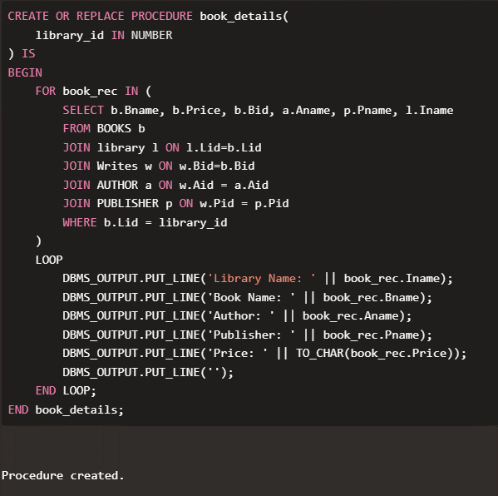
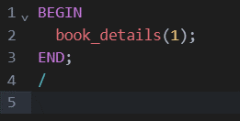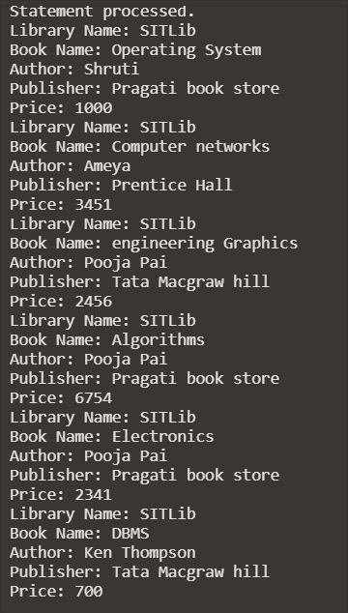

- Write a procedure to find out total no. of books written by a particular author.
CREATE OR REPLACE PROCEDURE books_by_author(
author_id IN NUMBER
) IS
total_books NUMBER;
author_name VARCHAR2(100);
BEGIN
SELECT a.Aname, COUNT(*) INTO author_name, total_books
FROM BOOKS b
JOIN Writes w ON w.Bid = b.Bid
JOIN Author a ON a.Aid = w.Aid
WHERE a.Aid = author_id
GROUP BY a.Aname;

DBMS_OUTPUT.PUT_LINE('Author Name: ' || author_name);
DBMS_OUTPUT.PUT_LINE('Total Books by Author: ' || total_books);
END books_by_author;
/

-- Calling the procedure
BEGIN
books_by_author(1);
END;
/
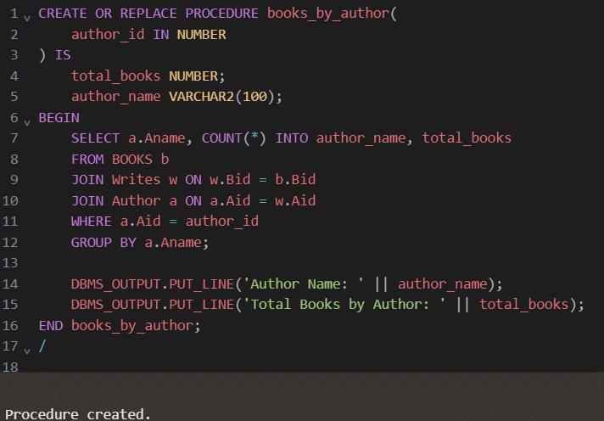
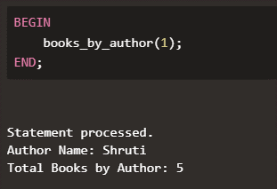

- Write a procedure to increase price of books by 10% which are sold by a particular seller to a particular library.
CREATE OR REPLACE PROCEDURE increase_price(
seller_id IN NUMBER,
library_id IN NUMBER
) IS
BEGIN
UPDATE BOOKS b
SET b.Price = b.Price * 1.1
WHERE b.Lid=library_id
AND EXISTS (
SELECT 1
FROM SELLER s
WHERE s.Sid=seller_id
);
COMMIT;
END increase_price;
/

--calling the function
BEGIN
increase_price(1, 1);
DBMS_OUTPUT.PUT_LINE('Price increased by 10% for books sold by seller ID 1 to library ID 1.');
END;
/

SELECT * FROM BOOKS, SELLER
WHERE Sid=1 AND lid=1;
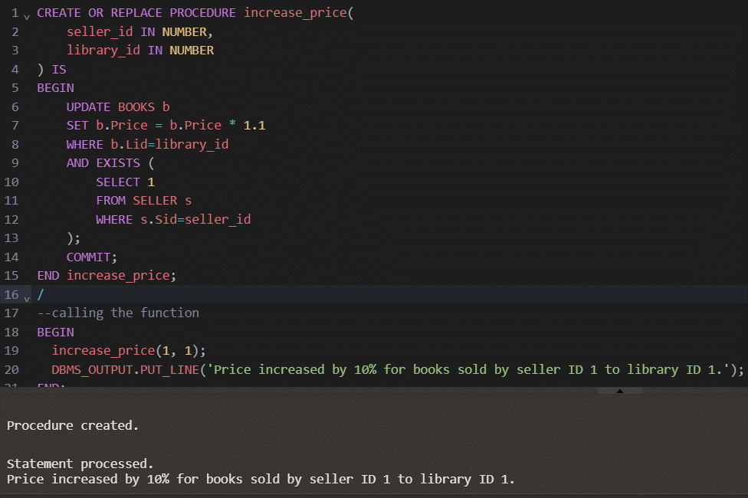
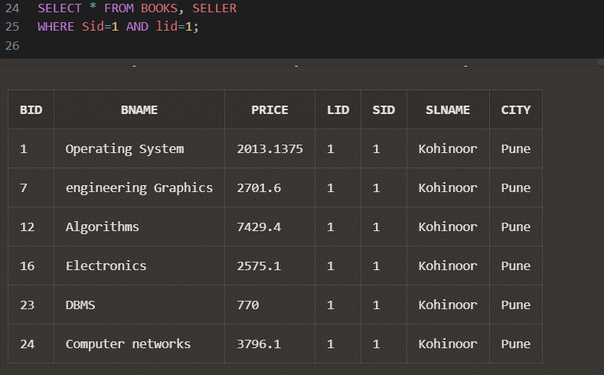

- Write a procedure to count total number of publishers who are providing books to a particular library.
CREATE OR REPLACE PROCEDURE publishers_for_library(
library_id IN NUMBER
) IS
total_publishers NUMBER;
library_name VARCHAR2(100);
BEGIN
SELECT l.Iname INTO library_name
FROM library l
WHERE l.Lid = library_id;

SELECT COUNT(DISTINCT p.Pid) INTO total_publishers
FROM PUBLISHER p
JOIN Writes w ON w.Pid=p.Pid
JOIN BOOKS b ON b.Bid=w.Bid
JOIN library l ON l.Lid=b.Lid
WHERE l.Lid = library_id;

DBMS_OUTPUT.PUT_LINE('Library Name: ' || library_name || ', Total Publishers for Library: ' || total_publishers);
END publishers_for_library;
/
--calling the procedure
BEGIN
publishers_for_library(1);
END;
/
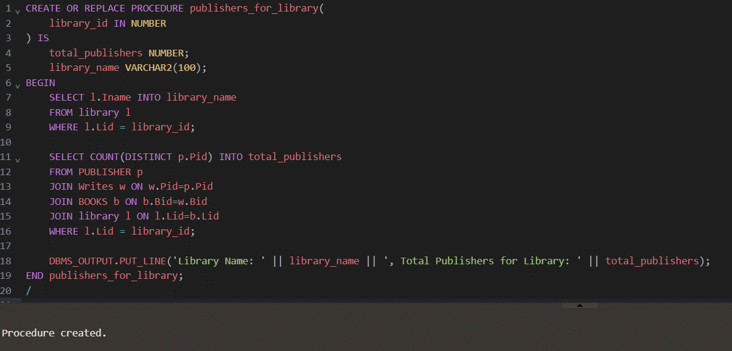
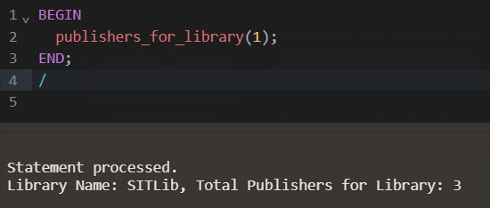

- Write a procedure to find the costliest and the cheapest books that a particular library has.
CREATE OR REPLACE PROCEDURE costliest_and_cheapest_books(
library_id IN NUMBER
) IS
costliest_book VARCHAR2(100);
cheapest_book VARCHAR2(100);
BEGIN
SELECT Bname INTO costliest_book
FROM BOOKS
JOIN library ON library.Lid=BOOKS.Lid
WHERE library.Lid = library_id
ORDER BY Price DESC
FETCH FIRST 1 ROWS ONLY;

SELECT Bname INTO cheapest_book
FROM BOOKS
JOIN library ON library.Lid=BOOKS.Lid
WHERE library.Lid = library_id
ORDER BY Price ASC
FETCH FIRST 1 ROWS ONLY;

DBMS_OUTPUT.PUT_LINE('Costliest Book in Library: ' || costliest_book);
DBMS_OUTPUT.PUT_LINE('Cheapest Book in Library: ' || cheapest_book);
END costliest_and_cheapest_books;
/
--calling the function
BEGIN
costliest_and_cheapest_books(1);
END;
/
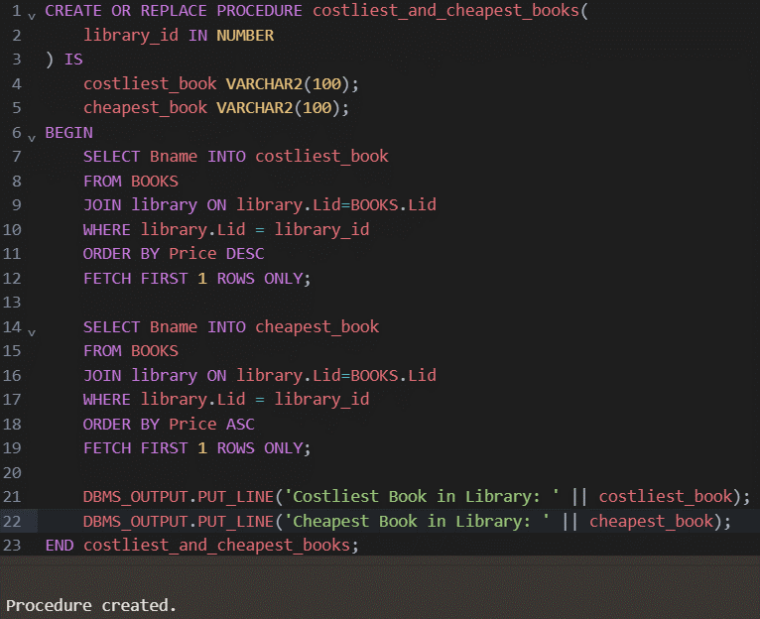
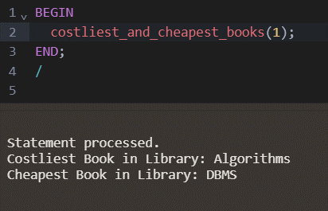

- Write a procedure to update the price of books by 25%, which are written by a particular author.
CREATE OR REPLACE PROCEDURE update_price_author(
author_id IN NUMBER
) IS
BEGIN
UPDATE BOOKS
SET Price = Price * 1.25
WHERE Bid IN (
SELECT DISTINCT Bid
FROM Writes
WHERE Aid = author_id
);
COMMIT;

DBMS_OUTPUT.PUT_LINE('Price increased by 25% for books written by author ID ' || author_id || '.');
END update_price_author;
/
--calling the procedure
BEGIN
update_price_author(1);
END;
/
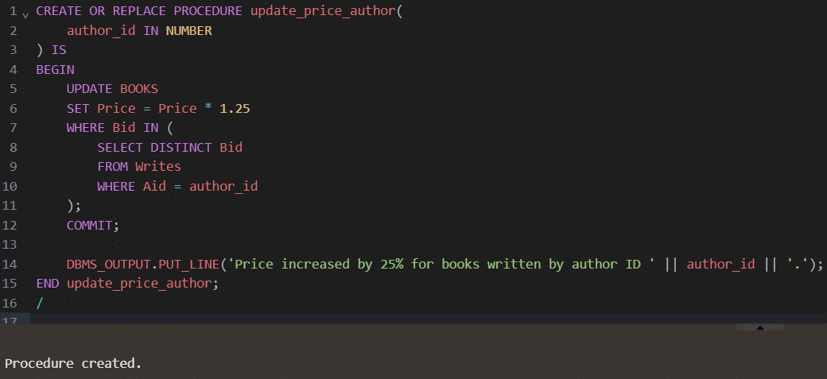
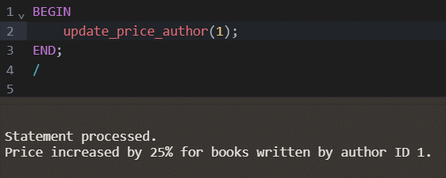

- Write a procedure to provide total money spent by a particular library in purchasing books in a particular month.
CREATE OR REPLACE PROCEDURE mspent_libmonth(
library_id IN NUMBER,
purchase_month IN VARCHAR2
) IS
total_spent NUMBER;
library_name VARCHAR2(100);
BEGIN
SELECT Iname INTO library_name
FROM library
WHERE Lid = library_id;

SELECT SUM(totalcost) INTO total_spent
FROM PURCHASE
WHERE lid = library_id AND TO_CHAR(p_date, 'YYYY-MM') = purchase_month;

DBMS_OUTPUT.PUT_LINE('Total Money Spent by ' || library_name || ' in ' || purchase_month || ': ' || total_spent);
END mspent_libmonth;
/
--calling the procedure
BEGIN
mspent_libmonth(1, '2017-04');
END;
/
