Name: Anushree Dahiya
PRN: 22070122023
Division: CSE-A1
Date: 13-04-24
DBMS Lab Assignment -09
SQL Triggers
Assignment 09 Lab Questions
- Implement After update trigger on the Books Table.
CREATE TABLE Book_Update (
Bid INT,
Bname VARCHAR2(50),
OldPrice NUMBER,
NewPrice NUMBER,
Update_Time DATE
);
--creating a trigger
CREATE OR REPLACE TRIGGER book_trigger
AFTER UPDATE ON BOOKS
FOR EACH ROW
BEGIN
INSERT INTO Book_Update (Bid, Bname, OldPrice, NewPrice, Update_Time)
VALUES (:OLD.Bid, :OLD.Bname, :OLD.Price, :NEW.Price, SYSDATE);
END;
/
--updating the table and displaying
UPDATE BOOKS SET Price=3000 WHERE Bid=24;
SELECT * FROM Book_Update;
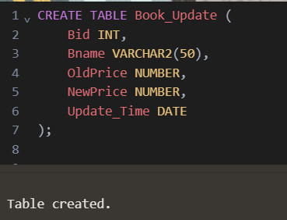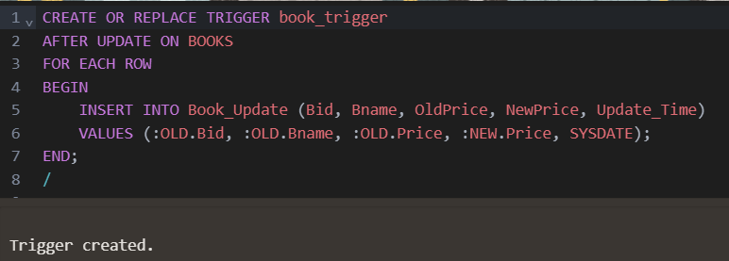

BEFORE UPDATING:-
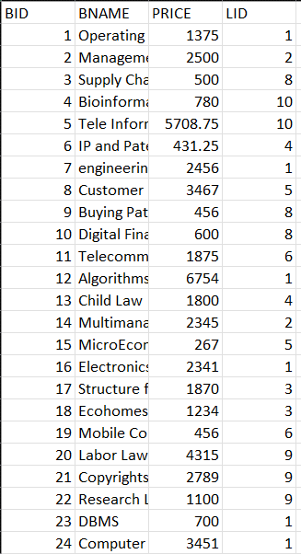
AFTER UPDATING:-
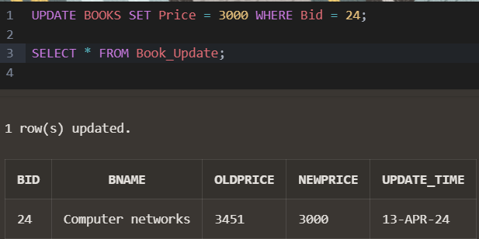
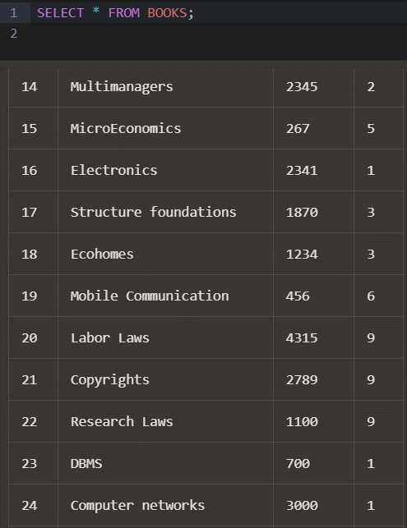

- Implement before insert trigger on the Books by Table.
CREATE OR REPLACE TRIGGER before_books
BEFORE INSERT ON BOOKS
FOR EACH ROW
BEGIN
IF :NEW.Price < 0 THEN
:NEW.Price := 0;
END IF;
END;
/
--inserting a negative value and displaying the table
INSERT INTO BOOKS VALUES (25, 'Computer networks', -3500, 1);
SELECT * FROM BOOKS;
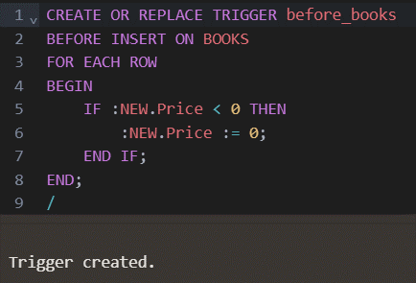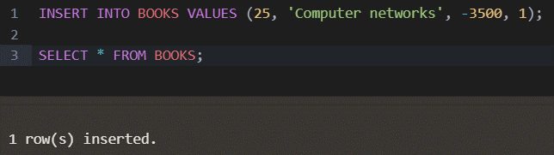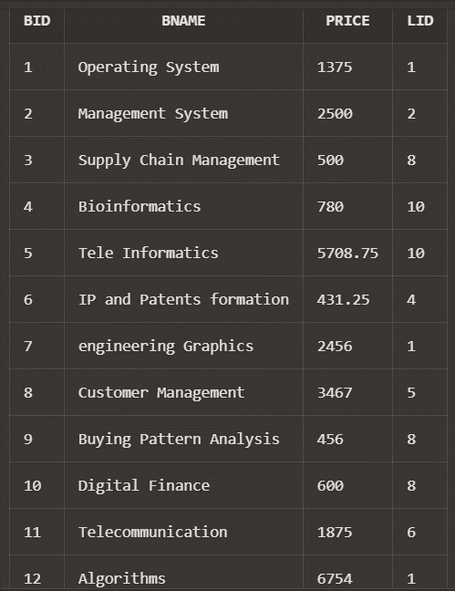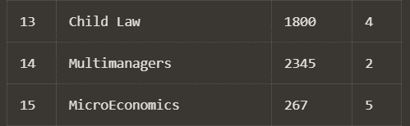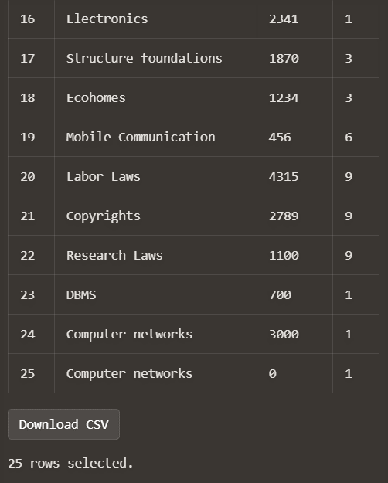

- Implement After update trigger on the Purchase Table.
CREATE TABLE Purchase_Update (
Prid INT,
OldCost NUMBER,
NewCost NUMBER,
Update_Time DATE
);
--creating a trigger
CREATE OR REPLACE TRIGGER purchase_trigger
AFTER UPDATE ON PURCHASE
FOR EACH ROW
BEGIN
INSERT INTO Purchase_Update (Prid, OldCost, NewCost, Update_Time)
VALUES (:OLD.Prid, :OLD.totalcost, :NEW.totalcost, SYSDATE);
END;
/
--updating the table and displaying
UPDATE PURCHASE SET totalcost=11000 WHERE Prid=1010;
SELECT * FROM Purchase_Update;
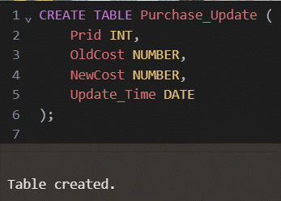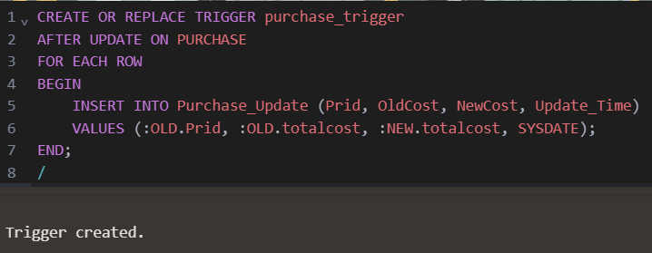
Before updating:-
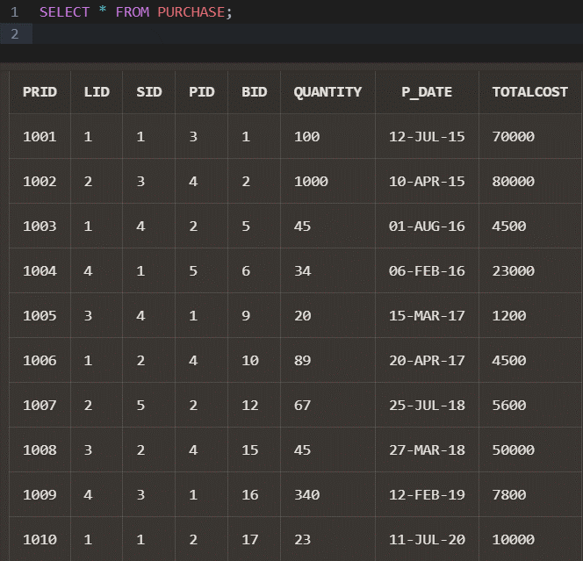
After updating:-
