LAB Manual
Name of Student : Anushree Dahiya PRN: 22070122023
Semester : IV Year AY 23-24
Subject Title: Operating Systems Lab
EXPERIMENT No : 12 Assignment No: 1
TITLE : Shell Script for Process operations DoP :16/04/2024

Aim : Implement shell script to list the processes for the current shell, Display information about processes, Display the global priority of a process, change the priority of a process with default arguments.
Learning Outcome:-
1. To understand Commands: PS, TOP, RENICE, NICE
2. To demonstrate shell script to implement above mentioned using Linux Commands
Hardware/Software :-
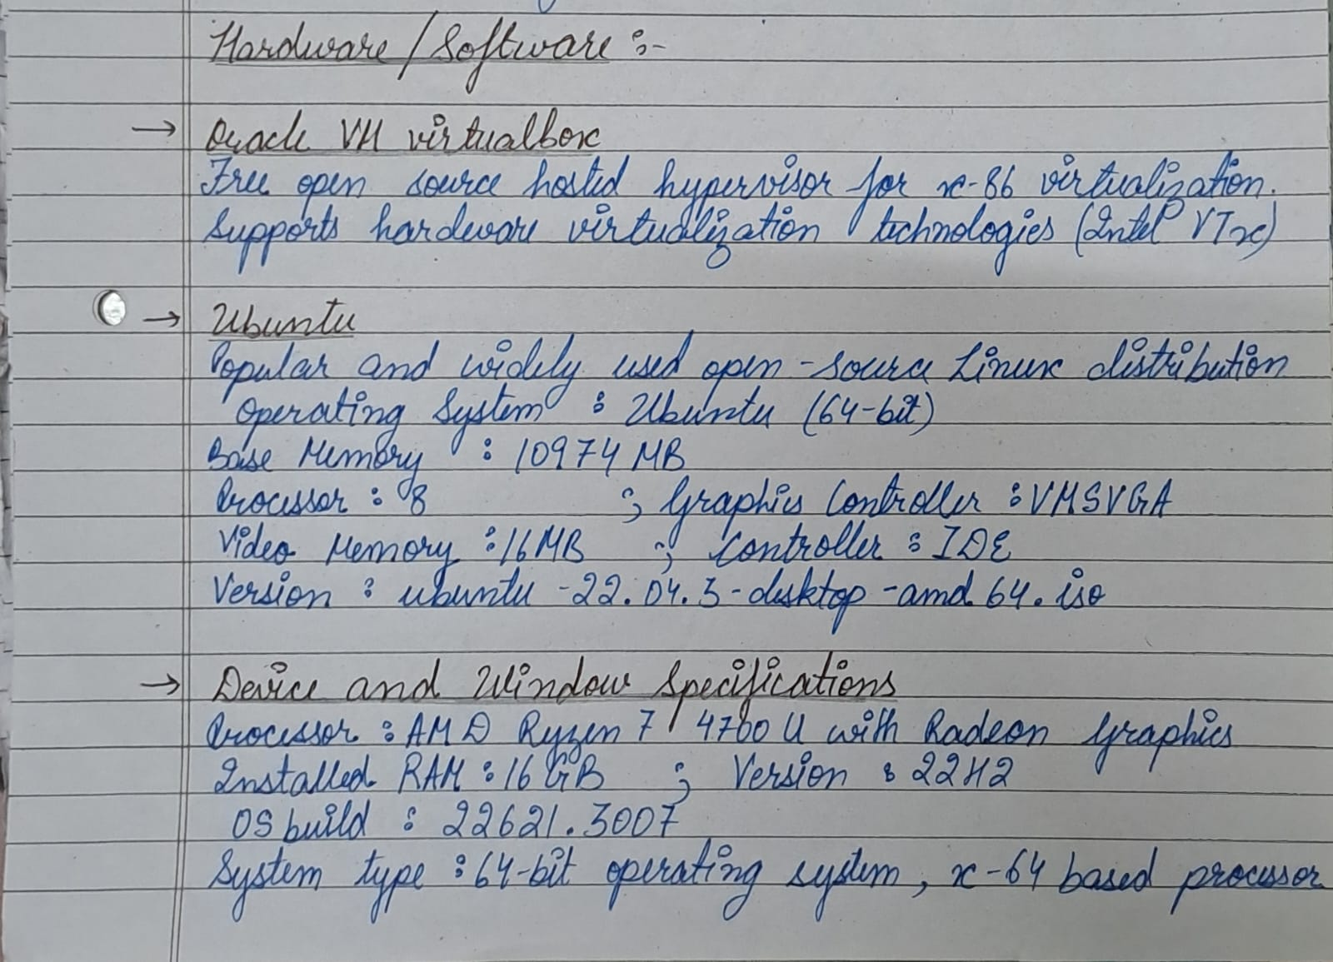
Theory: 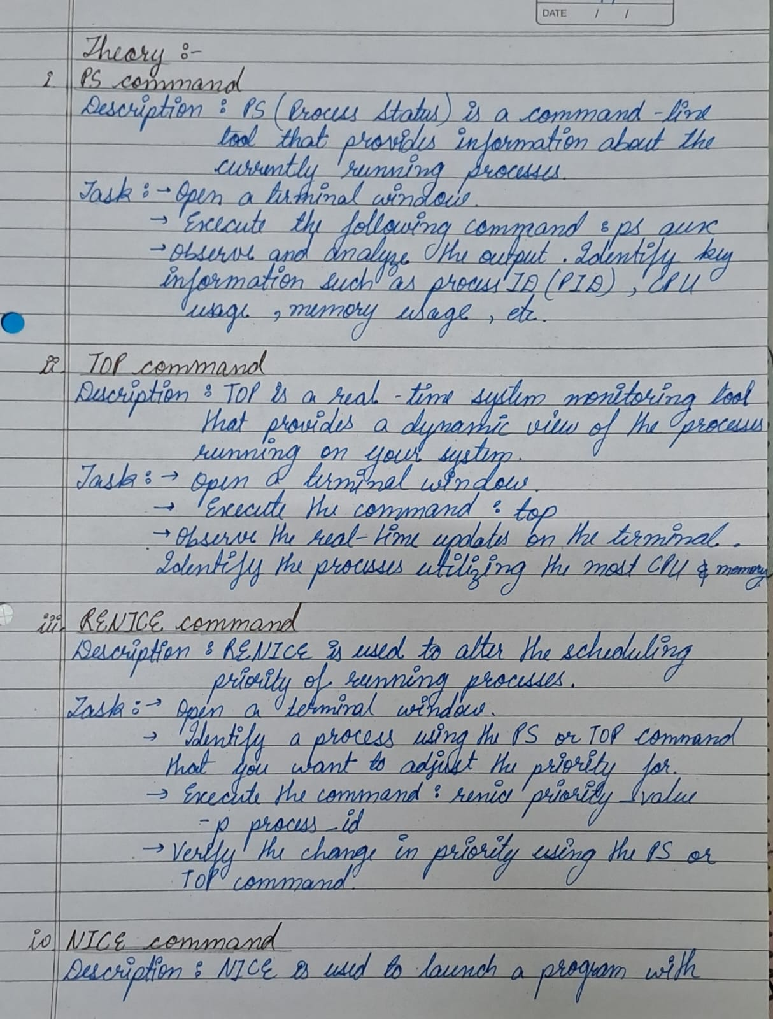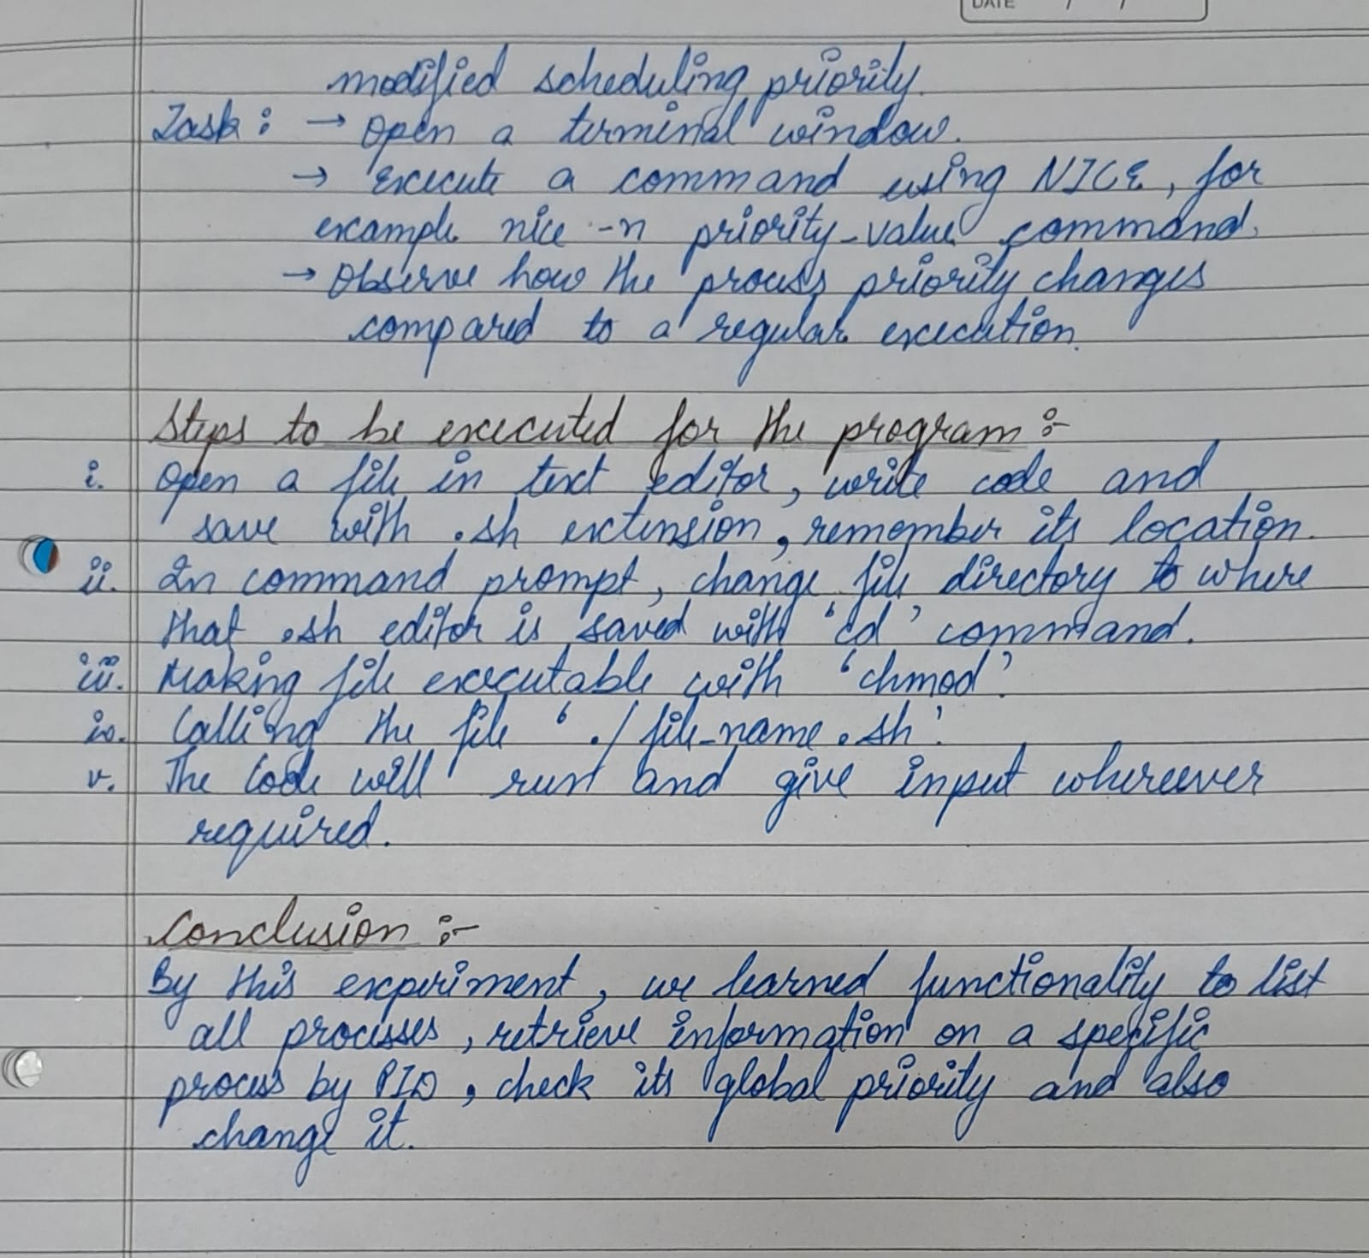

Control Structure
Algorithm:
- Shell script to print all processes, displaying their information, displaying global priority and changing it.
- Make a function to print all the processes using the ‘ps’ command.
list_processes() {
Execute: ps
}
- Make another function where user will give a particular process id and the details of the same will be displayed.
processes_info() {
Read: pid
Execute: ps -p <pid>
}
- Making another function to display the global priority of a specified process.
global_priority() {
Read: pid
Execute: ps -p <pid> -o pid, pri
}
- Defining a function where the priority of a particular function can be changed.
change_priority() {
Read: pid, priority
If priority is not provided, set it to 10
Execute: renice <priority> <pid> --changing the priority
Print: "Priority of <pid> changed to <priority>"
}
- Calling an infinity loop to display the menu and letting user choose the function that needs to be performed.
- Using the ‘case…esac’ calling the functions made according to the option chosen by the user and giving an option to exit the code also.

Program:
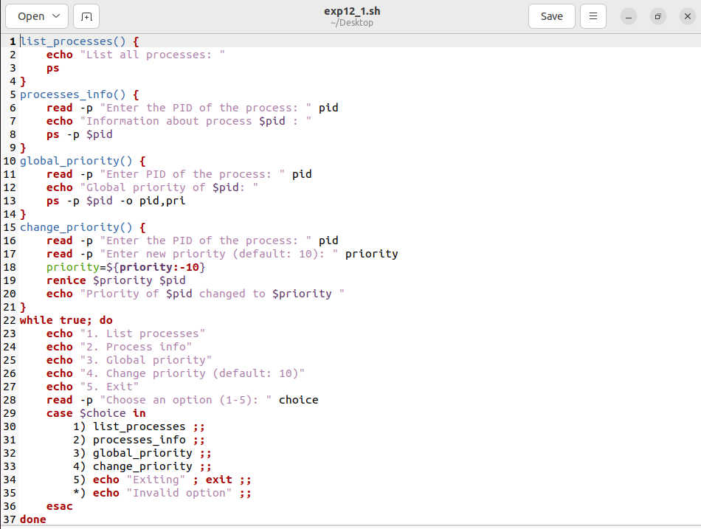
Output: 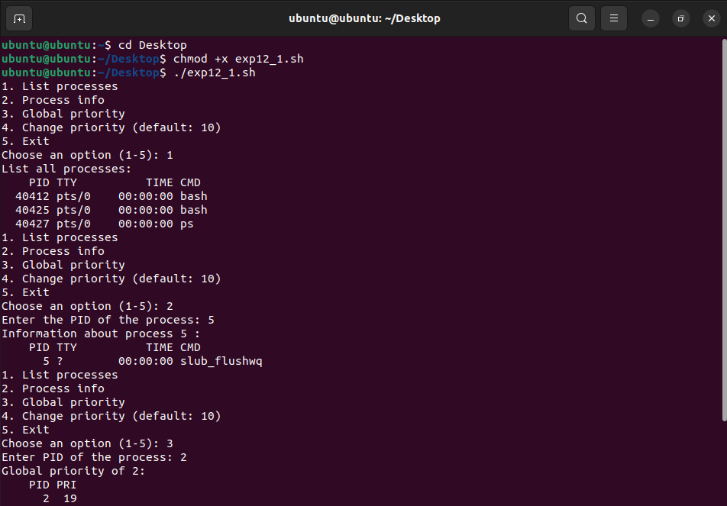
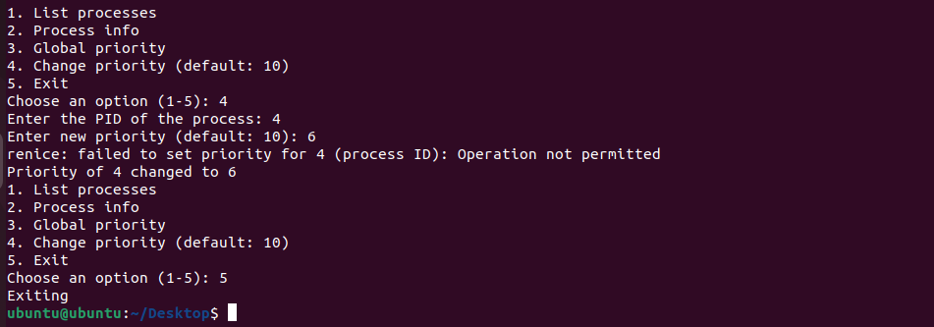

Steps to execute the program:
Conclusion:

