LAB Manual
Name of Student : Anushree Dahiya PRN: 22070122023
Semester : IV Year AY 23-24
Subject Title: Operating Systems Lab
EXPERIMENT No : 7 Assignment No: 7
TITLE : Switch Statement DoP : 20/02/2024

Aim : Implement shell script to demonstrate case...esac statements.

Learning Outcome:-
1. To understand the case...esac statements
2. To Demonstrate the shell script to demonstrate case...esac statements using Linux command.

Problem Statements :-
- To demonstrate in the Shell Script by using switch statement, checking whether a number is single/double/triple digit.

- To demonstrate in Shell Script, using switch statement, demonstrating different arithmetic operators and running the code in the loop until the user wants to exit from the code.

Hardware/Software :-
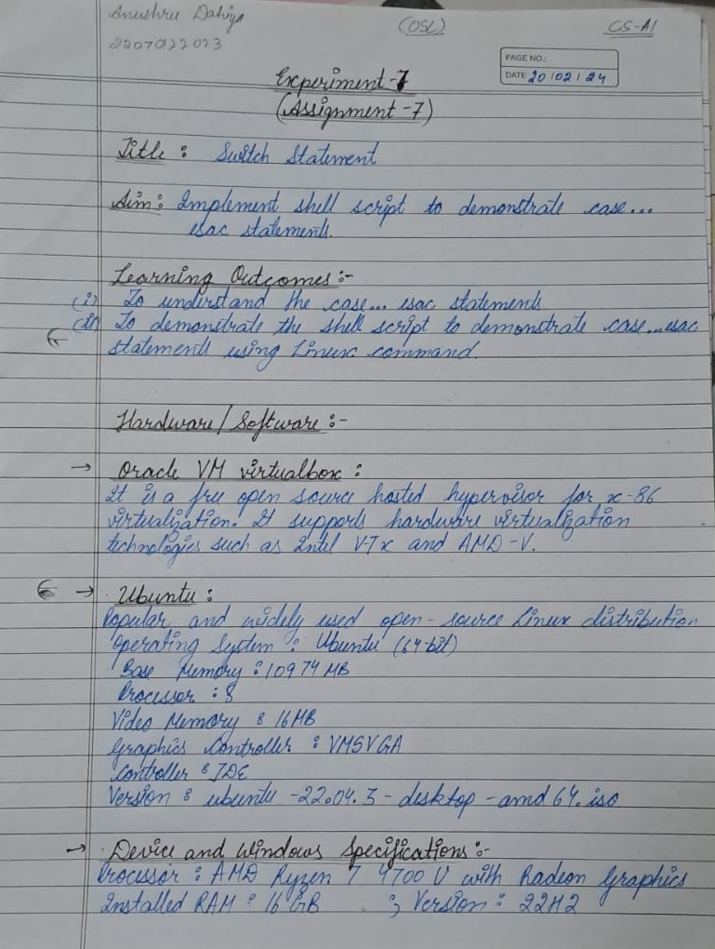

Theory:
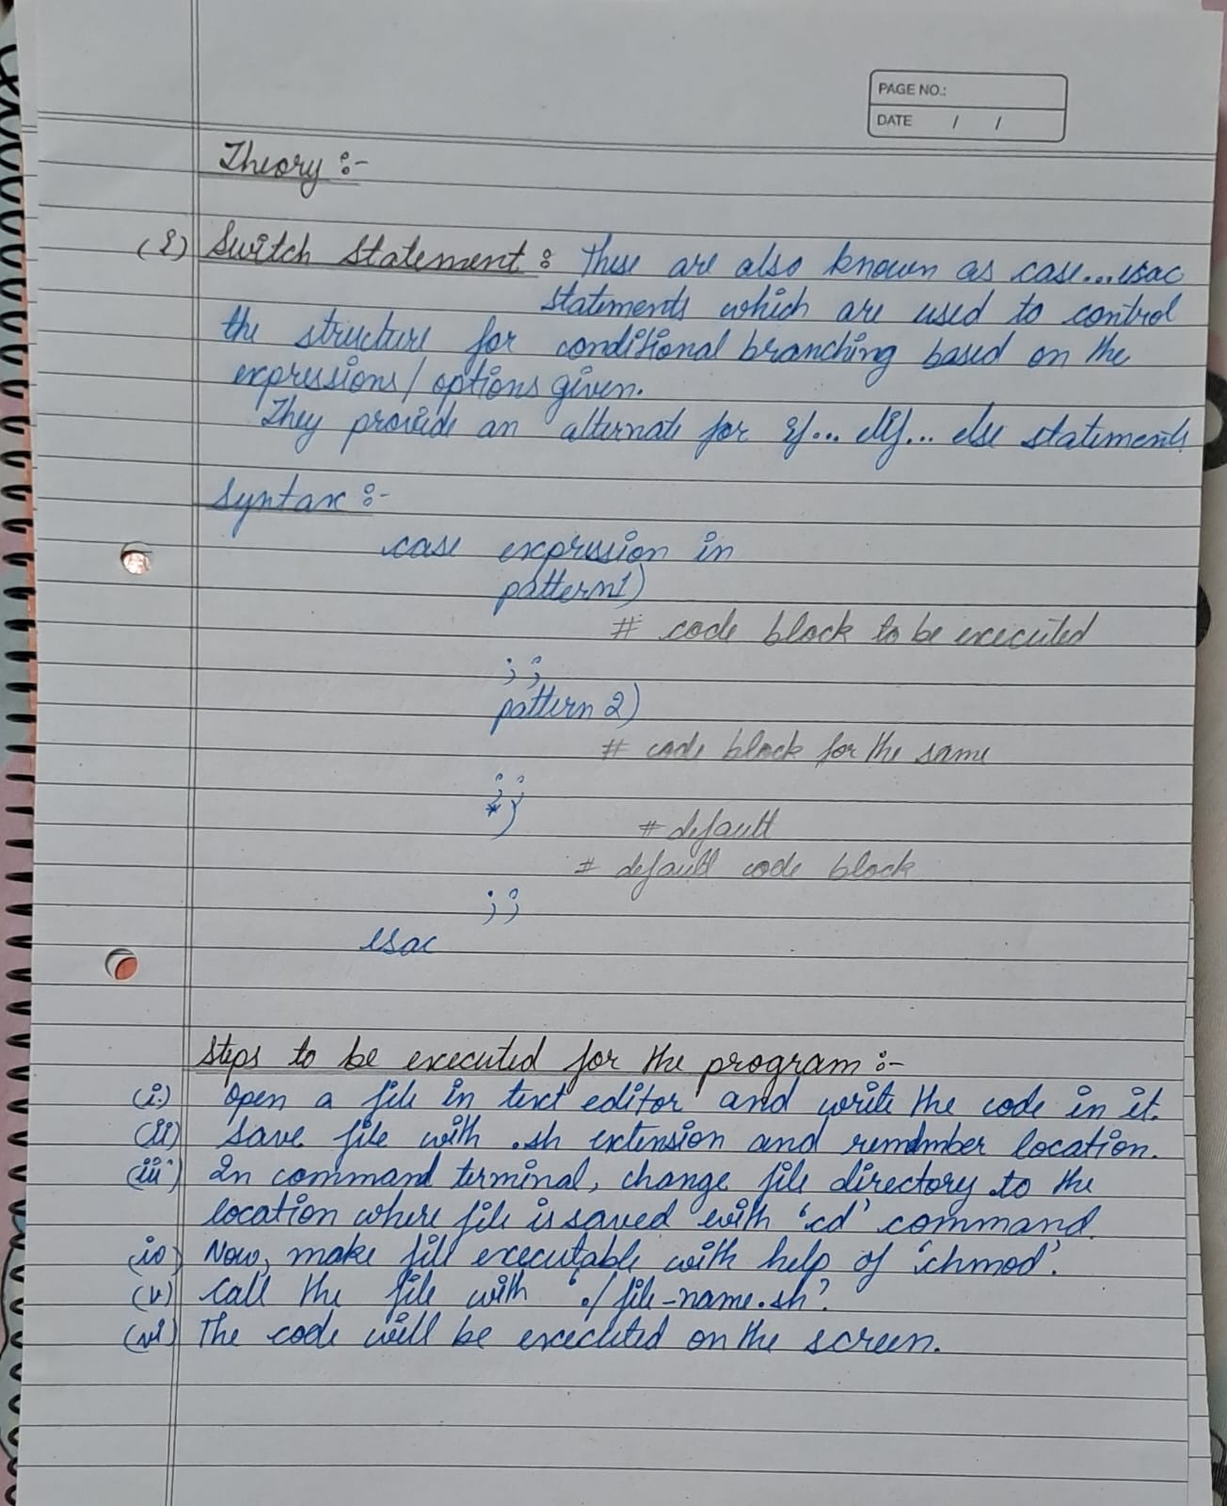

Control Structure
Algorithm:
- Using Shell Script to identify the digits of number entered by the user.
- Take the digit input from the user.
- Store it in a variable with the help of ‘read’ command.
- Now with the help of ‘case…esac’ statement, checking the number of digits in the number.
case $num in
[0-9])
echo “Entered number $num is single digit number”
;;

[0][0-9])
num=”${num#0}”
echo “Entered number is single digit”
;;

[1-9][0-9])
echo “Entered number is two digit number.”
;;

[1-9][0-9][0-9])
echo “Entered number is three digit number”
;;

*)
echo “Number is greater than 999”
;;

esac
- The output will be displayed.

- Using case…esac to perform different mathematical operations.
a. Take two inputs from the user.
b. Store it in two variable with the help of ‘read’ command.
c. Given user the options for which option need to be performed on the given numbers.
d. Now, firstly display the option from which the user will choose what he wants to do with the given numbers.
while true; do
echo “Enter 1 for addition”
echo “Enter 2 for subtraction”
echo “Enter 3 for division”
echo “Enter 4 for multiplication”
echo “Enter 5 to exit”
read num
- Display the cases or block of statements that will be taking place with the given options.
case $num in
[1])
echo “Addition of given numbers: $(($a + $b))”
;;

[2])
echo “Subtraction of given numbers: $(($a - $b))”
;;

[3])
If [ $b -eq 0 ]; then
echo “Not divisible”
else
echo “Division of given numbers: $(($a / $b))”
;;

[4])
echo “Multiplication of given numbers: $(($a * $b))”
;;

[5])
echo “Exiting the code”
break
;;

*)
echo “Invalid Entry”
;;

esac
done
- The output will be displayed.

Program:-
1.
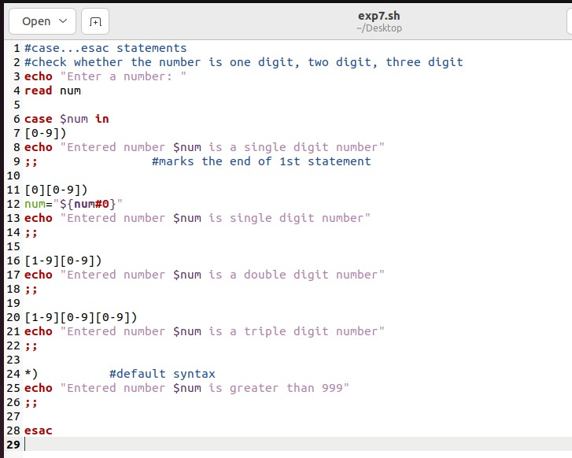
2.
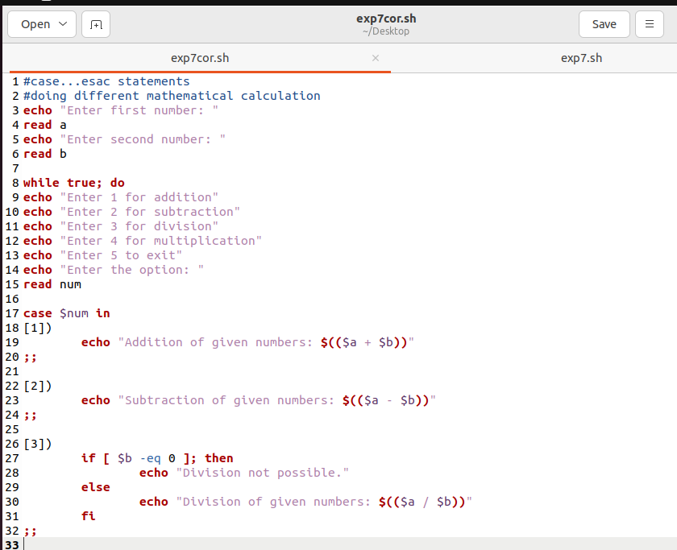
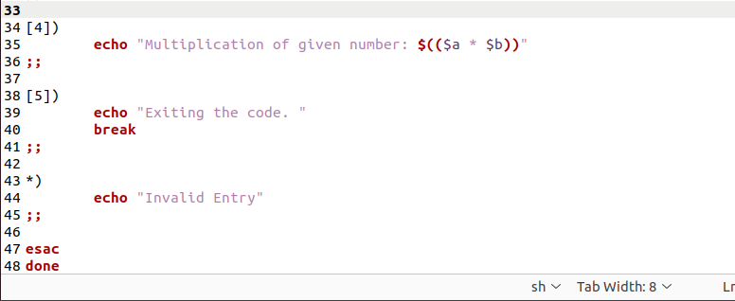

Output:
1.
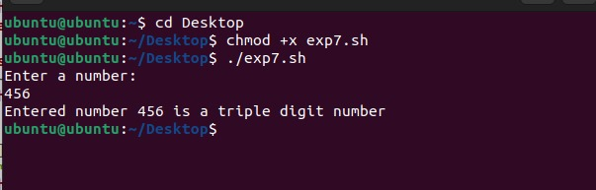
2.
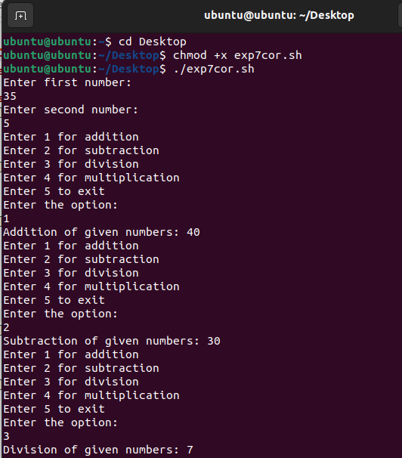
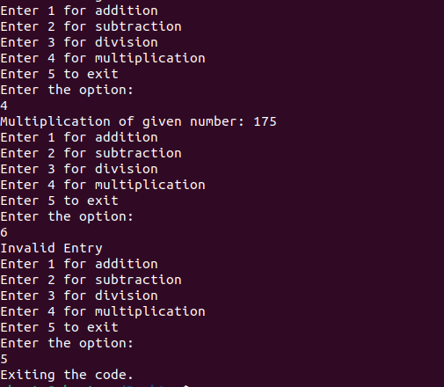

Steps to execute the program:

Conclusion:
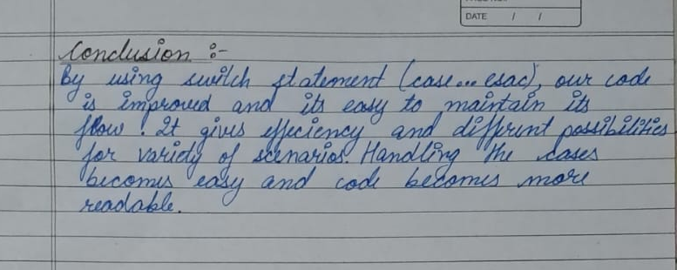

assessment schemes.
Attendance | Discipline | Short oral | Correctness of Lab Report | Timely completion of Lab Report | Total marks  (10) | Signature of Teacher with Date

