LAB Manual
Name of Student : Anushree Dahiya PRN: 22070122023
Semester : IV Year AY 23-24
Subject Title: Operating Systems Lab
EXPERIMENT No : 8 Assignment No: 3
TITLE : Basic Shell script for File operation DoP :05/03/2024

Aim : Implement and demonstrate shell script on file operations
Learning Outcome:
1. To understand the shell script for file operation
2. To Demonstrate the shell script for file operations
Hardware/Software :
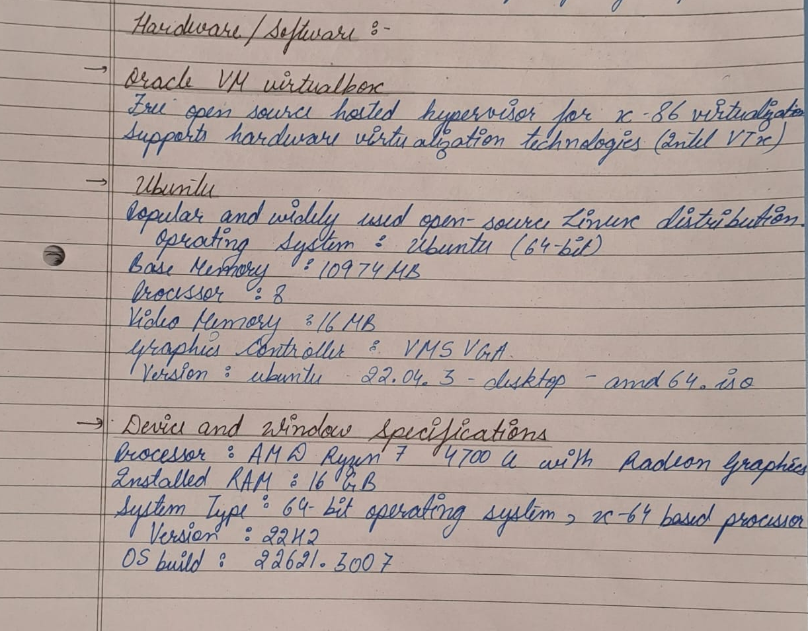

Theory: 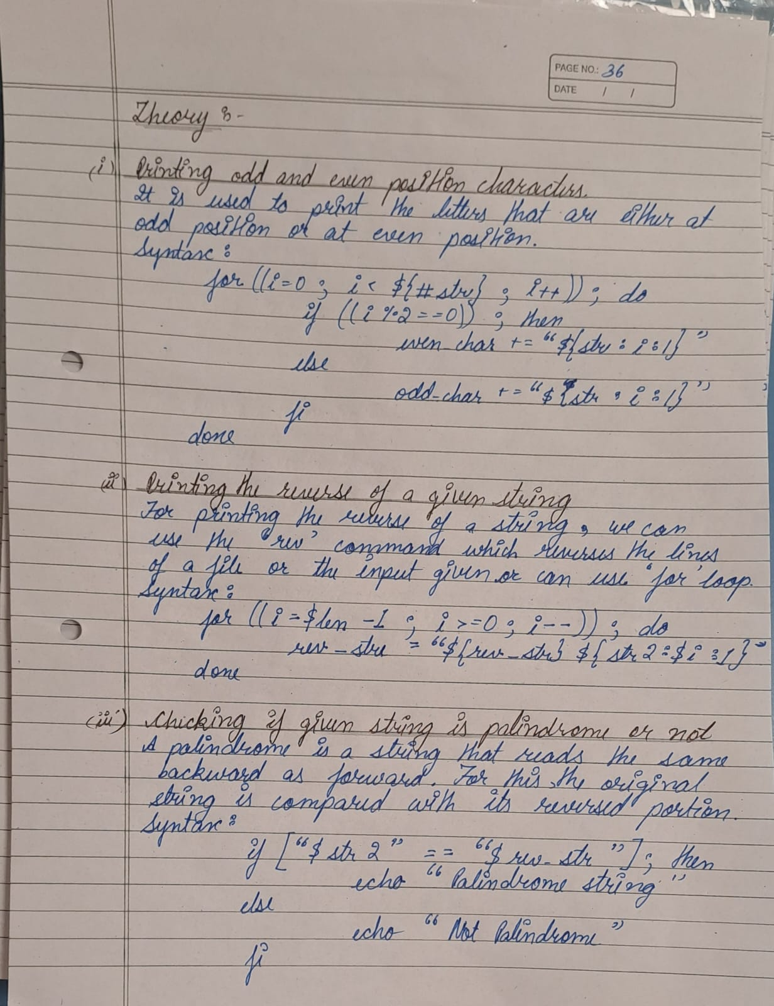 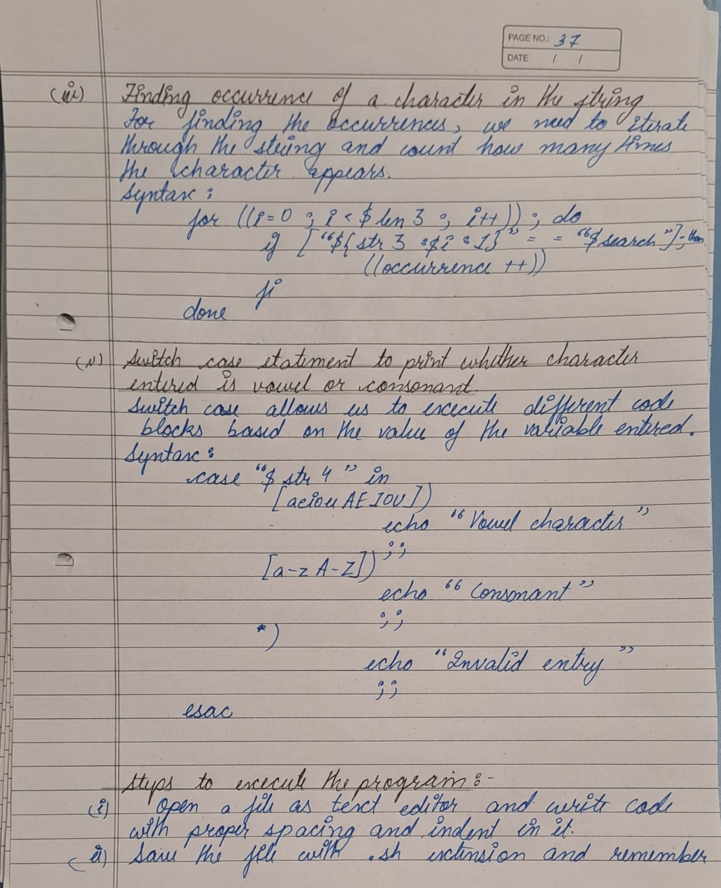

Control Structure

Algorithm:

- Printing odd and even position characters

- Take input from the user using echo and read command for a string.
- Using the for loop iterate through the string.
- for ((i=0; i< ${#str} ; i++)); do
if ((i%2==0)); then
even_char+= “${str:i:1}”
else
odd_char+= “${str:i:1}”
fi
done
- Now, Print the character at odd and even position separately.

- Reversing the string

- Take input for a string and store its value in str2.
- Now, making a new variable as length where the length of the string will be stored.
- Using the for loop to reverse the string.
- for ((i=$len-1; i>=0; i--));do
rev_str= “${rev_str}${str2:$i:1}”
done
- Now, we will print the output that will be stored in the rev_str variable.

- Checking if the given string is palindrome or not

- Taking input to check if the string is palindrome or not, storing it in a variable.
- Firstly, reversing the string and storing the value in a new variable.
for ((i=$len-1; i>=0; i--));do
rev_str= “${rev_str}${str2:$i:1}”
done
- Now, checking if the reversed string and the original string are equal or not and printing the output.
if [“$str” == “$rev_str”];then
echo “given string is palindrome”
else
echo “ Not Palindrome string”

- Finding the occurrence of a character in a string

- Take input for a string and storing it in a variable.
- Taking a input for the character that is to be searched in the string and storing that value in a new variable.
- Making a new variable that will store the occurrence value of the character that is to be searched.
- Using the for loop and iterating through the string to search for the given character.
for ((i=0; i<$length; i++));do
if [“${str:$i:1}” == “$search”];then
((occurrence++))
fi
- Printing the output that will contain the occurrence of the searched character.

- Using switch case to check if the entered character is vowel or consonant

- Taking input to check if the given character is vowel or consonant.
- We will use the switch case to run the block of code that will satisfy the condition for our input and printing the output simultaneously.
case “$character” in
[aeiouAEIOU])
echo “Entered character is a vowel”
;;
[a-zA-Z])
echo “Entered character is a consonant”
;;
*)
echo “Invalid Entry”
;;
esac

Program:

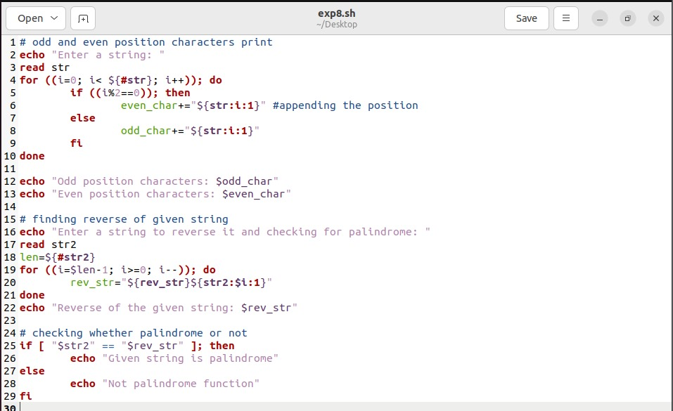
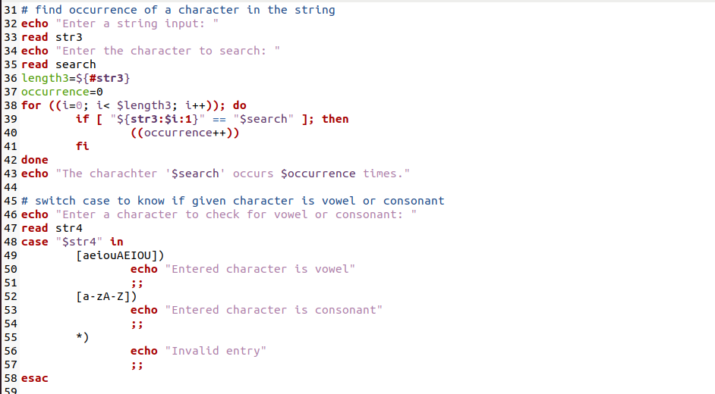

Output:
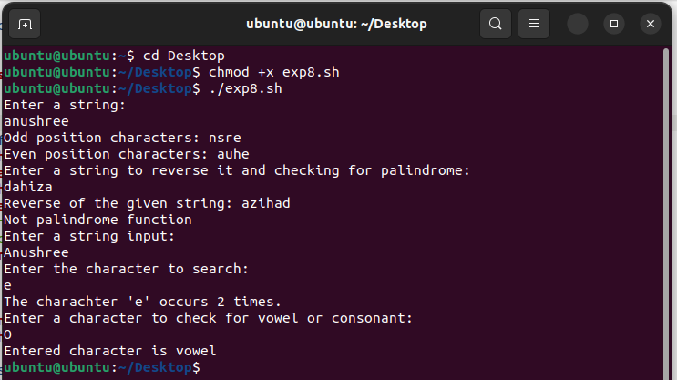

Steps to be executed:
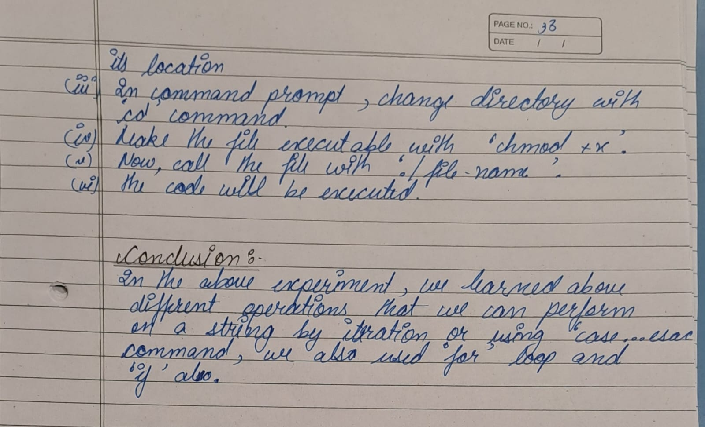

Conclusion:

assessment schemes.
Attendance | Discipline | Short oral | Correctness of Lab Report | Timely completion of Lab Report | Total marks  (10) | Signature of Teacher with Date

