ShopEase Auth Service
Submission evidence
Anushree Yadav | 5 November 2026

Summary
The Authentication Microservice is complete and pushed to GitHub. All 5 authentication APIs work against MySQL 8.4.11 in Docker, and every test in the final runs passed.
Repository: github.com/anushreeyadav/shopease-auth-service (branch main, commit d48e8a0)

Test results
Test | Result | Status
Automated test suite (pytest) | 299 passed, 0 failed, 1 deprecation warning | PASS
Test suite on a fresh copy, with no .env | 299 passed, 0 failed | PASS
22 API scenarios directly against Docker and MySQL | 22 of 22 passed | PASS
22 API scenarios through Swagger UI | 22 of 22 passed | PASS
22 API scenarios from the Postman collection (Newman) | 22 of 22 passed, 71 checks | PASS
Final code and security audit on Docker and MySQL | 68 of 68 checks passed | PASS
Final audit checks that need no Docker | 20 of 20 checks passed | PASS
Docker Compose: auth-service and auth-mysql | Both containers healthy | PASS

How this evidence was produced
Please read these points alongside the results:
- Swagger UI: a script operated the real page in Microsoft Edge. No person operated the browser.
- Postman: the collection ran in Newman, Postman's command-line runner. The Postman desktop application was not used.
- Evidence 1, 2, 3, and 11: these show real command output, drawn as images by a script. They are not pictures of the desktop or VS Code.
- Evidence 4 to 10: these come from the Swagger UI page. Tokens are redacted, and the curl text and documented response examples are hidden.
- Test data: all credentials shown are dummy values. No real password, secret, or whole token appears in this document.

Implemented APIs
Method | Path | Token | Purpose
POST | /api/auth/register | No | Create a user account
POST | /api/auth/login | No | Log in and get an access token
GET | /api/auth/me | Yes | Get the current user
POST | /api/auth/verify-token | Yes | Check a token and get its user
POST | /api/auth/change-password | Yes | Change the current user's password
GET | /health | No | Check the API process
GET | /health/db | No | Check the database connection
GET | / | No | Service information

API scenario results
Each scenario passed only if both its status code and its response content were correct. The same 22 scenarios also passed directly against the API.
ID | Scenario | Expected | Swagger UI | Newman | Result
TC-01 | Register a new user | 201 | 201 | 201 | PASS
TC-02 | Duplicate email | 409 | 409 | 409 | PASS
TC-03 | Invalid email format | 422 | 422 | 422 | PASS
TC-04 | Missing required fields | 422 | 422 | 422 | PASS
TC-05 | Mismatched confirm password | 422 | 422 | 422 | PASS
TC-06 | Weak password | 422 | 422 | 422 | PASS
TC-07 | Valid login | 200 | 200 | 200 | PASS
TC-08 | Wrong password | 401 | 401 | 401 | PASS
TC-09 | Unknown email | 401 | 401 | 401 | PASS
TC-10 | Inactive user | 403 | 403 | 403 | PASS
TC-11 | Current user with a valid token | 200 | 200 | 200 | PASS
TC-12 | Current user with no token | 401 | 401 | 401 | PASS
TC-13 | Current user with an invalid token | 401 | 401 | 401 | PASS
TC-14 | Current user with an expired token | 401 | 401 | 401 | PASS
TC-15 | Verify a valid token | 200 | 200 | 200 | PASS
TC-16 | Verify an invalid token | 401 | 401 | 401 | PASS
TC-17 | Valid password change | 200 | 200 | 200 | PASS
TC-18 | Wrong current password | 400 | 400 | 400 | PASS
TC-19 | Weak new password | 422 | 422 | 422 | PASS
TC-20 | No token | 401 | 401 | 401 | PASS
TC-21 | Login with the new password | 200 | 200 | 200 | PASS
TC-22 | Login with the old password | 401 | 401 | 401 | PASS

Security checks
Requirement | Evidence | Status
No plaintext passwords stored | The table has only password_hash, which holds a bcrypt hash. The submitted password was in no column. | PASS
Password hashes never returned | No hash or password_hash in any response from the audit's API calls | PASS
JWT secret not hardcoded | No .env secret value in any text file uploaded to GitHub | PASS
.env ignored by Git | git check-ignore matched it, and it was not in the commit | PASS
.env not in the Docker image | No .env file in the image, and no secret values in /app, its history, or its configuration | PASS
Tokens expire correctly | A one-minute token returned 200, then 401 after a real 65-second wait | PASS
Inactive users cannot authenticate | Login and all 3 protected endpoints returned 403 | PASS
Invalid tokens are rejected | Missing, malformed, altered, unsigned, and expired tokens: 27 of 27 requests returned 401 | PASS
No secrets in logs or documents | Logs and text files scanned, and images checked by eye: none found | PASS

Evidence screenshots

Evidence 1: Project folder structure
The files in the project, shown as a tree. .env, .venv, and caches are left out because Git ignores them.
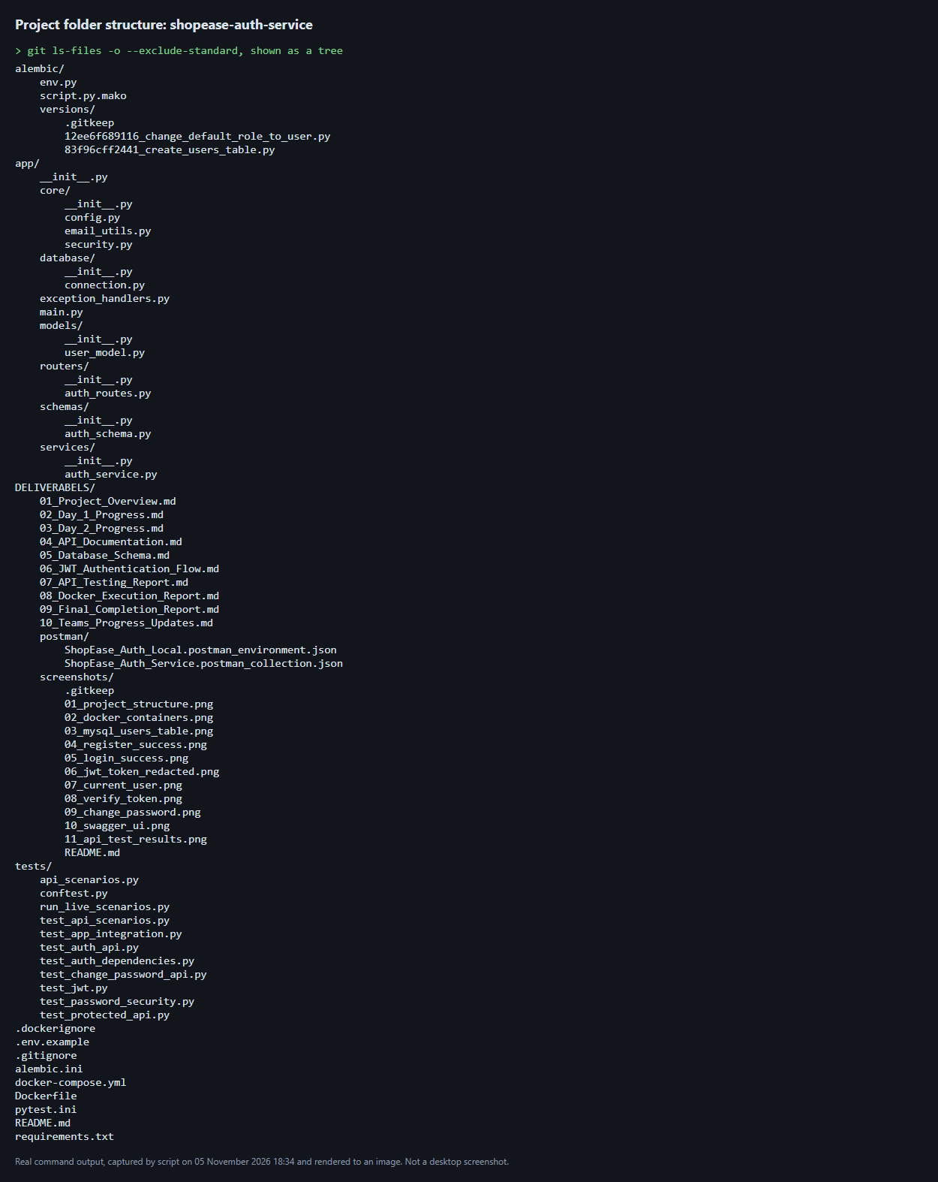

Evidence 2: Docker containers
Both services running and healthy.
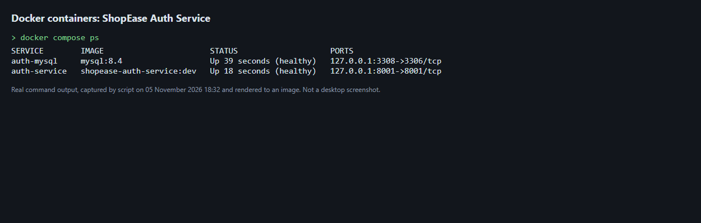

Evidence 3: MySQL database and users table
The shopease_auth_db tables, the users columns, and a dummy user. The hash column is left out of the query.
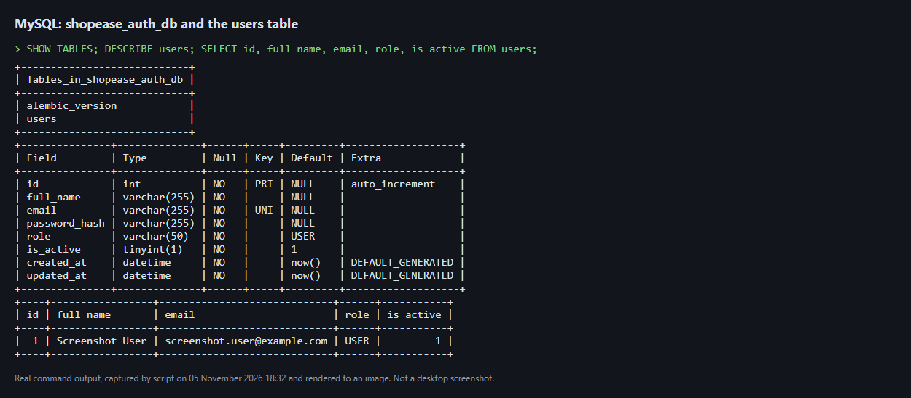

Evidence 4: Successful registration
POST /api/auth/register returned 201.
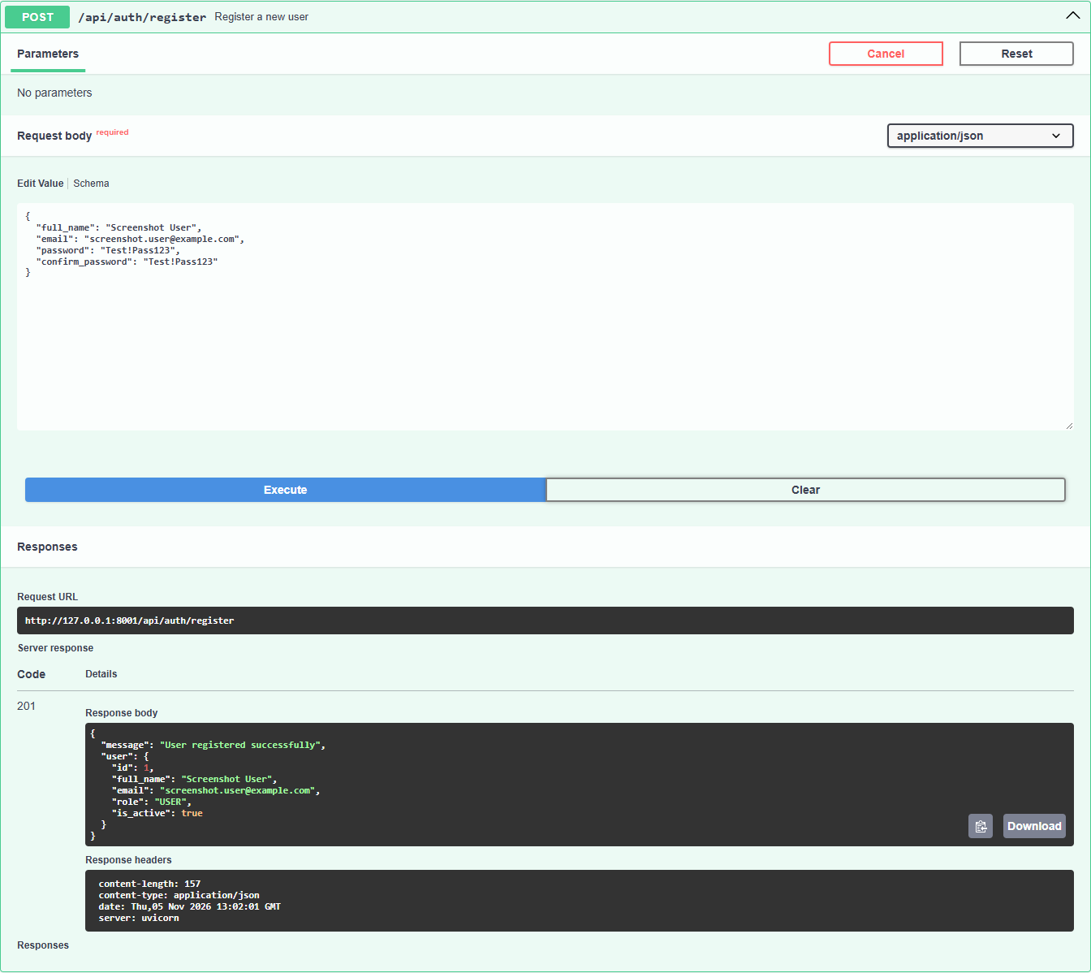

Evidence 5: Successful login
POST /api/auth/login returned 200. The token is redacted.
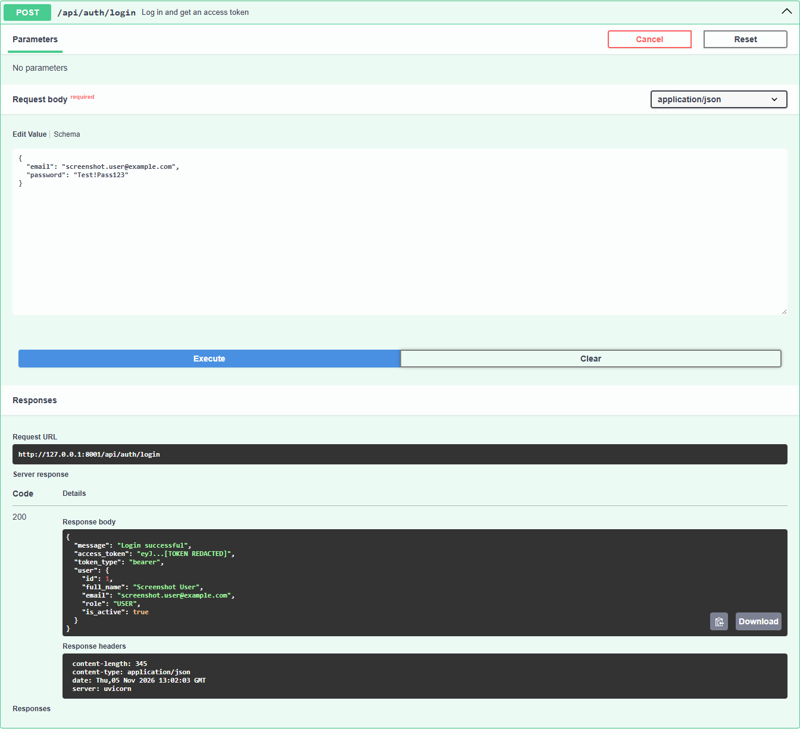

Evidence 6: JWT token response
The login response, with the token redacted.
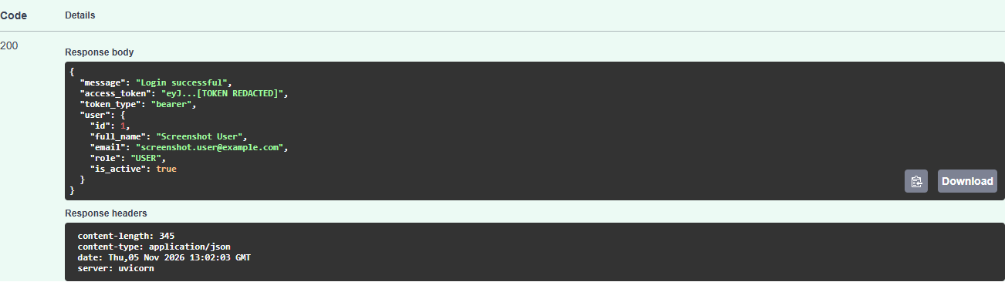

Evidence 7: Current-user API
GET /api/auth/me returned 200 with the user's profile.
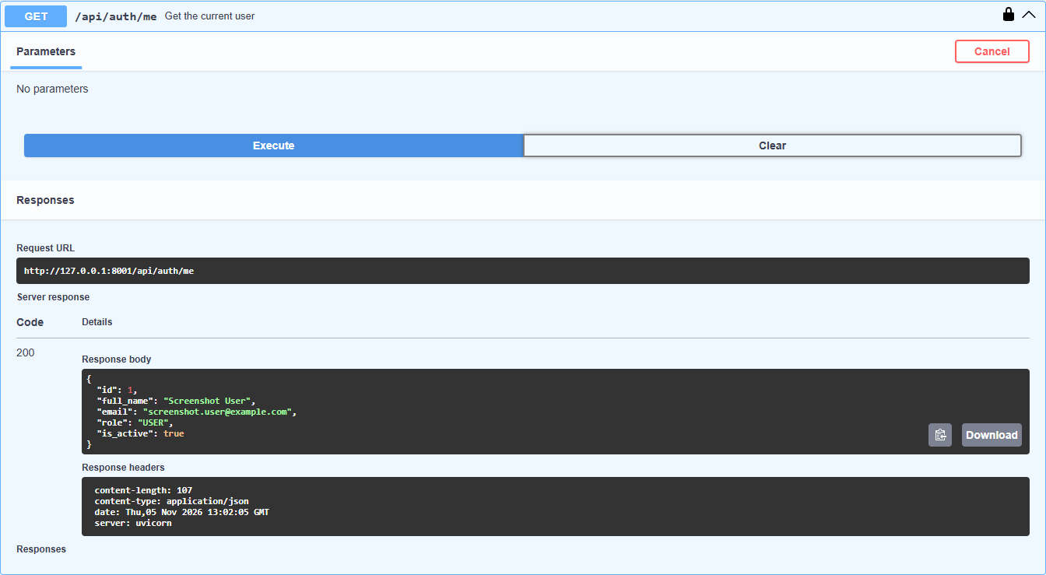

Evidence 8: Verify-token API
POST /api/auth/verify-token returned 200 with "valid": true.
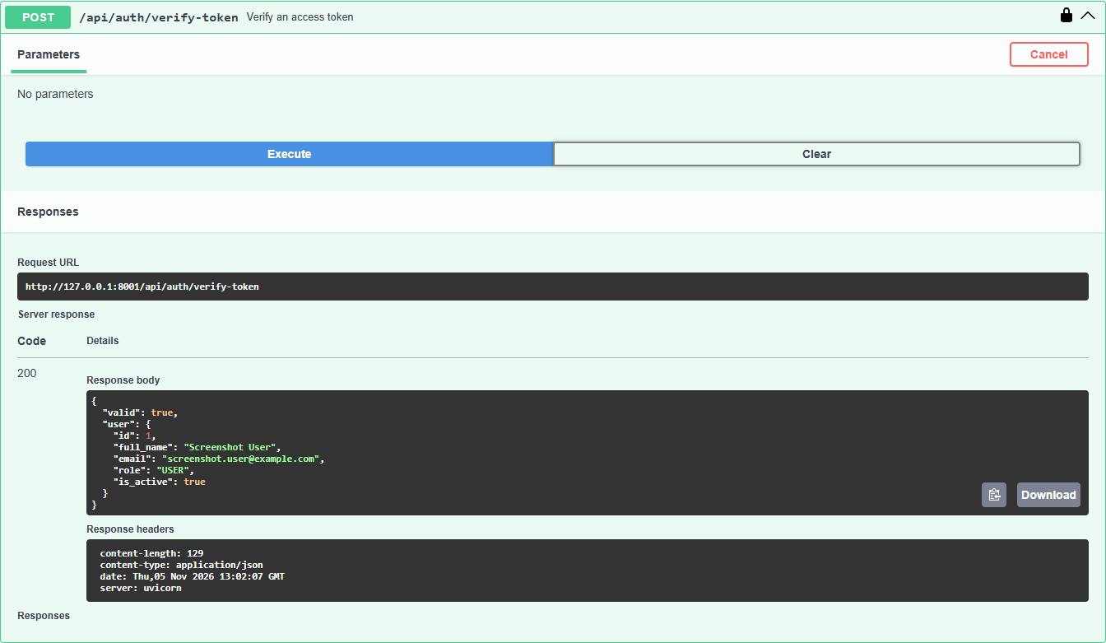

Evidence 9: Change-password API
POST /api/auth/change-password returned 200 with only a message.
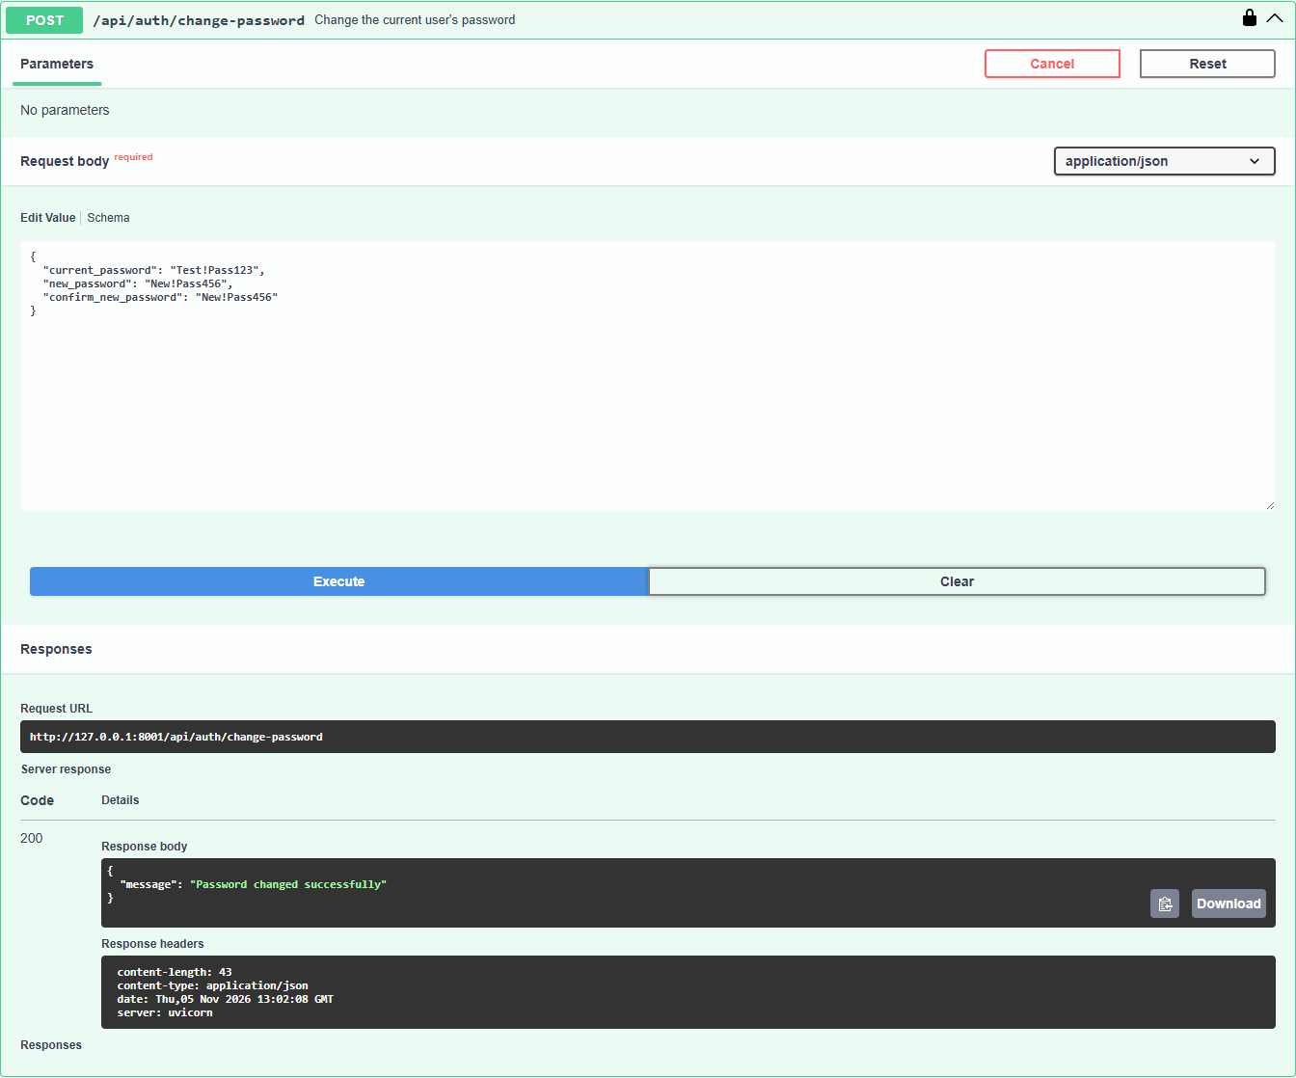

Evidence 10: Swagger UI
Every endpoint and the Authorize button. Protected endpoints show a padlock.
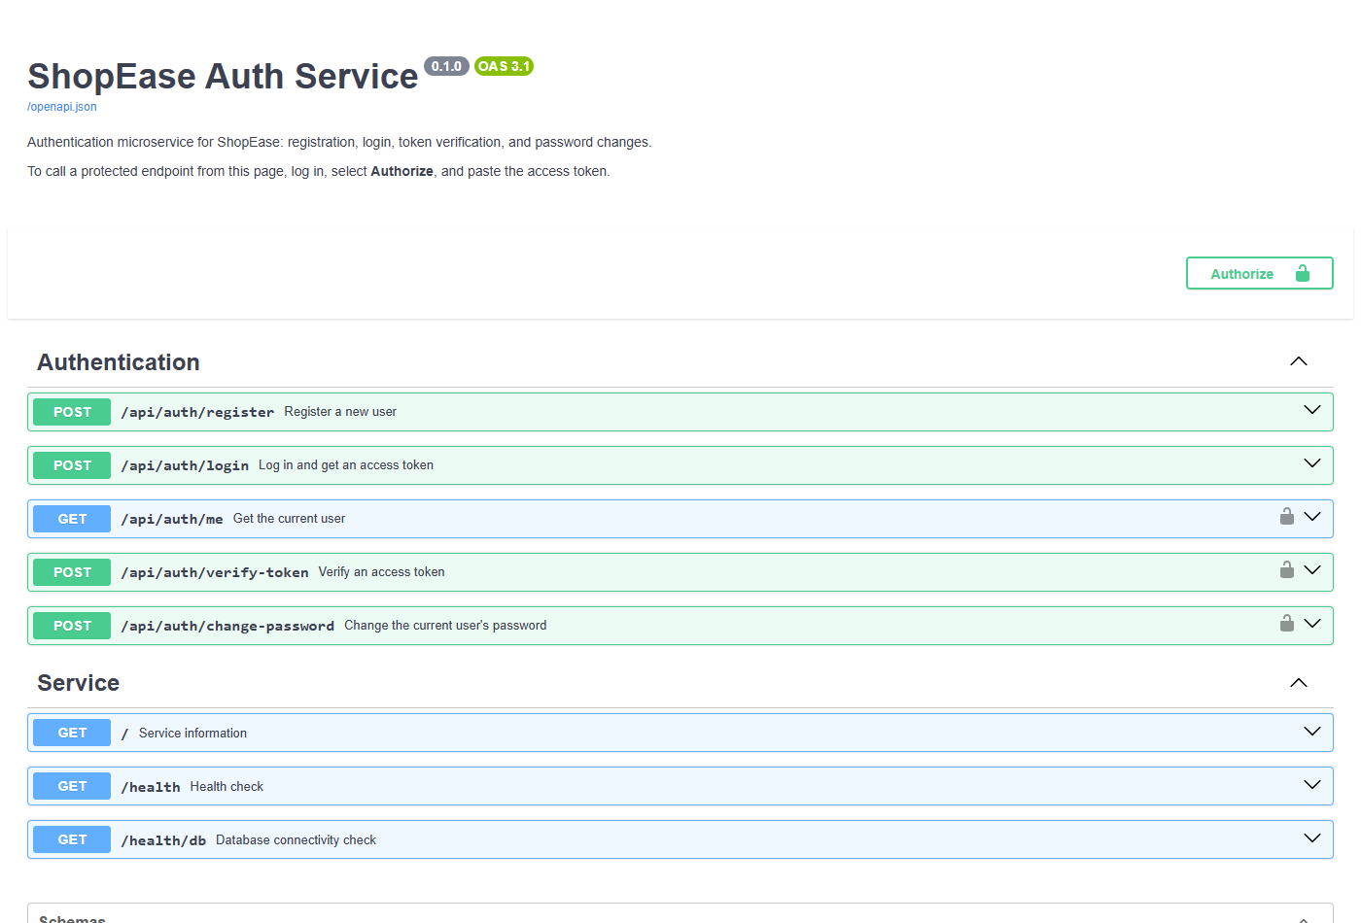

Evidence 11: API testing results
pytest and live scenario output, with the totals of the Swagger UI and Newman runs.
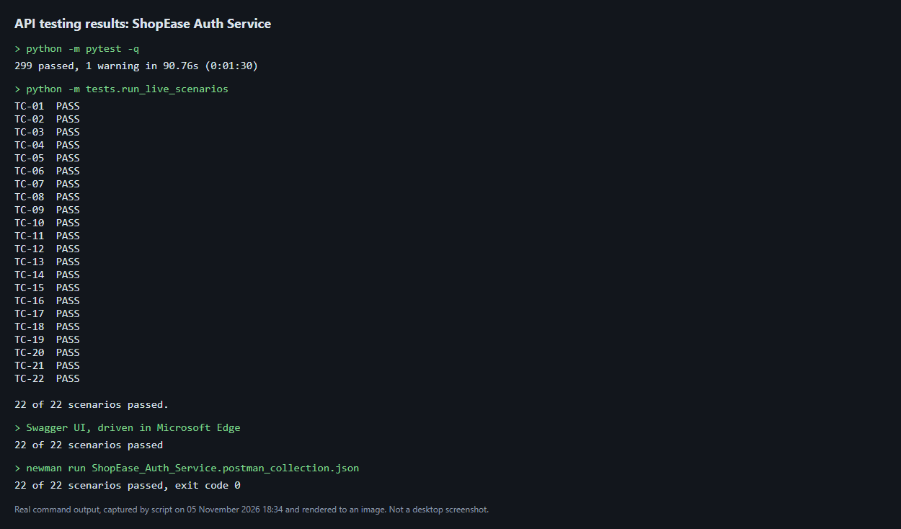

Known limitations
- No rate limiting: login and change-password attempts are not limited.
- Old tokens: a token issued before a password change keeps working until it expires, 30 minutes by default.
- Dependency advisories: python-jose 3.5.0 (CVE-2026-85394) and ecdsa 0.19.2 (CVE-2024-23342) have no fixed versions. The service accepts only its configured HMAC algorithm, which limits the exposure.
- No HTTPS: the service needs HTTPS in front of it before deployment.
- No integration: no other ShopEase microservice is connected, as required.

Not tested
- Several auth-service containers starting at once.
- A failed migration under Docker Compose's restart policy.
- A real 500 error on the running server. A simulated failure was tested instead.
- Load testing, and operating systems other than Windows 11.

