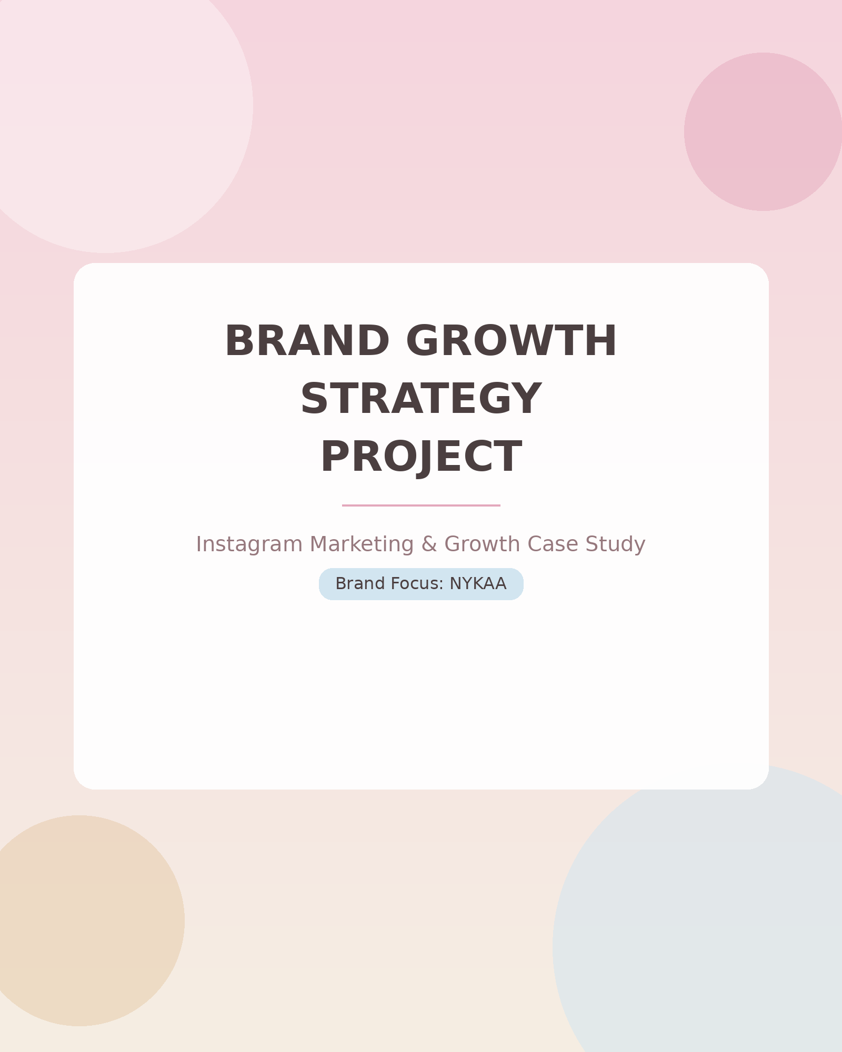
Table of Contents

1. Brand Overview
2. Project Objective
3. Instagram Audit
4. Competitor Analysis
5. Problems Identified
6. Marketing Strategy
7. Content Calendar
8. Sample Creatives
9. KPI Dashboard
10. Expected Results


For this Brand Growth Strategy Project, a brand was selected based on the following criteria:
- Has an active Instagram account
- Has visible competitors in the market
- Has enough existing content to analyze

Brand Selected: Nykaa
Nykaa is one of India's leading beauty, wellness, and personal care e-commerce platforms. It was chosen for this project because its Instagram presence is highly active, marketing-heavy, and offers rich material for audit and analysis — making it an ideal case study for a growth strategy.

Other Brands Considered
- Mamaearth
- boAt
- Zomato



Every successful social media strategy begins with a clear, measurable business goal. For this project, the objective defined was:

“How can Nykaa increase Instagram engagement and follower growth by 20% over the next 3 months?”

This objective gives the entire project direction — every audit, analysis, and content recommendation that follows is built to serve this single business goal.


An audit of Nykaa's current Instagram account was conducted, spending time noting both performance metrics and content patterns.

Basic Metrics Tracked
- Follow
- Impressions
- Average Likes
- Profile Visit
- Save
- Shares

Content Categories

Content Type | Frequency
Product Posts | High
Reels | Medium
Influencer Content | Medium
Educational Content | Low
Offers / Discounts | High


To understand where Nykaa stands in the market, 2–3 close competitors were analyzed:
- Mamaearth
- Sugar Cosmetics
- Minimalist

Comparison Table
Brand | Followers | Engagement
Nykaa | ~3.1M | ~0.05% (avg. 1.6K likes, 16 comments/post)
Mamaearth | ~1.1M | ~0.1% (avg. 1,075 likes, 26 comments/post)
Sugar Cosmetics | ~2.1M | ~0.03–0.10% (avg. 865–6K likes, 5–67 comments/post)
Minimalist | ~531K | Not enough public data to estimate reliably

Key Observations
- What competitors do better
- What content performs well across the category


Based on the audit and competitor comparison, the following problems were identified in Nykaa's current Instagram strategy:

“Nykaa posts many promotional posts but fewer educational reels.”
“Competitors receive higher engagement from influencer collaborations.”

These insights form the foundation for the growth strategy outlined in the next section — every recommendation directly addresses one of these gaps.


Based on the problems identified, a content strategy built around four core content pillars was created.

Content Pillars
  Beauty Tips |   Product Education |   Influencer Reviews |   User Generated Content

Each pillar directly responds to a gap found in the audit — for example, increasing Beauty Tips and Product Education content addresses the lack of educational reels, while expanding Influencer Reviews matches what drives engagement for competitors.


Below is a sample of the first few days-

Day | Content
1 | Skincare Reel
2 | Product Review
3 | Influencer Post
4 | Giveaway
5 | Beauty Tip Carousel
6 | UGC Repost
7 | Behind the Scenes Story

This pattern repeats across the month, rotating through all four content pillars to keep the feed balanced, fresh, and aligned with the growth objective.



A KPI dashboard was built in Power BI / Excel to track the performance of the new strategy over time. The following key metrics were monitored:

  Reach |   Impressions |   Engagement Rate
  Follower Growth |   Saves |   Shares

Tracking these six metrics consistently allows the strategy's effectiveness to be measured against the original objective: a 20% increase in engagement and follower growth within three months.

HERE IS THE SCREENSHOT OF DASHBOARD PREPARED IN POWER BI -

CHECK OUT THE WORKING MODEL THROUGHT GITHUB LINK – NYKAA DASHBOARD

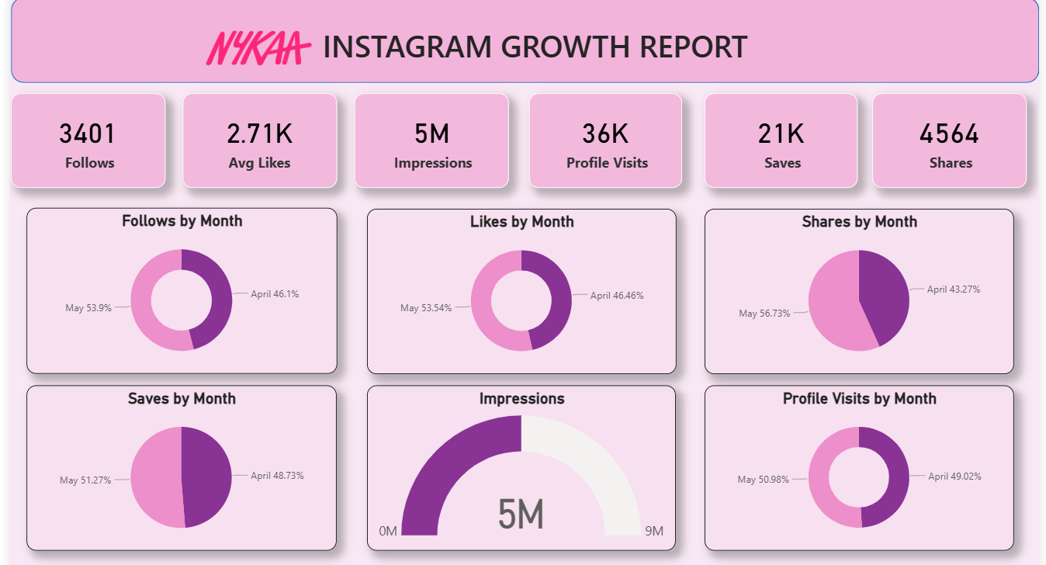

GITHUB

Based on the strategy implemented across content pillars, calendar planning, and creative execution, the following results are projected over the 3-month period:
- Increased Reach and Impressions through consistent Reels and educational content
- Higher Engagement Rate driven by influencer collaborations and UGC
- Steady Follower Growth aligned with the 20% target
- Improved Saves and Shares from value-driven Beauty Tips content

Final Portfolio Structure

