A. Linear Algebra
1. Define an additive function between two vector spaces. Let $V=R$be a vector space over the field $R$.
Show that there exists an additive function
$T:V→V$ that is not linear.

2. Let $A∈M_{n}(F)$. Show that $A$and $A^{T}$have the same eigenvalues with the same multiplicities.
Let $λ$be an eigenvalue of $A$with eigenspaces $V_{λ}$and $V_{λ}^{'}$corresponding to $λ$of $A$and $A^{T}$respectively.
(a) Show by an example that for a given common eigenvalue, these two eigenspaces may not be the same.
(b) Prove that for any eigenvalue $λ$,
$$dim⁡(V_{λ})=dim⁡(V_{λ}^{'}).$$
3. Let $A∈M_{3}(R)$given by
$$A=\left[\begin{matrix}3 & 0 & 0 \\ a & 3 & 0 \\ 0 & b & c\end{matrix}\right]$$
Find all values of $a,b,c$for which $A$is diagonalizable.

4. Let $A$be a square complex matrix and its characteristic polynomial is given by
$$p(t)=(t-1)^{3}(t-2)^{2}(t-3)^{4}(t-4).$$
Find the rank of $A$.

B. Python
Sudoku Validator
In a standard 9x9 Sudoku puzzle, the grid is divided into nine independent 3x3 sub-grids. To validate a Sudoku board efficiently, you must extract these blocks into a structured format without relying on nested Python for loops.
Given a 9x9 NumPy array representing a Sudoku board, write a purely vectorized NumPy operation to extract all nine 3x3 sub-grids and pack them into a single 3D array of shape (9, 3, 3).
Grid Mapping Protocol
The output 3D array must store the sub-grids sequentially in row-major order (left-to-right, top-to-bottom). The indices of the outer dimension [0] to [8] must map to the board positions as follows:
| block 0 | block 1 | block 2 |
| block 3 | block 4 | block 5 |
| block 6 | block 7 | block 8 |
Constraints
- You are forbidden from using Python for or while loops, list comprehensions, or iterator objects.
- Use only native NumPy functions, slicing techniques, or reshaping operations.
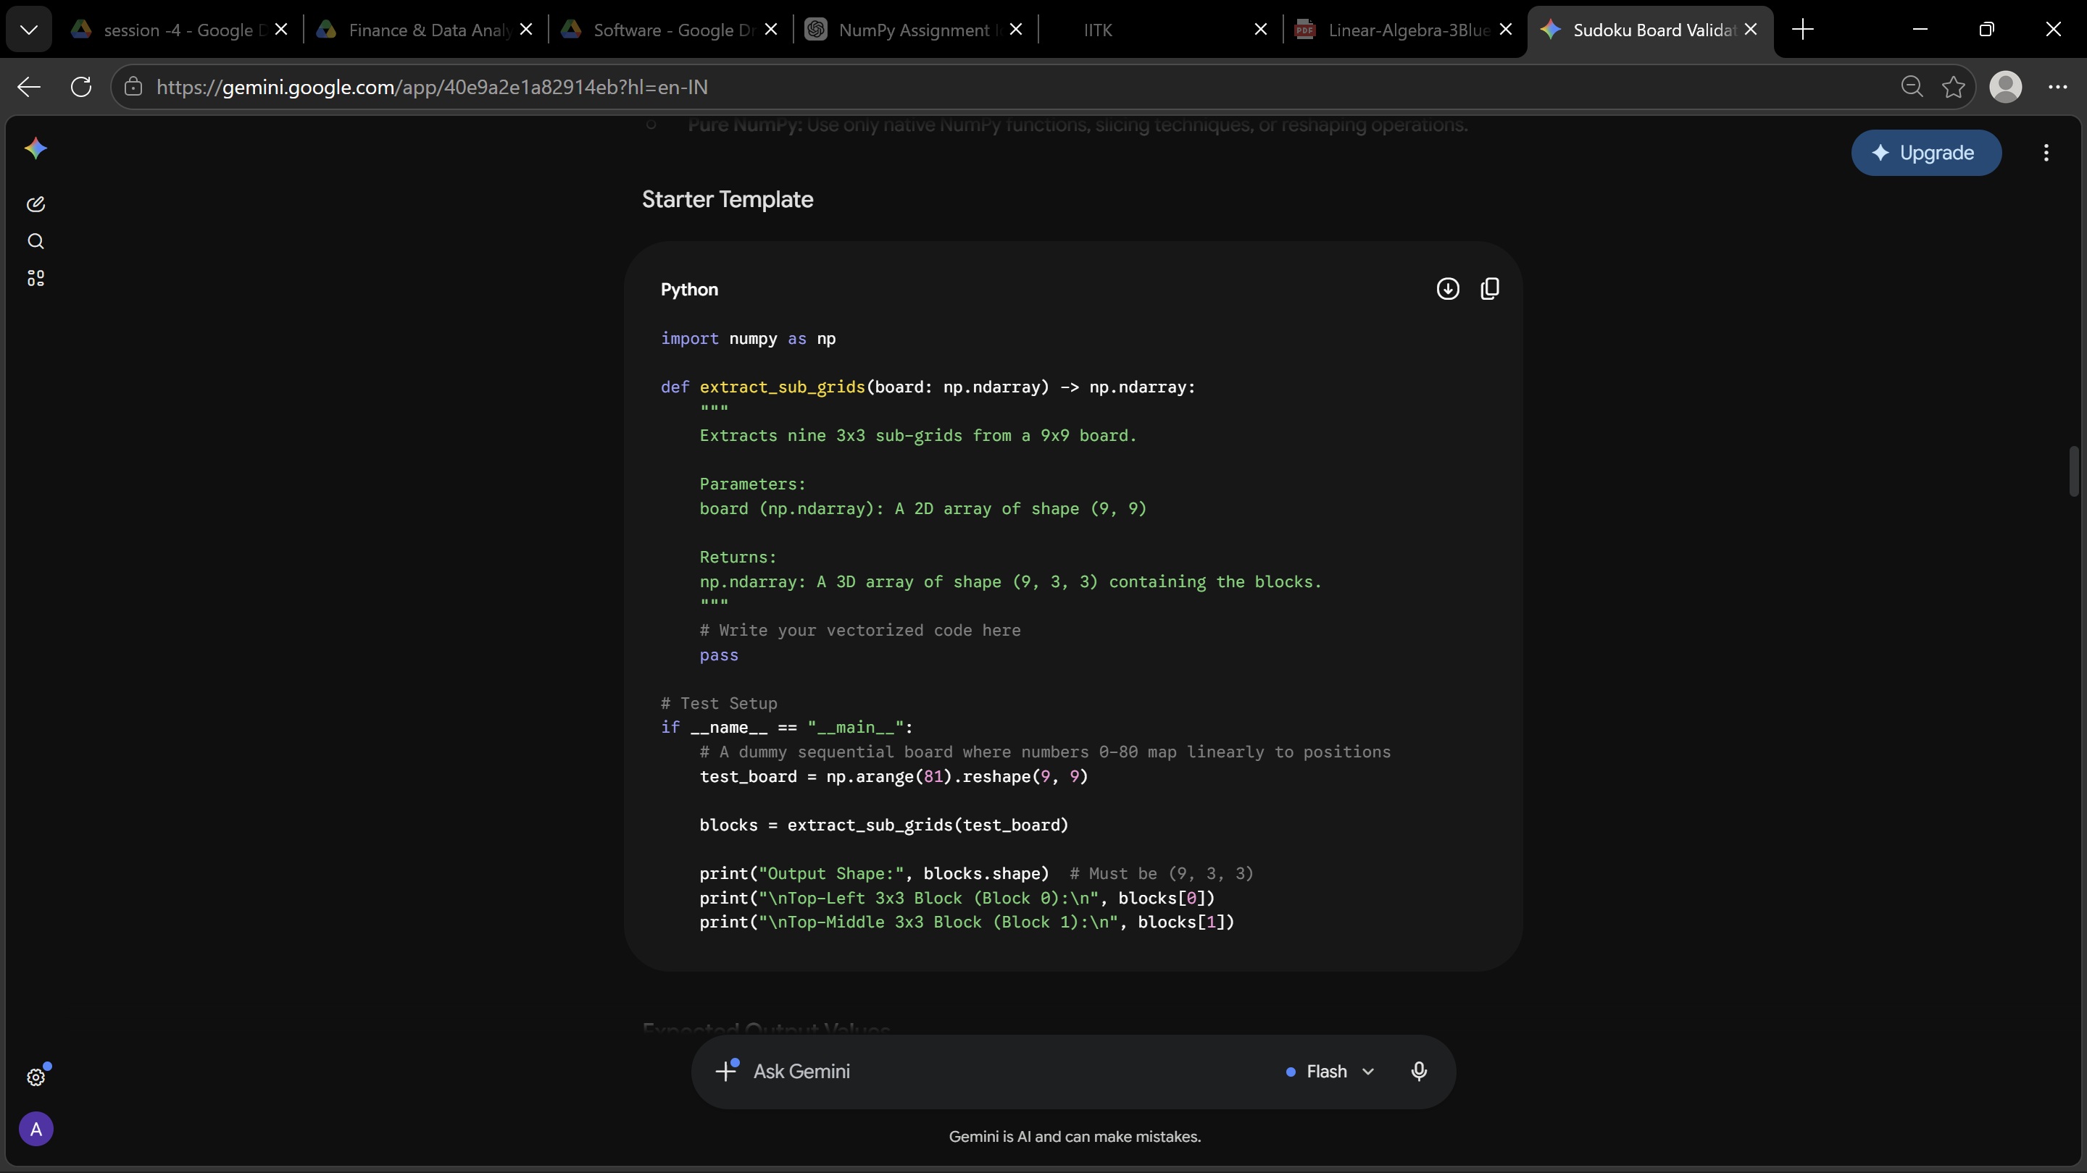
Expected Output Values
Using the sequential np.arange(81) test board, your function must output the exact arrays below for the first two blocks:
