WEEK1

CODE
board = ["1", "2", "3",
"4", "5", "6",
"7", "8", "9"]

players = {
"X": "Player 1",
"O": "Player 2"
}

winning_combinations = (
(0, 1, 2),
(3, 4, 5),
(6, 7, 8),
(0, 3, 6),
(1, 4, 7),
(2, 5, 8),
(0, 4, 8),
(2, 4, 6)
)

occupied = set()

def display_board():
print()
print(board[0], "|", board[1], "|", board[2])
print("--+---+--")
print(board[3], "|", board[4], "|", board[5])
print("--+---+--")
print(board[6], "|", board[7], "|", board[8])
print()

def check_winner(symbol):
for combination in winning_combinations:
if all(board[position] == symbol for position in combination):
return True
return False

def make_move(symbol):
while True:
choice = input(
f"{players[symbol]} ({symbol}), choose a position (1-9): "
)

if not choice.isdigit():
print("Please enter a valid number.")
continue

position = int(choice) - 1

if position < 0 or position > 8:
print("Please choose a position between 1 and 9.")
continue

if position in occupied:
print("This position is already occupied.")
continue

board[position] = symbol
occupied.add(position)
break

print("Welcome to Tic-Tac-Toe!")

current_player = "X"

while True:
display_board()

make_move(current_player)

if check_winner(current_player):
display_board()
print(players[current_player], "wins!")
break

if len(occupied) == 9:
display_board()
print("It's a draw!")
break

current_player = "O" if current_player == "X" else "X"

print("\nThanks for playing!")

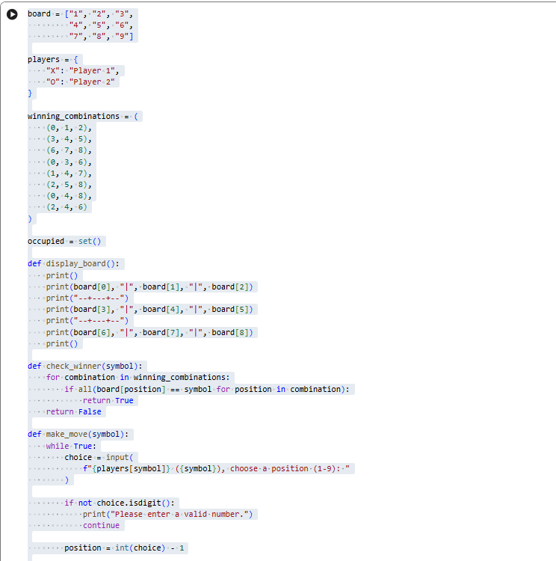
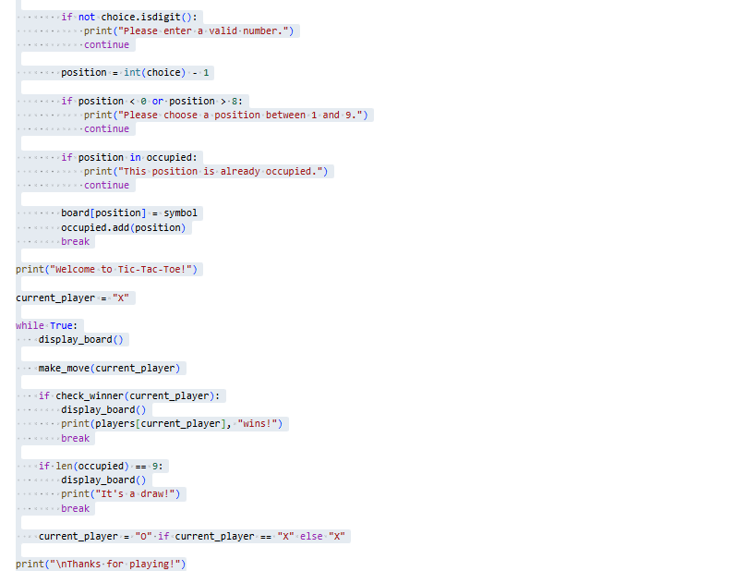

OUTPUT

