**IMPLEMENTATION OF BINARY SEARCH ALONG WITH SPACE AND TIME COMPLEXITY**

**PROGRAM**

#include<stdio.h>

void main()

{

int limit,i,j,temp,check,right,left=0,middle,flag=0,count=0;

count+=3;

printf("Enter the limit:\n");

scanf("%d",&limit);

count++;

int a[limit];

printf("Enter the elements:\n");

for(i=0;i<limit;i++){

count++;

scanf("%d",&a[i]);

count++;

}

for(i=0;i<limit-1;i++)

{

count++;

for(j=0;j<limit-1-i;j++)

{

count++;

if(a[j]>a[j+1])

{

count++;

temp=a[j];

a[j]=a[j+1];

a[j+1]=temp;

count+=3;

}

}

}

printf("The sorted array is :\n");

for(i=0;i<limit;i++){

count++;

printf("%d\t\n",a[i]);

count++;

}

printf("Enter the element to be searched:\n");

scanf("%d",&check);

count++;

right=limit-1;

count++;

while(left<=right)

{

count++;

middle=(left+right)/2;

count++;

if(check<a[middle])

{

count++;

right=middle-1;

count++;

}

else if (check>a[middle]){

count++;

left=middle+1;

count++;

}

else

{

printf("The element is present\n");

flag=1;

count++;

break;

}

}

if(flag==0)

{

count++;

printf("not present\n");

}

count+=2;

printf("Time complexity %d\n Space Complexity%d",count,(40+(4*limit)));

}

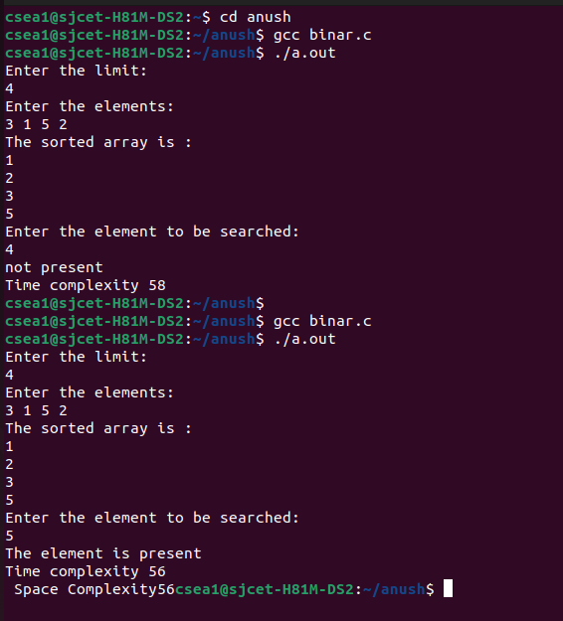**OUTPUT**