Collaborative Document
Google Docs Practical Demonstration
Technical Writing | MNIT Jaipur

1. Purpose
This sample document demonstrates structured writing and review elements that can be practised in Google Docs: headings, a table, an embedded diagram, comments, suggestions, sharing, and version history.

2. Document Structure and Formatting
Use the built-in title and heading styles to organize content. A clear heading hierarchy makes a document easier to read and helps readers navigate longer material.

2.1 Review and Collaboration
A document can be shared with a classmate using editing or suggesting access. Comments can be used to ask questions or provide feedback, while suggestions allow proposed changes to be reviewed.

3. Example Information Table
Google Docs feature | Purpose | Practice action
Comments | Give feedback or ask questions | Add a comment to a sentence
Suggestions | Propose edits for review | Switch to Suggesting mode
Version history | Review earlier document states | Open version history
Sharing | Collaborate with others | Share with a classmate

4. Collaboration Workflow Diagram
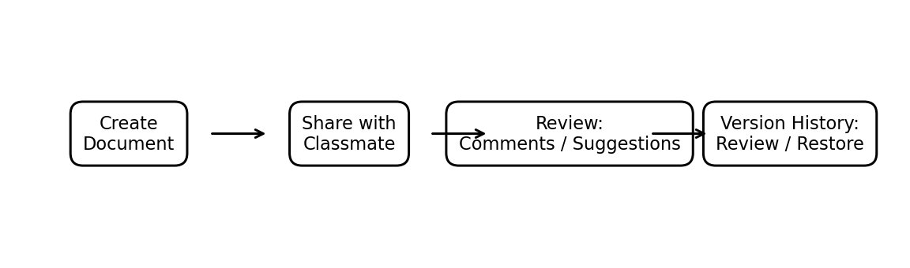
Figure 1. A simple workflow for creating, reviewing and recovering a shared document.

5. Version History
Google Docs saves changes automatically. Version history can be opened to inspect earlier versions and restore a previous state when required. Specific versions can also be named for important milestones.

6. Practice Checklist
- Create a Google Doc and share it with a classmate using Edit or Suggest access.
- Apply headings and add a comment and a suggested edit.
- Insert a table and embed an image or diagram.
- Open version history, inspect an earlier version, and restore it if needed.

End of practical document

