
Pure Life General Transporting

Company Profile
Abu Dhabi, United Arab Emirates
Telephone : 02 495 7027, 02 495 7028
Fax : 02 555 2400
Email : pure-life2014@hotmail.com
Direct contact :
Mohammad :- 0555507501
Anto Dcruz :- 0505220900

Introduction of the company

Pure Life is a Purely Transportion company, We deal with normal transportation and general waste and industrial waste transportation, We transport both liquid and solid waste, We are holding approval from Abudhabi centre of Waste Management to operate this service

Our Aims
The fundamental basis to all aspects of successful transportation with an affordable expense

- We try to achieve the best and make our work more than ordinary.
- We aim to become a recognized name in the field, synonymous with Quality, Safety and Value.
- To provide the best services satisfy the customer’s needs, requirements and expectations in a cost effective way.
- Our major aim is to remove the waste on time to keep good environment for the customers.
- Our strategy is good services and most suitable price for our customers.
- To be known as a reliable, efficient and services minded company.
- To employ the best industry practice and endeavour for excellence through total continuous improvement and innovation

Skip Loader
If you are looking for skip loader on a monthly or daily rental basis we can fulfill your requirements. Such services are provided specially for oilfield companies as strict environmental health and safety regulations must be adhered to. Categorically we take these concerns seriously. We listen to our customers, and we meet and exceed their expectations as a safe and clean waste management company.
We can provide waste advice and services specific to your needs all for one no-nonsense price – with no hidden extras. In addition we meet all the legal environmental requirements set out by the Centre Of Waste Management

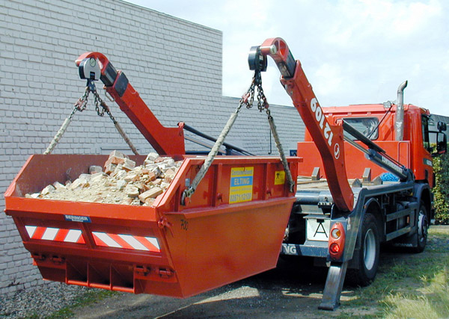

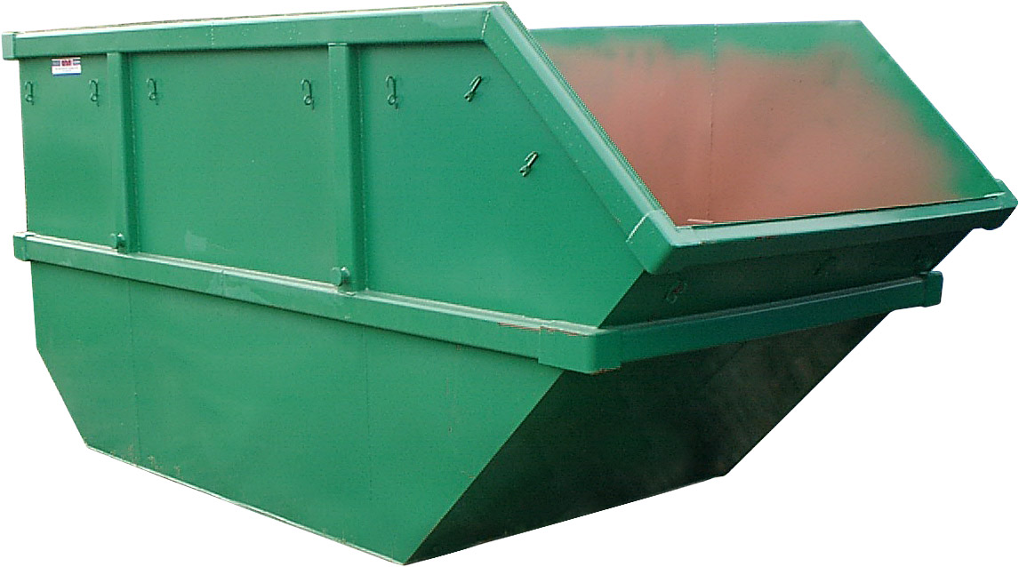

Tanker Service for Liquid Waste

Our tanker-trucks, with a capacity of 5,000 gallons, i.e.22, 220 litters, are truly registered for the transportation of both Trade/Sewage Waste and Hazardous Liquid Waste. They are operated either on “On-Call” or on “Fixed Schedule” basis.

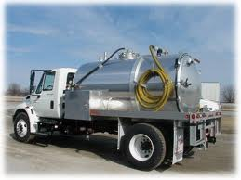

Tanker Service for Sweet Water

We arrange sweet water for the domestic and industrial sector, in 3000.4000.5000, 6000 gallon tankers as per the customer requirements

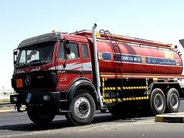

RENTAL OF TRANSPORT TRUCKS
We also Arrange 40 feet and 20 feet flat bed trailers for general transportation

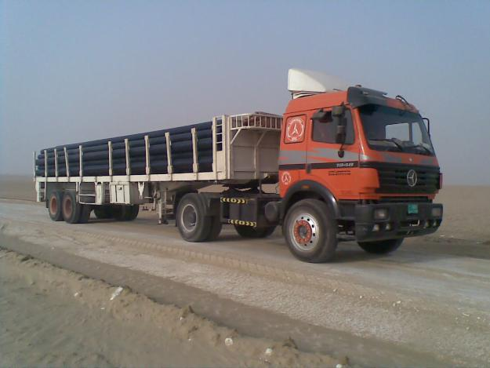

Waste collection bins:
We also supply below mentioned bins as per customer request and requirements
SL NO | DESCRIPTION | UNIT
1 | HDPE Plastic Waste bin 1100ltr. Heavy duty, Made in Turkey Max. loading: 440kgs D1200*E1360*F1200*G200*H750 mm. Net weight: 48.8kg Color: Green | 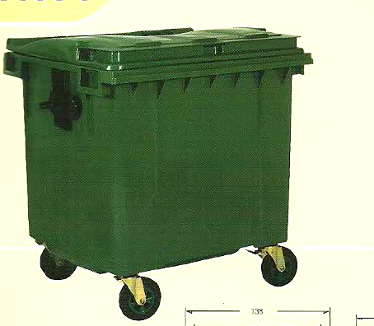
2 | Stainless steel 3compartment recycling station | 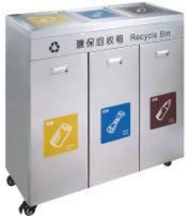
3 | Plastic Dustbin 120 ltr w/ wheel and cover. Heavy Duty, Made in Malaysia. Brand: GCCE | 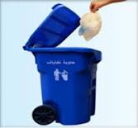
4 | Recycle Dustbin 240ltr set - Heavy duty, GCCE brand (1set x 240ltr) without stand | 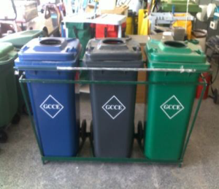
5 | RECYCLING BIN MICA-R 110 LC/W A3 RECYCLING STICKERS BLUE/RED/ YELLOW BRAND: OTTO - HEAVY DUTY, MADE IN GERMANY. | 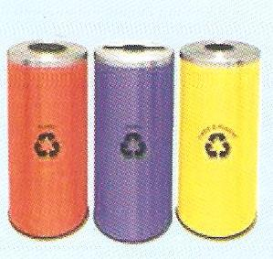
6 | FRP BIN QUARTZ 400L (METALLIC SILVER) WITH INNER & RECYCLING STICKER BRAND: OTTO, HEAVY DUTY MADE IN GERMANY | 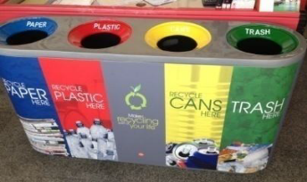
7 | Stainless steel square dustbin w/ ashtray on top [60x30cm] | 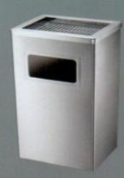
8 | RECYCLING BIN MICA-R 110 LC/W A3 RECYCLING STICKERS BLUE/RED/ YELLOW BRAND: OTTO - HEAVY DUTY, MADE IN GERMANY.
9 | RECYCLE BINS FRP BIN COMBO 260L (BLACK) WITH INNER LINER & RECYCLING STICKER. BRAND: OTTO, HEAVY DUTY MADE IN GERMANY | 