**INNER PAGE:**

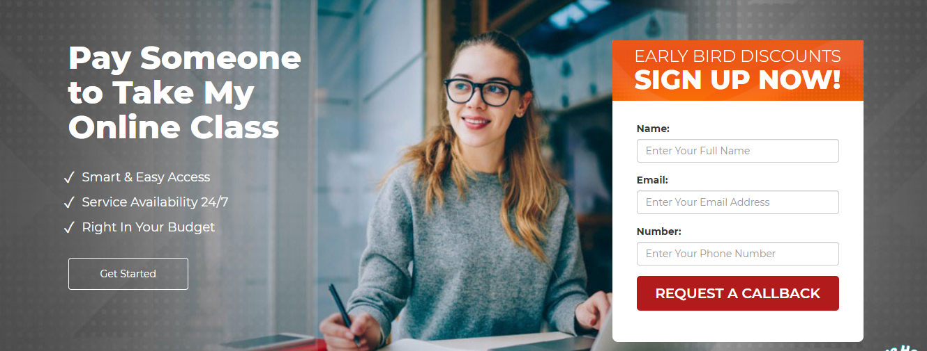

NAME:

EMAIL:

NUMBER:

PAY SOMEONE TO TAKE MY CLASS ONLINE

**LOGGING IN FIRST TIME? GET DISCOUNT**

* easiest access
* High availability
* Within budget

**RETURN A CALL**

**Get registered**



* 0% negative reviews
* 2000+ online quizzes completed
* Completely privileged and safe
* Classes took by professionals

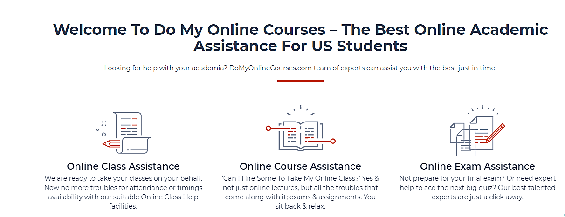

Welcome to take my class online- best online class assistance for US students

Can Someone to Take My Online Class for Me? Of course! We have online class takers with 99% punctual behavior.

**Online learning assistance**

At helpmyclassonline.com we are ready to take your classes online by our experts. Stay hassle free an get 100% attendance

**Online course helping**

Take my online classes for me? Yes why not our online course experts will help you in your thick and thin and complete your assignments and quiz.

**Online exam support**

Not prepared for your online exam due to some issues? Our online class takers will help you to get better results.

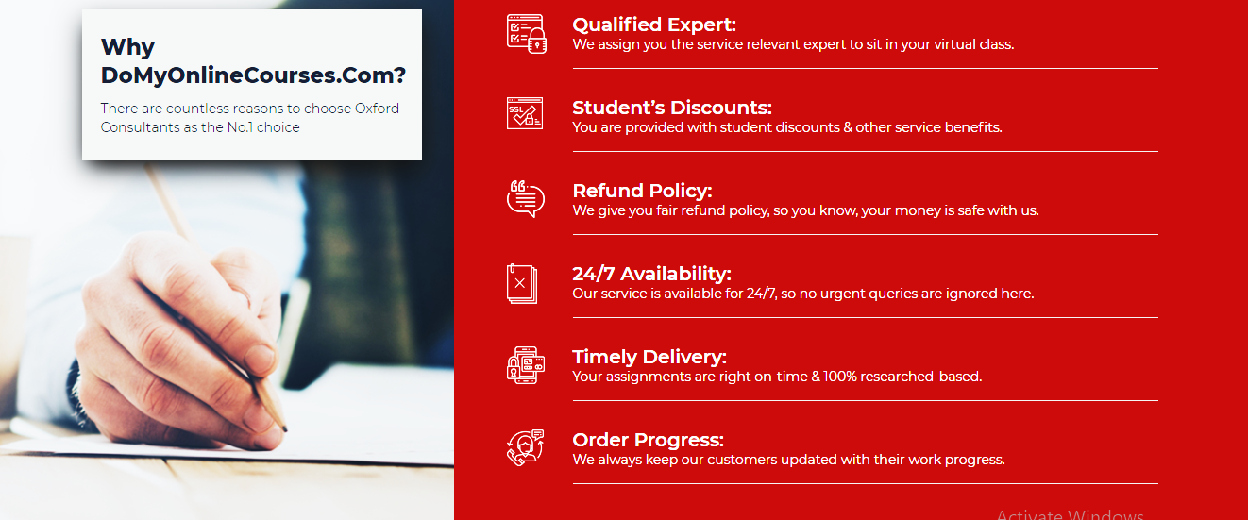

Why helpmyclassonline.com?

**Qualified professors**

We assign you the online class experts and takers to sit in your online class.

**New comer’s discount**

Service benefits and students discounts are provided.

**Repay policy**

Your money is safe with us because we are giving you safe refund policy.

**24/7 accessibility**

Availability is 24/7; it means you will never get ignored.

**Punctually delivered**

Online class tutors will deliver your assignment on time with 100% based on research.

**Up to date**

We keep our customers updated about their work.

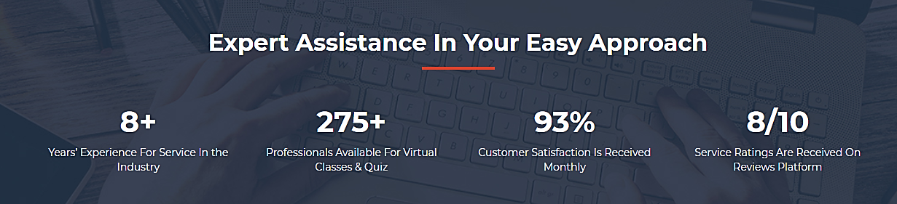

Better service in industries from 9+ years

350 + availability of professionals to conduct quizzes and classes

97% satisfied customer in a month

service rating 9/10 is received at reviews platform

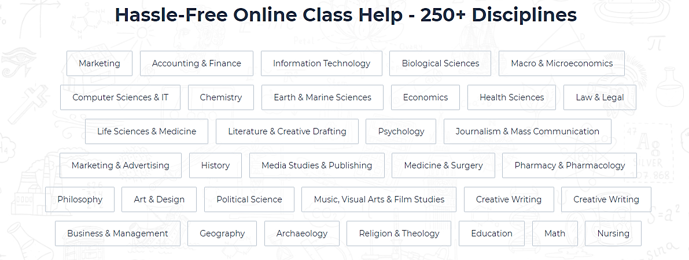**Care free online class help**

* Law
* Media science
* Marketing
* Medicines
* History
* Theology
* Statistics
* Nursing
* Finance
* Macro micro economics
* Marine sciences and earth
* Literature
* Zoology
* Visual arts
* Botany
* Information technology
* Mass communication
* Creative writing
* Aeronautics and Aviation Science.
* Economics
* Engineering
* Telecommunication
* Anatomy



Best online class helpers- helpmyclassonline.com

**William James**

Expert in computer

William James is expert in IT and attends all IT classes and submits IT related assignments within a time.

**Jayden Gabriel**

Professor of physics

Jayden Gabriel is a professor of physics selected by the senior students. He can attend all online exams.

**Hailey Quinn**

Senior editor

Hailey Quinn is responsible for all the online class assignments with free of errors.

**Alivia Vera**

Chemistry expert

Alivia Vera have done PhD in chemistry and help you to attend online chemistry class, quizzes and small assignments.

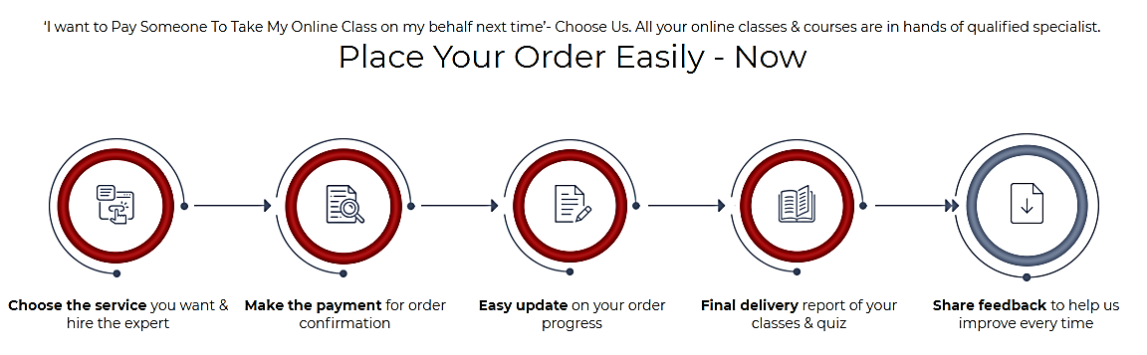

Can Someone to Take My Online Class For Me. Yes why not? All your online classes are attended by our professionals.

Give order and hire the expert to do your class online 🡪 pay us if order confirmed 🡪 rapid update on your order 🡪 quiz and classes final delivery report 🡪 share your response with us

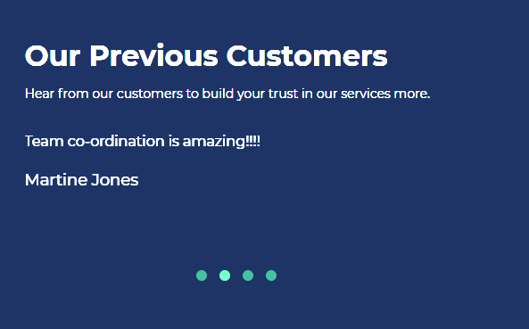

CUSTOMERS POSITIVE REVIEWS

Good work. Keep it up

* Jack Mateo

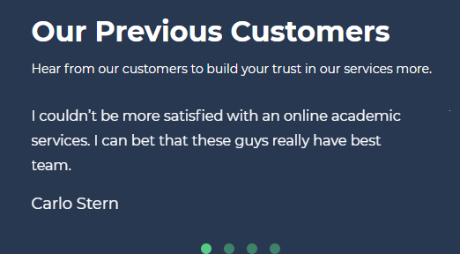

* Leo Jayden

Satisfied and instructions are followed. Great team work, keep going.