**INNER PAGE 2**



RETURN A CALL

SIGN UP ASAP AND GET DISCOUNT

NAME:

EMAIL:

NUMBER:

Hire someone to help my course online

* 100% in budget
* 24/7 available
* Easy and Relevant information

**Start up**



* 95% customer ranking
* 2000+ online courses completed
* Safe and top secret
* 400+ PhD online course takers

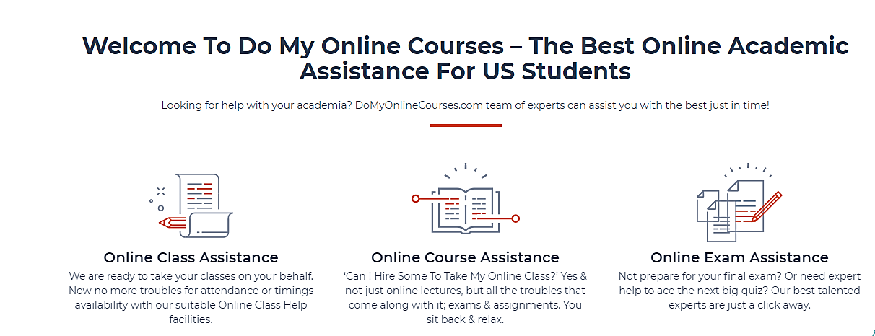

Welcome to help my course online- best online course help by experts for US students

Searching for online course help? Helpmyclassonline.com is the experts of doing courses online.

**Online course help**

Join us and our professionals are ready to do your course online with outstanding quality before the deadline.

**On time delivery**

Share your burden with helpmycourseonline.com to get served by our professionals with on time delivery.

**A1 grade**

We do your work with 0% plagiarism and 100% researched base which help you to score A1 grade at lower price.

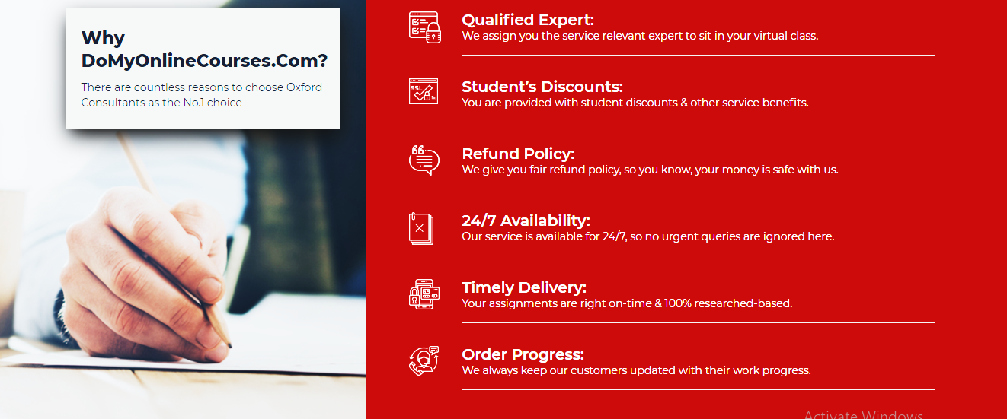

**Affordable rates**

We know that as a student this is difficult for you to give us high amount of money. We are offering you affordable rates.

**Always available**

Helpmyclassonline.com is 24/7 available for you because of your urgent assignments and quizzes.

**Course help**

Experts are available for you to help in an online exam and help you to get better grades.

**Delivered on time**

Your exams are delivered before the due date by our professionals.

**Positive replies**

Our experts will give you positive replies and will never disappoint you.

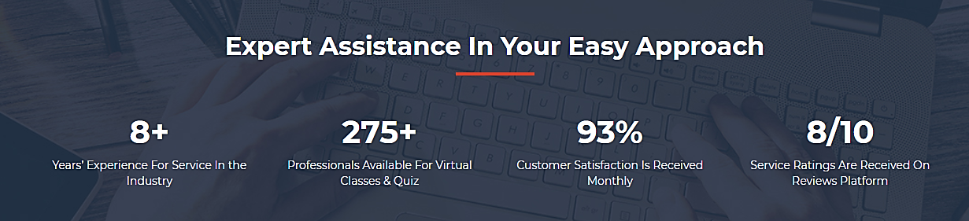

Experts assist in help my online course

9+ years’ experience in academic industry

300+ professionals available for taking your online course

50% happy customers received in a week.

9/10 ratings of a customer receives in a month

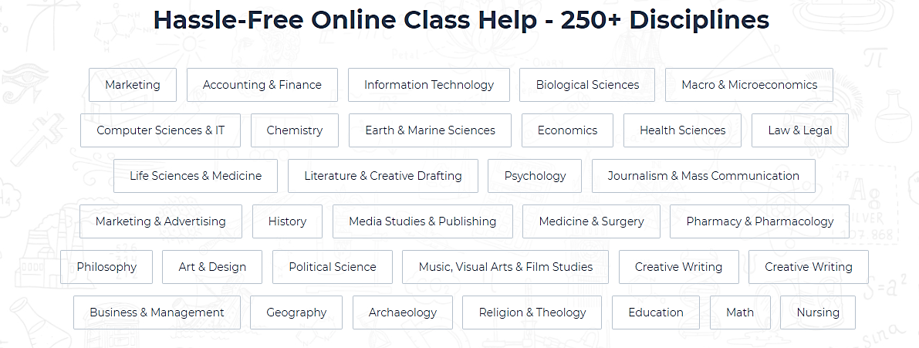

Online course help

* Accounting
* Chemistry
* Literature
* Microbiology
* Mass communication
* Surgery
* Physics
* History
* Statistics
* Graphics
* Maths
* Visual studies
* Ethnology
* International relations
* pharmacology
* Aeronautics and Aviation Science
* Anthropology.
* Religion
* Phycology
* Mechanical engineering
* Botany



Online course helpers- helpmyclassonline.com completes your course.

**Connor axel**

**Business expert**

A business expert and can take all business related courses and assignments with in a given time and with 0% plagiarism

**Bennett Watson**

**Physics professor**

Bennett Watson is a PhD professor and expert in physics and can take all physics courses and helps student to select the online course.

**George B. Patrick**

**Student helper**

He’s a student helper and listen all the queries of students and attends all the quizzes, short assignments etc.

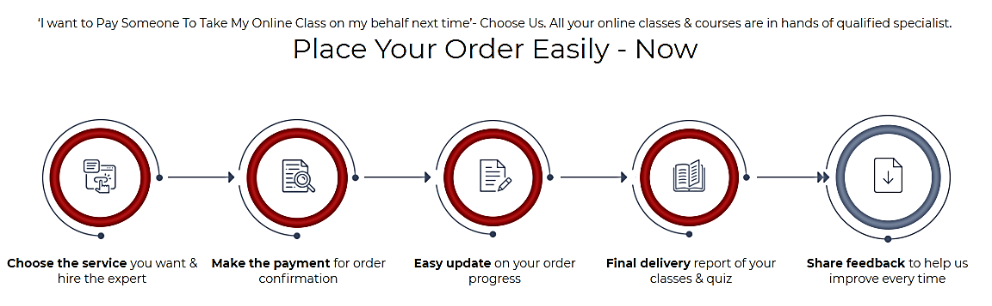

Can someone help my online course for me? Here we are, our PhD qualified can take your online course

Order is placed here- start up

Hire the qualified expert 🡪 confirm an order 🡪 update on your order 🡪 final report of your quiz 🡪 share your feedback

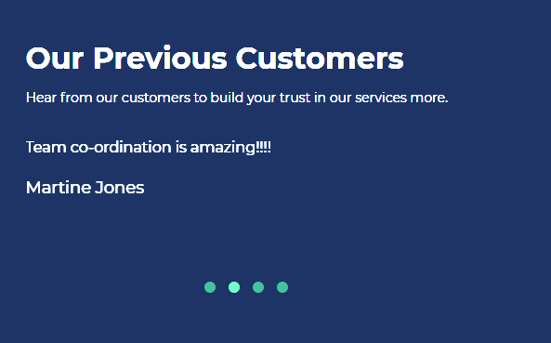

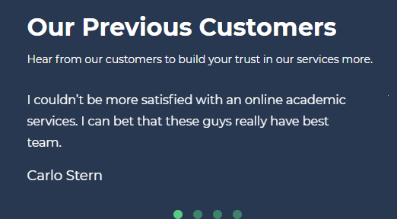

* I haven’t seen any other industry like you guys. appreciated

William James.