**INNER PAGE 3**

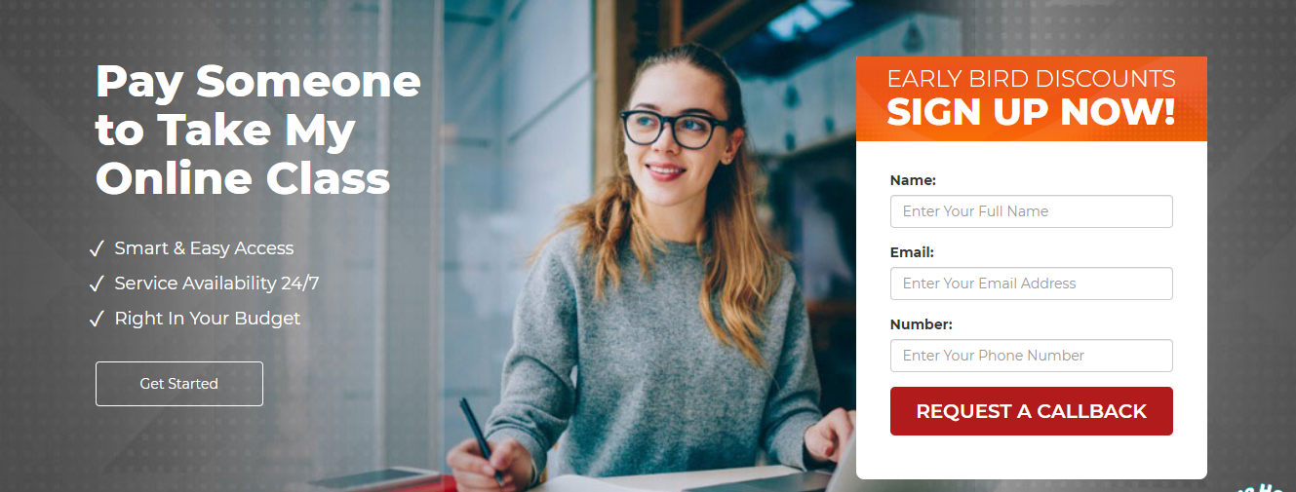

BECOME A MEMBER AND GET DISCOUNT

CALL US BACK

NAME:

EMAIL:

NUMBER:

Hire someone to help my exam online

* 24/7 assistance
* Cheaper price
* On time delivered

**Register online**



* 95% critic remarks
* 2000+ online exams completed
* Relevant and researched base
* online exams conducted by professionals

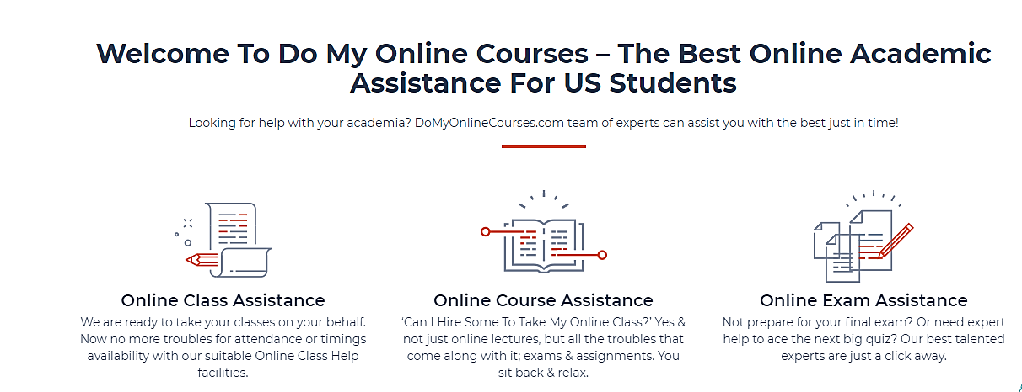

Come here at helpmyclassonline.com- online exams helpers available for US students

Can someone help my exam online for me? Join us today and get A1 grade in your exam.

**Online exam help**

Our 600+ PhD professionals help you in an online exam and provide you the researched based answers with clear concepts.

**Lower prices**

Pay to help my exam online for me. Why not? Helpmyclassonline.com offers you reasonable and affordable prices to help you in your exam.

**Response on time**

Helpmyclassonline.com will give your response within a minute and deliver your exam on time. Just register yourself and get good grades.

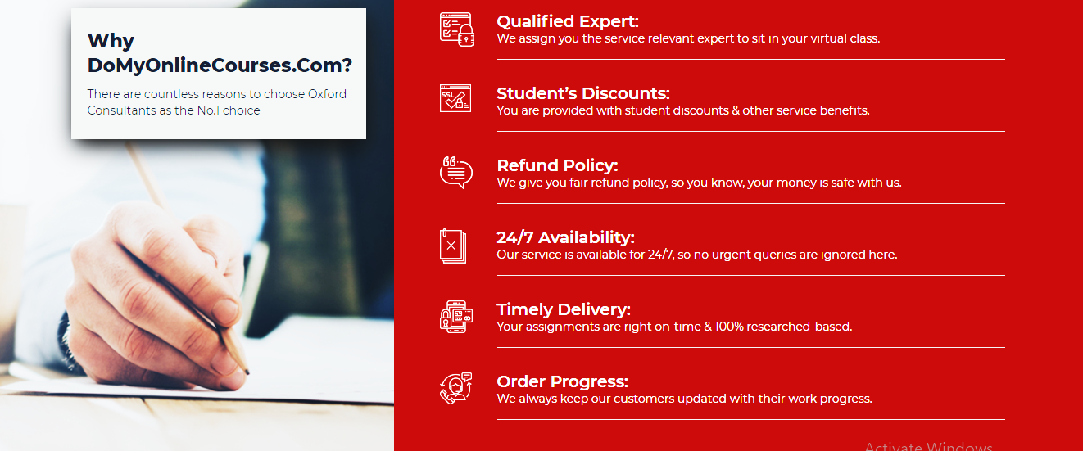

Pay to help my online exam for me.

**50% discount**

Affordable prices with 50% discount also.

**Plagiarism free**

Exam taken by the experts will be 100% plagiarism free so don’t care about plagiarism.

**Instant reply**

If you have any queries related to your exam you will get an instant and positive reply.

**Live help**

If you have an emergency and you want our help. We will help you in a minute.

**Secure payment**

Your money is safe and secures with us just pay us and we will start to do your work.

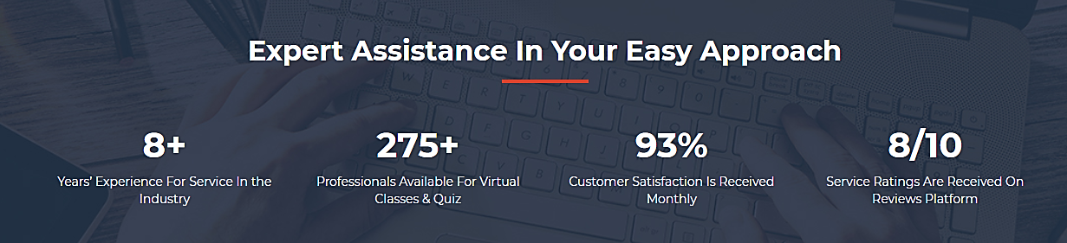

Professional assistance in your online exam

Online exam takers with 10+ year experience

600+ PhD professors available to take exams

95% positive reviews

9/10 A and A1 grades

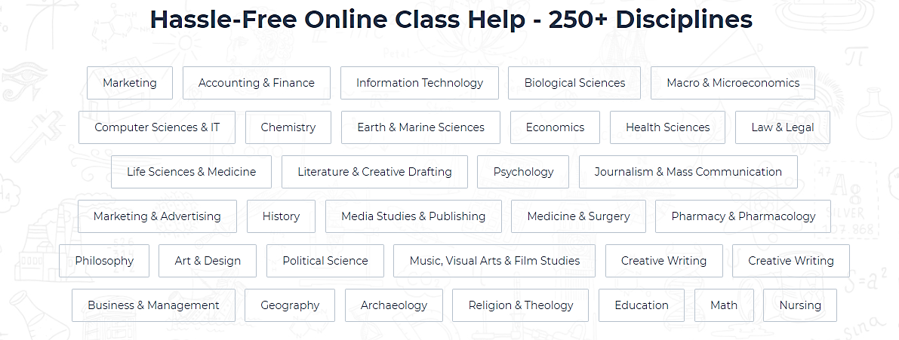

* Art
* Religion
* Politics
* 3d modelling
* General physics
* Drawing
* Physics
* Computer science
* Chemistry
* Pharmaceutics
* Anatomy
* General knowledge
* Family and relationship
* Ethology
* Ethics
* Marriage and relationship
* Business
* Tourism
* Health care
* Nursing
* Philosophy
* Media science
* Food and sciences
* Agriculture
* Analytics
* Psychology
* Biology



Best online exam takers- helpmyclassonline.com are having best exam helpers.

**Logan Oliver**

**Expert in maths**

He is a PhD professor and able to do all the statistics, business and maths related exam before the due date. You just have to relax.

**Adrian Caleb**

**Engineer professor**

Adrian Caleb is an engineer professor and make sure that all the engineers related exams are being done with 100% research based.

**Emery Gavin**

**Night exam taker**

She is a night exam taker and always available to help in exams which is taken at night and with short time.

**Taylor Matte**

**General knowledge professor**

She is a professor of GK and can give all general knowledge exams and quizzes

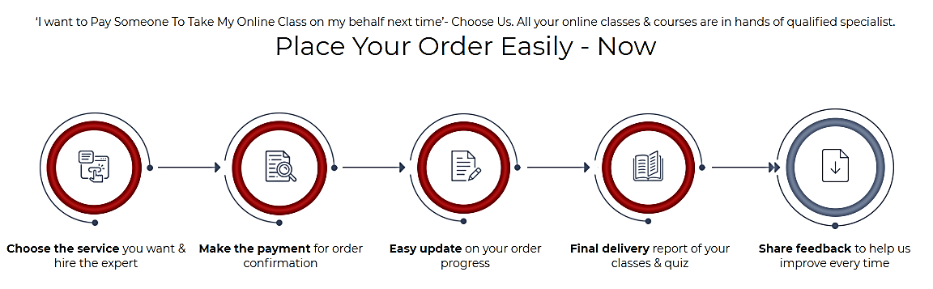

How to place an order

Submit your exam paper to the expert 🡪 general information about exam 🡪 receive your order 🡪 share your experience

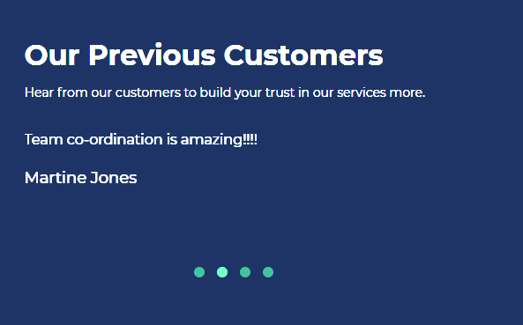

Customer reviews

I’m the topper of my class now just because of you guys. Thank you

* Jordan Patrick

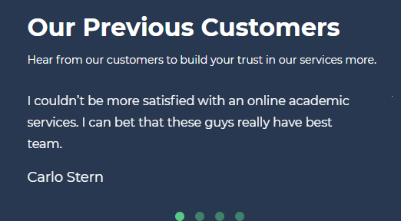

Customer reviews

You guys are great. Salute to you guys for helping me on my exam.

* Connor axel