**Assignment**

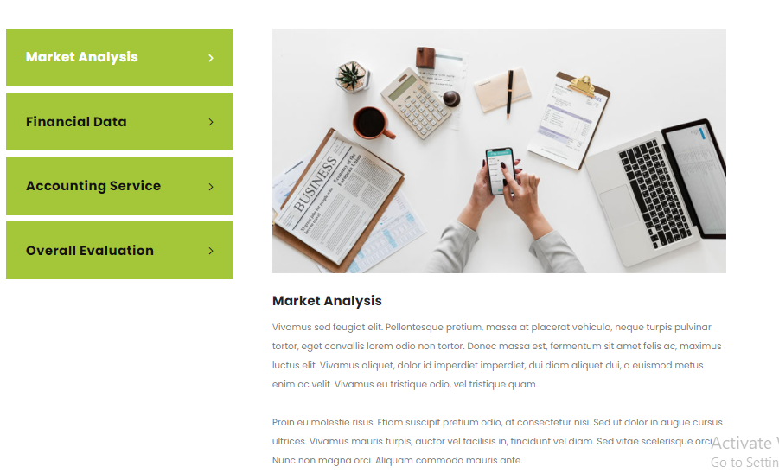

**Project Reports**

Project reports give visual representation about where your project is standing. It tells about how much time a student is spending on each task, what are project task statuses and each activity length. Moreover, a report offers clearly organised information regarding an investigated condition or issue

**Reflective Journals**

Reflective journals are the writing records of student’s personal experiences. Student reflects upon observations and responses to situation. Students' learning experiences are documented in reflective diaries. Instructors frequently urge students to keep track of learning-related occurrences, sometimes during the learning process but more often after they occur.

**Case Reports**

Case studies are usually written to describe the profile of the patient, sign, symptoms, diagnosis, and treatment of any patient. A case study is an in-depth investigation of a person, a group of individuals, or a unit with the goal of generalizing across several units.

**Annotated Bibliographies**

In contrast to an essay or literature review, which summaries and integrates different sources into a discussion on a topic, an annotated literature summary each reading and reviews each separately. The aim of an annotated bibliography is to summarize the key points of the text.



**How do we serve**

**Looking for an assignment assistance?**

Our Assignment Writing Service will provide a completely unique assignment that will assist you in becoming the finest. We work with a professional team of UK-based writers that will create a model response that is perfectly organized, well-sourced, and written in excellent English based on your needs and instructions.

**No Plagiarism**

**Quality Assurance**

**100% Marks**

**On time delivery**

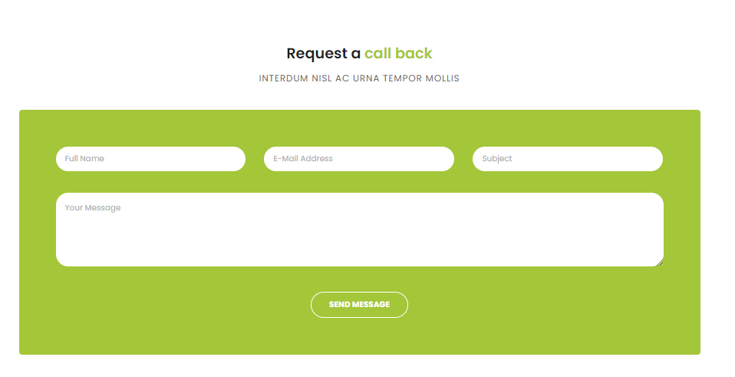

**Contact us now**

**Provide your information below**

**Full name**

**Email address**

**Subjects**

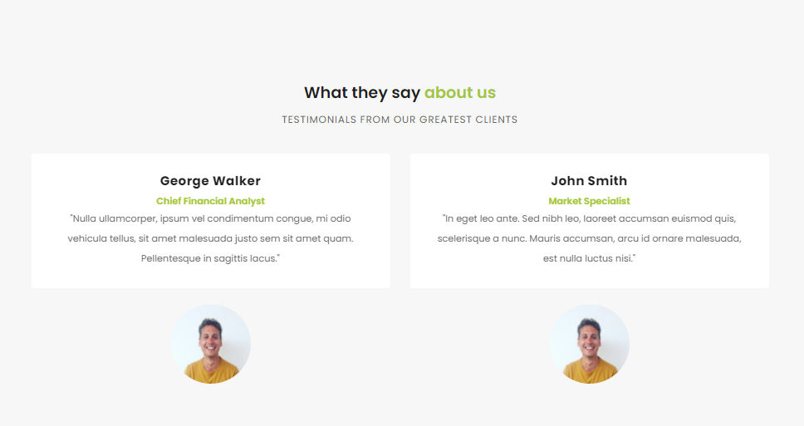

**Freddie**

This was by far the finest task I've had from your company. Well-thought-out and concise. You did well academically. I am really pleased with how it was written by you guys.

**Abigail**

The best possible service was rendered. They completed my work ahead of schedule, which I much enjoyed. I plan to utilize their service again soon.

**Matilda**

It's a fantastic service, and I appreciate your assignment aid. You help students in particular and your fees is very affordable. Thank you so much and I'll contact you again. I appreciate you assisting me.

**Joshua**

It took a long time to locate the best, but now I’ve found the finest, I'm unwilling to use any supplier again. You performed a fantastic job on my purchase, thanks a lot!