**Dissertation**

New website layout link

https://startmyonlineclasses.com/ukweb/index.php

New brand name: Primedissertation.co.uk

Penmypaper.co.uk

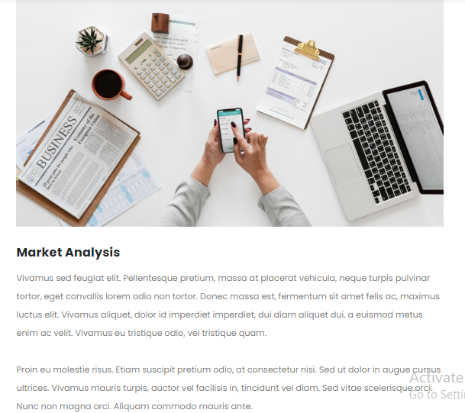

**Empirical Dissertations**

Primedissertation.co.uk emphasize on collection of data. A dissertation student may gather data via questionnaires, surveys or interviews etc. We must understand that we have to take people's opinions on what they think about and what they do in this dissertation.

**Non-Empirical Dissertations**

Non-empirical Dissertation are essentially the option for people who prefer to spend hours in libraries, analysis, critical thinking, reading, etc. Non-Empirical research fundamentally varies from empirical dissertation work that is performed without qualitative or quantitative information.

**Narrative Data**

Other than empirical thesis or a non-empirical dissertation, the narrative thesis is another method to write a dissertation. Primedissertation.co.uk provide these kinds of dissertation for the lab work, which includes several elements, procedures, analysis of results, interpretations of outcomes, etc.

**Case-study dissertation**

In this dissertation we examine and systematises a specific example of an information system. Primedissertation.co.uk helps you in evaluation of strong assessment of research essential to society, such as research anticipated to contribute to the future architecture of the system.

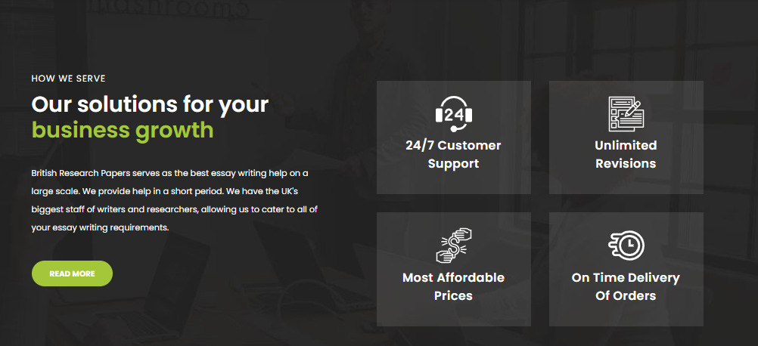

**Are you looking for Dissertation help?**

Our service will help you learn to write a thesis. Our most skilled experts can provide a fully customised, attractive and fascinating dissertation based on any title or offer. **Prime dissertation.co.uk** offers written dissertation content that meets all of the basic dissertation writing requirements.

**95% Satisfied Client**

**24/7 Availability**

**90+ Grades**

**100% confidentiality**

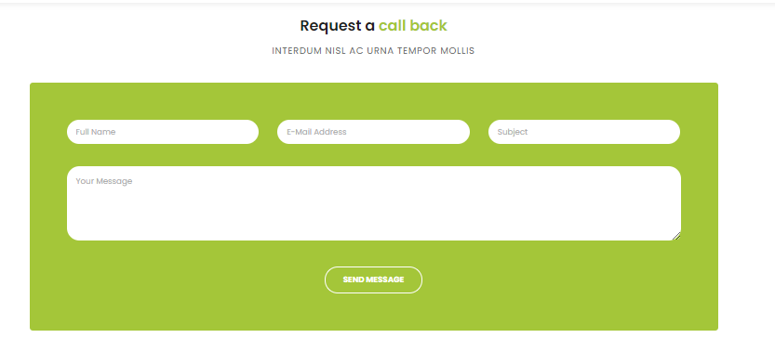

**Contact us now**

**Provide your information below**

**Full name**

**Email address**

**Subjects**

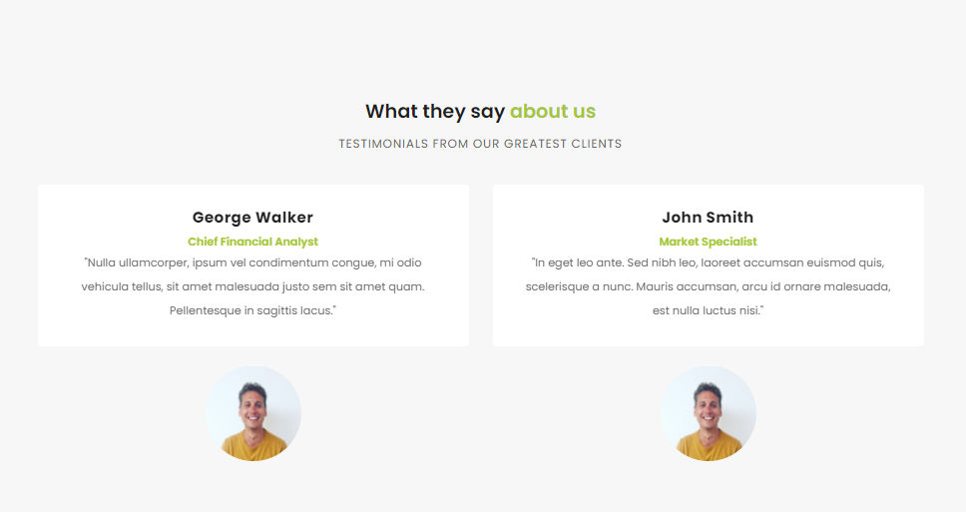

**Harry**

I know I can put my trust in the experienced staff even if I close my eyes. They provide great service and are unquestionably the best in the business. I wish you the best of luck in your academic endeavour’s!

**Elsa**

Because I'm not an expert on the subject, I hired one of your experienced writers to prepare a sample paper for me. Yesterday, I received a paper that was absolutely great! That load was lifted from my back.

**Jesse**

Your service is unquestionably the best. I'll be able to acquire certain alternatives for free if I work with you. Furthermore, the papers that I receive are of the highest quality. Thank you for your time and consideration, and please be safe.

**Anthony**

It's been a pleasure working with your company as usual. Appreciate the fruitful outcomes. I plan to make additional purchases from your website this year. Thanks for everything you do.