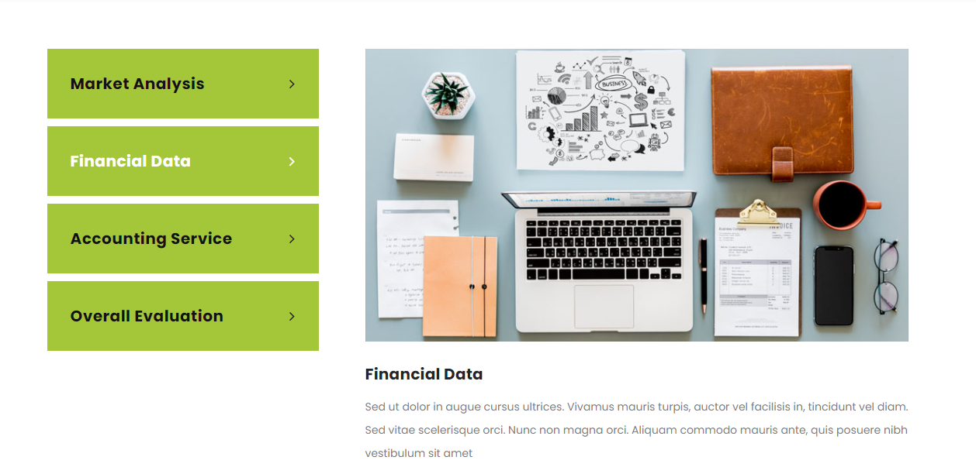

**Argumentative essay**

Argumentative essays are extremely similar to the convincing composition of essays. The distinction is that authors debate in argumentative essays about others instead of expressing their views directly. The emphasis is argumentative essay writing generally focused on advantages and disadvantages and argument.

**Expository essay**

This kind of essay contains a broad range of explanatory essays. This category includes all processing essays, comparison essays, contrast essays, cause and effect essays. This essay does not include emotive writing or personal emotions, and all of its subject is based completely on facts. Writers explain every subject with facts and examples.

**Narrative essay**

Want narrative essay service on a low budget? Narrative essays are written anecdotally based on personal experience. They are typically extremely attractive, depending on the author's perspective, and they convey a narrative or describe an experience for readers. The composition of narrative essays is typically based on actual events.

**Descriptive essay**

Descriptive essays are the kind of writings that require a student to describe a location, an item, a person, experience, emotions etc. The greatest thing about descriptive essay writing is that it produces a moving image of this particular subject in the imagination of readers. In descriptive essay writing, a writer essentially creates a picture of the particular subject about which he writes.

**Our services**

**Looking for essay help?**

**Primedissertation.co.uk** essay service includes the finest writers to assist you. Our experts look for the most relevant information on the subject and sort the relevant information. After that, we will have a round of questions. To ensure that your essay is devoid of mistakes, go back, edit and proofread it from beginning to end. Do not include any repetitions, grammatical or structural problems in the final copy. Check for mistakes or spelling issues in each section. You will never hear one of our clients complain about late delivery or missed deadlines. **Primedissertation.co.uk** complete the project by the specified time frame.

**Data collection**

**0% plagiarized**

**Q/A**

**On-time delivery**

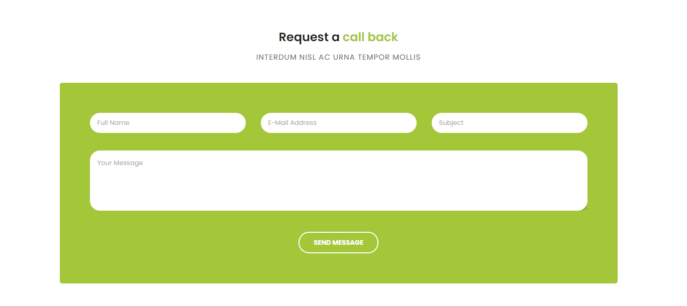

**Contact us now**

**Provide your information below**

**Full name**

**Email address**

**Subject**



**What our clients say**

**Alfie**

I randomly ordered a brief essay from dissertationnow.co.uk to check if they delivered on their promised on-time delivery. The task was completed on time, and the quality of the essay was outstanding.

**Theo**

I received the essay ahead of schedule, and it was well written. These are great resources, and the expert is amazing. They make changes quickly and expertly, and I would suggest them.

**William**

The best possible service was rendered. They completed my work ahead of schedule, which I much enjoyed. I plan to utilize their service again soon. Thank you so much.

**Langill**

Thanks to dissertationnow.co.uk. I want to express my gratitude to you for helping me out and providing me with high-quality essay aid. If I have any problems in the future, I will contact you again.