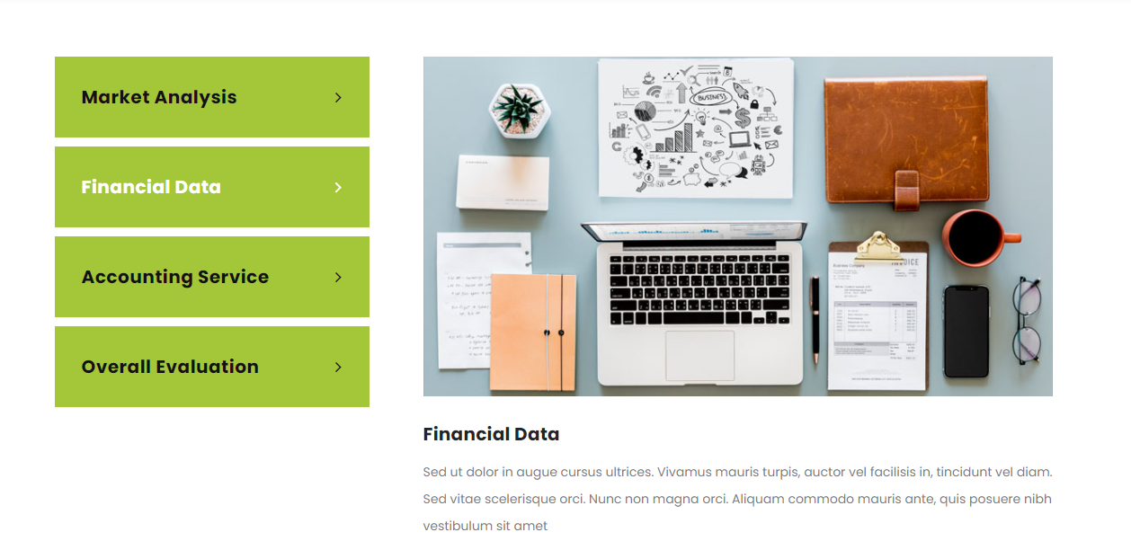

**Significance of the Study**

**Primedissertation.co.uk’s** expert in the opening chapter, explicitly outlines the study's objective and relevance. Discussing the study's theoretical and practical implications for communication professionals in the field being investigated helps to illuminate its significance.

**Review of Literature**

Others say that a theoretical foundation should be included in the chapters to provide more information in certain sections. As a result, the literature review summarizes and evaluates prior studies on the subject.

**Methodology**

Our data analysts examine your information and provide a report. Start with a description of the approach you used and why you felt it was the best choice. They accomplish this by citing the method's reference materials.

**Findings and discussion**

Discussions with our expert do not contain references to related research or the ramifications of your results in other works. Instead of just restating what they found, our chapter writers explain the implications of their results in connection to the theoretical body of knowledge on their issue and your profession as a whole. 

**How we do**

**How do our experts assist you?**

**Primedissertation.co.uk**’s writers begin their thesis writing by composing a thesis statement, which is then divided into many chapters. Then they provide techniques, objectives, and goals for summarization. Our expert's edit and proofread your work and they will assist you in both the acceptance and rejection of your project. After your supervisor's comments, our specialists revise your thesis to meet the standards set out.

**Thesis content**

**Thesis proposal**

**Editing and proofreading**

**Feedback impelemnetation**

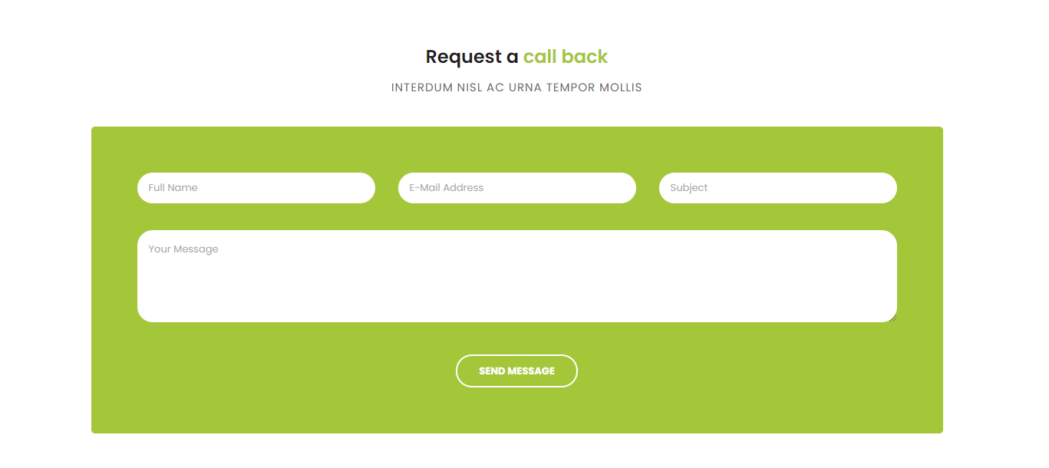

**Contact us now**

**Provide your information below**

**Full name**

**Email address**

**Subject**

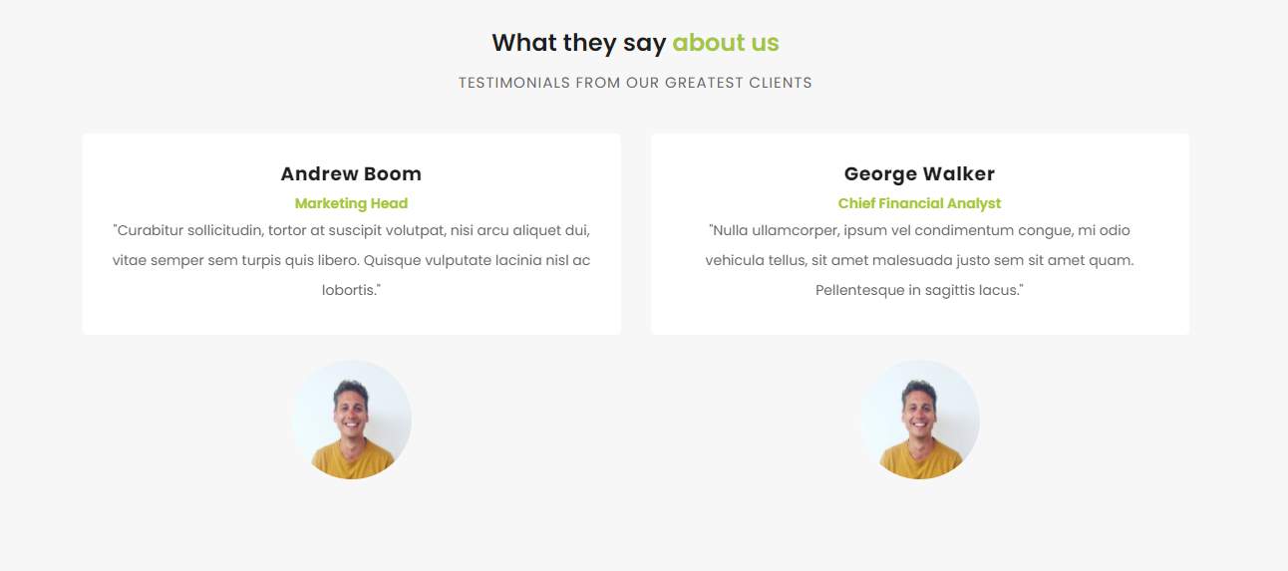

**Our client's review**

**Kevin**

The expert went above and beyond my expectations by finishing the task ahead of schedule. Above and beyond my expectations! Wonderfully executed project. Thank you so much for your kind words.

**Jessica**

I appreciate your thoroughness in addressing this issue. Now that you've clarified things for me, I have a better grasp of the question itself. You were a lifesaver for me!

**Henry**

I'm frequently swamped with schoolwork and assignments; I'm sure to turn to the same writer for assistance with this one as well. Thank you so much, guys. See you soon.

**Isabella**

Excellent work on the topic of my concern. I was concerned that it might take longer than expected to complete my purchase. However, your writer completed the task ahead of schedule. Great Work!