**HOME**

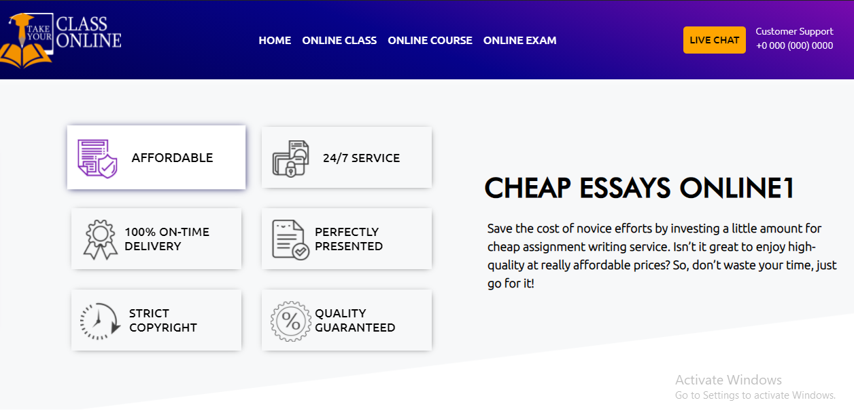

**AFFORDABLE**

We offer the best services in this industry and always seek 100% quality at affordable prices for the students. So what are you waiting for? We are here to provide you with academic support.

**24/7 SERVICE**

We provide you with 24/7 service support. If you want good grades in few hours, don't waste a minute and just go for it. We are always here to do your assignment and quizzes with high quality.

**100% ON-TIME DELIVERY**

We complete your assignments and quizzes on time or before time. Our experts are always available to meet your deadline and make your students' life stress-free. You just only have to contact us, and we are always available to interact with you.

**PERFECTLY PRESENTED**

Want your assignment with 100% quality? Don't worry at all! Our experts present your studies with great perfection, which matches your quality standards based on research and helps you secure your dream grades.

**STRICT COPYRIGHT**

Takeyourclassonline.com avoid copyright and complete your assignments with 0% plagiarism. So what are you looking for? If we are here to provide your tasks with the best quality. Our experts strictly follow the rules of copyright and help you to get an A1 grade.

**QUALITY GUARANTEED**

We know that you are very busy and can't focus on your class.Takeyourclassonline.com is the leading platform that provides you high-quality work by our expert writers, and they want you to experience success by achieving an A grade.

**ONLINE CLASS**

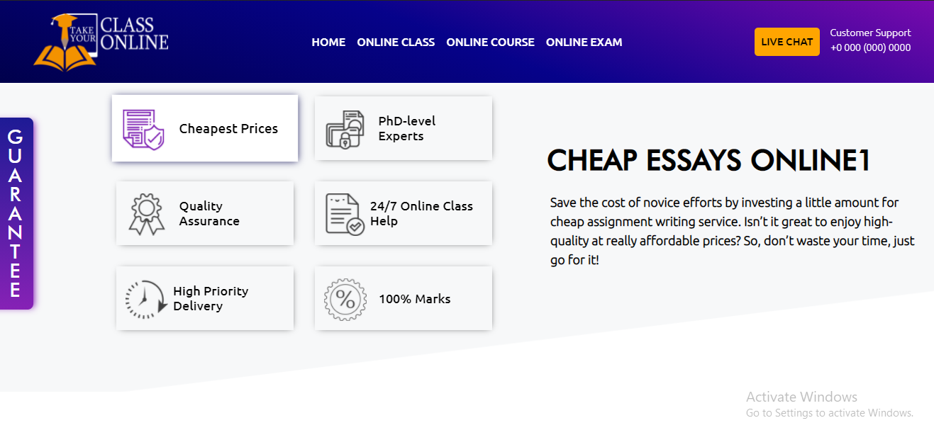

**Cheapest Prices**

We are providing you with cheap online class services. So save your money and enjoy the best benefits. Our experts ensure 100% results with high-quality assessment. We have set our bar high in providing excellent online class help.

**PhD-level Experts**

We have PhD level experts who assure 100% results in your online classes. The expert panel includes subject-related knowledge, who have completed their studies from international universities. More than 100 PhD scholars are serving at takemyonlineclass.com.

**Quality Assurance**

We assure the best quality with top results. Our experts make sure to keep your grades on top. So if you are busy with your work and cannot do well in your online classes, we are here to help you with the best quality result.

**24/7 Online Class Help**

The best thing about our services is that our customer support team is available 24/7. You may contact us by phone and email. We will be happy to help you and lead to you a successful path. Our high priority is to do your work on time.

**100% Marks**

Our experts give 100% results. We help students to improve their grades. Our platform guaranteed good grades, and we are always here to help you. So contact us if you want our support in your educational journey.

**ONLINE COURSE**

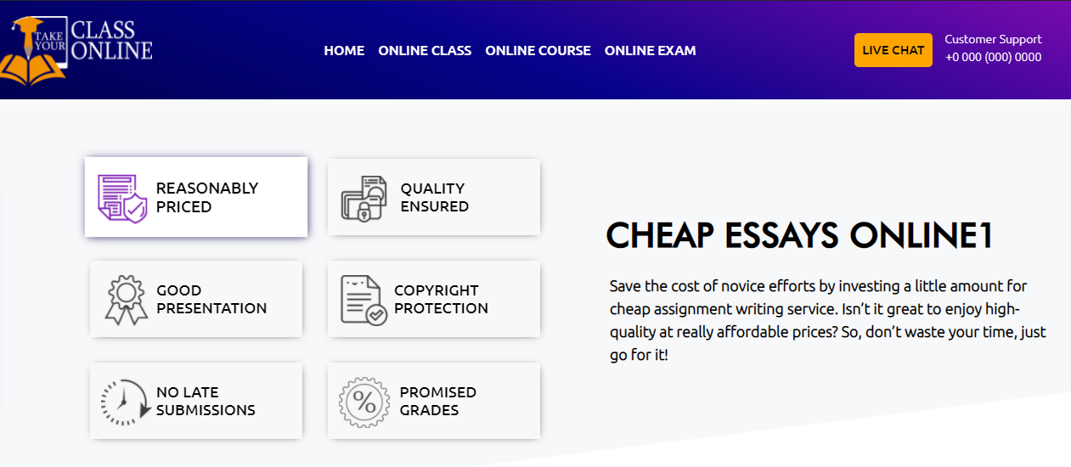

**REASONABLY PRICED**

Are you worried about paying a huge amount to someone for helping in your online course? Be happy because we are here to share your burden. We do your online course at a reasonable price. So, contact us to share your coursework and achieve good grades.

**QUALITY ENSURED**

We provide the best services with the best quality. Our goal is to build the trust of our clients and give them 100% results. We make your online course easy for you, so have faith in our enthusiastic and well-qualified experts.

**GOOD PRESENTATION**

Meet us if you want quality content with a good presentation. Our experts will academically present your work, so do not worry, we will do your course with enthusiasm and pass you with good grades.

**COPYRIGHT PROTECTION**

There is no high or low when it comes to copyright. We protect our client's work and deliver it with creativity. Our experts attempt your course intending to bring 100% originality.

**NO LATE SUBMISSIONS**

The best thing about takeyourclassonline.com is that we always deliver services on time. Our priority is to be punctual about your work because we care about deadlines. Our experts can do quality work in a limited time as well.

**PROMISED GRADES**

Do you list yourself as a high priority and are worried to raise them? Contact us, and we assure you of high grades so that all the doors of opportunity are kept open for you in the future.

**ONLINE EXAM**

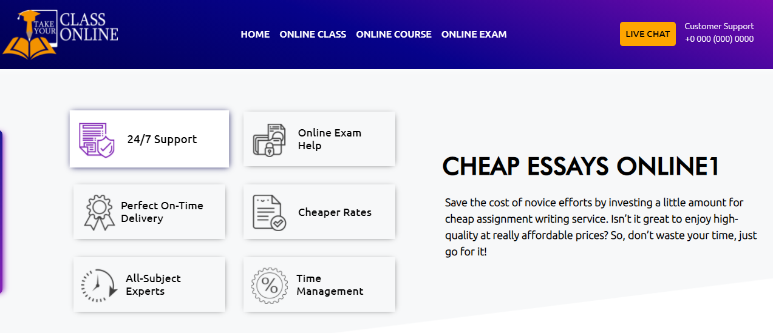

**24/7 SUPPORT**

Are you looking for an expert to take your exam? So here we are. We give 24/7 service to our clients even if there is day or night. We are always available to help you in achieving good grades.

**ONLINE EXAM HELP**

In your online exam, our experts can help you in various subjects. We have 1000+ experts who are available all the time to help you to get higher grades in your academics. So if you're not prepared well for your exam, then contact us ASAP.

**PERFECT ON-TIME DELIVERY**

Are you worried about an exam to get delivered on time? So be stress-free because we are here to give you on-time delivery of your exam. Our experts are very punctual and provide 100% results with good quality. Just stay with us and share your burden with us.

**CHEAPER RATES**

Are you worried about your exam and also about your savings? Then you are at the right place, and we are here to provide quality assistance with cheaper rates because we believe in earning trust and satisfaction instead of money.

**ALL SUBJECT EXPERTS**

We have experts to solve your online exam of any subject, no matter if it's mathematics, chemistry, or arts. Even if it's your quiz, our PhD, experts will help you in any way to get an A grade in your class.

**TIME MANAGEMENT**

Time management is one of the most crucial components which is directly proportional to exam stress. Don't worry about it, as we manage it smartly to assure quality within the given time limit.