Spring 2024: CS5720
Neural Networks and Deep Learning - ICP-2
Belli Anusha Sree (700758644)
GitHub link: https://github.com/anusreebelli/neuralnetwork-2.git
1. Write a program that takes two strings from the user: first name, last name. Pass these variables to
full name function that should return the (full name).
o For example:
▪ First name = “your first name”, last name = “your last name”
▪ Full name = “your full name”
o Write function named “string alternative” that returns every other char in the full name string.
Str = “Good evening”
Output: Go vnn

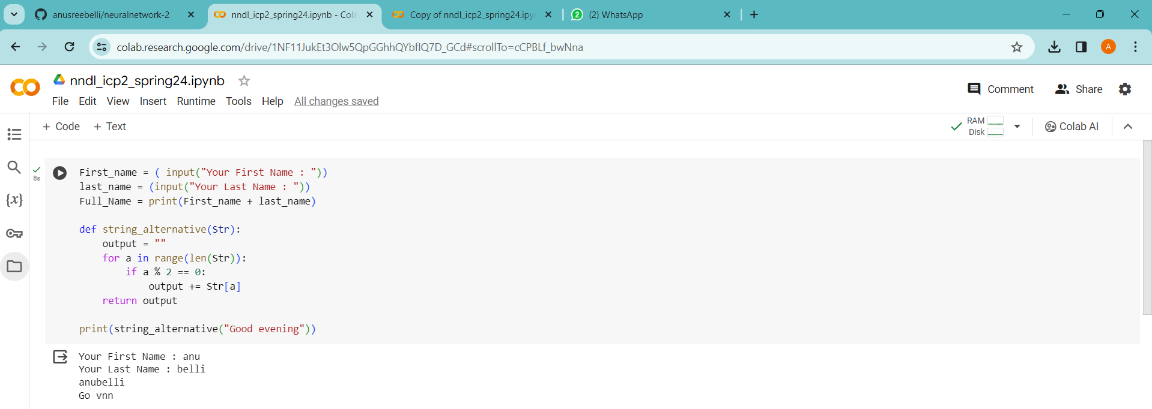
Note: You need to create a function named “string alternative” for this program and call it from
main function.
2. Write a python program to find the wordcount in a file (input.txt) for each line and then print the output.
o Finally store the output in output.txt file.
Example:
Input: a file includes two lines:
Python Course
Deep Learning Course
Output:
Python Course
Deep Learning Course
Wordcount:
Python: 1
Course: 2
Deep: 1
Learning: 1

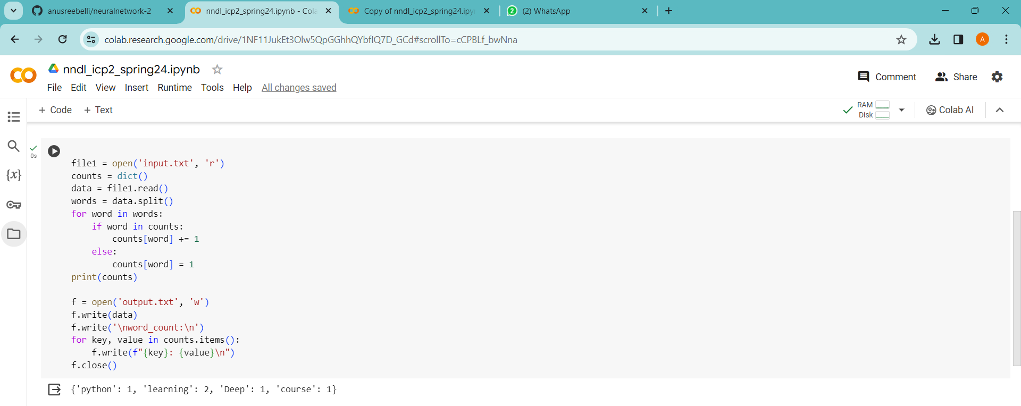

3. Write a program, which reads heights (inches.) of customers into a list and convert these
heights to centimetres in a separate list using:
1) Nested Interactive loop.
2) List comprehensions
Example: L1: [150,155, 145, 148]
Output: [68.03, 70.3, 65.77, 67.13]

