
GS HEALTH
PROJECT DOCUMENTATION
System Overview • Technology Connections • Detailed Application Workflows

1. Project Overview
Company The Patterns Company
Product GS HEALTH — Multi-Specialty & Digital Healthcare Platform
Purpose A multi-role digital platform intended to connect patients, doctors, specialists, clinics and administrators across multiple medical disciplines, and coordinate problem reporting, specialty provider discovery, cross-domain referrals, appointments, teleconsultations and medical/dental records.

2. Problem Statement
Fragmented patient access Patients may struggle to find available specialists for acute pain, specialized healthcare or complex dental conditions, delaying care.
Unstructured problem reporting Phone calls and walk-ins do not consistently capture symptoms, pain intensity, affected tooth quadrant or prior radiographs before consultation.
Manual scheduling Manual coordination can create double-bookings, doctor conflicts and clinic chair-time bottlenecks.
Scattered records Radiographs, photographs, charts and prescriptions can be distributed across paper files and disconnected systems.
Referral coordination gaps Referring doctors, dentists and specialist clinics need transparent case tracking, consultation coordination and attribution.

3. Proposed Solution
Structured triage Capture clinical and dental symptoms, pain scale, affected anatomical quadrant and diagnostic attachments.
Controlled availability Authorized doctors, dentists and administrators configure schedules and publish slots; patients select only published availability.
Role-based experiences Dedicated patient, doctor/dentist, clinic, admin and sub-admin dashboards with permission boundaries.
Cloud records Manage medical and dental records, radiographs and diagnostic documents using configured cloud storage and controlled access.
Referral collaboration Coordinate patient-to-doctor and doctor-to-doctor referrals with status updates and communication integrations.
Connected platform Combine Flutter clients, Node.js / Express APIs, Supabase PostgreSQL, storage, authentication and notifications.

4. User Roles and Responsibilities
Patient Register and authenticate; report clinical/dental symptoms; discover and favourite doctors; submit and track cross-domain referrals; book published appointment slots; manage medical and dental records; share records with authorized doctors; receive notifications.
Doctor / Dentist Maintain professional profile; configure availability where permitted; review assigned patient cases and referrals; accept / decline cases; manage appointments; consult patients; create clinical notes and e-prescriptions where enabled.
Clinic / Clinic Manager Manage clinic profile and associated doctors/dentists; coordinate consultation / working-hour information; review clinic appointments; route patient problems and monitor referrals where enabled.
Admin Manage users, providers and clinics; verify providers; configure global availability; assign doctors; manage appointments and referrals; oversee platform operations.
Sub-admin Perform assigned patient, doctor, referral and appointment operations within permissions granted by Admin.

5. Technology Stack — Connection View
The diagram below shows how the technologies connect as application layers and integrations. It is a connection diagram rather than a technology comparison table.
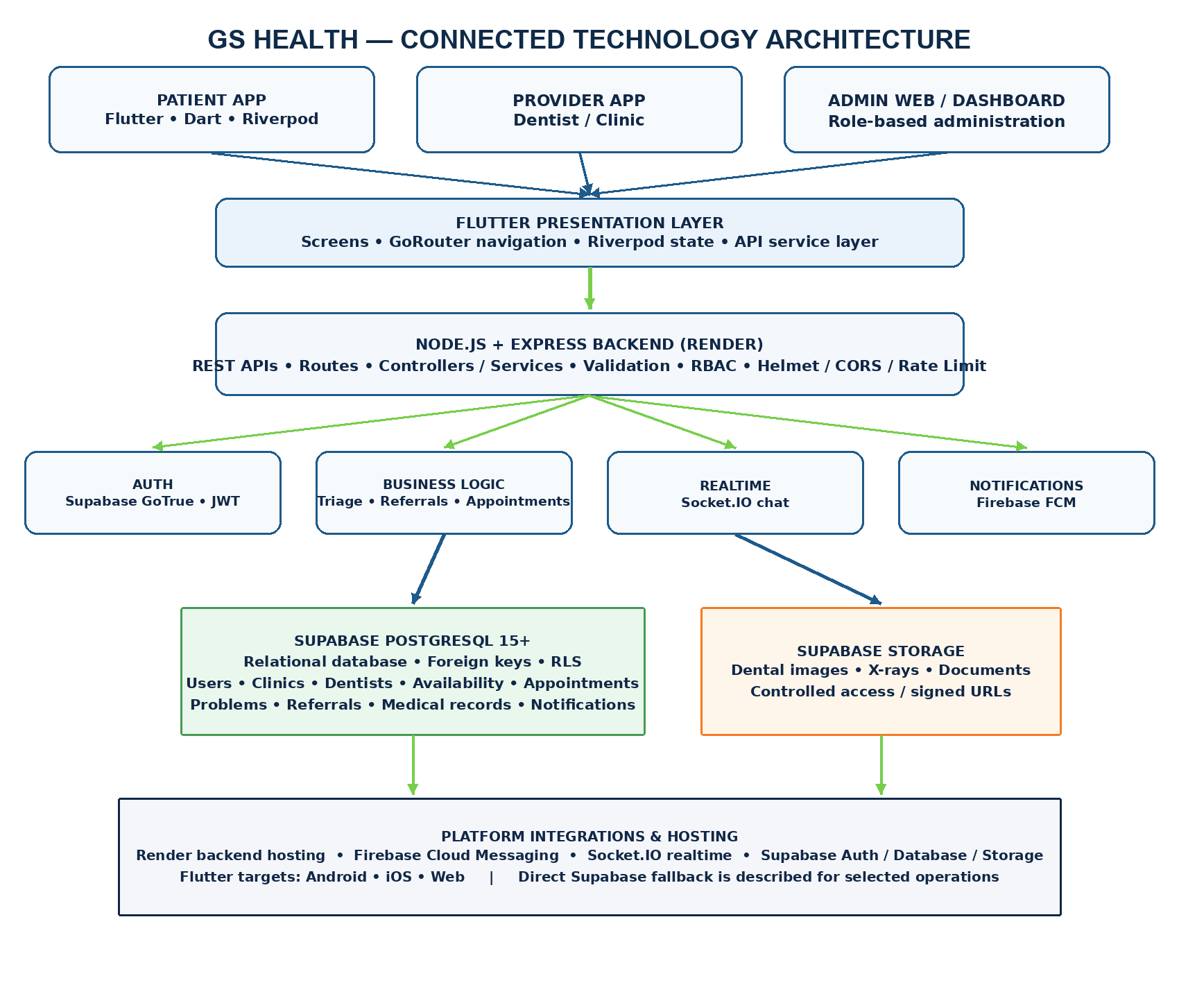
Communication summary: Flutter clients use the presentation and API service layers. The Node.js / Express backend handles REST requests and business rules, then connects to Supabase PostgreSQL. Supabase Storage holds uploaded files; Firebase Cloud Messaging delivers push alerts; Socket.IO supports realtime communication. The supplied specification also describes a direct Supabase fallback path for selected client operations.

6. Detailed Application Workflows
The following diagrams show the end-to-end user journey and system hand-offs. Each stage is described below the corresponding flow.

6.1 Patient Journey
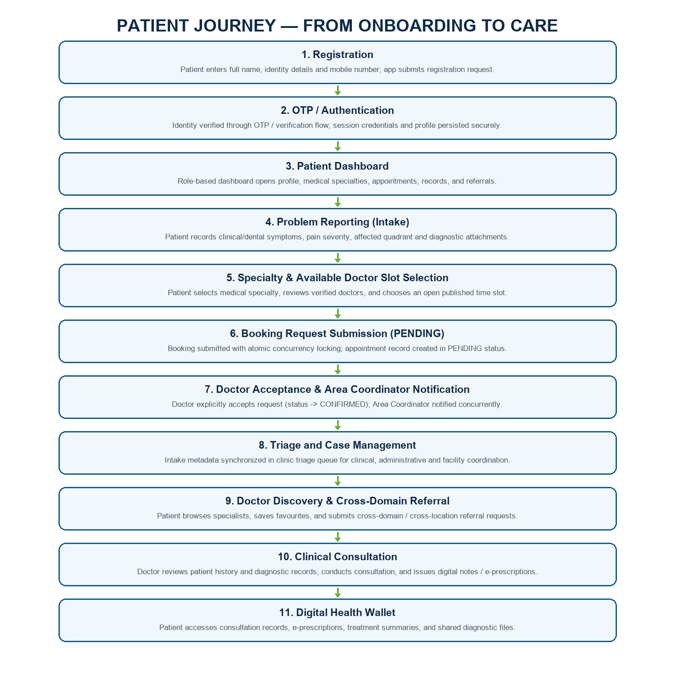
Step 1. Registration: patient enters identity details and mobile number in the Flutter app. The app submits the registration request to the configured authentication / backend flow.
Step 2. Authentication: OTP or the configured identity verification process confirms access. Session credentials and profile information are stored using the app's secure persistence approach; biometric unlock is available on supported devices if configured.
Step 3. Dashboard: after authentication, role-based navigation opens the patient experience and exposes permitted modules.
Step 4. Problem reporting (Intake): patient records symptoms, pain severity, affected tooth quadrant or anatomical area and relevant clinical photographs or radiographs. The media file is uploaded to cloud storage and problem metadata is written to PostgreSQL.
Step 5. Specialty and doctor slot selection: patient selects the required medical or dental specialty, views available certified doctors, and selects an open date and time slot generated strictly based on the doctor's published availability schedule.
Step 6. Booking request submission: patient submits the appointment booking request for the selected slot. The backend validates slot publication, verifies doctor availability, and establishes an atomic reservation lock preventing concurrent double-booking. The appointment record is created in PENDING status, awaiting doctor review and acceptance.
Step 7. Doctor acceptance and area coordinator notification: the assigned doctor receives an immediate notification to review the booking request and clinical case details, and the respective Area Coordinator is notified concurrently. Once the doctor explicitly accepts, the appointment transitions from PENDING to CONFIRMED and confirmation is sent to the patient.
Step 8. Triage and assignment: problem intake metadata and consultation requests remain accessible in the clinic / specialist triage queue. Relevant providers are notified and authorized clinic coordinators or administrators oversee case allocation and facility readiness.
Step 9. Doctor discovery and cross-domain referral: patient browses available doctors and clinics, saves favourites and can submit cross-domain referral requests. Referral status is surfaced to the patient in real time as receiving providers respond.
Step 10. Consultation: doctor reviews the submitted case, clinical history and authorized records, then conducts the consultation and creates consultation notes and e-prescriptions where enabled.
Step 11. Health wallet: patient can access consultation records, diagnostic summaries and authorized prescriptions securely through their digital health wallet.

6.2 Doctor, Dentist and Clinic Journey
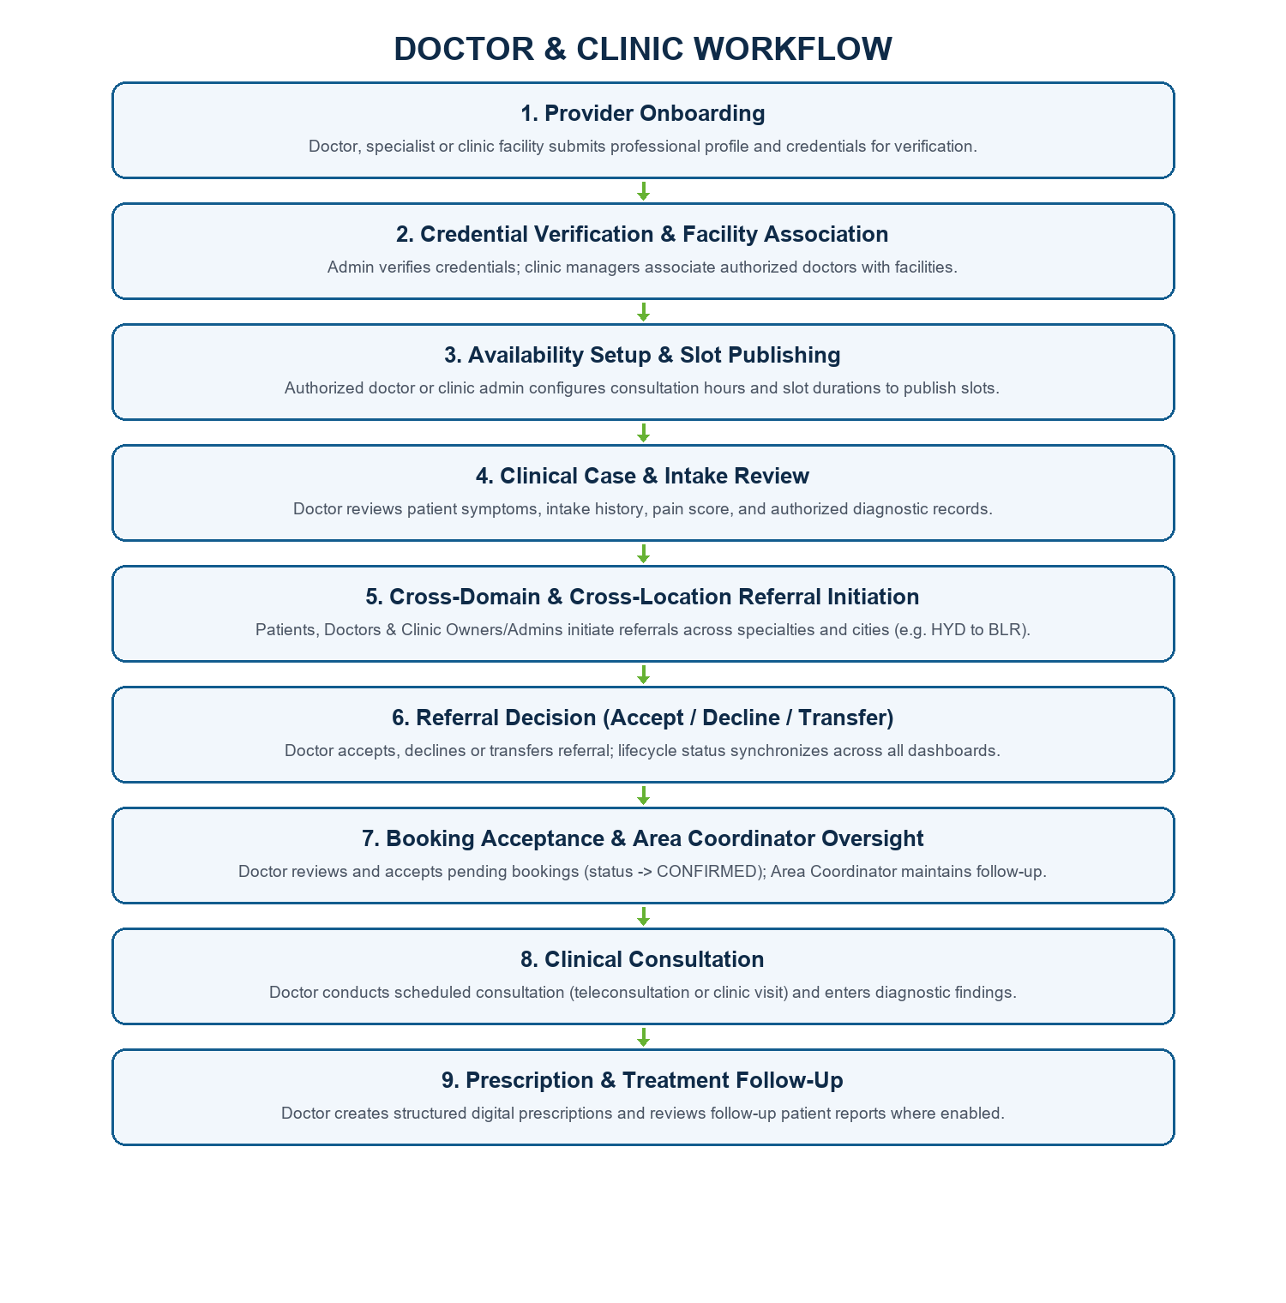
Step 1. Provider onboarding: doctor, dentist or clinic facility submits profile and professional / facility details. Provider verification is handled by Admin or an authorized Sub-admin where required.
Step 2. Clinic association: clinic manager associates registered doctors and dentists with the facility and maintains clinic information.
Step 3. Availability setup: authorized doctor, dentist or admin selects provider, dates, working hours and slot duration. Patients do not create or edit provider availability.
Step 4. Case review: assigned referrals and patient problems appear in the provider workflow. Doctor/dentist reviews symptoms, pain score, history and authorized radiographs/diagnostic records.
Step 5. Cross-domain referral decision & management: Patients, Doctors, and Clinic Owners/Admins can initiate referrals for any patient across different medical specialties, domains, and geographical locations to any verified doctor or specialist registered on GS HEALTH (for example, a clinic owner in Hyderabad can refer a patient in Bangalore to a specialist doctor in Bangalore or another location). The receiving doctor inspects the clinical case and accepts, declines, or transfers the referral where supported. Real-time referral status updates are persisted and reflected across all relevant patient, doctor, clinic, and administrative dashboards.
Step 6. Appointment and consultation: doctor sees scheduled appointments, reviews the case and records consultation information.
Step 7. Prescription and follow-up: doctor creates diagnosis, medication details and follow-up instructions where the feature is implemented.

6.3 Appointment and Slot Control
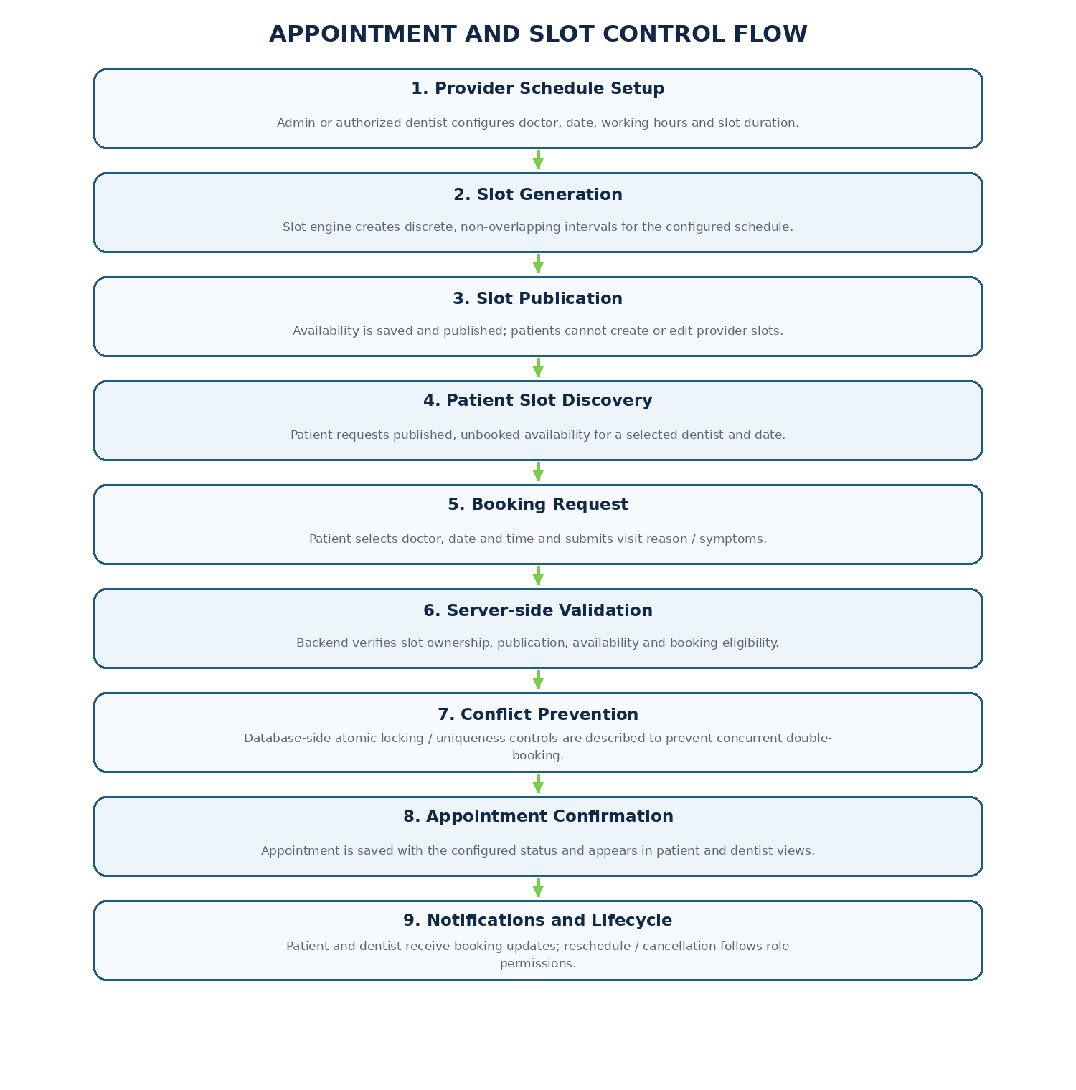
Step 1. Schedule owner: Admin or an authorized doctor/dentist configures the provider's working days, consultation window and slot duration.
Step 2. Slot generation: the system derives discrete non-overlapping time intervals from the configured schedule and saves them as provider availability.
Step 3. Publication: only published and unreserved slots are exposed to patient booking.
Step 4. Patient discovery: Flutter requests availability for the selected doctor and date and displays eligible published slots.
Step 5. Booking request & validation: backend verifies the selected slot is valid, published and available; an atomic reservation lock prevents concurrent double-booking and creates the appointment in PENDING status.
Step 6. Doctor acceptance & confirmation: doctor reviews and accepts the booking request, transitioning status from PENDING to CONFIRMED. Area coordinator and patient are notified, and confirmation is displayed in patient and doctor appointment views.
Step 7. Lifecycle: rescheduling and cancellation follow role-based rules and release or update availability as defined by the implementation.

6.4 Medical Records and Sharing
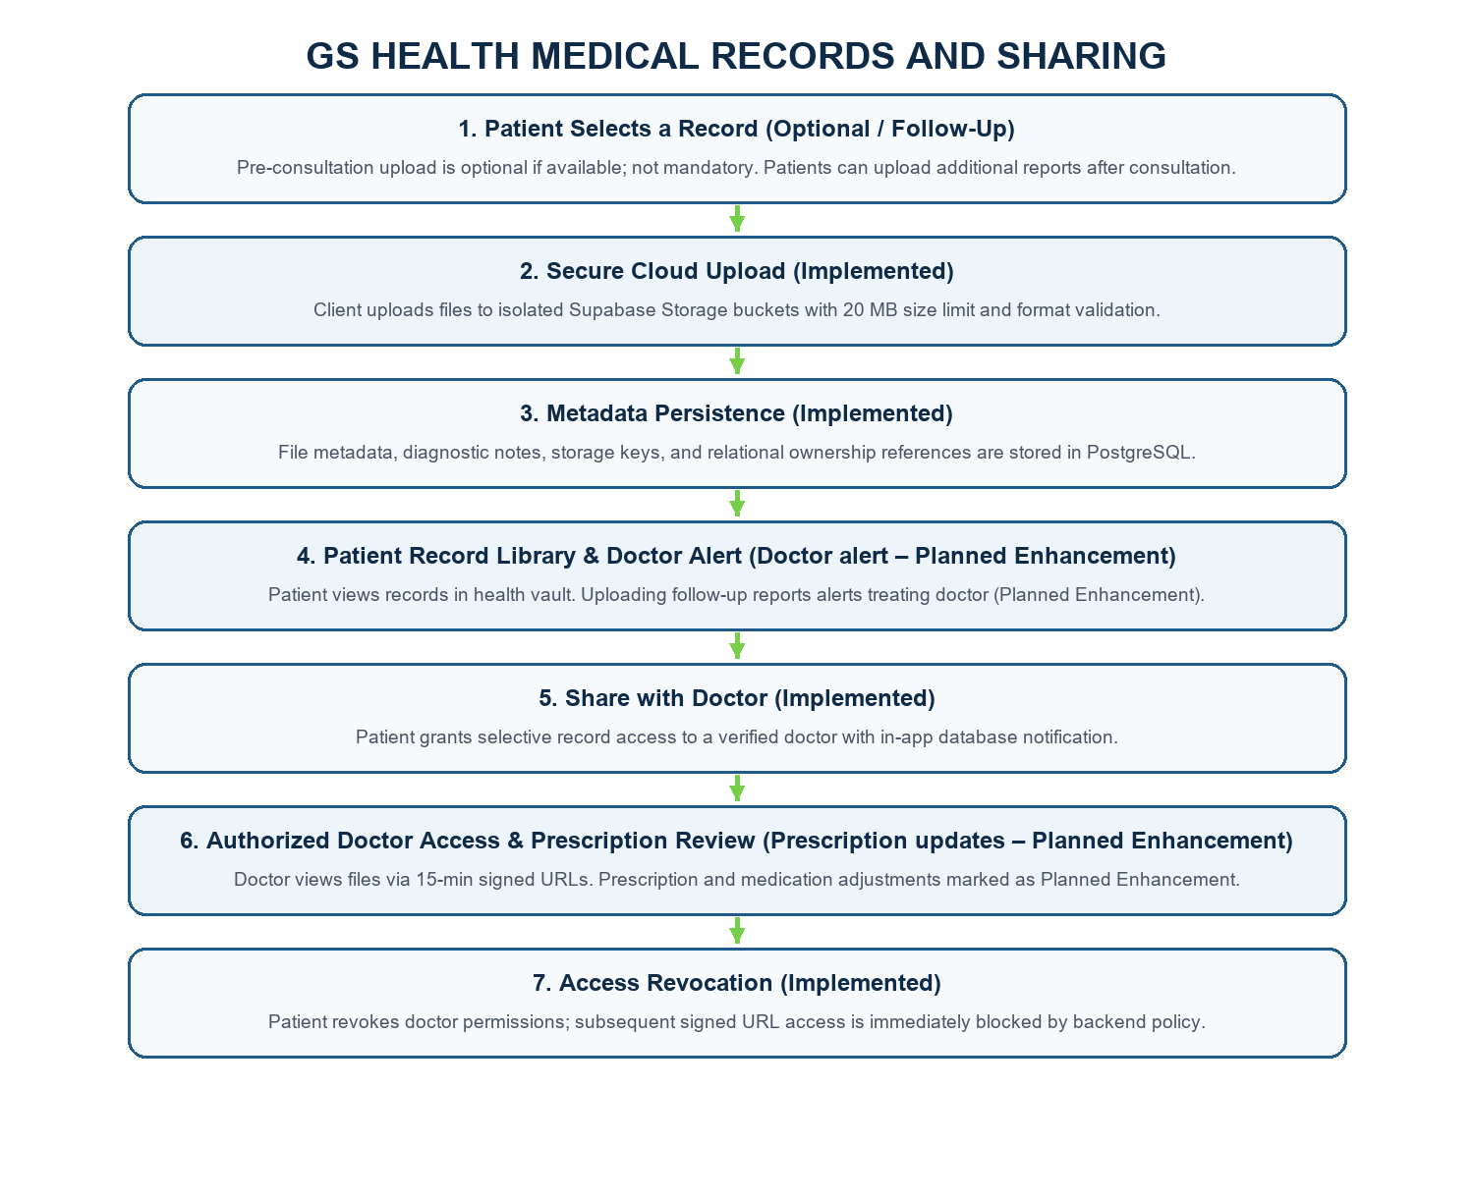
1. Existing Implemented Functionality (Verified in Source Code):
Step 1. Record upload & format validation (Implemented): Patient selects diagnostic files (radiographs, prescriptions, lab reports, treatment documents in JPG, JPEG, PNG, or PDF formats up to 20 MB size limit, verified in backend/src/controllers/recordController.js:27 and lines 326–334).
Step 2. Cloud storage & relational metadata (Implemented): Client uploads files directly to Supabase Storage with bucket-level file isolation. Relational metadata, MIME type, clinical notes, and ownership references are persisted in Supabase PostgreSQL (medical_records table, recordController.js:375-383).
Step 3. Patient library (Implemented): Uploaded records are indexed and displayed in the patient's health wallet, permitting secure preview and download (recordController.js:135-196).
Step 4. Selective doctor sharing & database notifications (Implemented): Patient explicitly selects a verified doctor and grants viewing permissions for selected records (recordController.js:495-614). Doctor authorization metadata is persisted, and an in-app database notification (Notification table: RECORD_SHARED) is dispatched to the doctor.
Step 5. Doctor access & tokenized URLs (Implemented): Backend validates doctor identity against the record's authorized permissions roster (recordController.js:85-100) before generating a secure, time-limited Supabase signed URL valid for 15 minutes (recordController.js:723, expiresIn: 900).
Step 6. Access revocation (Implemented): Patient retains full authority to revoke doctor access permissions at any time (recordController.js:617-670). Revocation immediately strips doctor access metadata and permanently blocks subsequent signed URL requests.
2. Client-Requested Enhancements (Planned Architecture & Roadmap):
• Optional pre-consultation uploads (Planned): Initial medical record upload prior to consultation is designated as strictly non-mandatory. Patients may upload existing records only if available; absence of prior records does not block appointment booking.
• Post-consultation follow-up uploads (Planned): Patient workflow is extended to support post-consultation submissions, enabling patients to upload diagnostic lab reports, biopsy results, and follow-up imaging recommended during the initial doctor consultation.
• Automated doctor push alerts on upload (Planned): Planned integration with Firebase Cloud Messaging / WebSockets to dispatch automated push alerts to the treating doctor immediately when a patient uploads follow-up diagnostic reports. (Existing implementation creates database notifications on explicit sharing only).
• Dynamic prescription & medication revisions (Planned): Enhanced clinical review workflow enabling doctors to examine newly submitted follow-up reports, adjust medication dosages or treatment plans, and dynamically reissue updated e-prescriptions directly from the provider dashboard.

6.5 Referral Workflow
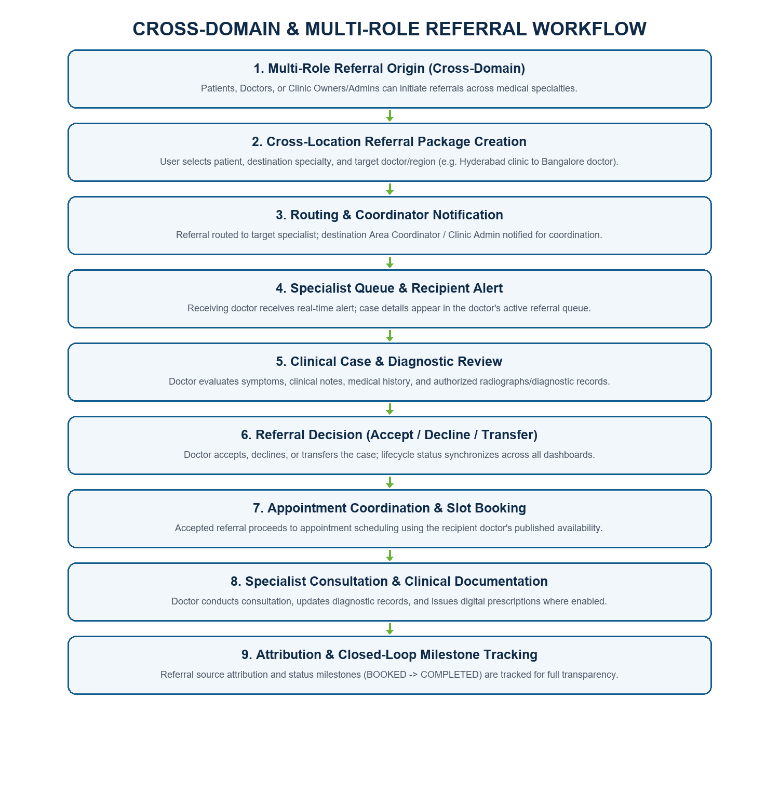
Step 1. Referral origin: Any Patient, Doctor, or Clinic Owner/Admin can initiate a referral for a patient to any verified doctor or specialist registered on the GS HEALTH platform, regardless of medical specialty or geographical location.
Step 2. Referral creation: The referring user selects the patient, destination medical specialty, and target doctor or location. Relevant patient details, clinical notes, and authorized medical records should be included in the referral.
Step 3. Referral routing: The referral should be routed to the selected doctor or specialist. The respective destination Area Coordinator or Clinic Administrator should also receive the referral notification for coordination and follow-up.
Step 4. Notification: the recipient is notified and can review the assigned referral.
Step 5. Review and decision: doctor/specialist inspects the case and accepts, declines or transfers it where supported.
Step 6. Accepted referral: appointment scheduling proceeds using the receiving provider's published availability.
Step 7. Declined / reassigned referral: the configured workflow routes the case for reassignment or closes it; exact behavior should be confirmed in the implementation.
Step 8. Attribution and tracking: referral origin and status are retained where implemented, and relevant users receive updates.

7. Backend and Database Communication
Normal request path
Flutter Screen → Riverpod State / API Service → HTTPS REST Request → Express Route → Authentication / Role Middleware → Controller / Service → Supabase PostgreSQL → JSON Response → Riverpod State Update → UI refresh.
Direct cloud fallback path described in the specification
Flutter Client → Supabase Client SDK → Supabase GoTrue / PostgreSQL. This path is described for selected operations when the Render REST API is unavailable. Direct client access must still be protected by RLS and must not expose privileged service credentials.
File path
Flutter File Picker → Supabase Storage (or the configured storage provider) → PostgreSQL metadata / ownership reference → authorized signed URL or controlled file retrieval.
Notification path
Application Event → Backend Notification Logic → Firebase Cloud Messaging → Patient / Provider Device.
Realtime path
Patient / Doctor Chat Client → Socket.IO Connection → Realtime Message Delivery → Recipient Client. Message persistence and authorization must follow the configured backend/database implementation.

8. Security and Access Control
Authentication Supabase GoTrue and JWT are listed in the supplied specification; client session persistence and optional biometrics are described.
Role authorization Patient, Doctor/Dentist, Clinic, Admin and Sub-admin access should be limited by role and granted permissions.
Database Supabase PostgreSQL with foreign keys and RLS is specified.
File access Medical files should be accessed through controlled permissions and signed URLs where configured.
API protection Helmet, CORS and rate limiting are listed in the backend stack.
Audit The specification describes audit tracking for record access, cancellations, role changes and critical events.

9. Deployment and Integrations
Flutter targets Android, iOS and Web are specified.
Backend hosting Render is specified for the Node.js / Express service.
Database and authentication Supabase Cloud PostgreSQL and GoTrue are specified.
Notifications Firebase Cloud Messaging is specified for push notifications.
Realtime Socket.IO is specified for live messaging.
Storage Supabase Storage is named; AWS S3 also appears in the supplied stack. Confirm the active production provider.

10. Important Verification Notes
This document is based on the supplied system specification. It explains the architecture and workflows described there; it is not an independent source-code audit. Verify implementation details such as OTP provider, exact API contracts, table and column names, RLS policies, file formats and limits, referral reassignment, record-sharing revocation, atomic slot locking and production storage provider before treating them as confirmed implementation facts.
The supplied specification states that GS HEALTH uses Supabase PostgreSQL as its exclusive relational database and has no MongoDB / Mongoose dependencies. The technology diagram reflects that stated architecture.

