INDEX:-
Sr. No. | Particulars | Page No.
1 | Introduction | 2-5
2 | Objectives of the Study | 6
3 | Review of Literature | 7-9
4 | Research Methodology | 10-11
5 | Scope of the study | 12
6 | Review of literature | 13
7 | Data Analysis | 14-22
8 | analysis of the survey | 23
9 | Findings & Interpretations | 24-25
9 | Conclusion and Recommendations | 26
10 | Bibliography | 27

INTRODUCTION
Food is one of the basic needs of human beings. However, the way people purchase and consume food has changed significantly with the development of technology. In the past, customers generally visited restaurants personally or ordered food through telephone calls. Today, customers can order food through websites and mobile applications within a few minutes.
Food delivery services have become an important part of modern life. Customers can search for restaurants, view menus, compare prices, select food items, make payments and track their orders using digital platforms.
The growth of food delivery services can be linked to the increasing use of smartphones, internet services and digital payments. Consumers are becoming more comfortable with online transactions, which has made online food ordering easier.
The main advantage of food delivery services is convenience. A customer does not have to travel to a restaurant to purchase food. Food can be ordered from home, office, college or any other suitable location.
Time-saving is another important advantage. People with busy schedules may not have enough time to travel to restaurants or prepare food. Online food delivery provides them with a convenient alternative.
Food delivery services also provide customers with greater choice. Customers can select from different restaurants and cuisines available in their area.
However, food delivery services also face several challenges. Customers may experience late delivery, cold food, poor food quality, incorrect orders or payment problems. These problems can influence customer satisfaction.
Therefore, customer satisfaction is an important subject for studying food delivery services.
Customer satisfaction refers to the level of happiness or disappointment experienced by a customer after using a product or service. If the service meets customer expectations, the customer may be satisfied. If the service performs better than expected, the customer may be very satisfied. If the service performs below expectations, the customer may become dissatisfied.
The present study focuses on understanding customer satisfaction with food delivery services. The study is based on a questionnaire survey containing responses from 106 participants.
The study examines the age and occupation of respondents, their frequency of ordering food online, their preferred delivery services, reasons for ordering online, spending patterns, problems faced, overall satisfaction and willingness to recommend food delivery services.
The purpose of the study is not only to identify whether customers are satisfied but also to understand the reasons behind their satisfaction or dissatisfaction.
1.1 BACKGROUND OF THE STUDY
The food delivery industry has changed greatly because of digital technology. Earlier, food delivery was mainly provided directly by restaurants. Customers usually had to call a restaurant and provide their order and address. With online food delivery platforms, customers now have access to many restaurants through a single application. The digital system has made the ordering process easier. Customers can view pictures, menus, prices, ratings and reviews before making their decisions. Digital payment has also reduced the need to carry cash. Customers may use different payment methods according to the options available to them. Another important development is order tracking. Customers can often see whether their order has been accepted, prepared, picked up and delivered. These developments have changed customer expectations. Customers now expect faster service, accurate information and reliable delivery. Therefore, companies operating in the food delivery industry must continuously improve their services to remain competitive.
1.2 MEANING OF FOOD DELIVERY SERVICES
Food delivery service means the process of ordering prepared food from a restaurant or food outlet and receiving that food at a selected location. In an online food delivery system, the customer usually uses a mobile application or website.
The process can be explained as follows:
Step 1 – Searching
The customer searches for restaurants or food items.
Step 2 – Selecting a Restaurant
The customer chooses a restaurant based on menu, price, ratings, reviews and personal preference.
Step 3 – Selecting Food
The customer selects the required food items from the available menu.
Step 4 – Placing the Order
The customer confirms the order and provides the delivery details.
Step 5 – Payment
The customer completes payment using an available payment method.
Step 6 – Food Preparation
The restaurant prepares and packs the order.
Step 7 – Delivery
The delivery partner collects the food and delivers it to the customer.
Step 8 – Feedback
After receiving the food, the customer may provide a rating or review.
Thus, food delivery is not just about transporting food. It includes the complete process from selecting a restaurant to receiving and evaluating the order.
1.3 EVOLUTION OF FOOD DELIVERY SERVICES
Food delivery services have developed gradually with improvements in communication and technology. In the traditional system, customers had limited choices. They generally ordered from restaurants located nearby. Telephone ordering improved the process because customers no longer had to visit the restaurant to place an order. The development of the internet introduced online ordering websites. Customers could view menus and place orders online. The introduction of smartphones and mobile applications made food ordering even easier. Customers could order food from almost anywhere. Digital payment systems further improved the process. Customers could make payments without using cash. Modern food delivery systems also provide order tracking and notifications. Customers can receive updates about the status of their orders. The industry has therefore moved from simple restaurant-based delivery to a technology-based system involving customers, restaurants, delivery partners and digital platforms.

1.4 FEATURES OF FOOD DELIVERY SERVICES
Food delivery services have several important features.
Convenience-Customers can order food without travelling to a restaurant.
Time Saving-Online ordering saves the time required for travelling and waiting.
Variety-Customers can select from different restaurants and cuisines.
Digital Payment-Customers can make payments using different digital methods.
Order Tracking-Customers can track their orders and receive updates.
Offers and Discounts-Many platforms provide promotional offers and discounts.
Reviews and Ratings-Customers can read reviews and ratings before selecting a restaurant.
Home Delivery-Food is delivered directly to the customer's selected location.
Easy Comparison-Customers can compare restaurants, prices and available food items.
Accessibility-Food delivery services allow customers to order food at different times and from different locations.
1.5 IMPORTANCE OF FOOD DELIVERY SERVICES
Food delivery services are important because they provide convenience to consumers.
For students, food delivery can be useful when they are studying or spending long hours at college.
For working people, delivery services can save time during busy working days.
For families, online food delivery provides an additional option when they do not want to cook.
For restaurants, online platforms provide access to a larger customer base.
Food delivery services also help restaurants receive orders through digital channels.
The availability of online reviews can help customers make informed decisions.
The growth of food delivery services has therefore affected both consumers and restaurants.

OBJECTIVES OF THE STUDY
The main objective of this project is to study customer satisfaction with food delivery services.
The specific objectives are:
1. To study the demographic profile of the respondents.
The study examines the age and occupation of respondents.
2. To understand the frequency of online food ordering.
The study examines how regularly respondents order food online.
3. To identify the food delivery services used by customers.
The study identifies the platforms most frequently used by respondents.
4. To understand the reasons for using food delivery services.
The study examines whether customers order mainly for convenience, time saving, discounts, easy payment or other reasons.
5. To study customer spending behaviour.
The study examines the average amount spent per food delivery order.
6. To identify problems faced by customers.
The study examines common issues such as late delivery, cold food, poor food quality and payment issues.
7. To measure customer satisfaction.
The study determines whether respondents are very satisfied, satisfied, neutral, dissatisfied or very disappointed.
8. To study recommendation behaviour.
The study examines whether customers are willing to recommend food delivery services to friends and family.
9. To identify areas requiring improvement.
The study attempts to understand where food delivery services can improve.
10. To provide suggestions.
The study provides practical recommendations based on the survey findings.

REVIEW OF LITERATURE
3.1 Introduction
A review of literature means studying existing ideas, theories and research related to the topic. Customer satisfaction has been widely studied in marketing and service management. In service businesses, customers judge both the final product and the process through which the service is delivered. Food delivery is a service where customer satisfaction is influenced by several factors.
3.2 Customer Satisfaction
Customer satisfaction is generally associated with the comparison between customer expectations and actual performance. If actual performance meets expectations, customers are likely to feel satisfied. If actual performance is lower than expectations, dissatisfaction may occur. Therefore, businesses need to understand customer expectations and continuously improve their services.
3.3 Service Quality
Service quality is an important factor influencing customer satisfaction.
In food delivery, service quality includes:
- Delivery speed
- Reliability
- Customer support
- Communication
- Packaging
- Convenience
A customer may judge the entire service rather than only the food.
For example, even if the food tastes good, a very late delivery may result in dissatisfaction.
3.4 Food Quality
Food quality is a central factor in food delivery.
Customers generally expect food to be:
- Fresh
- Tasty
- Properly cooked
- Hygienically prepared
- Properly packed
- Delivered at a suitable temperature
Poor food quality may negatively affect satisfaction.
3.5 Delivery Time
Delivery time is another important factor. Customers usually receive an estimated delivery time while placing an order. If the food arrives within the expected time, the customer may have a positive experience. If the order is significantly delayed, dissatisfaction may occur. Therefore, accurate delivery estimates and efficient logistics are important.
3.6 Convenience
Convenience is one of the strongest benefits of online food delivery.
Customers can order without:
- Travelling
- Waiting in restaurant queues
- Calling restaurants
- Carrying cash
This convenience can encourage customers to use food delivery platforms regularly
3.7 Price and Discounts
Price also affects customer behaviour. Customers often compare the total cost of orders across different platforms. Discounts and promotional offers may encourage customers to place orders. However, customers may become dissatisfied if additional charges are not clearly communicated. Therefore, transparent pricing is important.
3.8 Technology and Customer Experience
Technology has made food ordering faster and easier.
Mobile applications provide customers with:
- Restaurant search
- Menus
- Reviews
- Ratings
- Online payments
- Tracking
- Notifications
However, technical problems can negatively affect the customer experience.
3.9 Customer Loyalty
Customer satisfaction can contribute to customer loyalty.
Satisfied customers may:
- Order again
- Continue using the platform
- Recommend it to others
- Develop trust in the service
Therefore, companies should focus on long-term customer satisfaction rather than only individual transactions.
3.10 Research Gap
Many discussions focus on individual factors such as delivery time or food quality. The present study attempts to consider multiple aspects together. It studies demographic characteristics, ordering frequency, platform usage, reasons for ordering, spending, problems, satisfaction and recommendation intention. This provides a broader view of customer experience.

RESEARCH METHODOLOGY
4.1 Meaning of Research Methodology
Research methodology refers to the systematic process used to collect and analyse information. A proper methodology helps ensure that the research is organised and understandable.
4.2 Research Design
The study follows a descriptive research design. Descriptive research is used to describe the characteristics and opinions of respondents. The present study describes the behaviour and satisfaction of customers using food delivery services.
4.3 Type of Research
This is primarily a quantitative research study because the responses are converted into numerical frequencies and percentages. The numerical results are presented using tables and pie charts.
4.4 Primary Data
Primary data is information collected directly from respondents. For this project, primary data was collected through an online questionnaire. The college guidelines require students to have 100 responses collected at the time of viva. Your survey has more than the required 100 responses, so you can mention the actual number of responses collected in your final report.
4.5 Secondary Data
Secondary information was used to understand:
- Customer satisfaction
- Service quality
- Food delivery
- Consumer behaviour
- Online ordering
- Digital services
Sources include textbooks, educational material and reliable online information.
4.6 Sample Size
Sample size: 106 respondents
The survey dataset contains 106 responses.
4.7 Sampling Method
The study uses a convenience sampling method. Respondents who were easily accessible and willing to participate were included.
4.8 Research Instrument
A structured questionnaire was used for collecting primary data.
The questionnaire covered:
- Age
- Occupation
- Ordering frequency
- Delivery service used
- Reason for using delivery services
- Spending per order
- Problems faced
- Satisfaction
- Recommendation intention
4.9 Data Analysis Method
The collected responses were classified into different categories.
The data was analysed using:
- Frequency
- Percentage
- Tables
- Pie charts
- Interpretation
The formula used is:
Percentage = (Number of responses ÷ Total valid responses) × 100
4.10 Ethical Considerations
The survey was conducted for academic purposes. Respondents' personal information should not be unnecessarily displayed in the final project. Only relevant survey results should be used.

SCOPE OF THE STUDY
The study focuses on customer satisfaction with online food delivery services.
The scope of the study includes:
- Understanding the profile of respondents.
- Studying online food ordering frequency.
- Identifying commonly used food delivery services.
- Analysing customer spending patterns.
- Identifying problems experienced by customers.
- Measuring overall satisfaction.
- Studying customers' recommendation behaviour.
The study is based on 106 responses collected through a structured questionnaire.
The study is primarily concerned with the opinions and experiences of the respondents who participated in the survey. Therefore, the findings should be interpreted in the context of the sample studied.

REVIEW OF LITERATURE
Customer satisfaction has been widely discussed in the field of marketing and service management. It is generally understood as the customer's evaluation of a product or service after comparing their expectations with their actual experience.
In service industries, customer satisfaction is influenced not only by the final product but also by the quality of the service process. Factors such as reliability, responsiveness, convenience and service quality can affect customer perceptions.
In the context of food delivery services, customer satisfaction can involve multiple aspects of the customer journey. These include the ease of placing an order, availability of restaurants and menu items, pricing, discounts, payment options, delivery time, food condition and customer support.
The growth of digital platforms has increased the importance of convenience in consumer decision-making. Customers can place orders without physically visiting restaurants and can often track their orders through digital applications.
Food quality is another important aspect because the customer ultimately evaluates whether the delivered food meets expectations regarding taste, freshness and temperature.
Delivery performance can also influence satisfaction. Delays can create dissatisfaction, particularly when customers expect a specific delivery time.
Therefore, customer satisfaction with food delivery services can be viewed as a combination of convenience, service quality, delivery performance, food quality, pricing and the overall ordering experience.
The present study attempts to examine these aspects through primary data collected from 106 respondents.

DATA ANALYSIS AND INTERPRETATION
AGE GROUP OF RESPONDENTS
Age Group | Number of Respondents | Percentage
Below 18 | 23 | 21.70%
18–25 | 30 | 28.30%
26–35 | 23 | 21.70%
36–45 | 21 | 19.81%
Above 45 | 9 | 8.49%
Total | 106 | 100%
Age Group of Respondents
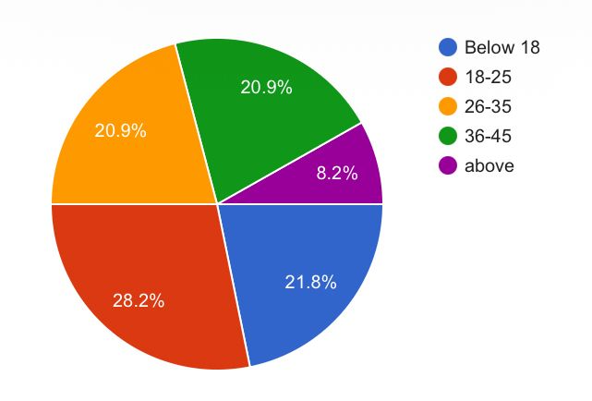
Interpretation
The data shows that the largest group of respondents belongs to the 18–25 age group, representing 28.30% of the total respondents. Respondents below 18 and those between 26–35 years each account for 21.70%. The 36–45 age group represents 19.81%, while respondents above 45 years account for 8.49%.
This indicates that the survey includes respondents from different age groups, with young adults forming the largest category.
OCCUPATION OF RESPONDENTS
Occupation | Number | Percentage
Student | 40 | 38.10%
Salaried employee | 22 | 20.95%
Self-employed | 20 | 19.05%
Business | 14 | 13.33%
Homemaker | 8 | 7.62%
Other | 1 | 0.95%
Total valid responses | 105 | 100%
Occupation of Respondents
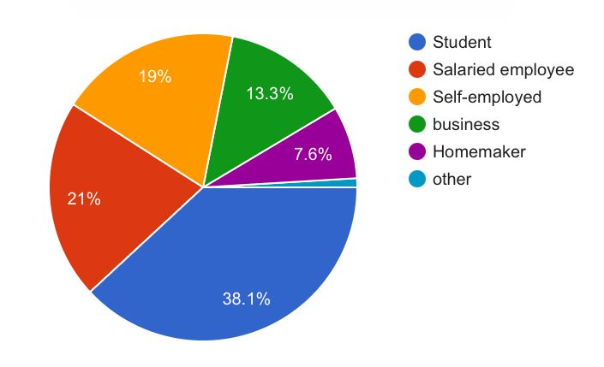
Interpretation
Students form the largest category, accounting for 38.10% of valid responses. Salaried employees account for 20.95%, while self-employed respondents represent 19.05%. Business respondents account for 13.33% and homemakers represent 7.62%. Only 0.95% selected other. The results indicate that students form a significant portion of the respondents, suggesting that food delivery services are particularly relevant to younger consumers and students included in the survey.
FREQUENCY OF ONLINE FOOD ORDERING

Frequency | Number | Percentage
Daily | 13 | 12.26%
Several times a week | 27 | 25.47%
Once a week | 27 | 25.47%
2–3 times a month | 17 | 16.04%
Rarely | 22 | 20.75%
Total | 106 | 100%

Frequency of Online Food Ordering
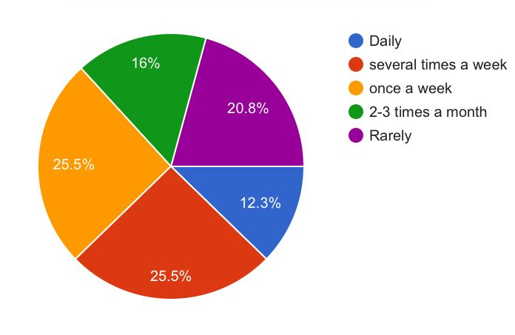
Interpretation
The results show that 25.47% of respondents order food online once a week, while another 25.47% order food several times a week. A further 12.26% order food online daily.
Around 20.75% of respondents order food rarely, while 16.04% order food two to three times a month.
The results indicate that online food ordering is a regular activity for a considerable proportion of respondents.
MOST FREQUENTLY USED FOOD DELIVERY SERVICE

Service | Number | Percentage
Both equally | 38 | 36.19%
Zomato | 32 | 30.48%
Other | 21 | 20.00%
Swiggy | 14 | 13.33%
Total valid responses | 105 | 100%

Food Delivery Services Used by Respondents
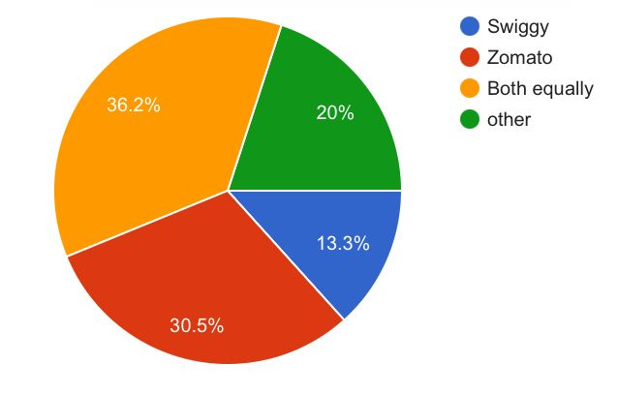
Interpretation
The largest category is respondents who use both services equally, accounting for 36.19% of valid responses. Zomato is selected by 30.48% of respondents, while 13.33% selected Swiggy. A further 20% selected other services.
The result suggests that respondents do not rely exclusively on a single platform. Many consumers appear to use more than one food delivery service, potentially depending on availability, pricing, offers and convenience.

MAIN REASON FOR USING FOOD DELIVERY SERVICES

Reason | Number | Percentage
Saves time | 34 | 32.08%
Convenience | 32 | 30.19%
Discounts/offers | 16 | 15.09%
Others | 16 | 15.09%
Easy payment | 8 | 7.55%
Total | 106 | 100%
Main Reasons for Using Food Delivery Services
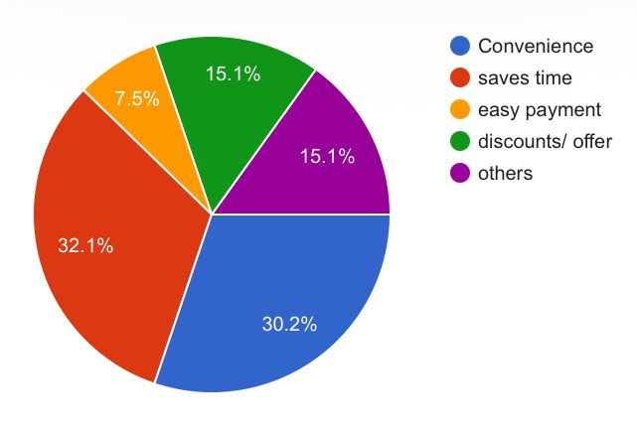
Interpretation
The most common reason for using food delivery services is saving time, selected by 32.08% of respondents. Convenience is the second most common reason at 30.19%.
Discounts and offers account for 15.09%, while other reasons also account for 15.09%. Easy payment was selected by 7.55% of respondents.
The results indicate that convenience and time-saving are the most important motivations for using food delivery services among the respondents.
AVERAGE SPENDING PER FOOD DELIVERY ORDER

Spending Range | Number | Percentage
Below ₹200 | 15 | 14.15%
₹200–₹500 | 57 | 53.77%
₹501–₹1,000 | 23 | 21.70%
Above ₹1,000 | 11 | 10.38%
Total | 106 | 100%

Average Spending Per Food Delivery Order
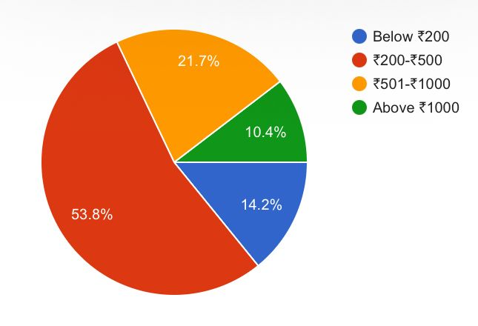
Interpretation
The majority of respondents, representing 53.77%, spend between ₹200 and ₹500 per food delivery order. Around 21.70% spend between ₹501 and ₹1,000.
A total of 14.15% spend below ₹200, while 10.38% spend above ₹1,000 per order.
Therefore, the ₹200–₹500 range is the most common spending category among the respondents.
PROBLEMS FACED WHILE ORDERING FOOD ONLINE

Problem | Number | Percentage
No major problems | 38 | 36.19%
Late delivery | 26 | 24.76%
Poor food quality | 16 | 15.24%
Cold food | 16 | 15.24%
Payment issues | 9 | 8.57%
Total valid responses | 105 | 100%

Problems Faced While Ordering Food Online
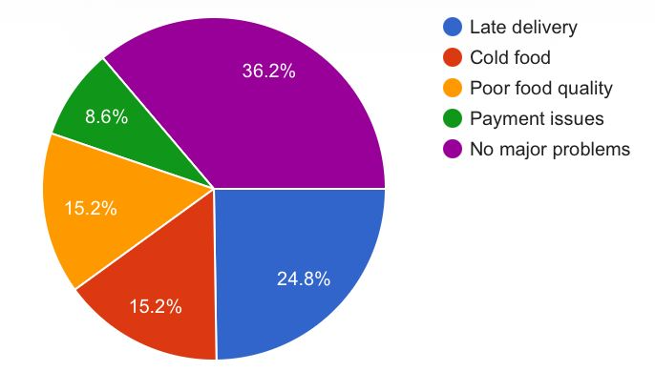
Interpretation
The largest group of respondents, 36.19%, reported that they face no major problems while ordering food online. However, late delivery was reported by 24.76% of respondents, making it the most significant specific problem. Poor food quality and cold food were each reported by 15.24% of respondents. Payment issues were reported by 8.57%.
Although many respondents do not experience major problems, delivery time and food condition remain areas where improvements could increase customer satisfaction
OVERALL CUSTOMER SATISFACTION
Satisfaction Level | Number | Percentage
Very satisfied | 20 | 19.05%
Satisfied | 42 | 40.00%
Neutral | 35 | 33.33%
Dissatisfied | 6 | 5.71%
Very disappointed | 2 | 1.90%
Total valid responses | 105 | 100%
Overall Customer Satisfaction with Food Delivery Services
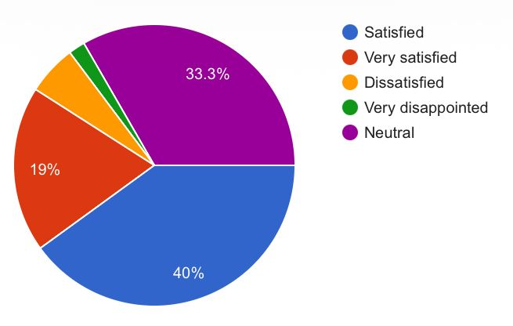
Interpretation
The results show that 40% of respondents are satisfied with online food delivery services, while 19.05% are very satisfied. Therefore, a considerable proportion of respondents have a positive view of food delivery services. At the same time, 33.33% of respondents selected neutral, indicating that a significant group does not express either a clearly positive or negative opinion. Only 5.71% reported being dissatisfied and 1.90% selected very disappointed.
Overall, the data suggests a generally positive level of satisfaction among respondents, although there is room for improvement in order to convert neutral customers into satisfied or highly satisfied customers.
WILLINGNESS TO RECOMMEND FOOD DELIVERY SERVICES

Response | Number | Percentage
Definitely yes | 27 | 25.47%
Probably yes | 31 | 29.25%
Not sure | 34 | 32.08%
Probably no | 7 | 6.60%
Definitely no | 7 | 6.60%
Total | 106 | 100%
Willingness to Recommend Food Delivery Services
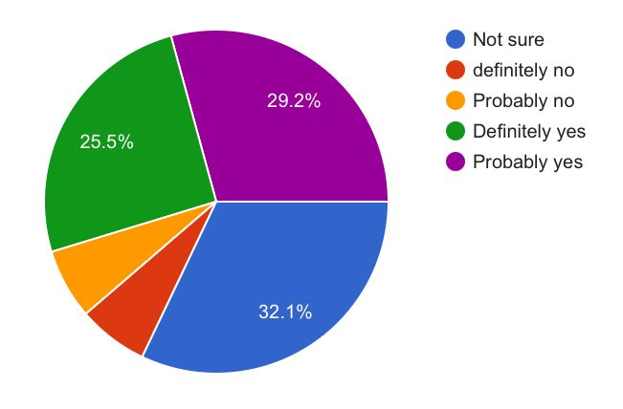
Interpretation
The largest category is respondents who are not sure whether they would recommend food delivery services, representing 32.08%. Around 29.25% selected probably yes and 25.47% selected definitely yes. Therefore, more than half of the respondents gave a positive recommendation response when the two positive categories are considered together.
Only 6.60% selected probably no and another 6.60% selected definitely no. The findings suggest that although overall satisfaction is generally positive, a substantial number of respondents remain uncertain about recommending food delivery services.
OVERALL ANALYSIS OF THE SURVEY
The survey provides useful information about the behaviour and satisfaction of consumers using online food delivery services.
The largest age group in the sample is 18–25 years, while students form the largest occupational group. This shows that younger respondents and students represent a substantial portion of the survey sample.
Regarding ordering frequency, once-a-week and several-times-a-week ordering are the two most common categories. This indicates that online food ordering has become a regular activity for many respondents.
In terms of food delivery platforms, the largest group uses both services equally, followed by Zomato. This suggests that customers may compare or use multiple platforms rather than remaining loyal to only one service.
Saving time and convenience are the two leading reasons for using food delivery services. This demonstrates the importance of convenience in online food ordering behaviour.
The most common spending range is ₹200–₹500, indicating that the majority of respondents generally make relatively moderate-value orders.
Regarding problems, the largest group reported no major problems. However, late delivery was the most frequently reported specific problem. Food quality and temperature were also mentioned by respondents.
The satisfaction results are generally positive, with satisfied and very satisfied respondents forming a significant portion of the sample. However, one-third of respondents selected neutral, indicating an opportunity for food delivery companies to improve customer experiences.
Finally, recommendation intention is mixed. While many respondents would probably or definitely recommend food delivery services, the largest single category is “Not sure”. This suggests that satisfaction does not always translate into strong recommendation behaviour.

FINDINGS OF THE STUDY
Based on the analysis of 106 responses, the following major findings were identified:
- The 18–25 age group is the largest age category, representing 28.30% of respondents.
- Students form the largest occupational category, accounting for 38.10% of valid responses.
- Online food ordering is a regular activity for many respondents, with 25.47% ordering once a week and another 25.47% ordering several times a week.
- Both equally is the most common response regarding frequently used food delivery services, accounting for 36.19% of valid responses.
- Saving time is the most common reason for using food delivery services, selected by 32.08% of respondents.
- Convenience is the second most important reason, selected by 30.19% of respondents.
- The most common spending range is ₹200–₹500, accounting for 53.77% of respondents.
- The largest proportion of respondents, 36.19%, reported no major problems while ordering food online.
- Among specific problems, late delivery is the most frequently reported problem at 24.76%.
- 40% of respondents are satisfied with online food delivery services.
- Another 19.05% are very satisfied, indicating a generally positive satisfaction pattern.
- A significant 33.33% of respondents are neutral regarding their satisfaction.
- The largest category for recommendation intention is “Not sure”, accounting for 32.08%.
- 29.25% of respondents would probably recommend food delivery services, while 25.47% would definitely recommend them.
- The findings suggest that convenience, time-saving, reasonable spending and satisfactory service are important aspects of the food delivery experience.
SUGGESTIONS AND RECOMMENDATIONS
Based on the findings of the study, the following suggestions can be made:
- Improve Delivery Timeliness
Late delivery was the most frequently reported specific problem. Food delivery companies should improve delivery-time estimates and route planning to reduce delays.
- Maintain Food Quality
Food delivery platforms and restaurant partners should ensure that food maintains acceptable quality during preparation, packaging and transportation.
- Improve Temperature Control
Since some respondents reported receiving cold food, appropriate packaging and transportation methods should be used to maintain food temperature.
- Provide Accurate Delivery Estimates
Customers should receive realistic delivery estimates rather than overly optimistic timings. Regular updates can also improve customer confidence.
- Strengthen Customer Support
Quick and effective customer support can help resolve problems involving delayed orders, missing items, poor food quality and payment difficulties.
- Offer Relevant Discounts
Discounts and offers were one of the reasons respondents use food delivery services. Companies can provide offers that are relevant to different customer groups while maintaining service quality.
- Improve the Overall Customer Experience
Since a significant number of respondents are neutral about their satisfaction, companies should focus on improving the complete ordering experience rather than concentrating only on price.
- Encourage Customer Feedback
Food delivery services should regularly collect customer feedback and use it to identify recurring problems.
- Increase Transparency
Customers should receive clear information about delivery charges, estimated delivery time, restaurant ratings and order status.
- Focus on Customer Retention
Since positive satisfaction can encourage repeat purchases and recommendations, companies should focus on consistently delivering reliable service.

CONCLUSION
The study titled “A Study on Customer Satisfaction with Food Delivery Services” was conducted to understand consumer behaviour and satisfaction towards online food delivery services.
The study was based on 106 responses collected through a structured questionnaire. The responses were analysed using frequency counts and percentages.
The findings show that online food delivery is a regular activity for many respondents. The 18–25 age group and students represent significant portions of the sample. The most common reasons for using food delivery services are saving time and convenience.
The majority of respondents spend between ₹200 and ₹500 per order. Many respondents reported that they do not face major problems while ordering online. However, late delivery remains the most frequently reported specific problem, followed by issues related to food quality and temperature.
The overall satisfaction results are generally positive. A substantial proportion of respondents are satisfied or very satisfied with food delivery services. However, the presence of a sizeable neutral group indicates that service providers still have opportunities to improve customer experiences.
The recommendation results show that many respondents have a positive attitude towards recommending food delivery services, although “Not sure” is the largest individual category.
Overall, the study concludes that convenience and time-saving are major benefits of food delivery services, while delivery performance and food quality remain important areas for improvement. Food delivery companies can improve customer satisfaction by providing timely deliveries, maintaining food quality, improving customer support and responding effectively to customer feedback.

BIBLIOGRAPHY
Books
- Kotler, Philip and Keller, Kevin Lane. Marketing Management. Pearson Education.
- Kotler, Philip, Armstrong, Gary and others. Principles of Marketing. Pearson Education.
- Zeithaml, Valarie A., Bitner, Mary Jo and Gremler, Dwayne D. Services Marketing: Integrating Customer Focus Across the Firm. McGraw-Hill.
Research Material
- Online resources and educational material relating to customer satisfaction, service quality and online food delivery services were referred to for understanding the concepts used in this project.
Primary Data
- Primary data collected through a structured questionnaire from 106 respondents, August 2026.

John Wilson Education Society’s
Wilson College
(Autonomous Minority Institution)

NAME: Anushka khadka
ROLL NO: 2627-Bcom34-133
PROGRAMME: Sy-Bcom
SUBJECT: Field Project
TOPIC: ‘A Study on Customer Satisfaction with Food Delivery Services’
INCHARGE: Ms Komal

