COLORS:

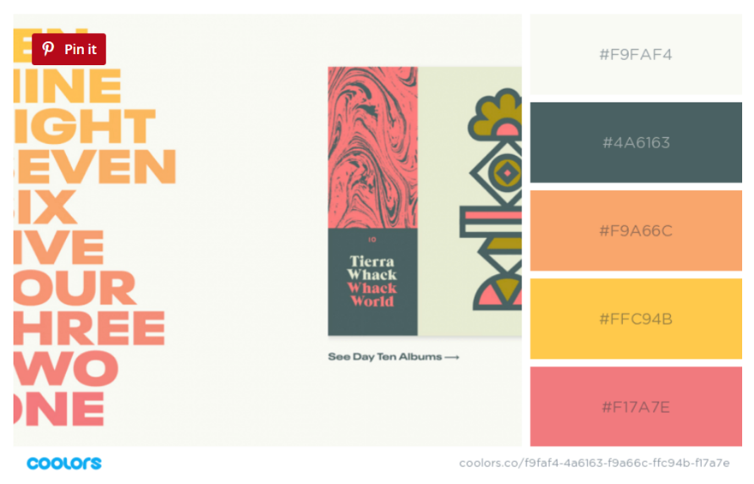

FONT: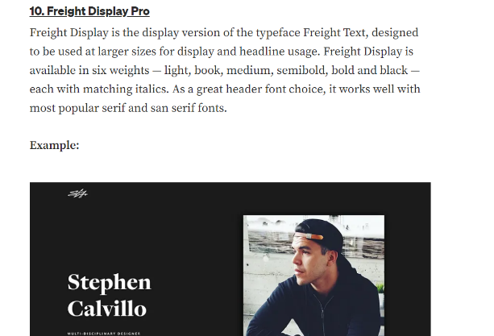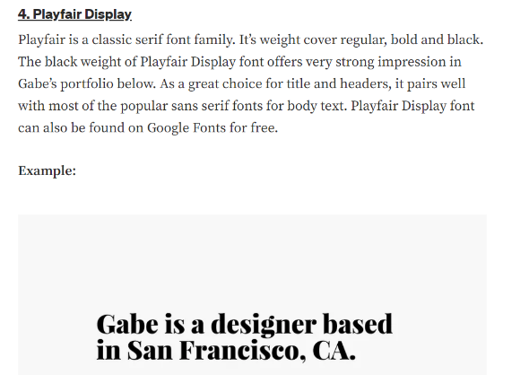

THINGS TO INCLUDE:

1. Navigation bar- faded with bright text
2. Side bar with twitter, linkedin and github icons and links
3. Skills, internships with duration and progressive bars
4. Resume downloading option
5. Photograph
6. Contact me details with email option