**5. Develop an application that uses ArrayAdapter with ListView.**

Mainactivity.xml

*<?***xml version="1.0" encoding="utf-8"***?>*

<**android.support.constraint.ConstraintLayout xmlns:android="http://schemas.android.com/apk/res/android"**

**xmlns:app="http://schemas.android.com/apk/res-auto"**

**xmlns:tools="http://schemas.android.com/tools"**

**android:layout_width="match_parent"**

**android:layout_height="match_parent"**

**tools:context=".MainActivity"**>

<**TextView**

**android:layout_width="wrap_content"**

**android:layout_height="wrap_content"**

**android:text="Courses"**

**android:id="@+id/tv1"**/>

<**ListView**

**xmlns:android="http://schemas.android.com/apk/res/android"**

**xmlns:tools="http://schemas.android.com/tools"**

**android:id="@+id/lv1"**

**android:layout_width="match_parent"**

**android:layout_height="match_parent"**

**tools:context=".MainActivity"**

**android:layout_marginTop="50dp"**>

</**ListView**>

</**android.support.constraint.ConstraintLayout**>

Mainactivity.java

**package** com.example.sjcet.arrayadapterlistview;

**import** android.support.v7.app.AppCompatActivity;

**import** android.os.Bundle;

**import** android.widget.ArrayAdapter;

**import** android.widget.ListView;

**import** android.widget.TextView;

**public class** MainActivity **extends** AppCompatActivity {

TextView **tv1**;

ListView **lv1**;

@Override

**protected void** onCreate(Bundle savedInstanceState) {

**super**.onCreate(savedInstanceState);

setContentView(R.layout.***activity_main***);

**tv1**=(TextView)findViewById(R.id.***tv1***);

**lv1**=(ListView)findViewById(R.id.***lv1***);*// display(welcom changing to admin)*

*// listvivew operation*

String[] courses={**"MCA"**,**"MBA"**,**"BBA"**,**"BCA"**};

ArrayAdapter adapter = **new**

ArrayAdapter(**this**,android.R.layout.***simple_list_item_1***,courses);

**lv1**.setAdapter(adapter);

}

}

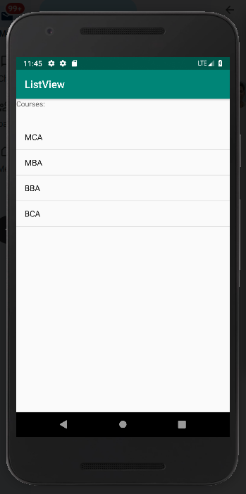

**4.Implement Options Menu to navigate to activities**

**Mainactivity.xml**

*<?***xml version="1.0" encoding="utf-8"***?>*

<**android.support.constraint.ConstraintLayout**

**xmlns:android="http://schemas.android.com/apk/res/android"**

**xmlns:tools="http://schemas.android.com/tools"**

**xmlns:app="http://schemas.android.com/apk/res-auto"**

**android:layout_width="match_parent"**

**android:layout_height="match_parent"**

**tools:context=".MainActivity"**>

<**TextView**

**android:layout_width="wrap_content"**

**android:layout_height="wrap_content"**

**android:text="Hello World!"**

**app:layout_constraintBottom_toBottomOf="parent"**

**app:layout_constraintLeft_toLeftOf="parent"**

**app:layout_constraintRight_toRightOf="parent"**

**app:layout_constraintTop_toTopOf="parent"** />

</**android.support.constraint.ConstraintLayout**>

**Maianctivity.java**

**package** com.example.sjcet.optionmenu;

**import** android.support.v7.app.AppCompatActivity;

**import** android.os.Bundle;

**import** android.view.Menu;

**import** android.view.MenuInflater;

**import** android.view.MenuItem;

**import** android.widget.Toast;

**public class** MainActivity **extends** AppCompatActivity {

@Override

**protected void** onCreate(Bundle savedInstanceState) {

**super**.onCreate(savedInstanceState);

setContentView(R.layout.***activity_main***);

}

@Override

**public boolean** onCreateOptionsMenu(Menu menu) {

MenuInflater inflater = getMenuInflater();

inflater.inflate(R.menu.***main_menu***, menu);

**return true**;

}

@Override

**public boolean** onOptionsItemSelected(MenuItem item) {

**switch** (item.getItemId()){

**case** R.id.***emergency***: *// full colon*

Toast.*makeText*(**this**,**" Emergency clicked"**,Toast.***LENGTH_SHORT***).show();

**break**;

**case** R.id.***profile***:

Toast.*makeText*(**this**,**" Profile clicked"**,Toast.***LENGTH_SHORT***).show();

**break**;

**case** R.id.***aboutus***:

Toast.*makeText*(**this**,**" About us clicked"**,Toast.***LENGTH_SHORT***).show();

**break**;

**case** R.id.***signout***:

Toast.*makeText*(**this**,**" Signout clicked"**,Toast.***LENGTH_SHORT***).show();

**break**;

}

**return super**.onOptionsItemSelected(item);

}

}

**menu.xml**

*<?***xml version="1.0" encoding="utf-8"***?>*

<**menu xmlns:android="http://schemas.android.com/apk/res/android"**>

<**item**

**android:id="@+id/emergency"**

**android:title="Emergency clicked"**/>

<**item**

**android:id="@+id/profile"**

**android:title="Profile clicked"**/>

<**item**

**android:id="@+id/aboutus"**

**android:title="About us clicked"**/>

<**item**

**android:id="@+id/signout"**

**android:title="Signout clicked"**/>

</**menu**>

