**Test Scenario 1:**

* To verify the REST APT Trade response for Trade

**Solution:**

Designed to read the End point URL from Configuration.properties file and fetch the Trade response into output folder.

set the configuration of Key < RestEndPointUrl>

Note : This file location also parameterized and passed in the configuration file.

Key < TradeResponsefile>

**Expected behavior** : Trade response file will be saved in the specified location. Already existing file will be overridden.

Based on the above configuration test script will connect to Candle stick REST API and download Response and store in the folder :- .\\output\\Trade_Details_Response.txt

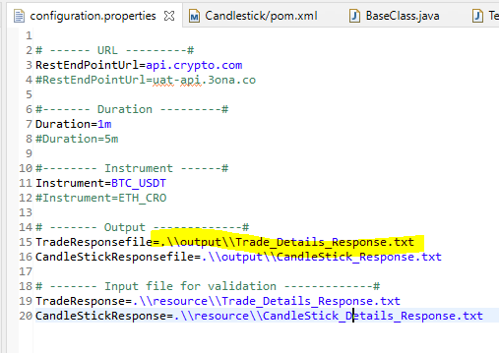

**Test Scenario 2:**

* To verify the REST APT Candle Stick response for Candle stick

**Solution:**

Designed to read the End point URL from Configuration.properties file and fetch the Candle Stick response into output folder.

* set the configuration of Key < RestEndPointUrl>

Note : This file location also parameterized and passed in the configuration file.

Key < CandleStickResponsefile>

**Expected behavior** : Trade response file will be saved in the specified location. Already existing file will be overridden.

**Test Scenario 3:**

* To verify the consistency of candle Stick of any Instrument for any duration

**Solution:**

Parameterize the Instrument type and duration in Configuration.properties file as shown below.

If you want to get Candle stick response for Instrument - BTC_USDT and duration – 5M

Then set the configuration of Key < Duration > and <Instrument> as

Duration=5m

Instrument= BTC_USDT

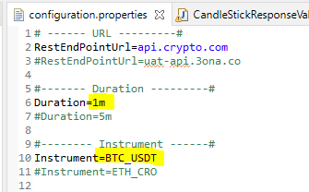

Note : This file location also parameterized and passed in the configuration file as similar to duration and instrument.

Pick random record timestamp and it’s previous and next record timestamp and see if the duration match with the request duration. i.e. 1m or 5m as mention in the configuration file.

**Expected behavior** :

Manipulated Candle stick duration should match with the actual Candle stick record duration.

**Test Scenario 4:**

* To verify the consistency of Trade Price Vs Candle Stick Price

**Solution:**

Read the Candle Stick and Trade Response file from the path mentioned in the configuration file. Get the Time stamp from Trade response for 1 minute. Manipulate openPrice, maxPice, minPrice, closePrice and volume from the Trade response data. Compare the price with Candle Stick for the same timestamp of the Trade data.

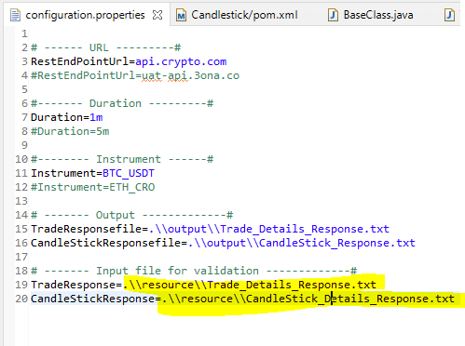

**Expected behavior** :

Manipulated trade data i.e. openPrice, closePrice, maxPice, minPrice, and volume should be match with the Actual Candle stick data.