WEEK 1

Aim
To create an ATS-friendly resume webpage using basic HTML elements.

Description:
This experiment demonstrates the creation of a structured resume using basic HTML. The webpage includes personal details, contact information, career objective, educational qualifications, technical skills, work experience, projects, certifications, strengths, languages known, and declaration. HTML elements such as headings, paragraphs, lists, tables, images, and horizontal lines are used to organize the resume.

Program:
ATS Friendly Resume Using Basic HTML

Program Code:
<html>
<center>
<img src="image.png" width="155" height="175" alt="Loading..">

<head>
<h1>
RANGALA ANUSWETHA
</h1>
<body>
Student
</body>
</head>
</center>

<h2 style="color: red;">
<strong>Contact Information</strong>
</h2>

<table border="1" width="400" height ="125">

<thead>
<tr>
<th><strong>Information</strong></th>
<th><strong>Details</strong></th>
</tr>
</thead>

<tr>
<td>Email</td>
<td>mohan@gmail.com</td>
</tr>
<tr>
<td>Phone</td>
<td>+91 9876543210</td>
</tr>
<tr>
<td>LinkedIn</td>
<td>https://linkedin.com</td>
</tr>

</table>

<hr>

<h2 style="color: red;">
<strong>Educational Details</strong>
</h2>

<table border="1" width="600" height="125">

<thead>
<tr>
<th>Degree</th>
<th>University</th>
<th>Year</th>
<th>Percentage</th>
</tr>
</thead>
<tr>
<td>BTech</td>
<td>ANITS</td>
<td>2024-2028</td>
<td>80</td>
</tr>

<tr>
<td>Intermediate</td>
<td>SR Junior College</td>
<td>2022-2024</td>
<td>80</td>
</tr>

<tr>
<td>SSC</td>
<td>Vignan's High School</td>
<td>2022</td>
<td>80</td>
</tr>
</table>
<hr>
<h2 style="color: red;">
Technical Skills
</h2>
<ul>
<strong>
<li>HTML</li>
<li>Python</li>
<li>AWS</li>
</strong>
</ul>

<hr>

<h2 style="color: red";>
Projects
</h2>

<table border="1" width="600" height="105">
<thead>
<tr>
<th>Title</th>
<th>Tools</th>
<th>Description</th>
</tr>
</thead>
<tr>
<td>Static Website Hosting</td>
<td>HTML, CSS, JS, GitHub, AWS S3, AWS Code Pipeline, AWS
CodeBuild</td>
<td>Hosted a static website using Amazon S3</td>
</tr>
</table>

<hr>

<h2 style="color: red;">
Strengths
</h2>

<ul>
<strong>
<li>Quick Learner</li>
<li>Leadership Skills</li>
<li>Problem Solving</li>
<li>Team Player</li>
<li>Communication Skills</li>
</strong>
</ul>
<hr>
<h2 style="color: red;">
Languages Known
</h2>

<ul>
<strong>
<li>Telugu</li>
<li>English</li>
<li>Hindi</li>
</strong>
</ul>

<hr>

<h2 style="color: red;">
Declaration
</h2>

<body>
I hereby declare that the above information is true and correct to the best of my knowledge and belief.
</body>

<div align="right">
<b>Signature</b>
<br>
Mohan
</div>

</html>

Details About Program:
Saved in: Week 1 folder of the repository.
File used: HTML file with an image stored in the images folder.
Technology used: HTML.
Execution: The HTML file is opened in a web browser.
Working: Basic HTML elements are used to create and organize different sections of the resume. Tables are used for contact, education, and project details, while lists are used for skills, experience, certifications, strengths, and languages.

Output:

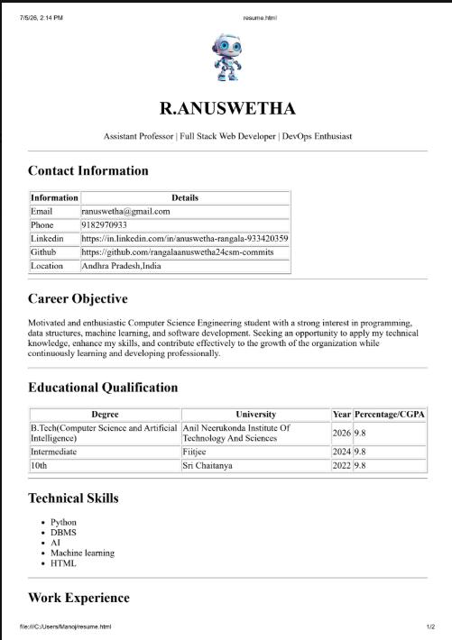

Result:
The ATS-friendly resume webpage was successfully created using basic HTML elements and displayed in a web browser.

