1. *1* What? 1 Error! Bookmark not defined.

*2.* What? 1

3. Section 1 Intro, Snapshot, In-depth 1

3.1. Sub-Section Nature-based sols, Cross-reference, Quantitative information 1

Roman section 1 Annexes 1

Sub-sub-Section Themes in Section 3 1

I. Roman section 2 1

Roman section 3 1

# What?

National Biodiversity Strategy and Action Plan

Target Similarity Assessment: Cambodia

Preliminary National Summary

Blablabla;ppp[oo[

Note

Footnote1

citationhhhhhhhhhhhhhhhhhhhhhhhhhhhhhhhhhhhhhhhhhhhhhhhhhhhhhhhhhhhhhhhh

Caption

Intro

# Section 1 Intro, Snapshot, In-depth

## Sub-Section Nature-based sols, Cross-reference, Quantitative information

### Roman section 1 Annexes

#### Sub-sub-Section Themes in Section 3

##### Roman section 2

###### Roman section 3

Bla bla

List

* Bullet1
* Bullet2

extra

Header

Text text text text tex

Text text text text tex

Text text text text text

Text text test footnote[1]

Figure

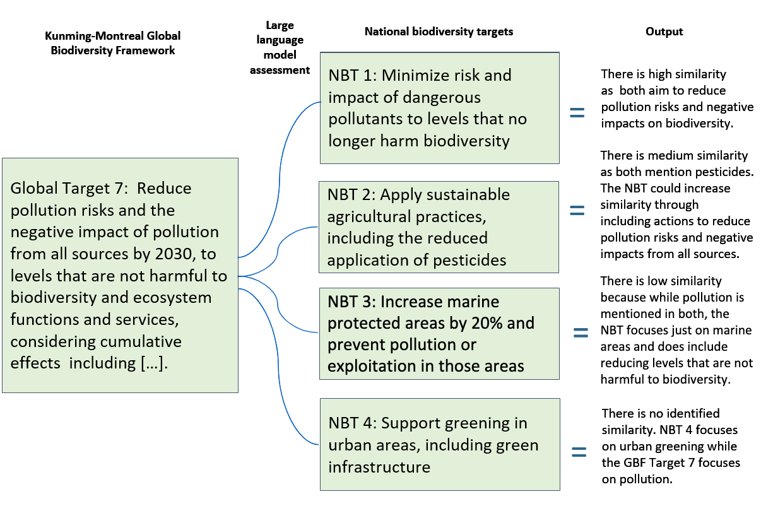

Figure

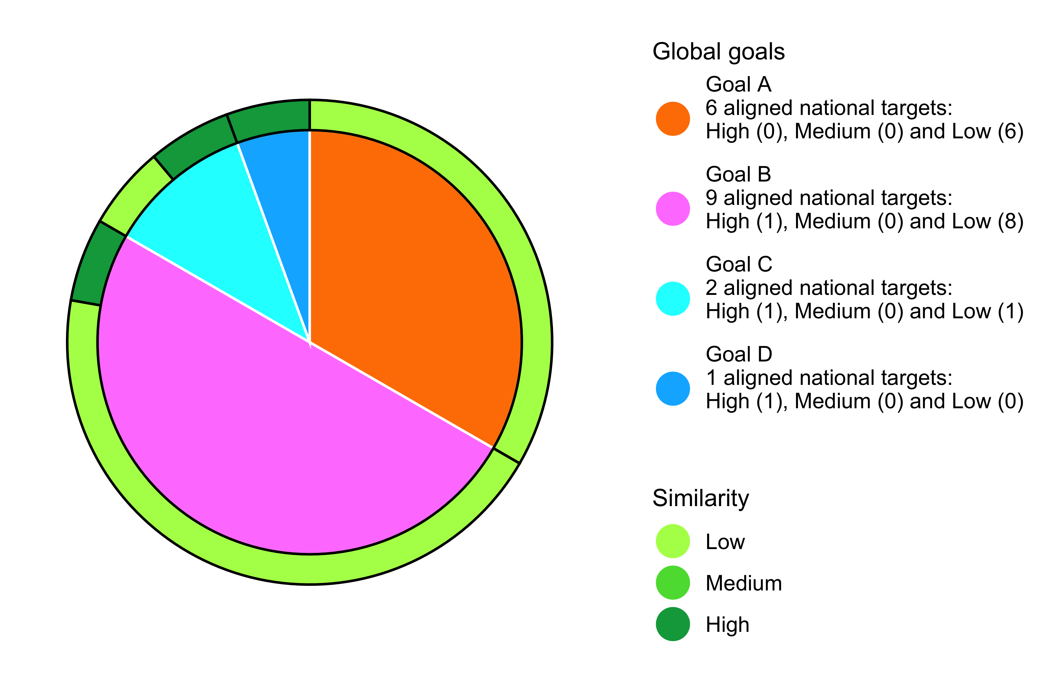

keywords

Box text

Box text

Box text

Table

|  |  |  |  |  |
| --- | --- | --- | --- | --- |
|  |  |  |  |  |
|  |  |  |  |  |

### Test (because uuuuuuhrgh!)

Summary box

Might be better to read this

From afar, no?

1.