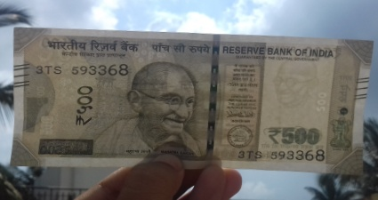 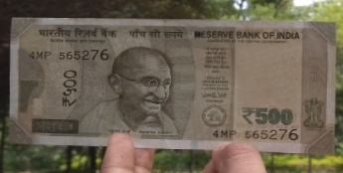

Figure 1: 500 Real Currency Figure 2: 500 Fake Currency

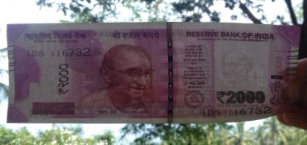 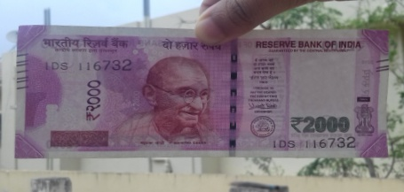

Figure 3: 2000 Real Currency Figure 4: 2000 Fake Currency

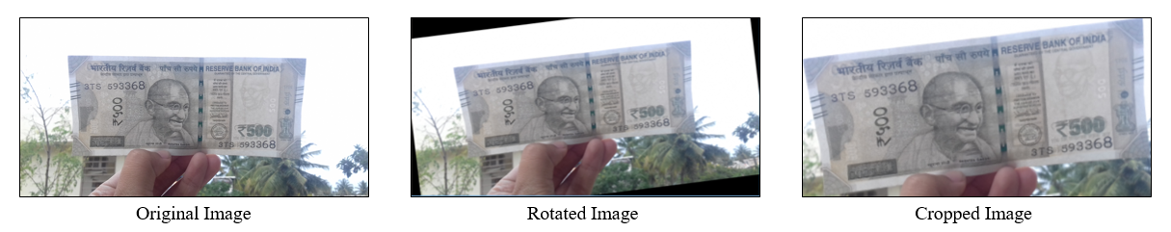

Figure 5: Image Replication by Data Augmentation