Regression_Assignment_Analysis
- Mutiple Linear Regression
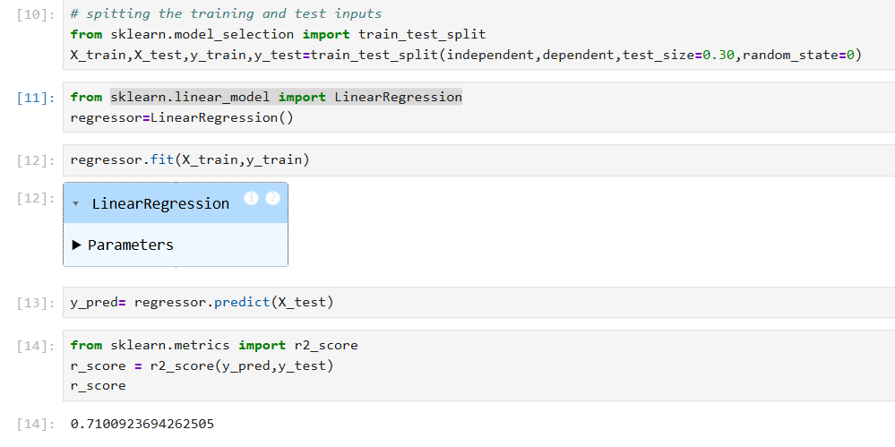

When checked the R_Score value is 0.7100
Since the value does not look good trying with SVM

- SVM
Using rbf as kernel
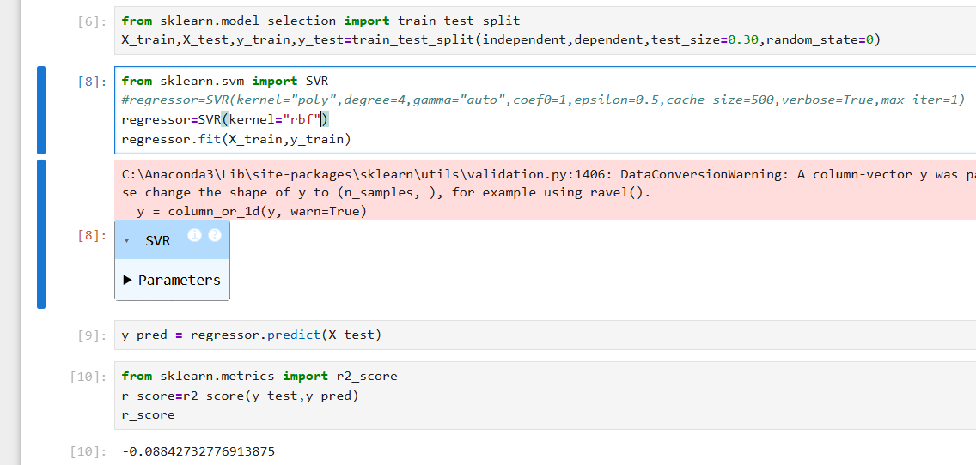

The R_Score value is -0.088 which is poor
Now with same kernel and altering other values as below
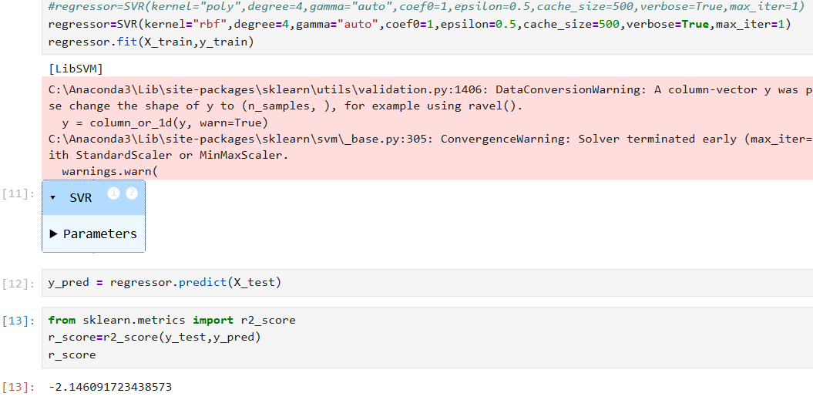

The R_Score is -2.14 which is again poor. Trying other option of kernel and provided the details in tabular as below –
kernel | degree | gamma | epsilon | cache_size | verbose | max_iter | R_score
rbf | 3 | scale | 0.1 | 200 | False | -1 | -0.088
rbf | 4 | Auto | 0.5 | 500 | True | 1 | -2.14
sigmoid | 4 | Auto | 0.5 | 500 | True | 1 | -0.0899
poly | 3 | scale | 0.1 | 200 | False | -1 | -0.064

Since the R_score is low going to try with other models

- Decision Tree
criterion | splitter | max_depth | min_samples_split | min_samples_leaf | min_weight_fraction_leaf | max_features | random_state | max_leaf_nodes | min_impurity_decrease | ccp_alpha | R_score
squared_error | random | None | 2 | 1 | 0.0 | None | None | None | 0.0 | 0.0 | 0.6318
friedman_mse | best | None | 2 | 1 | 0.0 | None | None | None | 0.0 | 0.0 | 0.7056
friedman_mse | random | None | 2 | 1 | 0.0 | None | None | None | 0.0 | 0.0 | 0.7624
absolute_error | best | None | 2 | 1 | 0.0 | None | None | None | 0.0 | 0.0 | 0.6666
absolute_error | random | None | 2 | 1 | 0.0 | None | None | None | 0.0 | 0.0 | 0.6835
poisson | best | None | 2 | 1 | 0.0 | None | None | None | 0.0 | 0.0 | 0.7229
poisson | random | None | 2 | 1 | 0.0 | None | None | None | 0.0 | 0.0 | 0.6747

As in the above procedure the highest R score is 0.7624, need to try Random Forest now.
- Random Forest
n_estimators | criterion | max_features | bootstrap | min_samples_split | min_samples_leaf | R_score
100 | squared_error | 1.0 | True | 2 | 1 | 0.8538
100 | absolute_error | 1.0 | True | 2 | 1 | 0.8520
100 | friedman_mse | 1.0 | True | 2 | 1 | 0.8540
100 | poisson | 1.0 | True | 2 | 1 | 0.8526

The highlighted one looks better compared to other ones above – 0.8540
But this is low compared to decision tree R_score. (0.8540)

Among the above all this seems to the highest value so proceeding with deploying the same.

